Biochemical Pathway Visualization Questionnaire

Section A: Usage Data

- How often do you use biochemical pathways in your profession?

- What do you use biochemical pathways for?

- When you need to look up something about biochemical pathways, do you mostly consult books or do you use biochemical pathway tools (or both)?

- Please rate your familiarity with the following biochemical visualization/editing tools. (See Section D for views of the tools)

Other tools

- For the biochemical pathway visualization/editing tools you have used, please indicate any problems you faced using them.

- In general, what are the constraints you face when visualizing/editing biochemical pathways?

Section B: Preference Data

- Which tool(s) do you prefer using for visualizing and editing biochemical pathways?

- Please rate the importance to you of features that could be available in biochemical visualization/editing tools.

- Indicate other features that you would like to have in a biochemical visualization tool. Rank the importance of the features (from “Very important” to “Very unimportant”) and state your reason(s).
Feature Importance Reason(s)

Appendix D shows how biochemical pathways are displayed in various visualization tools. The example used in the appendix is glycolysis. Please review all figures and answer the following questions.

- Rank the tools in terms of your preference. Use 1 for the most favorite and 5 for the least favorite. State the reason(s) for your choice.
Rank Reason(s)

- Which of the following notations/representations for biochemical pathway visualization/editing do you prefer? State your reason(s).

Section A: Personal Data

- Your age group:

- Your profession:

- Your highest educational level:

- Your background:

- Years of experience in using computers:

- Years of experience with biochemical pathways:

Section D: Appendix

1. BioCarta

Figure 1. Representation of glycolysis in BioCarta. Nothing is clickable.
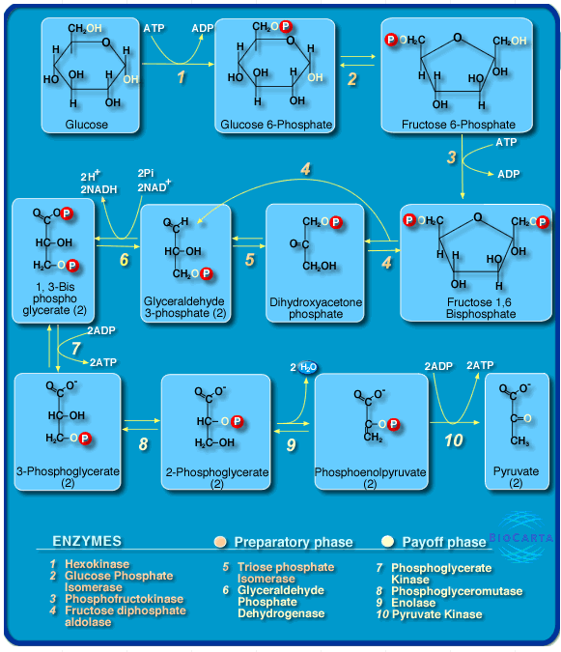
www.biocarta.com

Figure 2. Legend for biochemical pathway representation in BioCarta
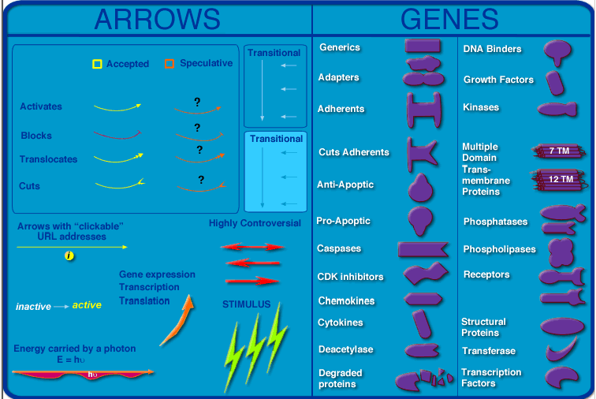

2. ExPASy

Figure 3. Representation of glycolysis in ExPASy. Only enzymes are clickable. Arrows outside the picture take you to linked pathways.
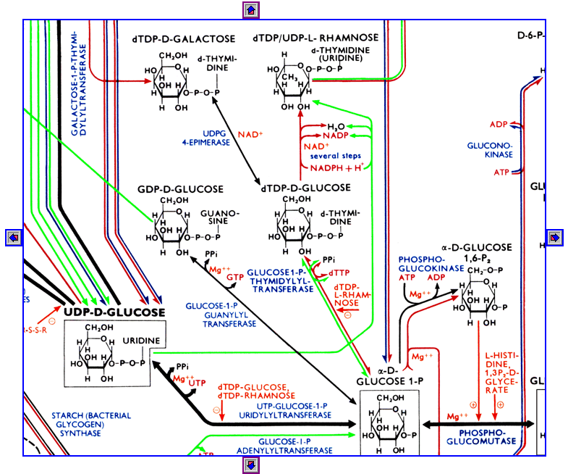
http://www.expasy.org/cgi-bin/search-biochem-index

Legend:
- Substrates of enzymatic reactions are shown in black, enzymes in blue, coenzymes in red. Regulatory effects are shown in orange. This color is also used for pathway names and for information on the location of reaction. For numbering systems, green is used.
- The color of the reaction arrow shows where the reaction was observed: black = general pathways, blue = in animals, green = in plants and yeast, red = in prokaryotes.
- Bold arrows indicate main pathways of metabolism.
- Points on both ends of an arrow indicate reversibility of this reaction under biological conditions.

3. KEGG

Figure 4. Representation of glycolysis in KEGG. All items (substrates, enzymes, arrows) are clickable.
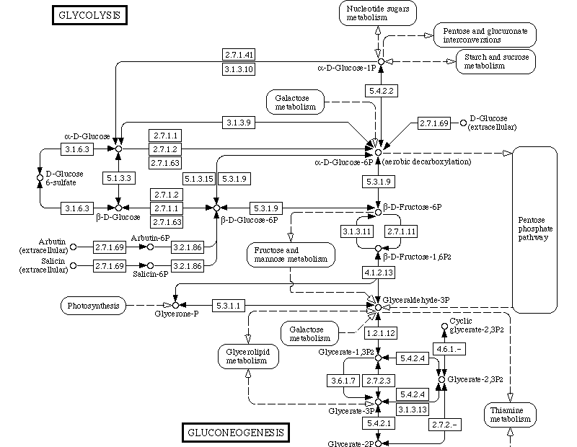
http://www.kegg.com/

Legend:
- An enzyme, represented by its EC number, is drawn in a box.
- Adjacent pathways are drawn in semi-rectangles.
- Substrates are drawn in ovals.
- The enzymes found in the gene catalog of a specific organism are marked green in order to identify the organism-specific pathways.
- The enzymes found in a given database are marked blue in order to help retrieve, for example, known 3D structures.
- The enzymes found by the EC number search against pathway maps are marked red.

4. MetaCyc

Figure 5. Representation of glycolysis in MetaCyc. All items (substrates, enzymes, arrows) are clickable.
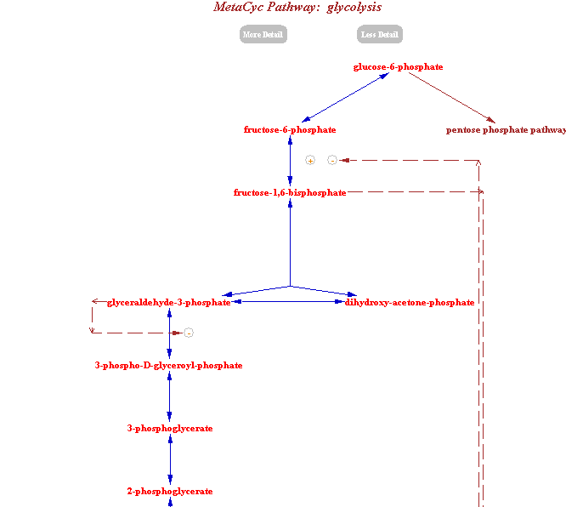
http://www.biocyc.com/

5. WIT

Figure 6. Representation of glycolysis in WIT. All items (substrates, enzymes, arrows) are clickable.
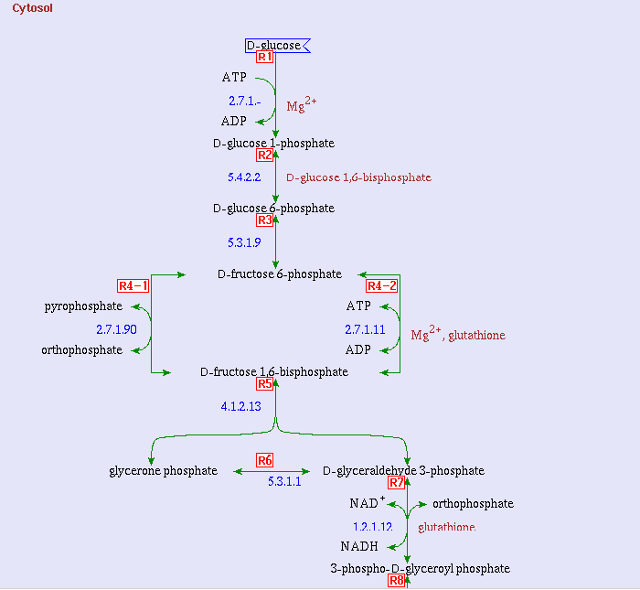
http://wit.mcs.anl.gov/WIT2/

