Animated Exploring of Huge Software Systems

Liqun Wang

Thesis

submitted to the Faculty of Graduate and Postdoctoral Studies
in partial fulfillment of the requirements
for the degree of Master of Science

System Sciences Program
School of Information Technology and Engineering
University of Ottawa
Ottawa, Ontario, Canada

©Liqun Wang, 2002

ACKNOWLEDGEMENTS

I would like to acknowledge the help that I have received during my research.

Grateful thanks to:

• Dr. Timothy Lethbridge, my supervisor, for his support, guidance, patience and intelligent comments.
• The KBRE group for their help, comments, and the valuable discussions with them.
• The students who participated in this study
• My friends for their concerns and encouragement.

ABSTRACT

There are many software visualization tools available today to help software engineers to explore software systems. However, when a system is huge, some of these tools do not satisfy the exploration requirements. The big problem is that the techniques the tools use do not provide an effective display and access mechanism to handle huge information spaces within the limitations imposed by available screen space.

To alleviate the problem, this thesis describes methods that help users to explore huge software systems. In particular, we apply dynamic browsing incorporating such details as an extra result box mechanism, plus pattern based searching to help users to handle large query results. Then the thesis introduces the algorithms we apply to generate the layouts. We propose the radial angle model to visualize the internal structures of rooted trees. Also we apply the spring model to visualize the external structures among rooted trees. Next, the thesis describes various animation methods we use to smooth the transitions, track the focus of exploration, clarify unexpected results, and illustrate complex operations. In addition, we modify traditional camera animation, and propose an animation timing scheme ‘slow-in fast-out’ to exaggerate the reality. Next, the thesis describes a series of experiments we conducted to assess the effectiveness of the browsing, layout algorithm and animation techniques we implemented. Finally the thesis describes how we use the analysis of the experiment results to guide our future research.

TABLE OF CONTENTS

Chapter One: Introduction 1
1.1 Current Problems of Visualizing Large Software System 1
1.1.1 Background 1
1.1.2 Visualizing the Software 1
1.1.3 Difficulties in Software Visualization 2
1.2 Related Research 2
1.2.1 Browsing Techniques 2
1.2.2 Layout Algorithms 3
1.2.3 Animation Techniques 4
1.3 Motivation and Objectives 4
1.4 Contributions of the Thesis 5
1.5 The Organization of the Thesis 6
Chapter Two: Browsing Techniques 7
2.1 Literature Review 7
2.1.1 Panning and Zooming 7
2.1.2 Multi-viewer 8
2.1.3 Focus and Context Browsing 8
2.1.4 Tree-maps Viewer 9
2.1.5 3D Browsing 10
2.1.6 Dynamic Interactive Browsing 10
2.1.7 Searching and Browsing 11
2.1.8 Summary 12
2.2 Browsing Approach of TkSee Visualizer 12
2.2.1 Browsing Requirements of TkSee Visualizer 12
2.2.2 Browsing Approach of TkSee Visualizer 13
2.3 Features of the Browsing Approach of TkSee Visualizer 14
2.3.1 Interactive Exploration 15
2.3.2 Pattern Based Searching 15
2.3.3 Exploration of Multiple Relationships among Multiple Entity Types 16
2.3.4 Limits on the Number of Expanded Nodes on Screen 16
2.3.5 Preserving the User’s Mental Map 17
2.3.6 Handling Large Query Results 18
2.3.7 Panning 20
2.4 Summary 20
Chapter Three: The Layout Algorithm 21
3.1 Literature Review of Related work 21
3.1.1 Background of Graph Drawing 21
3.1.2 The Spring Model Layout Algorithm 23
3.1.3 The Sugiyama Layout Algorithm 24
3.1.4 Radial Layout 26
3.1.5 Incremental Layout Algorithms 26
3.2 Layout Approach of TkSee Visualizer 28
3.2.1 Layout Requirements of TkSee System 28
3.2.2 Layout Algorithm of TkSee Visualizer 30
3.3 Detailed Discussion of the Layout Algorithms of TkSee Visualizer 32
3.3.1 The Radial Angle Model 32
3.3.2 Modeling Rooted Trees 41
3.3.3 Modeling by Heuristics 42
3.3.4 Be Capable to Adjust the Layout Manually 44
3.4 Layout Results Given by TkSee Visualizer 45
3.5 Summary 46
Chapter Four: Animation 48
4.1 Functionality of Animation: 48
4.2 Basic Rules of Animation design 48
4.2.1 Parameters to Animate 49
4.2.2 Animation Control 49
4.2.3 Animation Path 50
4.2.4 Animation Timing 50
4.2.5 Frame Rate 50
4.2.6 Psychological Factors 51
4.2.7 Applying Principles of Cartoon Animation 51
4.3 Animation Techniques Used in the Visualization of Software 52
4.3.1 Camera Animation 52
4.3.2 Layout Animation 52
4.3.3 Shrinking/Growing Animation 53
4.3.4 Problems in the Animation Usage 53
4.3.4.2 Other Usage of Animation 54
4.4 Animation Techniques Implemented in TkSee Visualizer 54
4.4.1 Animation Design 55
4.4.2 Layout Animation and Grow/Shrink Animation 57
4.4.3 Intelligent Camera Animation 59
4.4.4 Zero-result Animation 61
4.4.5 Result-already-exist Animation 63
4.4.6 Updating Animation 65
4.4.7 Root Updating Animation 68
4.5 Summary 69
Chapter Five: The Architecture of TkSee Visualizer 70
5.1 TkSee Visualizer 70
5.2 Process Flow of TkSee Visualizer 71
5.3 User Interface of TkSee Visualizer 73
5.3.1 Symbol Indicator 74
5.3.2 Start Exploration Toolbox 74
5.3.3 Explore Toolbox 75
5.3.4 Preferences Toolbox 75
5. 3.5 Animation Setup Toolbox 76
5.3.6 Color Design 77
5.3.7 Other Interface Techniques 78
Chapter Six: Evaluation Experiments 79
6.1 Methodology 79
6.1.1 Test Users 79
6.1.2 Experiment Preparation 80
6.1.3 Experiment Process 81
6.2 Analysis of Experiment Results 82
6.2.1 Browsing Techniques 82
6.2.2 Layout Algorithms 86
6.2.3 Animation Techniques 90
6.2.4 User Interface 94
6.2.5 The Default Value of System Parameters 94
6.2.6 General Feedback of the Tool 97
6.3 Summary 100
Chapter Seven: Conclusion And Future Work 101
7.1 Review of the Research 101
7.2 Conclusions 102
7.3 Limitations and Future Work 102
References 104
Appendices 110
Appendix A: The Instructions of the Experiment 110
Appendix B: Test Tasks 111
Appendix C: Informed Consent Form 113

LIST OF FIGURES

Figure 2-1: The extra result box 14
Figure 2-2: The extra result box and pattern based searching: (1) Extra result box is not used; (2) The pattern based searching string is “*”; (3) The pattern based searching string is “get_d*”. 20
Figure 3-1: The key concepts in radial angle model 34
Figure 3-2: The angular assignment of child nodes 35
Figure 3-3: Preserve the mental map 36
Figure 3-4: Model unit 38
Figure 3-5: When the neighbor gap angle is larger than the child node angle 40
Figure 3-6: When the neighbor gap angle is smaller than the child node angle 40
Figure 3-7: Root nodes are placed in the cross points of a grid. 42
Figure 3-8: The flow chart of whole modeling process 44
Figure 3-9: A layout within a rooted tree 45
Figure 3-10: A layout with multiple rooted trees 46
Figure 4-1: The slow-in fast-out animation timing model 56
Figure 4-2: Layout animation (1) Node find_plane_activity is clicked to expand (2) The child nodes of find_plane_activity are growing from find_plane_activity (3) The child nodes stop moving as they reach their destinations 59
Figure 4-4: Intelligent camera animation (1) Node system_typ is clicked to expand (2) Intelligent camera animation is performed 61
Figure 4-5: Zero-result animation (1) User does an exploration on node prio but there is no query result (2) The node prio grows up 63
Figure 4-6: Result-already-exist animation (1) User does an exploration on node dcd_absent_str but the result has already existed on the screen (2) The node chopin is pushed away 65
Figure 5-1: TkSee Visualizer 71
Figure 5-2: The flowchart of the Tcl/Tk component 72
Figure 5-3: The flow chart of the C++ core program 73
Figure 5-5: The symbol indicator 74
Figure 5-6: The start exploration toolbox 74
Figure 5-8: The preference toolbox 76
Figure 5-9: The animation toolbox 77

LIST OF TABLES

Table 6-1: Default value of system parameters 97
Table 6-2: Users’ comments on the tool 98
Table 6-3: The summary of the experiment results 100

Chapter One: Introduction

1.1 Current Problems of Visualizing Large Software System

1.1.1 Background

In today’s software industry, large software systems are everywhere. Some systems, particularly legacy software, may contain millions of lines of code. These large systems are extremely complex, so understanding the design, as well as changing and repairing the code in such systems are inordinately time consuming and costly. How to effectively maintain such large systems has been a big problem.

1.1.2 Visualizing the Software

A good picture is worth ten thousand words, so one way to help software engineers to cope with complexity and to increase programmer productivity is through visualization. Because humans are inherently visual creatures, visual representations can make the process of understanding software easier.

Software visualization (SV) is the use of pictures for looking at and understanding software systems. Depending on the nature of the software understanding problem, different aspects of software structure or behavior are visualized. For example, visualizing the structure of classes and relationships among the software entities to help users to understand the program. Visualizing the data structures of a program in an intelligent way can help the programmer to solve memory leaks. Algorithm animation is yet another example of software visualization that has proven to be very useful in teaching computer algorithms.

Besides the advantages of making programs easy to understand, software visualization also has other merits, such as being graphically appealing and being potentially easier for people to use than textual views, etc.

1.1.3 Difficulties in Software Visualization

The big difficulty in software visualization (SV) is dealing with the huge graph needed to fully represent software versus the limited screen space available. Without effective display and access mechanisms, the information itself is useless. In an SV system, software entities are presented as nodes while the relations among the nodes are represented as arcs. When the number of nodes is 1000-2000 or so, browsing the screen with panning and zooming is enough. When the number of nodes is more than that, special browsing techniques must be used.

The various structures of software entities and the relations among them are presented to the user of a visualization tool using general layout algorithms. However, general layout algorithms may not 100% satisfy the requirements of some SV areas. Such as the entities in the graph drawing are represented as dots while in SV they are presented as nodes of some size. Some small changes can cause a big problem.

1.2 Related Research

There are two key classes of techniques we need to examine to better understand approaches to SV. These are browsing techniques and layout algorithms.

1.2.1 Browsing Techniques

The biggest problem with browsing techniques is dealing with the huge graph versus the small amount of screen space. A lot of research has been done to cope with the problem. There are three main ‘static’ browsing techniques:

• The multiple-viewer [25][3] offers two viewers. One viewer gives a global view while the other gives a view of local detail.

• The focus+context viewer [4][5][39] attempts to use distortion to display the whole graph in one viewer. The area near the focus is shown in detail while the area away from the focus is shown only in overview.

• 3D browsers [22][23][24] are another general approach to browsing.

When the nodes number less than 3000, those algorithms work well. But when the system contains millions of nodes, dynamic browsing techniques [20][37] give a better solution. They dynamically generate small parts of the overall graph as the user is exploring on it. However, although dynamic browsing techniques can browse huge software systems, they nevertheless have difficulty handling huge query results (e.g. situations when the user clicks on an entity to show related entities and hundreds of related entities must be displayed).

1.2.2 Layout Algorithms

In SV, a few general layout algorithms are used to describe various structures and relationships in a program. For example, the Sugiyama layout algorithm [2] can be used to illustrate hierarchical relations among classes; and the spring model [1] can present non-hierarchical relationships among software entities. These graph drawing approaches are selected based on the properties of the graph type. They give readable layouts that obey aesthetic principles.

In this thesis, a new layout algorithm, incremental layout, is created to work with a new dynamic browsing technique. These new techniques require a lot of analysis with regard to both the browsing technique and the layout algorithm. One problem that must be considered is how to preserve the user’s mental map during dynamic exploration.

1.2.3 Animation Techniques

When users change the focus of the view while browsing the diagram, camera animation is activated to smooth the transition. Layout animation is conducted in the incremental layout to preserve mental map. In the incremental layout, animation is applied after every exploration. This gives the user an expectation: they are waiting for change after every click. If there is no change, they might think something is wrong. That is another mental issue we should also consider.

1.3 Motivation and Objectives

According to the problems in understanding huge software systems, as well as the achievement of previous research in software visualization, we need to investigate how software visualization techniques can be specifically adapted to meet the requirements of program comprehension through visualization. Also, with our approaches we have to assess how much we can do to improve the performance of software visualization.

The aim of my thesis is to find a good method to help users to explore very large software systems. We attempt to build a new software visualization tool that employs advanced methodologies and implements our approaches. The tool will be capable of browsing huge software systems and handling huge query results. It can explore multiple relationships among multiple software entities. The layout given by the tool should be clear and satisfies the aesthetics of graph. Furthermore, the user’s mental map should be preserved during the exploration.

1.4 Contributions of the Thesis

We employ dynamic browsing techniques to browse huge software systems. In the browser, a mechanism is proposed to handle large query results. We propose a layout algorithm that matches our dynamic browsing technique and satisfies the requirements of a browsing tool called TkSee Visualizer. We apply multiple animation techniques to smooth the layout transition, aiding the user in tracking objects and clarifying the exploration results. Finally, we design a series of experiments to evaluate our approaches and point out directions for future study. Our major contributions are:

- We have implemented a prototype tool, TkSee Visualizer, to browse and manipulate huge software systems.

- In TkSee Visualizer, we employ dynamic browsing techniques. These incorporate with pattern based searching and an extra result box to deal with the difficulties in exploring large query results.

- We apply incremental layout to match our dynamic browsing techniques. Besides this, we modify the radial graph algorithm to describe the internal structure of rooted trees. Furthermore we use the spring model to provide the layout among the rooted trees. All together, this is our layout algorithm for TkSee Visualizer.

- In TkSee Visualizer, we adapt animation techniques to preserve the mental map. Also, animation is used to clarify the exploration results even when there are no outcomes. In addition, we propose intelligent camera animation so as not to lose track of focus while using screen space more effectively. Furthermore, we propose a cartoon-style animation timing ‘slow-in fast-out’ to make exploration more enjoyable and draw attention to it.

- Several experiments are carried out to evaluate our techniques.

1.5 The Organization of the Thesis

The rest of the thesis is organized as follows:

Chapter 2 reviews various popular browsing techniques then describes the browsing technique we used in TkSee Visualizer.

Chapter 3 summarizes layout algorithms used in SV tools. After that it explains our radial angle layout model.

Chapter 4 introduces diverse animation techniques and animation design rules, then focuses on the animations we implemented in the TkSee Visualizer

Chapter 5 describes the implementation of the prototype tool TkSee Visualizer

Chapter 6 presents a series of experiment results to assess the effectiveness of our
browsing approach, layout model and animation techniques.

Chapter 7 sums up our research and points out future study directions.

Chapter Two: Browsing Techniques

In this chapter, first we introduce several browsing techniques, highlighting their advantages and shortcomings. Then we point out the browsing requirements of TkSee Visualizer. Based on these requirements and properties of various browsing techniques, we propose the browsing approach of TkSee Visualizer. At the end we explain our approach in depth.

2.1 Literature Review

Two key issues should be satisfied by any browsing technique: We must allow users to 1) browse information spaces, and 2) focus quickly on the items of interest. The key difficulty regarding these issues is to display a large information space on a limited size screen. Many browsing techniques have been proposed and implemented to tackle this difficulty.

2.1.1 Panning and Zooming

One obvious solution is using common interface techniques of panning and zooming. When these are used, the software system is fully visualized into a graphical map. The user scrolls the window across the map to view portions of the map at one time. In addition to panning, the users can also zoom in or zoom out on special parts to view them more clearly. This method is simple and easy to use, but a drawback is that whenever a portion of the map is viewed in detail, large portions of the map are off-screen, and when the map is large, users cannot locate the place they are interested in quickly.

2.1.2 Multi-viewer

Some browsing techniques present two viewers. One gives the global view of the graph, while the other gives the detail of the focus point on the global viewer. Bifocal [25] and Information Mural [1] are the examples of this concept.

Information Mural [3] is a 2D information visualization tool. It uses visual attributes such as grayscale shading, intensity, color, and pixel size, along with anti-aliased compression techniques to compress a large information space to fit entirely within a display window. Besides the global viewer, Information Mural also supplies the second viewer to display detailed information of the focus area in the global viewer. The graph in the detail viewer is updated as the focus moves around the global viewer.

Multi-viewer has the advantage of presenting both local detail and overall structure. But it requires extra screen space and forces users to mentally integrate the two views. On the local detail viewer, the part adjacent to the enlarged area is not visible at all.

2.1.3 Focus and Context Browsing

Fisheye view [4][5] is a widely used focus and context browsing technique. It presents both local detail and global context in one view without switching among multiple viewers. The places near the focus are shown in detail while remote regions are shown in successively less detail. As the user moves the focus, the graph constantly changes to keep the area near the focus enlarged.

The fisheye view is implemented in the software visualization tool Shrimp [32] as one of its browsing techniques.

One drawback of fisheye view is that some typical diagrams will change to very weird shapes so as to be unrecognizable after the fisheye view transformation. It also requires the diagram of the system to be predefined before viewing. When the system is huge it is therefore impractical.

Another well-known focus and context browsing technique is Hyperbolic Browser [39] which attempts to take advantage of the properties of hyperbolic geometry to visualize large hierarchies. It can display up to 10 times as many nodes as conventional tree browsers. But the hyperbolic browser is weak in giving the directionality of links and also the location of a node in the overall space.

2.1.4 Tree-maps Viewer

Johnson and Shneiderman proposed a space filling tree map approach to visualize hierarchical information structures [28]. In tree-maps, a hierarchy is drawn as a set of nested boxes in which each node is presented as a rectangular region composed of the rectangular regions that represent its children. It attempts to organize nodes all over the screen to increase the usage of screen space.

Treeviz [47] for the Macintosh is an implementation of the tree-maps concept. Each of the nodes can be colored dependent upon the type of the file, and the lightness can indicate age etc. The user can click on these rectangles to either get more information or to perform options such as delete etc.

The main advantage of tree-maps is its ability to visualize large hierarchies. It is claimed that 1-3000 nodes, each with an area of 100 pixels, can be displayed in the screen of 640 by 480 pixels. While a standard 2-D hierarchy browser can typically display around 100 nodes under that circumstance. The other advantage is its ability to emphasize some attribute of the data, for example size of files, by the size of the rectangular regions. However tree-maps tend to obscure the hierarchical structure and result in the user losing the context while focusing on one part of a hierarchy.

2.1.5 3D Browsing

Another attempt to maximize the effective use of the available screen space is three-dimensional visualization techniques. The best-known examples are The Perspective Wall [22] and Cone Trees [23].

The Perspective Wall visualizes linear information such as time, on a folded wall with a center panel for showing detail and two perspective panels for displaying context. Once a note is selected on a perspective panel, the wall scrolls to bring the panel that has the focus node to the front. The trade-off between detail and context can be adjusted by manipulating the degree of folding, the width of the detail panel, and the angle of the field of view.

Cone Trees embed the tree in a three dimensional space. The embedded tree has joints. When a level in the hierarchy is expanded, cones are rotated to bring the selected data items to the front of the display. The expanded new contents are arranged around the bottom of the inverted cone.

The use of three dimensions provides more space freedom in graph layout than 2D. Also it gives users a better "feel" for the structure of the information space [40]. But such displays still suffer from a lack of screen space along with the burden of 3D visualization. For Cone Trees, trees with more than approximately 1000 nodes are difficult to manipulate [40].

2.1.6 Dynamic Interactive Browsing

The browsing techniques that require the predefinition of the overall geometrical representation of the graph before browsing are called static browsing techniques. Panning and zooming, multi-viewer, tree map, etc, and all the browsing techniques we have discussed before are static browsing techniques. Contrary to static browsing techniques, dynamic browsing techniques do not predefine the whole graph before users browse through it. They build the visualization incrementally as the user is exploring the graph. OFDAV [37] and NicheWorks [20] are implementations of the dynamic browsing technique.

In dynamic browsing, the graph updates after each valid exploration action. The change between consecutive updates should be small enough; otherwise the changes will confuse the user. This problem is called preserving the user’s mental map of the diagram [14]. Most dynamic browsing systems apply both the incremental layout algorithm and animation to solve this problem.

Another problem is how to save screen space while keeping browsing effective. M. L. Huang et al [37] proposed a deletion policy with two strategies to solve the problem. One of the strategies is called FIFO. They push every expand node into a Queue. The “least recently used” focus node, the first node in the queue, is deleted when the Queue is full. The other is called Largest K-distance rule. The node that has the largest graph-theoretical distance from the new focus node is deleted when the Queue is full.

Static dynamic browsing can effectively deal with graphs of moderately large size (with hundreds or thousands of nodes); they do not handle huge graphs (with millions of nodes). Comparing with static dynamic browsing, dynamic interactive browsing techniques are better techniques for browsing huge software systems since the size of the system does no matter to it. Dynamic browsing is a new approach that still needs a lot of effort to be perfect. They currently are not able to give clear architectural views of a software system.

2.1.7 Searching and Browsing

According to S. E. Sim [33], searching is planned activity with a specific goal, whereas browsing is more of an explorative strategy with no fixed endpoint. Browsing and searching complement each other. The shortcomings of browsing are matched by the strengths of the search. “An information space can only be fully utilized when both navigation styles, browsing and searching, are available.”[33] If a visualization tool combines with searching, it will be a more powerful tool.

2.1.8 Summary

In this section, we described the most popular browsing techniques, panning and zooming, multi-viewer, focus and context browsing, tree-maps, 3D browsing and dynamic interactive browsing. So far, dynamic interactive browsing techniques are the best technique to browse a huge software system. If we combine searching with browsing, we can offer users a more effective browser.

2.2 Browsing Approach of TkSee Visualizer

Our browsing approach should meet the browsing requirements of as defined for the TkSee system [7,48].

2.2.1 Browsing Requirements of TkSee Visualizer

- The TkSee system deals with legacy systems that have millions of lines of code. The Visualizer therefore should handle a huge amount of information.
- The TkSee system can explore multiple relationships among multiple software entities. The Visualizer should also provide this feature.
- In TkSee, a single query during the course of browsing can result in thousands of items to display. The Visualizer should handle therefore huge exploration results.

Although these requirements are given by TkSee, they are limitations also found in other tools.

2.2.2 Browsing Approach of TkSee Visualizer

We adopt the dynamic browsing technique as our browsing technique of TkSee Visualizer to help users to navigate huge software systems. In addition, we propose an extra result box mechanism combining with pattern based searching to handle large query results.

2.2.2.1 Handle Huge Information

We do not display the whole software system on the screen at a time. Starting from the software entities the user defines, we incrementally update the graph as the user clicks a node to do exploration with selected parameters. Like the OFDAV[37] system, we apply the incremental layout algorithm and animations to preserve mental map. We will discuss the incremental layout algorithm in Chapter three and animation in Chapter four. Again like the OFDAV system, we drop nodes when too many nodes are displayed on the screen to prevent clutter. We use FIFO as our deletion policy. More detailed discussions are given in the next section.

2.2.2.2 Explore Multiple Relationships among Multiple Software Entity Types

TkSee offers four exploration relationships. They are “what nodes are defined by node A”, “which node defines node A”, ” what nodes are referred to by node A” and “which nodes refer to node A”. Also four software entity types exist in the TkSee. They are “files”, ”routines”, “data” and “type”. Every exploration activity is specified by particular exploration relationship and software entity type that are to be displayed. We apply colors to distinguish different relationships and software entities. More detailed discussions are given in the next section.

2.2.2.3 Handle Large Query Results

We propose a mechanism called ERBS to deal with huge query results. It is composed of extra result box browsing technique and pattern based searching.

If a query gives a large number of results, we show the maximum displayable results and hide the rest in a box. The box can be treated as a special node. The remaining results update those shown nodes when user clicks the box. We give the number range of the query result on the box. The user can append a name pattern upon the query result to get more precise results. More detailed discussions are given in the next section.

Figure 2-1: The extra result box

2.3 Features of the Browsing Approach of TkSee Visualizer

In TkSee Visualizer, exploration is done interactively. Searching can be appended with the exploration to refine the results. Users can explore multiple relationships among multiple entity types. To preserve the space, the expanded node number is limited to less than a certain number. The user’s mental map is preserved and users can handle large query results with the help of extra result box and pattern based searching.

2.3.1 Interactive Exploration

In TkSee Visualizer, an exploration is activated when the user clicks on a node; the exploration is specified as a query. The mechanism to create queries is well designed that users can conduct their explorations easily and effectively.

The Visualizer offers small sets of buttons to help users to create the query (see Fig 5-7). They are four exploration relation buttons and four result entity type buttons that cover all the explanation relationships and result entity types defined in TkSee.

The query language used in TkSee is TA [7]. A TA query can be discomposed into the subject of action, action type and the object of the action. The clicked node is the subject of the exploration action. Four exploration relationships radio buttons define the action type. The entity type radio buttons describe the result of the query.

When the user clicks on a node, a query is specified with the clicked node id, the selected exploration relationship and the selected result entity type.

2.3.2 Pattern Based Searching

In TkSee Visualizer, a pattern based searching function supplied by TkSee can be appended to the exploration to refine the query results.

In TkSee Visualizer, the first exploration is ready to start after user inputs the name or name pattern of the first nodes. Visualizer offers an edit bar to define the name of the first node. It accepts a grep-like regular expression. The Visualizer also offers a set of radio buttons to help users to define the entity type of the first node. When the user clicks the ”Start Exploration” button beside the edit bar, the search string which contains the name and the entity type is created and is sent to TkSee as a query. A node or a few nodes that satisfy the search string will be shown on the screen.

Another way to use searching is to refine the query results during the exploration. Once user gets the exploration results, he or she can append a search string on the results as a filter to narrow down the results. This helps the user to handle the large exploration results. We will discuss this in detail in section 2.3.6.

2.3.3 Exploration of Multiple Relationships among Multiple Entity Types

The TkSee Visualizer can explore multiple relationships on a node. The node can be file, routine, data and type. And results given by multiple dependencies can be added together on a node.

We use different colors and arrow directions to distinguish diverse exploration relationships and entity types. According to the meaning of the exploration relationships, we separate relationships into two groups: define (“defines” and “is defined by”) and refer (“refers” and “is referred by”). We assign one color to each of the group. And we use two arrow directions to distinguish “defines” from “is defined by”, and “refers” from “is referred by”. Therefore six colors have to be chosen to represent four software entity types and two association relationships. We will discuss the color design in depth in Chapter five.

2.3.4 Limits on the Number of Expanded Nodes on Screen

The size of the screen is limited. While more and more nodes are expanded, the visibility of the diagram decreases and the display speed slows down. We have to make a rule to keep a reasonable number of nodes on the screen so that the user can have enough information to do the exploration work, while still having a clear view of a significant part of the system, and in addition having the display update at high speed.

We decide to adopt the FIFO deletion policy proposed by [37]. A queue is created to keep track of all the expanded nodes on the screen. Once a node is clicked to expand it, it is added to the queue. Once the node is clicked to close it, it is removed from that queue.

When the number of expanded nodes on the screen exceeds the maximum expanded node number, the length of the queue, we drop the oldest node in the queue.

In the experiment discussed later in this thesis, we show how we have maintained a reasonable default maximum number of expanded nodes. Before exploration, users can change the number according to their preference.

2.3.5 Preserving the User’s Mental Map

Compared to static browsing, dynamic browsing may show a lot of changes during the exploration. Some nodes will disappear while some nodes will appear. Users may have difficulties tracing the changes. This is called mental map problem. In TkSee Visualizer, the incremental layout algorithm and animations are applied to help preserve the user’s mental map. The incremental layout algorithm can give continuous frames which contain small changes. Layout animation smoothes the layout transitions that help the user to focus on the most recent node user has interacted with. Camera animation helps the user not to lose the track on the focus node.

We will give more detailed discussion on the user’s mental map and the incremental layout algorithm in the Chapter three and animations in the Chapter four.

2.3.6 Handling Large Query Results

2.3.6.1 Problems in Browsing Large Exploration Results

Very often, the query returns a large number of query results. If we display all of the results on screen, they may overlap each other so as to be invisible since the screen space is very limited. Also, it will take a long time to display all of them on the screen so users will lose their patience. Actually, the user has no interest in viewing all the results. They are only interested in a few nodes.

2.3.6.2 Our Solutions to Browse a Large Number of Exploration Results

In TkSee Visualizer, we decide to show only part of the query results if they exceed a certain number, the maximum displayable child number.

We design a special box called the extra result box. This looks like a special kind of node. When the query result exceeds the maximum displayable child number, we show the maximum displayable child number of query results along with the extra result box pretending that the remaining query results are hiding inside the box. When a user clicks the box, the current shown query results are replaced with the remaining query results from the box. The user can browse all the query results by keeping clicking the box.

On the extra result box, we give the range of the query results (e.g. 10-20 of 50, >100). According to the number, users can know the approximate number of the query results. This helps user to know where they are when they browse the query results. It also helps the user to make the decision whether to refine the specification of the query to decrease the number of exploration results.

The Visualizer also offers an exploration search bar to allow user to do search within the query results. Normally the search string is set to “*” which accepts all query results as the search results. When the extra result box is shown after the exploration, the user can specify the search string to filter out the results they are concern with from the complete set of results.

An experiment we will discuss later is designed to determine the reasonable default maximum displayable child number on the screen at a time. Also our system allows users to change the number according to their preference before exploration.

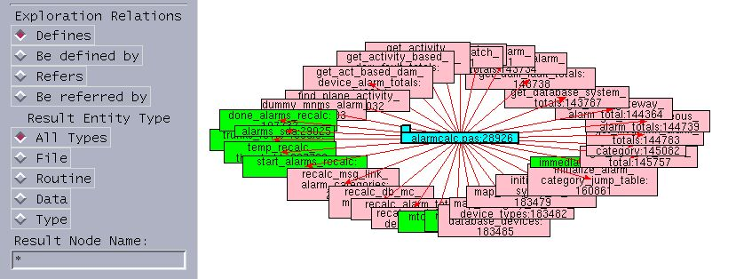
(1)
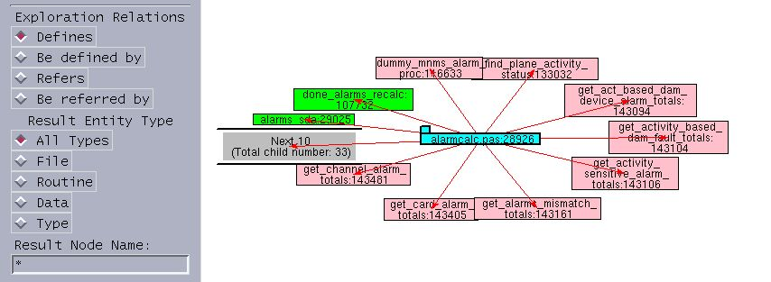
(2)
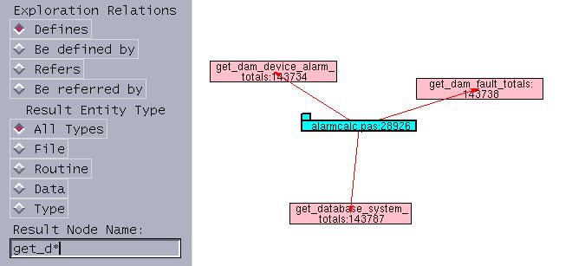
(3)

Figure 2-2: The extra result box and pattern based searching: (1) Extra result box is not used; (2) The pattern based searching string is “*”; (3) The pattern based searching string is “get_d*”.

2.3.7 Panning

Panning is also supported in TkSee Visualizer. Users can drag the background around to view the whole diagram.

2.4 Summary

After analyzing the diverse browsing techniques, we choose to employ dynamic interactive browsing techniques in TkSee Visualizer to browse huge software systems. The tool supports interactive exploration. It can explore multiple relationships on various software entity types. A FIFO deletion policy is used to limit the expanded node number on the screen. Panning is also supported by TkSee Visualizer. An incremental layout algorithm and animations are applied to preserve the mental map. In particular, with the help of pattern based searching function existing in the TkSee and the extra result box mechanism we proposed, Visualizer can handle large exploration results.

Chapter Three: The Layout Algorithm

In this chapter, first we introduce the layout algorithms that are widely used in software visualization. Then we list the layout requirements of TkSee. Based on these requirements, we choose the best layout algorithm for our system and modify it to serve our system better. At the end of this chapter, we give some layout results created by our layout algorithm.

3.1 Literature Review of Related work

The layout algorithm is as important an issue in software visualization as the browsing technique. A lot of layout algorithms for different graph types have been developed successfully. Among these algorithms, the tree layout [41], spring model [1], Sugiyama layout [2], radial drawing [44] and incremental layout [37,19] are widely used in software visualization.

3.1.1 Background of Graph Drawing

The basic graph drawing problem can be described as this: given a set of nodes with a set of relations (edges), calculate the position of the nodes and the curve to be drawn for each edge under certain criteria. In order to understand a layout algorithm well, we have to know some basic graph types and the criteria of the graph drawing.

3.1.1.1 Types of Graph Drawing

Layout algorithms can be categorized with respect to the type of layout they generate. There are three main approaches to how edges can be drawn:

• Polyline drawing: each edge of the graph is drawn as a polyline chain.

• Straight-line drawing: each edge of the graph is drawn as a straight-line segment.

• Orthogonal drawing: each edge of the graph is drawn as polyline chain of alternating horizontal and vertical segments.

In addition, some other constraints can be placed on the drawing method:

• Grid drawing: vertices, crossings, and edge bends have integer coordinates.

• Planar drawing: no two edges cross.

• Upward (resp. downward) drawing: for acyclic digraphs, each edge is drawn as a curve monotonically nondecreasing (resp. nonincreasing) in the vertical direction.

In this thesis, we are primarily interested in directed graphs (also called digraphs): each edge is directed. A directed graph is acyclic if it has no directed cycles. More specifically, we are interested in rooted trees:

• Rooted Tree: a tree in which one node is designated as the root. [42]

3.1.1.2 Drawing Criteria

There are two aspects to the drawing criteria.

First, the drawing should satisfy the constraints imposed by the definition of properties and classification of layouts of the applied graph types. Different type of graphs may require different constraints. For example, the layout of the planar graph should avoid edge-crossings, while a grid layout should position nodes at points with integer coordinates.

Second, the layouts should be pleasing and readable – satisfying general aesthetic rules. For example, nodes and edges must be evenly distributed, edges should have similar lengths, edges should, where possible, be straight lines, isomorphic sub-structures should be displayed in the same manner, edge-crossings should be kept to a minimum, etc. According to Purchase’s usability study [44], reducing the crossings is the most important aesthetic.

3.1.2 The Spring Model Layout Algorithm

(1) Basics of The Spring Model:

The spring layout [1], also called the force-directed method, is a method for creating straight-line drawings; directionality of the graph is not considered. The spring model treats the data layout system as a mechanical system, in which vertices are replaced with steel rings and edges are replaced with springs. The rings are attracted by the springs if they are far apart or repelled if they are too close. All springs in the system have the same length so the layout is symmetrical to satisfy aesthetics.

In the spring model, the linear spring force exerted on a ring in Hookes Law is replaced with a logarithmic force since the traditional force is too strong for the data layout system:

C1*log(d/C2) (formula 2-1)

Where d is the length of the spring, and C1 and C2 are constants. When d=C2, there is no force exerted on the string. Thus C2 is the recommended distance between two nodes.

Also an inverse square law force is applied in the spring model. It is exerted on the non-related vertices to repel then from each other:

C3/sqr(d) (formula 2-2)

Where C3 is a constant and d is the distance between the vertices.

The spring model is heuristic. The algorithm first places the vertices in random locations. Then it calculates the forces on the vertices and moves them toward their stable positions. This operation is repeated a few times until the whole system reaches its minimal energy state or it reaches its maximum calculation time.

(2) Properties of the Spring Model:

The spring model can give a good layout for undirected graphs. The software visualization tool Shrimp [32] is one of many tools that use this model as one of its layout algorithms. However, the model can be rather slow. Frick’s study [45] shows that the workload of the method is O(N³) where N is the number of the nodes in the graph. Moreover, the spring model is highly unpredictable. The layout of almost identical graphs might be very different. Furthermore, vertices, in the spring model, are abstract dots without width and height. When the spring model is used in software visualization, the dots have to be replaced by area-consuming nodes. The size and other geometry features of the nodes should be considered to avoid overlapping in the modeling.

3.1.3 The Sugiyama Layout Algorithm

Sugiyama et al. [2] presented a comprehensive approach to drawing hierarchies. The basic approach is to first assign a layer number to each node according to the relations among the nodes. Then place nodes of a given layer in a certain order to reduce crossings. It can be described as the following four steps:

Step1 Assign vertices to the layers according to a given set of directed pairwise relations among elements of a system. Arcs are directed downward and vertices are distributed uniformly.

If the hierarchy contains long span edges such that some vertices end up in non-contiguous layers, dummy vertices and edges are added in the skipped layers to conform to a proper hierarchy.

Step2 Employ the barycentric method (BC) to handle the crossing problem of each two-layer hierarchy. The basic idea of BC is to assign the x-coordinate of each vertex with the barycenter (average) of the x-coordinates of its neighbors (in the other layer) so that the amount of crossing is reduced.

A multiple-layer hierarchy can be also worked out with the scheme. First, one separates the whole hierarchy into a few consecutive two-layer hierarchies. Then employs BC to reduce the crossings within each two-layer hierarchy. Then the whole system is done.

Step3 Employ the priority layout method (PR) to assign horizontal positions of vertices to reduce the number of bends. A priority number, the connectivity of a vertex to its neighbors, is assigned to each vertex. The vertex with high priority determines its position first. The highest priority number is given to a dummy vertex; its x-coordinate will use the same x-coordinate as its parents. The normal vertices are positioned with their barycenters. The adjustment should preserve the ordering established in the crossing reduction step. If two vertices have the same barycenter, the algorithm moves the one out of the way that has the lower priority.

Step 4: display the layout on the terminal.

Unfortunately, the Sugiyama algorithm tends to have very poor stability. A small logical change in the graph results in a large change in relative positions of nodes in the drawing.

3.1.4 Radial Layout

A tree is a connected acyclic graph. Within the tree layout category, a variety of algorithms have been invented. These include tree [41], H-tree [43], radial drawing [44], cone tree [23] and tree-maps [28], etc. A classical tree layout will position children nodes “below” their common ancestor.

Radial drawing is a variation of a layered drawing where the root of the tree is placed at the origin and layers are concentric circles centered at the origin. A subtree is then laid out over a sector of the circle. Each node is allocated a sub-sector within the sector assigned to its parent. The size of the sector is proportional to the angular width of that node’s subtree. When all the nodes are the same size, the angular width of a node’s subtree is simply proportional to the number of leaf nodes among its descendants. The algorithm ensures that two adjacent sectors do not overlap.

The radial layout is predictable. However, it gives a less clear view for indicating where the root of the tree is and thus it is not a good method to visualize a hierarchy.

3.1.5 Incremental Layout Algorithms

In the dynamic browsing system, the system displays only a small portion of the full graph; this portion is called a logical frames. Exploration means to move the logical frame along some trajectory to display other parts of the graph. In other words, nodes are added to the diagram or discarded from the screen during the exploration. Compared to static visualizing of a graph, some specific considerations have to be taken to reposition the changed graph. A particular class of layout algorithms, the incremental layout algorithms, has therefore been developed to deal with the requirements.

3.1.5.1 The Criteria of the Incremental Algorithm

S. C. North [19] summarized three criteria for incremental updating of graphs. They are as follows, listed by the order of the importance:

- Consistency: adherence to layout style rules of the graph. For example, a tree should always look like a tree during any period of exploration.
- Stability: make the fewest changes as possible between successive diagrams to preserve the mental map.
- Readability: the diagrams should satisfy the usual readability criteria for drawing of graphs. They should be pleasing and easy to read.

3.1.5.2 The Mental Map

Much research has been done to characterize stability between layouts. Misue et al did a lot of work on how people perceive and remember the structure of diagrams. In his paper [14], he discussed what he called the mental map and gave precise rules to reserve it:

- Orthogonal ordering: the direction of each pair of nodes should be preserved after a layout adjustment
- Proximity: nodes that are close together before the adjustment should remain close together after the adjustment.
- Topology: graphical objects inside a region should stay inside that region after a layout adjustment.

3.1.5.3 Previous Work

Some incremental layout algorithms have been implemented successfully in SV systems. For different graph types, the trajectory to generate new logical frames might be different. Here are examples:

- DynaDAG [19]:

DynaDAG is a heuristic algorithm for incremental layout of hierarchies that satisfies proximity and topological stability. It attempts to split a layout adjustment into a few logical steps that incorporate proximity and topological stability. For example, when inserting a node, DynaDAG first moves the node downward along the same X coordinate to the next layer. Then adjusts its Y coordinate to left or to right by the barycenter value.

- OFDAV: online force-directed animated visualization [37]

OFDAV is a system for assisting web document navigation. It modified the force-directed graph drawing algorithm to minimize the overlaps among the neighborhoods and puts the focus nodes in a straight line to indicate the direction of the exploration. In addition, OFDAV produces a continuous sequence of layouts that satisfy the usual readability drawing criteria. It uses these sequences as “in betweening” animation frames to smooth the transition between key frames in order to preserve the mental map.

3.2 Layout Approach of TkSee Visualizer

In this section, first we summarize the requirements of TkSee Visualizer. Based on these requirements, we choose a general layout algorithm as the basic layout algorithm of TkSee Visualizer. If it is necessary, we modify it a little to make it work better for our system. This is explained below.

3.2.1 Layout Requirements of TkSee System

We summarize the layout requirements for TkSee Visualizer in six points:

(1) Be capable of exploring four relationships:
The TkSee system can explore four relationships among software entities. They are “what nodes are defined by node A”, “which node defines node A”, ” what nodes are referred to by node A” and “which nodes refer to node A”. In TkSee Visualizer, these four relationships should be explorable from any node.

(2) Be capable of visualizing parent-child relationship:
When a node is clicked to explore with the predefined query, the graph is updated. The clicked node is the parent node of the result nodes. The results are child nodes of the clicked node. The layout should present the relationship between the clicked node and the result nodes clearly. The ideal layout is that child nodes surround the parent node.

(3) Be capable of preserving the user's mental map:
Since we use dynamic browsing, the diagram changes because of the exploration. The change should be as minimal as possible to preserve the user's mental map.

(4) Be capable of visualizing rooted tree - rooted tree relationships:
Besides the categorization of parent nodes and child nodes, nodes can also be categorized into root nodes and non-root nodes. Root nodes are those that do not have a displayed parent node (although there may be relationships in the database) while non-root nodes have parent nodes currently displayed on the screen. The term rooted tree refers to a root node and its associated descendents. There is no displayed relation among rooted trees. The system should be capable of displaying both parent-child relationships and rooted tree - rooted tree relationships.

(5) Be capable of giving non-overlapped layout as much as possible
A node is drawn in rectangle with the entity’s name. The size of the rectangle depends on the length of the name of the node. The layout should avoid non-overlapping the nodes as much as possible.

(6) Be capable of adjusting the layout manually:
Another requirement is that when the layout algorithm cannot give a perfect layout for some reasons, the user can move nodes to get a clear view manually.

3.2.2 Layout Algorithm of TkSee Visualizer

After studying the properties of various layout algorithms and the requirements of TkSee Visualizer, we propose below the layout algorithm for TkSee Visualizer. The layout algorithm is a mixture of the incremental layout algorithm, the radial algorithm and the spring model algorithm. Besides, we add some constraints on the algorithm so it can handle nodes with sizes and satisfy the requirements of dynamic browsing.

3.2.2.1 A Mixture of Multiple Layout Algorithms

Since TkSee Visualizer applies dynamic browsing, the incremental layout algorithm is a must. We choose to use the radial algorithm to visualize the layout within a rooted tree because the radial algorithm is predictable, gives a clear layout with respect to parent-child relationships, and uses the limited screen space effectively. Also in TkSee, we are dealing with much data that will not be hierarchical. However, the radial drawing algorithm is not good at visualizing the rooted tree - rooted tree relationship. We choose to use the spring model to visualize the rooted tree - rooted tree relationship because the spring model is good at visualizing undirected graphs.

3.2.2.2 Abstract Dots are Replaced by Nodes

The vertices mentioned in the radial algorithm and spring model are dots. In TkSee Visualizer, they are nodes with width and height. This raises the problem of large nodes covering other nodes or arcs.

In radial drawing, child nodes are placed in concentric circles surrounding their parent nodes. In TkSee Visualizer, any node, including a child node, is placed horizontally since this enables users to most easily read the text in it. The nodes that are placed above or below the parent node therefore occupy a larger angle than those that are placed at the left or right side of the parent node. Hence the angular assignment rule for child nodes in the radial drawing algorithm must be modified.

The definition of the distance between two related nodes should also be modified. It should consider the width and height of the node and the slope of the arc between the two related nodes. For example, when child nodes are placed on the left side or right side of their parent node, longer segments of the line between the parent and child centers fall within the child and parent body than those child nodes are placed under or above the parent nodes. This solution can be also used while dealing with the distance between two rooted trees. Every rooted tree can be treated as a “big” node that includes all the offspring of the rooted tree. The distance between two rooted trees should consider the size of the rooted tree and the slope of the arc between the two rooted trees.

3.2.2.3 Basic Idea of the Radial Angle Model

In order to satisfy the requirements of TkSee Visualizer, we modified the radial layout algorithm and called it the radial angle model. The following is the basic idea of the radial angle model:

- The definition of distance should consider the facts of node size and the slope of the arc.
- The concept of the layer is discarded. The length between a parent node and its unexpanded child node is fixed and so is the length between a parent node and an expanded child node. The later one is longer than the former one.
- When a node is clicked, the slope of the link between the node and its parent node will not be changed. This setup maintains orthogonal ordering stability during the exploration.
- The angle between neighboring child nodes should be the same to avoid overlapping.
- The modeling unit is composed of an expanded node, the parent nodes of the expanded node and child nodes of the expanded node.
- The radial angle model uses heuristics

3.3 Detailed Discussion of the Layout Algorithms of TkSee Visualizer

In this section, we explain in detail the modeling within a rooted tree and the modeling among rooted trees. At the end, we give a process diagram 3-8 to outline the whole modeling process.

3.3.1 The Radial Angle Model

In this section, we explain the radial angle model in depth. We start by introducing key concepts of the model. Then we explain each aspect of the model.

3.3.1.1 Key Concepts of the Radial Angle Model

Before explaining the radial angle model in detail, we give the definitions of some concepts we will use.

Clicked node: the focus node

Expanded node and unexpanded node: An expanded node is the kind of node that was clicked to open. It has child nodes. An unexpanded node is the kind of node that has never been clicked or was clicked to close. It does not have child nodes. On Fig 3-1, _node_0 and _node_4 are expanded nodes. The other nodes are unexpanded nodes

Parent node and child node: The clicked node is the parent node of the result nodes. The results are child nodes of the clicked node. On Fig 3-1, _node_4 is the parent node of _node_8, _node_6 and _node_7; _node_8, _node_6 and _node_7 are child nodes of _node_4.

Child node angle: We define the child node angle as the maximum angle among the lines that are drawn from each of the child node's edges to the center of the parent node of the child node. On Fig 3-1, A4 is the child node angle of _node_2

If a child node is an expanded node, the child node angle is the maximum angle among all the lines pointing from each edge of every child node to the center of the parent node of the expanded node. On Fig 3-1, A5 is the child node angle of the expanded node _node_4.

Child left angle and child right angle: We define the child left angle as the angle between the slope of the child node and the left line of the child node angle. Similarly, the child right angle refers to the angle between the slope of the child node and the right line of the child node angle. On Fig 3-1, A1 is the child left angle of _node_4 and A2 is the child right angle of _node_4.

Distance of two nodes: we define the distance between two nodes as the segment of the slope line that falls outside the two nodes. On Fig 3-1, D1 is the distance between _node_0 and _node_5.

Neighbor gap angle: The neighbor gap angle is that from the left line of the right neighbor node’s child node angle to the right line of the left neighbor node’s child node angle. On Fig 3-1, A3 is the neighbor gap angle of _node_2.

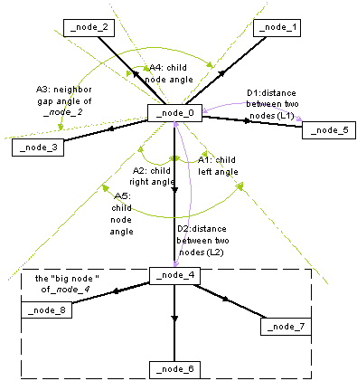
Figure 3-1: The key concepts in radial angle model

3.3.1.2 Length between Two Nodes

In the radial drawing algorithm, there exist layers. They are concentric circles that refer to the exploration depth from the root. In Visualizer, the nodes have sizes. More space is needed. Layers have to be discarded from the radial angle layout. We use fixed link length between parents and its child nodes to replace the layer.

We assign a fixed length between parent nodes and their unexpanded child nodes. We name it as L1 (see Fig 3-1). We assign a longer fixed length between parent node and their expanded child nodes. We name it as L2 (see Fig 3-1). This setup matches common sense. We also use L2 as the spring length among rooted trees. It is the distance constant C2 used in the logarithmic spring force formula (Formula 2-1).

The user can modify L1 according to their preferences during explorations.

3.3.1.3 The Angular Assignment of Child Nodes

In the radial drawing algorithm, the angular sector occupied by each node is proportional to its number of children. However, since nodes have size, this rule does not work any more in the radial angle model.

We generate a new rule to push child nodes away. For an expanded node, the angle among its child node should be equal. If the angles are equal, the expanded node is in the stable state. The parent node of the expanded node is a special child node. As we will discuss later, it joins the modeling and follows the same angular assignment rule.

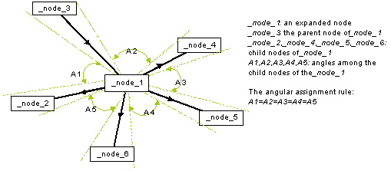

Figure 3-2: The angular assignment of child nodes

3.3.1.4 Preserve the User’s Mental Map

In the radial angle model, the user's mental map is preserved by keeping orthogonal ordering between the clicked node and its parent during the exploration.

Once a node is clicked, the distance between the clicked node and its parent grows from L1 to L2 or shrinks from L2 to L1. But the slope of the clicked node to its parent node will remain the same as before it is clicked. Orthogonal stability is therefore preserved. When a node is clicked to expand, its child nodes grow out. The child node angle of the clicked node enlarges. This change pushes the sibling nodes away from the clicked node. But the relative positions of the clicked node and its sibling nodes will not be changed. So do the relative positions between the clicked node and its parent nodes. Similar things happen as a node is clicked to be close.

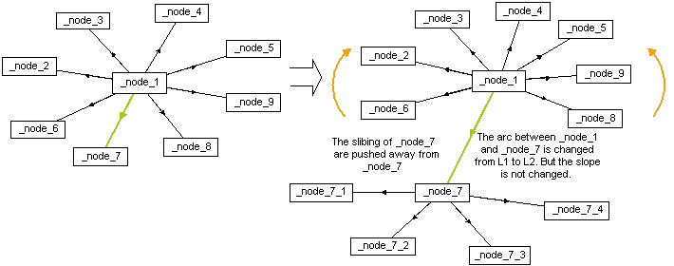
Figure 3-3: Preserve the mental map

3.3.1.5 Model Unit

We choose to include the expanded node and its parent nodes and descendents as a modeling unit instead of a node. The whole modeling process is decomposed to the sum of modeling the expanded nodes independently. This idea simplifies the modeling dramatically. This model unit decision is also supported by the fact that the expanded node is the key unit in the incremental exploration. Whenever a node is clicked, such that a new expanded node is created or an expanded node is closed, the modeling is activated.

Within each rooted tree, all the unexpanded child nodes are connected at least to one expanded node. Thus any node within a rooted tree participates in the modeling at least once. Although each expanded node is modeled independently, since we also bring its parent nodes and child nodes into the model unit, the change within one modeling unit will affect the other expanded nodes eventually to give a reasonable layout finally.

When we create a modeling unit, if a child node of the expanded node is an expanded node, we accept the child node as one “big node”. The “big node” includes the expanded child node and all its descents. In order not to complicate the problem unnecessarily, we stop tracing any expanded child nodes of the “big node”.

In order to keep orthogonal stability, the slope of parent nodes to the expanded node will not be modified in the modeling. The function of parent nodes in the model unit is more like references. We changed the position of the child nodes to achieve the stable state of the model unit. The stable state of the model unit is the state when the parent nodes are in these positions.

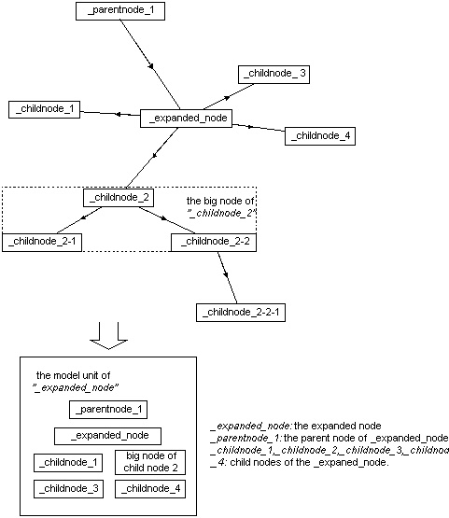

Figure 3-4: Model unit

3.3.1.6 Working Principles of the Radial Angle Model

As we discussed in the section 3.3.5, the modeling of whole graph is accumulated with the modeling of each expanded node. We separate the modeling processing into nine steps:

For each expanded node:

Step 1: Create the modeling unit

Before modeling, we create the modeling unit for an expanded node. The modeling unit includes the expanded node, the parent nodes of the expanded node and the child nodes of the expanded node obtained from all the involved exploration relations.

Within the modeling unit:

Step 2: Calculate the slope of each child node to the expanded node and the slope of each parent node to the expanded node.

Step 3: Calculate the child node angle, the child left angle and child right angle of each child node and parent node. As we said, an expanded child node is treated as one "big node".

For each child node of the expanded node:

Step 4: According to the slope of a child node, one finds this child node's left neighbor node and the right neighbor node.

Step 5: Compute the neighbor gap angle, the left sum angle and the right sum angle of a child node.

Step 6: If the neighbor gap angle is larger than the child node angle, we move the node between its left neighbor node and right neighbor node until it has equal angle with its left neighbor node and its right neighbor node.
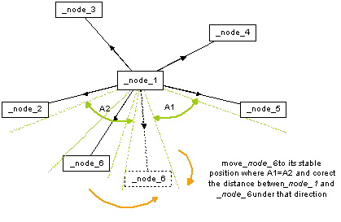
Figure 3-5: When the neighbor gap angle is larger than the child node angle

Step 7: If the neighbor gap angle is smaller than the child node angle, we move the child to the point that splits the neighbor gap angle with the ratio of the child left angle and child right angle.

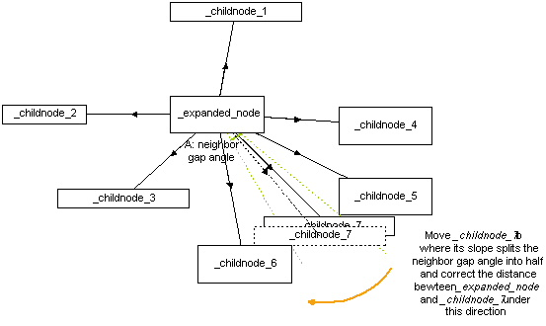
Figure 3-6: When the neighbor gap angle is smaller than the child node angle

Step 8: Along the new slope of the child node, we move the child node to the place where the distance between the child node and the expanded node is L1 (if the child node is an unexpanded node) or L2 (if the child node is an expanded node). (See diagram 3-5, 3-6)

Step 9: Update the coordinate values of the nodes that join the modeling.

3.3.2 Modeling Rooted Trees

The modeling among rooted trees is different from the modeling among nodes within a rooted tree. They are modeled using the spring model.

3.3.2.1 The Spring Model

We use the formula C1*log(d/C2) that we have discussed in 3.1.2, to calculate the spring force between “connected” rooted trees. We set C1 to 1 and C2 to L2. We use another formula we discussed in 3.1.2, C3/sqr(d), to calculate the force between “non-connecting” rooted trees. We set C3 with 0.2*sqr(L2).

3.3.2.2 Initializing the Positions of Rooted trees

Since there is no relation among rooted trees, we have to set up virtual relations among those roots to use the spring model. Once we get first nodes from the edit bar, we locate those nodes on the cross points of a grid to assign them reasonable initial coordinate values. We assume each root only has relations with its virtually connected root nodes. For example, on Fig 3-4, “node5” has relations only with its connected neighbors “node2”, “node4”, “node6” and “node8”. “_node_5” has no relation with its non-connected neighbors “_node_1”, “_node_3”, “_node_7” and “_node_9”.
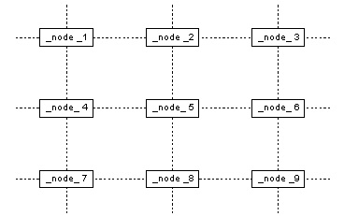
Figure 3-7: Root nodes are placed in the cross points of a grid.

We use the same length springs among the roots. As we discussed before, the length of the spring is L2.

3.3.2.3 Adjusting the Root Positions with the Spring Model

For each rooted tree, we first calculate the distances between the rooted tree and all its “connected” rooted trees. Again the distance we mention here is the distance segment that is outside the bodies of two rooted trees. Based on these distances, we calculate the spring force exerted on the rooted tree with formula 2-1.Then we calculate the distances between the rooted tree and all its “non-connected” rooted trees. Basing on these distances, we calculate the inverse square law force exerted on the rooted tree with formula 2-2. After that we add the spring force and the inverse square law force together. Then we move the rooted tree to its stable position where the forces it received are near zero.

3.3.3 Modeling by Heuristics

In the radial drawing algorithm, the modeling is done by recursion. But in TkSee Visualizer, nodes have size. It is too complicated to compute the layout using recursion. We do the whole layout modeling in heuristics. Using heuristics allows us to deal with difficult situations without exhaustive and intractable calculations. However perfect results are not guaranteed.

We put all the operations in a huge loop. We also set up a maximum number of iterations as the stop condition of the loop. Within the loop, we first use spring model to model the layout among the rooted trees. We update the coordinate value of each rooted tree after the modeling. If the rooted tree is an expanded rooted tree, we move the root node and its descendants together so the layout within the rooted tree is kept after the rooted tree modeling. Then we model every expanded node under every rooted tree with the radial angle model. We update the coordinate value of each node after each expanded node modeling. We repeat the operation until every node is in its stable position or we reach the maximum number of iterations.

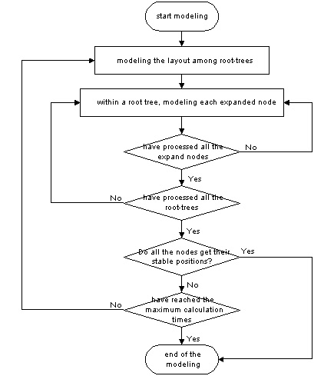
Figure 3-8: The flow chart of whole modeling process

3.3.4 Be Capable to Adjust the Layout Manually

Every node on the screen is movable. Users can drag any node to the place they like. Sometimes, the query gives out too many results or the situation may be too complicated so that the maximum calculation time is reached before a perfect layout is created. As the result, a few nodes may cover each other. Under this situation, users can drag covered nodes to new places to get a clear view of them. These manual adjustments are taken into account when subsequent queries are made.

3.4 Layout Results Given by TkSee Visualizer

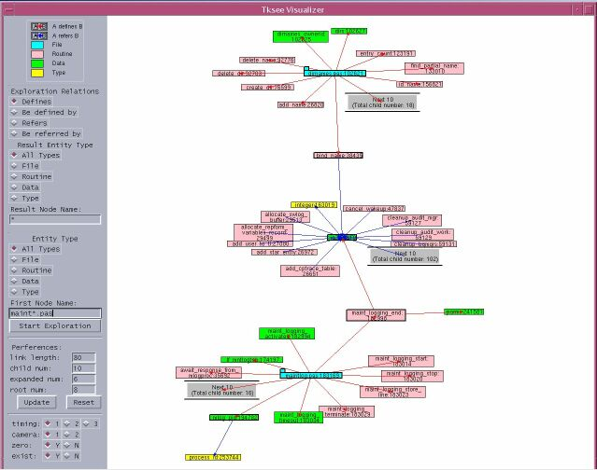
Figure 3-9: A layout within a rooted tree

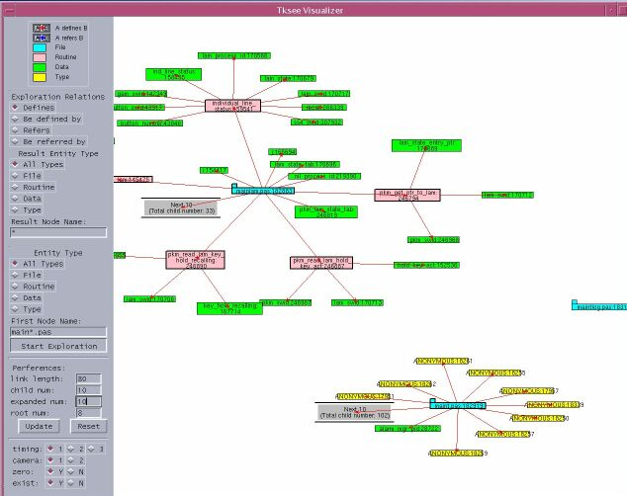
Figure 3-10: A layout with multiple rooted trees

Figure 3-9 shows a layout of a rooted tree by TkSee Visualizer. From this figure, we can see parent-child relationships are visualized clearly. Parents are surrounded by their children. Four relationships are explored on the nodes on the diagram. Color red stands for “define” while color blue stands for “refer”. The directions of the arcs refer the directions of the relationships. Furthermore, there is no overlapping among the nodes. Figure 3-10 shows a layout of multiple rooted trees. Three disjointed rooted trees are seen in the diagram. The neighborhood is visualized properly by the spring model.

3.5 Summary

In this chapter, we address all the aspects of the layout algorithm of TkSee Visualizer. After introducing various famous layout algorithms used in SV and studying the requirements of TkSee Visualizer, we proposed the radial angle model to visualize dependencies among nodes within a rooted tree. The radial angle model follows the rules of incremental layout algorithms to preserve the user's mental map. We also use the spring model to model the layout among rooted trees. In addition, we use modeling units to accelerate the calculations. The resulting layout satisfies the requirements of TkSee Visualizer.

Chapter Four: Animation

In this chapter, first we introduce the functionality of animation. Then we explain the key aspects and basic rules of animation design. After that, we summarize the animation techniques applied in the area of software visualization. Finally, we describe our animation approaches performed in TkSee Visualizer.

4.1 Functionality of Animation:

According to Gary and Wagner, “Animation is the presentation of a series of images to give the impression of motion. When the individual images, called frames, change quickly enough, the human visual system integrates them into continuous motion.” [9].

Animation has been applied in user interface [17,26], data visualization [16,22,23], algorithm animation [30] and software visualization [6,32] areas. It is used to emphasize change, or to interpret a complex idea or relationship. Also it can help the user in tracking objects. In addition, it is used to smooth the transitions as the user changes focus. Furthermore, it brings a lot of fun to the users, making them more attracted to the software.

4.2 Basic Rules of Animation design

Animation design includes three basic decision aspects: which parameters to animate, how to control the variation of parameters through software, and how to assemble a series of sequences into a complete animation. [8] Besides considering these basic aspects, applying principles of cartoon animation in the animation design can make the animation more alive and enjoyable.

4.2.1 Parameters to Animate

According to the type of parameters, we can choose to animate the data, visualization techniques or the view.

In general, any set of data can be animated if their values can be reduced to single scalar or vector values. Instead of being displayed as a static image, parameters relating to the creation of the visualization itself can be animated to give more information about the visualization. When the visualization is built in 3-D geometry, animating the view must be considered. Animating the view refers to all motions of the observer and, motions of the visualization objects within the field of view. [8]

4.2.2 Animation Control

Key frame animation control is the most wildly used animation control. This idea originated from traditional hand-drawn animation. In traditional hand-drawn animation, the animator produces key frames that are drawings used to control visual aspects of the animation, such as object positions, lighting, and color. [12] Normally key frames are spaced up to several seconds apart. The assistants of the animator produce in-betweens (or tweens) that are drawings with the key frames to smooth the motion. [11]

Key frame computer animation control uses a similar approach. In computer animation, key frames are states of visualization produced by setting a set of parameters on the objects in time. Besides being used to control visual aspects of the animation, for scientific animation, key frames are also used to control arbitrarily selected parameters of the visualization. The in-betweens are interpolated by the computer automatically.

4.2.3 Animation Path

Animation path refers to the path that the animated parameters move between the two key frames. Straight line is the straightforward choice. However using slight curves can reinforce the reality of the movement of the objects. [24]

4.2.4 Animation Timing

Animation Timing is also called the interpolation method. It refers to the method that gets the in-between points between two key frames. The good philosophy about animation timing, especially in engineering domains, is to remain true to the data and meanwhile make the motion as smooth as possible.

Linear interpolation and splines for interpolating are the most commonly used interpolation methods. Linear interpolation is simple and works well in many cases, such as Shrimp [32]. For more complex motions, especially in multiple dimensions, spline curves do a better job, such as visualizations of the Gnutella network system [16].

4.2.5 Frame Rate

Frame rate is the rate at which images are presented. It is a key factor in animation. The low threshold of frame rate is between 20 and 25 frames per second. Below this threshold, many people will perceive flicker [9].

The higher the frame rate, the smoother the animation will appear. But a high frame rate requires more work to produce the animation. One must resolve this tradeoff to choose the right frame rate.

4.2.6 Psychological Factors

Some psychological factors should be considered during the design. Animation should be just the right length, neither too short nor too long. If it is too short, the meaning of the animation may not be explained clearly and it may confuse the user. If it is too long, users will lose patience waiting for it. Another issue is avoiding "information overload". If too many parameters are varied in animation at once, it becomes difficult to interpret the results visually. Therefore, one should provide simple animations to present the point. [10]

4.2.7 Applying Principles of Cartoon Animation

In the cartoon industry, animators have developed sets of principles and techniques that strengthen the illusion of reality. Some of the rules, such as solidity, exaggeration, and reinforcement [24], can be applied in computer animation. So far most computer animations are performed straightforwardly. Few use cartoon-style techniques that make the system more alive and enjoyable.

Bay-Wei Chang et al implemented some cartoon principles in their user interface tool Self [17]. In Self, menus transform smoothly from a button to an open menu. Objects enter the screen by traveling from off-screen or growing from a point. Before objects move, they take a small, quick contrary movement. Objects move with slow in and slow out. They do not come to a sudden standstill, but vibrate at end of the motion to get to their destination; Self achieved a great success by performing these rules.

Ka-Ping Yee et al prompted slow-in slow-out animation timing approach in their Gnutella network [16]. They start the animation slowly, accelerate it smoothly, and then decelerate it at the end. It is implemented by a segment of the arctangent function.

4.3 Animation Techniques Used in the Visualization of Software

The most widely used animation technique in software visualization is camera animation. In some dynamic exploring systems, layout animation, sometimes combining with grow/shrink animation, is used to smooth the layout transition. However, a few problems exist in the usage of animation in the visualization of software.

4.3.1 Camera Animation

In 3-D geometry, camera animation moves the new focus to go to the front. For example, in Cone Tree [23], when a node is selected, the Cone Tree rotates so that the node and its ancestors up to the top are brought to the front. In Perspective Wall [22], when user selects a note on a sidewall, the wall moves. The sidewall with the selected note is moved to the center of the view.

In 2D, camera animation pushes the new focus node to the center of the window, ensuring users never lose track on the last focus node, such as In SHRIMP [32].

4.3.2 Layout Animation

In a dynamic exploring system, when new nodes appear on the screen or nodes drop from the screen, the layout algorithm is performed to adjust the position of other nodes in the screen to give a new balance layout. Layout animation is used to smooth the position adjustments, such as in tuk-tuk [6].

4.3.3 Shrinking/Growing Animation

The principles of cartoon animation are applied in some systems. A node will not appear or vanish suddenly from the screen. When nodes are added to the screen, the added nodes are animated to grow up from a point to their full size. When nodes are deleted from the screen, the deleted nodes are animated to shrink from their full size to nothing.

4.3.4 Problems in the Animation Usage

Camera animation has a drawback under some circumstances (explained later). Besides the layout animation and camera animation, animation can also be used in some other ways, such as clarify information.

4.3.4.1 The Disadvantage of Camera Animation

In a 2D dynamic exploring system, if the new focus node is a leaf node and was near an edge of the window before it is clicked, the camera animation will push it all the way to the center of the window. Such a big movement will cause ineffective usage of the screen space. Some part of the screen is empty while some nodes that the user may be also interested in are pushed outside of the window unnecessary.

Some systems add a function that user can choose to turn on or turn off the camera animation. But this cannot really solve the problem. In some dynamic exploring systems, layout animation is also implemented. Layout animation responds to every click operation of the user. The user will not lose track of the objects if camera animation is turned off. However when the clicked node is near the edges of the window, the exploration results may be invisible within the screen. The user has to drag the diagram to have a complete view of the new focus node and its descendants. This is definitely not what the user wants. We need more intelligent camera animation.

Such camera animation has the following requirements:

- The camera animation can turn on or turn off automatically. It turns on when the exploration results are invisible after the layout modeling. It turns off when the exploration results are visible after the layout modeling.
- If camera animation is activated, the optimum stop position should be the place where it makes as many nodes as possible to be visible within the window.

We propose a new approach of camera animation and call it intelligent camera animation. This gets rid of the disadvantage of camera animation and satisfies the requirements we listed above. We will discuss it in detail in section 4.4.3.

4.3.4.2 Other Usage of Animation

Despite aiding the user not to lose track of action, and smoothing transitions, animation should also be used to elucidate the exploration information. We will explain how we achieved this in the next section.

4.4 Animation Techniques Implemented in TkSee Visualizer

We implemented layout animation and intelligent camera animation in the Visualizer. Besides this, we designed updating animation to illustrate the work of extra result box. Also we designed zero-result animation and result-already-exist animation to clarify some special query results. Furthermore, we proposed a new cartoon style animation timing, slow-in fast-out, to exaggerate the changes caused by each click.

4.4.1 Animation Design

In this section, we first describe our setup for each aspect in the animation design. Then we explain the slow-in fast-out animation timing in detail.

4.4.1.1 General Setup

We chose the position of the nodes as the parameter to animate. We used key frame animation control to manipulate animation. The two key frames are the state of nodes before the modeling and the state of the nodes after the modeling. In layout animation, intelligent animation, zero-result animation and result-already-exist animation, we use the straight line as the animation path. While in updating animation, we used curves as the animation path. We proposed a slow-in fast-out animation timing to interpolate the animation path to get the frames between the two key frames. We will discuss it in the next section. We chose to display 25 frames a second so the system will not have too much load while the picture will not flick.

4.4.1.2 Slow-in Fast-out Animation Timing

Instead of using the traditional cartoon slow-in slow-out animation timing model, we propose a new model and call it slow-in fast-out. We want to give a strong impression to the user by exaggerating the reality.

At the beginning, we move the nodes slowly. Then move them quicker and quicker. The length of the moving step therefore gets longer and longer. This model is implemented by the function of the sum of arithmetic progression [15]. We can view it from Figure 5-1.

An arithmetic progression (AP) is a sequence of terms in which any term minus its previous one gives a constant. This constant is called the common difference.

Let a be the first term, d be the common difference of an AP and n be the index of the moving step, the nth term of the AP is:
Tn = a + (n - 1)d
We contribute Sn as the length of the nth moving step. The sum of the first n terms is:
Sn = ½ n [2a + (n - 1)d]
The difference of any adjacent moving steps is:
Sn – Sn-1 = Tn = a + (n - 1)d (n>=1)
The difference grows by d when n goes up by 1.

In the TkSee Visualizer, we assign a = 0 and d = 2. It works perfectly.

Figure 4-1: The slow-in fast-out animation timing model

4.4.2 Layout Animation and Grow/Shrink Animation

In TkSee Visualizer, Layout Animation and grow/shrink animation combine together.

When a node is clicked to expand, its child nodes are added around the clicked node. When a node is clicked to close, its child nodes are dropped from the screen. Under any case, the layout algorithm is activated to give a new layout. Layout animation is therefore performed.

When a node is clicked to expand, its new child nodes, given by the current exploration relationship, are created as a point and covered by the clicked node. Then they move to their destinations given by the modeling while the sizes of child nodes grow up to their normal sizes. This metaphor is to push the new added child nodes as they grow from the clicked node.

Since the child nodes grow up from their parent node, when the parent node is clicked to close, it is better to drop the child nodes back to the parent node. When the animation starts, the child nodes move toward the parent node while their sizes shrink. Then the shrunk child nodes disappear under the clicked node. They are deleted when the layout animation ends. The animation makes it appear that the dropped child nodes are absorbed by the parent node.

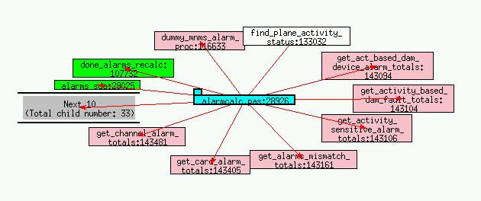
(1)
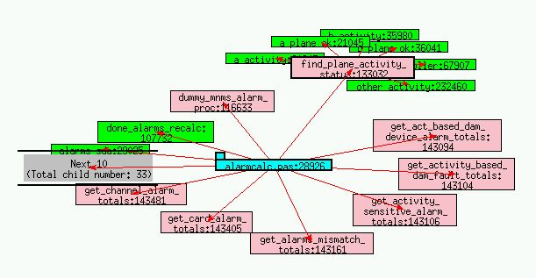
(2)
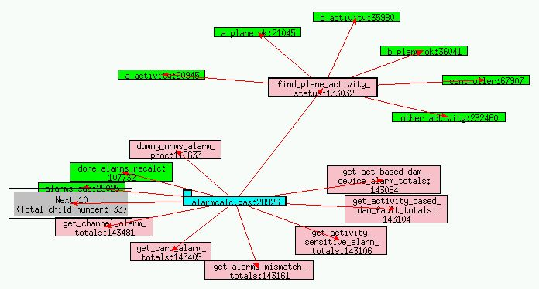
(3)

Figure 4-2: Layout animation (1) Node find_plane_activity is clicked to expand (2) The child nodes of find_plane_activity are growing from find_plane_activity (3) The child nodes stop moving as they reach their destinations

4.4.3 Intelligent Camera Animation

Camera animation is also implemented in the TkSee Visualizer. However it is modified. We call it intelligent camera animation. In our approach, it is activated only when the clicked node and its child nodes are outside of the window. When it is activated, instead of pushing the new focus node to the center of the window, we push the nodes toward a place where all the hiding nodes are seen totally.

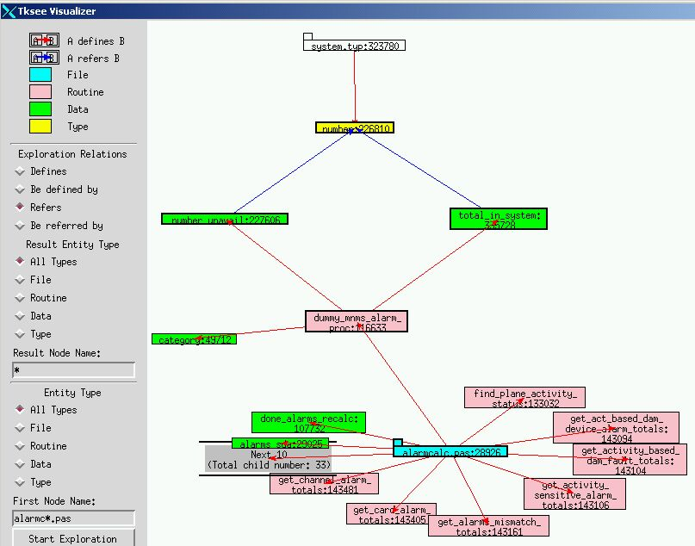
(1)
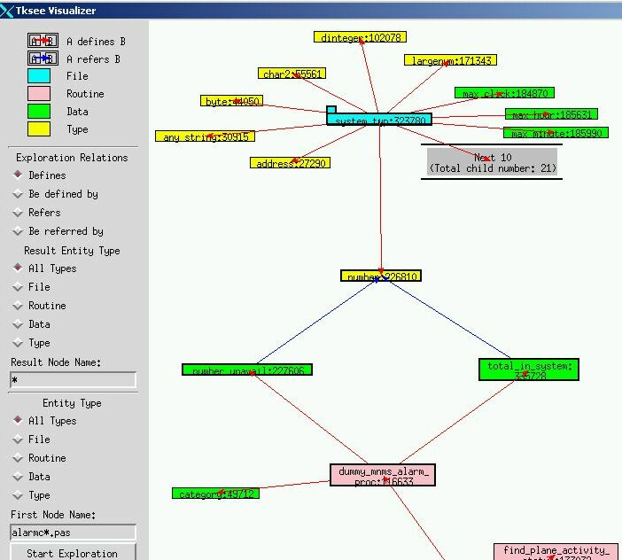(2)
Figure 4-4: Intelligent camera animation (1) Node system_typ is clicked to expand (2) Intelligent camera animation is performed

4.4.4 Zero-result Animation

Other than smoothing the transition and tracing the exploration, animation can also be used to illustrate special results when the layout animation is not applicable. This setup is more understandable and enjoyable than text.

When the user clicks on a node to do an exploration, if there is no result given from the query, zero-result animation is conducted to advise the user of the situation.

We enlarge the size of the clicked node gradually to 1.5 times its original size and then shrink it back. The animation expresses a feeling that some result inside the clicked node tried to get out of it but failed.

Similarly, when users try to start a new exploration from the editor bar, if there is no query result given from the query, an alternative zero-result animation is preformed. We create a normal size node with some black dots on it to fake the text string of the node information. First we enlarge the node from a dot to its full size. Then we shrink it back to null.

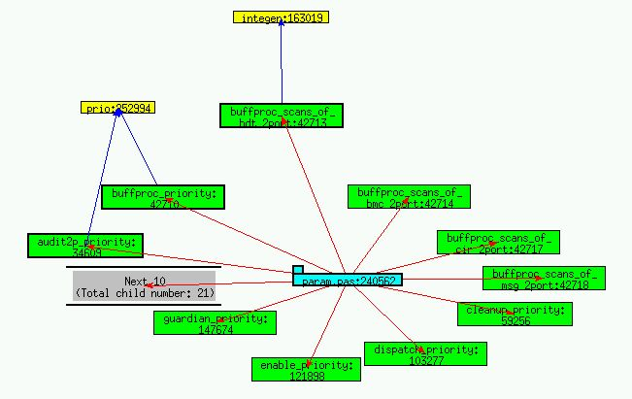
(1)
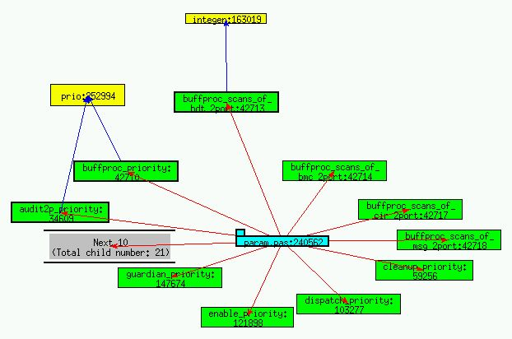
(2)
Figure 4-5: Zero-result animation (1) User does an exploration on node prio but there is no query result (2) The node prio grows up

4.4.5 Result-already-exist Animation

Under some situation, the query results may have already existed on the screen before users conduct a query. For example, in Fig 4-6, user does an exploration on node A with “what nodes defined by node A”. Node B is defined by node A. Then user does exploration on node B with “which node defines B”. Node A defines B. But at the moment, node A already exists on the screen and connects with node B in that relationship. When this happens, we perform the result-already-exist animation.

First we push the query results that already exist on the screen away from the clicked node along the link between the clicked node and the existing query results. Then we drag them back to where they are. The animation tells the user the pushed-dragged nodes are the query results and that they have already existed on the screen.
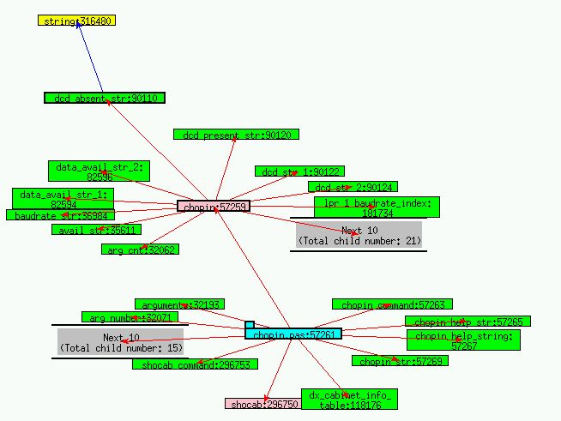
(1)
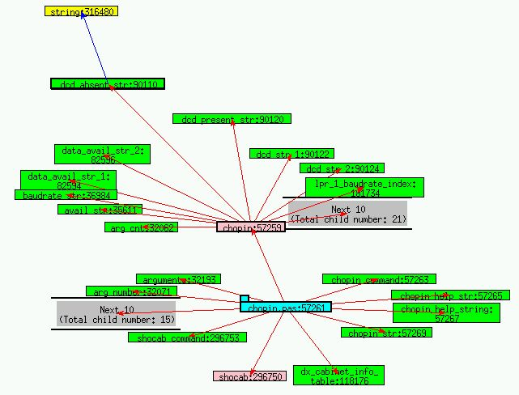
(2)
Figure 4-6: Result-already-exist animation (1) User does an exploration on node dcd_absent_str but the result has already existed on the screen (2) The node chopin is pushed away

4.4.6 Updating Animation

We animate the updating process of extra result box and call it updating animation.

4.4.6.1 Animation Path

Since we pretend that besides the results shown on the screen the remaining query results are hidden in the box, it is more understandable if we move the displaying nodes into the box and move the new nodes come out from the other side of the box to their expected places.

Furthermore, in TkSee Visualizer, child nodes surround their parents. It would be more natural if we move the nodes around the parent node into or out of the extra result box on an ellipse track rather than in a straight line.

4.4.6.2 Clearing Sub-Process and Displaying Sub-Process

In order not to confuse the user with too much information at a time, we update the query results after we clear the current child nodes. We name these two sub-processes as clearing process and displaying process.

Each sub-process has two key frames. The start position of the node in the clearing process is the node’s coordination position when user clicks the box. Its final position is the current position of the special box. For the displaying sub-process, the start position of the new node is the position of the special box and its final position is the current position of the replaced node.

4.4.6.3 Working Steps of Updating Animation

Clearing sub-process and displaying sub-process use the same methodology.

For each child node, first we calculate the slopes of the child node at its start position and end position of the sub-process and note them as start_ slope and end_ slope. Then we interpolate the difference of start_ slope and end_ slope with slow-in and fast-out animation timing. Once we get each interpolation point, we adjust the position by the layout algorithm. By knowing these positions of all the child nodes of the sub-process, we can produce the animation of the sub-process.

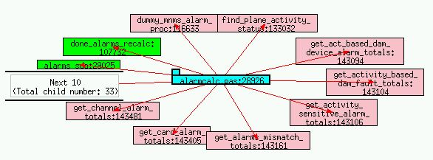
(1)
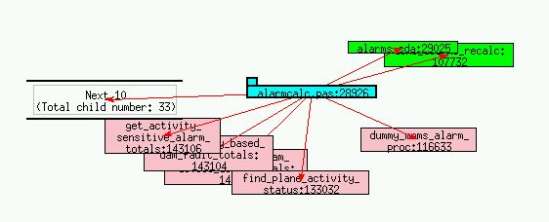
(2)
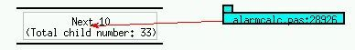
(3)
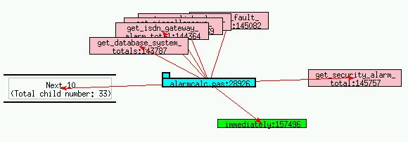
(4)
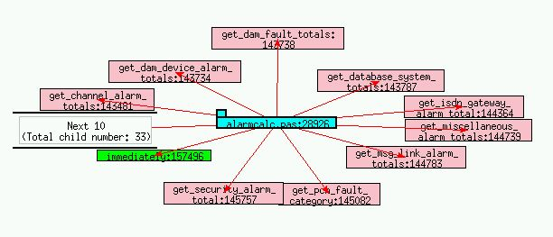
(5)
Figure 4-7: updating animation (1) User clicks on the extra result box (2)(3) The clearing sub-process (4)(5) The displaying sub-process

4.4.7 Root Updating Animation

As we discussed in section 4.6, when the number of the root query results is more than a certain number, a special box, called extra root box, is created. Only certain numbers of roots are displayed on the screen while the remaining roots are hidden inside the box. The current query results are updated by the new query results from the extra root box if user clicks the box. A special animation is designed to illustrate the root refreshing procedure. We call it root updating animation.

Since there is no association among rooted trees, when the user clicks on the extra root box to view the rest of the query result, the old root results move to the box in straight-lines. They move from the box to their destinations in straight lines.

Like the updating animation, in order not to confuse the users with information overload, we fulfill the root updating animation in two steps: do the clearing sub-process first and then do displaying sub-process.

4.5 Summary

To summarize, animation is a very useful technique in the visualization of software. It not only can be used to smooth transitions and aid the user not to lose the track of objects, but also can be used to illuminate information. In TkSee Visualizer, we implemented several animation techniques. In particular, we proposed the intelligent camera animation to overcome the drawback of camera animation in ineffective use of space. Furthermore, we proposed a new animation timing model slow-in fast-out.

Chapter Five: The Architecture of TkSee Visualizer

In this chapter, we address the implementation of TkSee Visualizer. First we overview the work principle of the tool. Then we summarize the process flow of the program. Finally, we introduce the interface of the tool.

5.1 TkSee Visualizer

We want to design a software visualization tool to help users to understand huge software systems, such as legacy systems. TkSee Visualizer is the result. In this tool, we will implement the techniques we have discussed earlier in this thesis: dynamic browsing, our incremental layout algorithm and various animations. We will then use the tool to evaluate the effectives of those techniques.

The database TkSee Visualizer connects with contains millions of software entities and the dependencies among them. These data are parsed from legacy systems of Mitel ( www.mitel.com ) using reverse engineering techniques. TkSee, a source browser, supplies the interface through which the Visualizer can communicate with the database.

Fig 5-1 illustrates the relation of TkSee’s database and TkSee Visualizer. This connection TkSee is dynamic: Once TkSee Visualizer gets the query parameters from the interface, it performs the query on the TkSee database and computes the results. Then, it models the layout with the layout algorithm and then visualizes the layout on the screen.

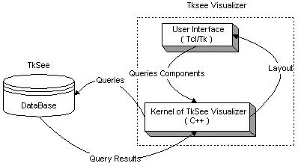
Figure 5-1: TkSee Visualizer

5.2 Process Flow of TkSee Visualizer

TkSee Visualizer can be separated into two parts: user interface and core processor. The interface of TkSee Visualizer is coded in Tcl/Tk. In this part, it gets commands from the users, send the commands to the core processor and displays/updates the graph as returned by the core processor (See Figure 5-2). The core processor is written in C++. It is in charge of communicating with the database, modeling the layout and managing the data of the query results (See Figure 5-3).

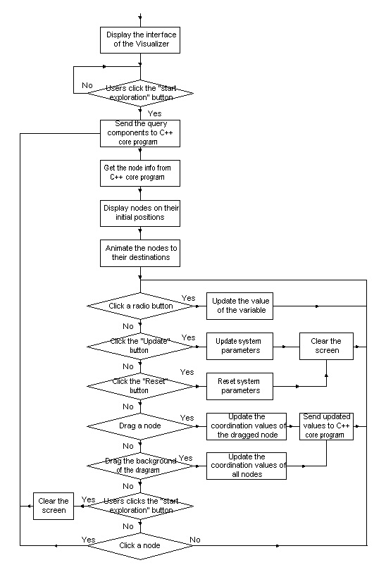
Figure 5-2: The flowchart of the Tcl/Tk component

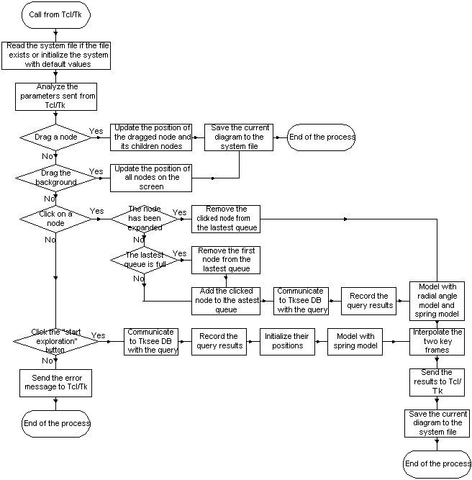

Figure 5-3: The flow chart of the C++ core program

5.3 User Interface of TkSee Visualizer

TkSee Visualizer supplies five toolboxes to help users to control the exploring process.

5.3.1 Symbol Indicator

TkSee can explore four software relationships among four software entities. TkSee Visualizer uses various colors and different arrow directions to identify them. The symbol indicator toolbox illustrates the meaning of each color and arrow direction.
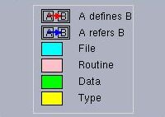
Figure 5-5: The symbol indicator

5.3.2 Start Exploration Toolbox

The exploration toolbox can help users start new exploration. After users give the pattern for the node names and choose the type of the nodes they want to start with, users can left click the Start Exploration button to display the first nodes of the exploration on the screen

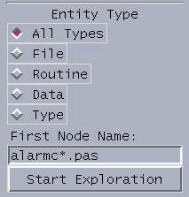
Figure 5-6: The start exploration toolbox

5.3.3 Explore Toolbox

With the help of the exploration toolbox, users can create the exploration query. Once users find the node they are interested in, users choose the relationship type they want to explore through the “Exploration Relations” radio button; they define the entity type of the exploration results through “Result Entity Type” radio button, and they input a pattern for the names of exploration results in the “Result Node Name” editor bar. Then they left click on the node they are interested. TkSee Visualizer will visualize the query results based on their choices.

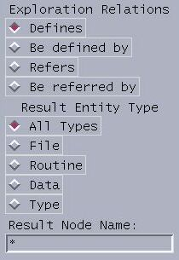
Figure 5-7: The explore toolbox

5.3.4 Preferences Toolbox

Some system parameters can be changed during explorations based on the user’s preferences. They are listed in the Preference toolbox:

Link length: the length between two nodes
Child num: the maximum number of displayed children of parent nodes
Expanded num: the maximum number of expanded nodes on the screen at one moment
Root num: the maximum displayed number of rooted trees on the screen at one moment

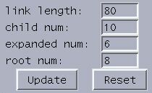
Figure 5-8: The preference toolbox

5. 3.5 Animation Setup Toolbox

In the animation setup toolbox, users can choose the animation timing type, camera animation type and turn on/off Zero-Result animation and Result-All-Exist animation.

Timing: Animation timing. There are three choices. Type 1: objects move at a constant speed; type 2: objects move faster and faster to their destinations; type3: similar to type2 but at a higher speed.

Camera: Camera animation. There are two choices. Type 1: after each click, the focus node moves to the center of the screen; type 2: the focus node moves only when the focus node and its new child nodes are outside of the screen after clicking. It moves toward to the center of the screen but stops moving when the expanded node and its child nodes can be seen within the window.

Zero: Zero-result animation. It used to clarify that no result is given from an exploration. (Y-turn on; N-turn off)

Exist: Result-All-Exist animation. It is used to clarify that the results of an exploration have already existed on the screen. (Y-turn on; N-turn off)

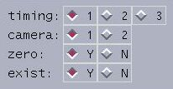
Figure 5-9: The animation toolbox

5.3.6 Color Design

Six colors have to be chosen to represent four software entity types and two association relationships. According to Ben Shneiderman’s opinion [34], it is always good to use black letters on a white background and reserve color for special highlighting. Therefore we choose white as the background color of the tool and all texts are written in black.

Heterogeneous object nodes and relation aces may cover each other on the screen from time to time. Colors must be picked up carefully so that blurring and vibrations will not happen when colors meet colors. [49] did a lot of experiments on the color combination. We use those experiment results as references for the color design in the tool.

[49] ‘s experiment shows color red, blue and black can be seen clearly under white background. Therefore we pick color red and blue to present the two association aces. Besides, we draw a black rectangle surrounding every node on the screen. This setup makes users always have clear views on the nodes and aces.

Within each node, the node is filled with a color to identify the node’s object type and above it the object name is written in black. Colors have to be chosen carefully to represent different object types on which the black text and red or blue aces can be seen clearly. [49]’s study shows when color green, yellow and cyan are used as background of the node, black, red and blue line can be viewed clearly on each of them. Therefore green, yellow and cyan are picked to represent software entities. Besides these three colors, color pink is picked to represent the left software entity that is tested to satisfy the clearness.

5.3.7 Other Interface Techniques

Panning and dragging are also supported in TkSee Visualizer. Users can drag the background around to view the whole diagram. Also users can drag any node to have a clear view on it.

Chapter Six: Evaluation Experiments

We designed a series of experiments to access the performance of the techniques implemented in the Visualizer. In this chapter, we first describe each aspect of the experiment. Then we analyze the results of the experiment. Finally, we summarize the conclusions.

6.1 Methodology

We performed the evaluation using human evaluators. We followed general principles of usability testing, including writing instructions for the users, designing the test tasks and questionnaire, and then conduct the study. Our study received ethics approval from the University of Ottawa’s Research Ethics Board.

6.1.1 Test Users

In order to attain enough reliability in our results, according to [46] five test users is must. A good test user candidate should be a potential user of the tool. We believe that anyone whose work involves any step of the life cycle of software development is a good test user candidate. We organized two groups of users, experts and novices, to evaluate the tool. The distinction of groups is based on the knowledge level of software visualization.

Six participants were chosen to attend the testing. All of them are from the computer science department, University of Ottawa. Some of them are master students, some are Ph.D students, and some of them are research associates in the school. All of them have solid knowledge and working experience in software development and maintenance.

Among the six participants, one was doing related research in the software visualization field. He had never used TkSee Visualizer before. One had 3-4 years experience with TkSee, but he had used TkSee Visualizer and some other software visualization tools before. We considered these two test users as experts. The other four have a little knowledge or no knowledge about software visualization. We treated them as novices.

6.1.2 Experiment Preparation

Before the test, we designed a set of instructions for the experiment, a series of test tasks, and a questionnaire. The instructions and test tasks assist the users to understand the tool in a short time. The questionnaire enables the users to supply us with their opinions about the tool.

6.1.2.1 Instructions

In the instructions (See appendix A), we gave users an overview of the tool. First we explained the concept of the software visualization and described the main techniques implemented in the tool. Then we highlighted the purpose of the experiment. At the end of the instructions, we introduced the user interface of the tool. Then we gave a brief tutorial on the tool so users would know how to start exploration and how to explore.

6.1.2.2 Test Task

We helped users to understand the system by fulfilling the tasks (See appendix B). Three tasks were designed. They cover most of the features of the tool.

The first task contains four small tasks. Each one highlights a few important features of the research. The first small task assesses the effect of extra result box and pattern based searching. The next small task evaluates the deletion policy, zero-result animation and result-already-exist animation. The following small task asks users to explore a file in multiple steps to observe the difference between standard camera animation and intelligent camera animation. The last small task enables the user to feel the advantage of software visualization. While exploring the tasks, users can judge the dynamic browsing technique and layout algorithm.

The second task asks users to do some exploring of their own with various preferences set and make their decision on the animation timing type, camera animation type, zero-result animation, and result-already-exist animation.

The third task asks users to change the parameter values on the TkSee Visualizer and do experiments to decide the default values of system parameters, such as the link length between two nodes, etc.

6.1.2.3 Questionnaire

We designed 20 questions for the questionnaire (See section 6.2) that cover all the important techniques implemented in the tool. All questions have been confronted in the tasks, so users should not have difficulty to answer them.

We gave five choices for each question, so users would express their feelings more precisely. We avoided using specific concepts of software visualization in the questions and choices, so novices would not be confused by the questions even they lacked knowledge. Also we avoided using “intelligent”, ”advanced”, etc words in the choices to expose the researcher’s desire, so the user’s decision would not be affected by choice itself.

6.1.3 Experiment Process

Each time, the test was done by one person. So it is easy for us to capture the test user’s reaction to the tool.

Before we started the test, we asked test users to read and sign a consent form (Appendix C). Then we asked them to read the instructions to get the overview of the tool and the experiment. After test users finished the material, we presented a demonstration about using the tool to explore a software system. During the demo, we highlighted the key issues of the tool. After that, we emphasized the purpose of the test to the users again to alleviate any anxiety they may have. We told them the test did not test their ability to use the tool; instead it assessed the performance of the tool. Also, the evaluation was more feature-oriented than usability-oriented.

Then we started the test. During the test, I encouraged them to speak their thoughts out loud and feel free to ask me questions. Each test lasted one hour.

After the test, I asked the participants to complete the questionnaire.

6.2 Analysis of Experiment Results

In this section, we categorize the questions in the questionnaire by features. For each question, first we gather the test users’ choices together. Then we give our conclusion based on these data. At the end, we summarize our conclusions by features.

6.2.1 Browsing Techniques

In this section, we focus on the evaluation of the browsing techniques employed in the TkSee Visualizer.

6.2.1.1 Dynamic Browsing

Question: Do you think the dynamic browsing technique implemented in the Visualizer can help you explore huge software systems?

Choices | Novice  (4 users) | Experts  (2 users) | All Users  (6 users)
Not useful at all
A little useful
Moderately useful
Very useful | √√√√ | √√ | √√√√√√
Exactly what I want

Conclusion:

All users thought the dynamic browsing technique implemented in the Visualizer are very useful and can help them to explore huge software systems.

6.2.1.2 Extra Result Box

Question 1: Do you think the extra result box is needed?

Choices | Novices  (4 users) | Experts  (2 users) | All Users  (6 users)
No need at all
A little needed
Moderately needed | √ | √ | √√
Very needed | √√ | √ | √√√
Exactly needed | √ |  | √

Conclusion:

One third of the participants thought the extra result box is moderately needed. They do not mind having the feature or not in the software. The rest of the users thought the extra result box is very needed or extremely needed. Therefore the extra result box is liked by most people. Users accepted the idea of the extra result box. Novices liked the idea more than the experts.

Question 2: Are you confused by the way the extra result box works?

Choices | Novices  (4 users) | Experts  (2 users) | All Users  (6 users)
Not confused at all | √√√ | √ | √√√√
A little confused | √ | √ | √√
Moderately confused
Very confused
Always confused

Conclusion:

Most users were not confused by the way the result box works. The idea of the extra result box is straightforward. Both experts and novices understand it.

6.2.1.3 Extra Result Box and Pattern based searching

Question: Do you think the extra result box plus pattern based searching can help you handle the huge exploring results?

Choices | Novice  (4 users) | Experts  (2 users) | All Users  (6 users)
Not useful at all
A little useful
Moderately useful | √ | √√ | √√√
Very useful | √√√ |  | √√√
Exactly what I want

Conclusion:

Half of the users thought the extra result box plus pattern based searching is moderately useful to handle the exploration of huge numbers of results, while the other half thought the mechanism is very useful. From the answers, we know that users thought the extra result box and pattern based searching are a good idea, but improvements are needed.

Some usability problems might affect the evaluation of the feature. Two users complained that the name pattern should be reset after each exploration.

6.2.1.4 Deletion Policy

Question: Do you think the deletion policy is needed?

Choices | Novices  (4 users) | Experts  (2 users) | All Users  (6 users)
No need at all
A little needed
Moderately needed | √√ |  | √√
Very needed | √ | √ | √√
Exactly what I want | √ | √ | √√

Conclusion:

One third of the users did not mind having the deletion policy or not. Two thirds of the participants preferred to have the feature in the tool. Since more people like it, the deletion policy should be implemented in the tool.

Experts like the feature more than the novices. Some novices were confused when they first saw some expanded nodes shrinking automatically. It appears they would like the policy when they get used of it.

6.2.1.5 Summary

All test users thought dynamic browsing can help them to explore huge software systems. Both experts and novices accept the idea of the extra result box. The extra result box and pattern based searching together can help them to deal with huge query results. But the feature needs to be fine tuned. The deletion policy is very much needed.

6.2.2 Layout Algorithms

In this section, we focus on the evaluation of each aspect of the layout algorithm employed in the TkSee Visualizer.

6.2.2.1 Preserving User’s Mental Map

Question: When you click on a node to do exploration, are you confused about the changes in the graph?

Choices | Novices  (4 users) | Expert  (2 users) | All Users  (6 users)
Not confused at all | √√ | √√ | √√√√
A little confused | √ |  | √
Moderately confused | √ |  | √
Very confused
Always confused

Conclusion:

Four users said they were not confused at all about the changes in the graph when they clicked on a node to do exploration. One user felt a little confused by the changes, and one user felt moderately confused. In general, most of the users reported they were satisfied by the stability of the layout as continuous updates take place.

6.2.2.2 The Capability of Giving Non-Overlapped Layout

Question: Can the layout algorithm effectively provide non-overlapped layout?

Choices | Novices  (4 users) | Experts  (2 users) | All Users  (6 users)
Not at all | √ |  | √
A little
Sometimes | √ |  | √
Almost | √ | √√ | √√√
Always | √ |  | √

Conclusion:

Six users gave four different opinions on this question. There are two extreme answers. One user regarded that the layout algorithm implemented in the system cannot effectively provide non-overlapped layout at all. And one user regarded that the layout algorithm can always provide non-overlapped layout. Among the rest of the answers, three users thought the system could almost give non-overlapped layout while one user thought the system could give non-overlapped layout sometimes.

We neglected those two extreme answers to simplify the decision making process. Since most users of the remaining users chose the choice “almost”, we believed that users appreciated the capability of giving non-overlapped layout of our radial angle model. But improvements are definitely needed.

6.2.2.3 The Clearness of Illustrating Relationships

Question1: Do you think the TkSee Visualizer can give clear layout of the dependencies among the nodes?

Choices | Novices  (4 users) | Experts  (2 users) | All Users  (6 users)
Not clear at all
A little clear | √ |  | √
Moderately clear | √ |  | √
Very clear | √ | √√ | √√√
Extremely clear | √ |  | √

Conclusion:

All experts thought the tool could give clear layout illustrating relationships among nodes. Four novices shared four different opinions from a little clear, moderately clear, very clear to extremely clear. In general, more people thought the clearness of the layout is acceptable.

Some users suggested that the arrows on the links should be moved outside of the node since they affected the clearness of the layout.

Question2: Do you think the TkSee Visualizer can give clear layout of the relationship among the rooted trees?

Choices | Novices  (4 users) | Experts  (2 users) | All Users  (6 users)
Not clear at all
A little clear
Moderately clear | √√√ |  | √√√
Very clear | √ | √√ | √√√
Extremely clear

Conclusion:

One third of the users thought the layout of the relationship among the rooted tree are moderately clear. While one third of the users thought the layout is very clear. Experts liked the layout more than novices. To sum up, users are satisfied with the clearness of the layout of rooted trees.

One possible reason that users thought the layout was not clear is when there are multiple rooted trees on the screen and each one has a few expanded nodes, the modeling got very complicated. The modeling will be stopped before it gets the ideal layout because it reaches the maximum calculation time.

6.2.2.4 Summary

Users are satisfied with the stability of the layout given by the radial angle model. They are also satisfied with its capability of giving non-overlap layout. The clearness of layout to illustrate the relationships among nodes is accepted. A few improvements are needed to give clear layout among rooted trees.

6.2.3 Animation Techniques

In this section, we concentrated on the evaluation of the animation techniques employed in the TkSee Visualizer. The question will be mainly focused on the performance of the slow-in fast-out animation timing, intelligent camera animation, zero-result animation, result-already-exist animation, and extra result updating animation.

6.2.3.1 Animation Timing

Question: Among the two animation timings, which one do you like?

Choices | Novices  (4 users) | Experts  (2 users) | All Users  (6 users)
Animation Timing Type1  (Constant speed) | √√ |  | √√
Animation Timing Type 2  (Increasing speed) | √√ | √√ | √√√√

Conclusion:

From the answer, we can see that four users liked slow-in and fast-out animation timing while the other two users preferred constant speed animation timing. In general, more people liked slow-in and fast-out animation timing. Those who liked this animation timing thought the faster the better.

6.2.3.2 Intelligent Camera Animation

Question: Among the two camera animations, which one do you like?

Choices | Novices  (4 users) | Experts  (2 users) | All Users  (6 users)
Camera Animation Type 1 (Always move to center) | √ | √ | √√
Camera Animation Type 2 (Move towards center, but only when results would be off the screen) | √√√ | √ | √√√√

Conclusion:

Two test users liked always-move-to-center (regular) camera animation because it highlights the focus after every click. While four test users liked intelligent camera animation more because it keeps the last focus node on the screen while keeping more nodes on the screen.

More people like intelligent camera animation than regular camera animation. But regular camera animation can be kept in the tool as an option.

6.2.3.3 Zero-Result Animation

Question: What do you think of the zero-result animation?

Choices | Novices  (4 users) | Experts  (2 users) | All Users  (6 users)
Not needed at all
A little needed
Moderately needed
Very needed | √√ | √ | √√√
Exactly what I wanted | √√ | √ | √√√

Conclusion:

Three participates thought the zero-result animation is very needed while three others thought the animation is exactly what they wanted. All test users chose to have zero-result animation than not have it. Experts shared the similar opinions with the novices.

6.2.3.4 Result-Already-Exist Animation

Question: What do you think of the result-already-exist animation?

Choices | Novices  (4 users) | Experts  (2 users) | All Users  (6 users)
Not needed at all
A little needed
Moderately needed
Very needed | √ | √√ | √√√
Exactly what I wanted | √√√ |  | √√√

Conclusion:

Just like the attitude to zero-result animation, three test users thought the result-already-exist animation is very needed while three others thought the animation is exactly what they wanted. All test users chose to have the feature than not to have it.

6.2.3.5 Extra Result Updating Animation

Question: What do you think of the extra result updating animation?

Choices | Novices  (4 users) | Experts  (2 users) | All Users  (6 users)
Not needed at all
A little needed | √ |  | √
Moderately needed | √ | √ | √√
Very needed | √√ | √ | √√√
Exactly what I wanted

Conclusion:

Half of the test users thought the extra result updating animation is very needed. Within the rest of the test users, two thought it is moderately needed. One thought it is a little needed. In general, the animation is needed to illustrate the functionality of the extra result box. But it clearly should be improved. Some test users complained that the animation is too slow. They suggested increasing the speed of the animation and simplifying the track of the animation.

6.2.3.6 Summary

Slow-in fast-out animation timing is more welcomed than constant speed animation timing. 67% of the test users like intelligent camera animation while 33% users prefer camera animation. All the users choose to have zero-result animation and result-already-exist animation. Extra result updating animation is needed but needs improvements.

6.2.4 User Interface

Question: How clear are the symbols and descriptions on the software relationships and software entity types that used in the TkSee Visualizer?

Choices | Novices  (4 users) | Experts  (2 users) | All Users  (6 users)
Not clear at all
A little clear
Moderately clear | √√ | √ | √√√
Very clear | √√ | √ | √√√
Extremely clear

Conclusion:

Half of participates thought that the symbols and descriptions of the software relationships and software entity types are moderately clear. Half of participants thought that the symbols and descriptions are very clear. The feature is approved by users, but there are a lot of places that need to improve. We will discuss it more in section 6.2.6.

6.2.5 The Default Value of System Parameters

In this section, we first list out all participants’ decision regarding each system parameter. Then we print out the default value of the system parameters according to the users’ answers. The final default value is the average value of all users’ answers.

Question 1: What should be the most comfortable link length among nodes?

Test Users | Link Length
Novice 1 | 80
Novice 2 | 100
Novice 3 | 150 and more
Novice 4 | 150
Expert 1 | No idea
Expert 2 | 80

Conclusion:

Five users gave their preferences:
Link length = (80+100+150+150+80)/5 = 120

Question 2: What should be the maximum displayable child number?

Test Users | Displayable Child Number
Novice 1 | 10
Novice 2 | 10
Novice 3 | 10
Novice 4 | 5
Expert 1 | 5-8
Expert 2 | 15 or 16

Conclusion:

All users gave their preferences:
Maximum displayable child number = (10+10+10+5+(5+8)/2+(15+16)/2)/6 = 10

Question3: What should be the maximum number of the expanded nodes on the screen at one moment?

Test Users | Expanded Node Number
Novice 1 | = Displayable child number
Novice 2 | No idea
Novice 3 | = Displayable child number
Novice 4 | 5-10
Expert 1 | 6
Expert 2 | 15

Conclusion:

Five users gave their preferences:
Expanded node number = (10+10+(5+10)/2+6+15)/5 = 10

Question: What should be the maximum displayable rooted tree numbers on the screen?

Test Users | Displayable rooted tree number
Novice 1 | = Expanded node number
Novice 2 | 3
Novice 3 | 1
Novice 4 | 5
Expert 1 | Everything should be there
Expert 2 | 10

Conclusion:

Five users gave their preferences:
Displayable rooted tree number = (10+3+1+5+10)/5 = 6

Summary:

The default of system parameters given by the test users is listed in the table:

System Parameters | Default Values
Link length | 120
Displayable child number | 10
Expanded node number | 10
Displayable rooted tree number | 6

Table 6-1: Default value of system parameters

We will assign these results in the tool as the default system parameters. Meanwhile these values can still be changed through the preferences box.

6.2.6 General Feedback of the Tool

In the questionnaire, we gave users a chance to point out the weak points of the tool. We categorized these responses and wrote them into table 6-2.

Question: What features and improvements do you think the TKSEE Visualizer should have but the current system does not have?

Problem Locations | Comments | Test Users
Tool Box  (Descriptions) | (1) Using bubbles to give some more explanations | Novice3
Tool Box  (Descriptions) | (2) The extra result box as one of the interface stuff should be explained in the symbol indicator tool box | Expert2
Tool Box  (Descriptions) | (3) Using list box + choice (or pop up menu) instead of radio box to save space | Expert2, Novice2
Tool Box  (Descriptions) | (4) Avoid using passive expressions | Novice3
Tool Box  (Descriptions) | (5) “Be referred by” -> “is referred by”  “Be defined by” -> “is defined by” | Expert2
Tool box  (Operation) | Should reset the exploration pattern after each exploration | Novice1, Expert1
The nodes on the screen (Description) | (1) Move arrows on the links outside of the node since it affects the clearness of the layout. | Novice3
The nodes on the screen (Description) | (2) Modify the outlook of extra result box; such as record board. | Expert2
The nodes on the screen (Operation) | (1) Select the object first then click to do the exploration | Novice3
The nodes on the screen (Operation) | (2) Be capable to “add” new results on the node without removing the past results | Novice4
The nodes on the screen (Operation) | (3) Can discard rooted trees that user is not interested in | Expert2, Novice3
Browsing | Using zooming technique | Novice3
Layout algorithm | Give layout with less overlap | Novice3
Animation | Improve zero-result animation | Novice4
Feedback | (1) Show busy cursor when users are waiting for the results; | Expert1
Feedback | (2) Give the total child number even when the extra result box is not applicable | Expert1
Feedback | (3) Add a state bar to point out the information expressed by the no result animation and result-already-exist animation, etc using text | Expert2, Novice3

Table 6-2: Users’ comments on the tool

Conclusion:

All opinions given by the users are very constructive. We will consider them in the future work.

Question: If the features and improvements you mentioned in the last question were added to TKSEE Visualizer, would it make it a good software exploration tool?

Choices | Novices  (4 users) | Experts  (2 users) | All Users  (6 users)
Yes | √√√ | √√ | √√√√√
No
I do not know | √ |  | √

Question: In general, do you think the techniques provided by TkSee Visualizer would result in more helpful tool than one lacking such techniques?

Choices | Novices  (4 users) | Experts  (2 users) | All Users  (6 users)
Very much | √√√ | √ | √√√√
Better | √ | √ | √√
Same
Worse
Worst

Conclusion:

All the test users thought the TkSee Visualizer is a very helpful tool for them to explore a huge software system. If we accepted their opinions to improve the tool, most of them thought Visualizer would become a better tool.

6.3 Summary

We summarize the experiment results in the following table:

Features | Conclusions
Dynamic browsing | Very helpful to explore huge software system
Extra result box | The idea is accepted by both exports and novices
Extra result box plus pattern based searching | Useful to handle huge query results
Deletion policy | Very needed
Preserve users’ mental map | The layout given by radial angle model can preserve the user’s mental map
Non-overlap layout | In most cases, the layout can give out non-overlapped layout
Clear relationships | Can provide clear relationships among the software entities.
Animation timing | More people like slow-in fast-out animation timing
Camera animation | Intelligent camera animation is preferred by most users
Zero-result animation | Very needed
Result-already-exist animation | Very needed
Extra result updating animation | Needed but needs improvements
Symbols and descriptions used in the tool | Good but need improvements

Table 6-3: The summary of the experiment results

Chapter Seven: Conclusion And Future Work

7.1 Review of the Research

This thesis has presented our experience of using the dynamic browsing technique, an incremental layout algorithm and several types of animation to visualize huge software systems. Our methods are straightforward and are shown to be effective to handle huge software systems.

First, we offered the extra result box mechanism plus a name pattern to handle huge results.

Then, we proposed a new interactive layout algorithm, the radial angle model to fit the dynamic browsing technique. It can preserve the user’s mental map and also present clear relationships among nodes and rooted trees.

Next, we implemented multiple animation techniques in the Visualizer. Despite the camera animation used in the traditional information visualization, the layout animation applied in the software visualization, we used animations to clarify the special exploration results, such as no outcome. We also designed new animation timing, slow-in and fast-out to exaggerate the changes. Moreover, we improved the camera animation to track the exploration while keeping more nodes within the screen.

Finally, we performed a series of experiments to analyze the effectiveness of the techniques implemented in the tool. The experiment showed that TkSee Visualizer was a very useful tool for software visualization.

7.2 Conclusions

Through the study, we learned that dynamic browsing is a powerful technique to visualize huge software systems. Extra result box plus pattern based searching can effectively handle the huge exploration results. Our deletion policy is also welcomed by users.

The incremental layout provided by the radial angle model preserves the user’s mental map. It can give clear layout of relationships among nodes and rooted trees. Also, in general, it can provide a non-overlapped graph.

In addition, animation is shown to be important. People like fast animation, therefore slow-in fast-out is more preferred by users. Intelligent camera animation is preferred by lots of people, but general camera animation is also a few people’s favorite. Those animations that are used to clarify the results are all the users’ choices.

7.3 Limitations and Future Work

Because of the lack of time and funding, in the evaluation test, we only chose six test users who all come from the University of Ottawa. This gave us 70% confidence within 15% of the true mean. Also the backgrounds of the test users are too similar. In order to obtain higher confidence on the validity of the results, we should perform a larger evaluation test with heterogeneous groups, such as choosing more than 15-20 test users who are the potential users of the tool with different backgrounds.

During the tests when a lot of nodes are displayed on the screen, the overlap degree among nodes goes up. One reason is that the modeling stops before it gets the ideal layout since it exceeds the maximum calculation time. The other reason is that the repelling among sibling nodes is not strong enough. A more fast and effective layout algorithm is needed.

Another weakness of our methods is that the user may have a less clear global view of the whole system. This weakness is caused by the dynamic browsing technique as a whole. Some additional methods may improve the situation: Instead of starting exploration from a set of nodes picked using a pattern, we can also try to start exploration from some diagram of the structure of the system.

The deletion policy needs to improve as well. Some test users thought that it would be more reasonable if the threshold of the deletion policy depended on both the expanded nodes number and the total nodes number on the screen.

The experiment demonstrated that the techniques implemented in the TkSee Visualizer are very helpful to explore huge system, but they are a little weak for real work. Some more powerful exploration abilities are needed, such as zooming; giving all the relations between two selected nodes, etc.

From the comments gathered from the experiment, the user interface of the tool has many problems (See table 6-2). These affect the performance of the tool. A thorough usability evaluation is needed to collect more information to guide further improvements.

Further studies should focus on the following areas: modify the layout algorithm so the overlap degree will decrease when a lot of nodes are shown on the screen; find a method to help user to have a better global view of the system; develop some more powerful exploration abilities to help users to explore software effectively; improve the deletion policy so it works more reasonably; and do a usability examination on the tool to guide the improvements of the user interface of the tool.

References

[1] P. Eades, "A Heuristic for Graph Drawing", Congressus Numerantium 41,pp. 149-160, 1984

[2] K. Sugiyama, S. Tagawa and M. Toda, "Methods for Visual Understanding of Hierarchical Systems", IEEE Trans. Sys., Man, and Cybernetics, SMC 11(2), pp. 109-125, 1981.

[3] Dean F. Jerding and John T. Stasko , GVU Center, College of Computing, Georgia Institute of Technology, “The Information Mural”, on-line posting viewed Aug 30,2002 at <http://www.cc.gatech.edu/gvu/softviz/infoviz/information_mural.html>

[4] George W. Furnas, "Generalized Fisheye Views", Proceedings of CHI, 1986 (Boston, MA, April 13-17, 1986)

[5] Manojit Sarkar and Marc H. Brown, "Graphical fisheye Views of Graphs", Proceedings of CHI. 1992 (Monterey, CA, May 3-7, 1992)

[6] Mao Lin Huang and Peter Eades, "A Fully Animated Interactive System for Clustering and Navigating Huge Graphs ", In the Proc. of 6th International Symposium on Graph Drawing (GD’98), at Montreal, Canada, August 13-15, 1998.

[7] Timothy C. Lethbridge and Nicolas Anquetil, "Architecture of a Source Code Exploration Tool: A Software Engineering Case Study", University of Ottawa, computer Science Technical Report TR-97-07

[8] Edited by Richard S. Gallagher, "Computer Visualization: Graphics Techniques for Scientific and Engineering Analysis", Boca Raton: CRC Press, c1995

[9] V. Gary and Charles A. Wagner, "Effects of Update and refresh Rates on Flight Simulation visual Displays Kellogg", NASA Technical Memo 00415, Dryden Flight Research Facility, Ames Research Center.

[10] James F. Blinn, "The Mechanical Universe: An Integrated View of a Large Scale Animation Project", SIGGRAPH’87 course Notes, 1987.

[11] Eli L. Levitan, Handbook of Animation Techniques, Van Nostrand Reinhold Company, New York, 1979

[12] Gregory MacNicol, Desktop Computer Animation, Focal Press, Boston, 1992.

[13]. Edward Pincus and Steven Ascher, The Filmmaker’s Handbook, NAL Penguin, New York, 1984

[14] K. Misue, P. Eades, W. Lai, K. Misue, and K. Sugiyama, "Layout adjustment and the mental map", Journal of Visual language and computing, 6:183-210,1995.

[15] Edited by Milton Abramowintz and Irene A. Stegun, "Handbook of Mathematical Functions with Formulas, Graphs, and Mathematical tables", 1964

[16] K. Yee, D. Fisher, R. Dhamija and M. Hearst, "Animated Exploration of Graphs with Radial Layout", Proceedings of InfoVis 2001

[17] B. W. Chang and D. Ungar, “Animation: From Cartoons to the User Interface”, Proceedings of UIST’ 93, Atlanta, GA, 1993

[18] P. Eades, and M. L. Huang, “Navigating Clustered Graphs using Force-Directed Methods,” Journal of Graph Algorithms and Applications, vol. 4, no.3, pp. 157-181, 2000

[19] S. C. North, “Incremental Layout in DynaDAG”, Proceedings of Graph Drawing’95, 1996.

[20] G. J. Wills, “NicheWorks – interactive visualization of very large graphs,” Proceedings of Graph Drawing ’97, 1997

[21] Blain A. Price, Ian S. Small, and Ronald M. Baecher. “A Taxonomy of Software Visualization”, Proceedings of the 25th Hawaii International Conference on System Sciences, Jan. 1992

[22] J. D. Mackinlay, G. G. Robertson and S. K. Card, “The Perspective Wall: Detail and context smoothly integrated”, Proceedings of CHI’91, 1991.

[23] G. G. Robertson, J. D. Mackinlay, and S. K. Card, “Cone Trees: Animated 3D visualizations of hierarchical information,” Proceedings of CHI’91, 1991.

[24] T. Munzner, “H3: Laying out large Directed Graphs in 3D Hyperbolic Space”, Proceedings of Information Visualization’97, 1997.

[25] R. Spence, and M. Apperley, “Data base navigation: An office environment for the professional”, Behaviour and Information Technology 1 (1), 43-54, 1982

[26] R, Baecher, I. Small, and R. Mander, “Bringing icons to life”, CHI ’91 conference, 1991 Proceedings, 1-6

[27] Marc H. Brown, “Zeus: A System for Algorithm Animation and Multi-View Editing”, In Proceedings of IEEE Workshop on Visual Languages, New York: IEEE Computer Society Press.

[28] B. Johnson and B. Shneiderman, “Tree-maps: A Space-Filling Approach to the Visualization of Hierarchical Information Structures”, Proceedings of IEEE Visualization'91, IEEE, Piscataway, NJ (1991), 284-291.

[29] F. Thomas and O. Johnston, Disney Animation: the Illusion of Life, Abbeville Press, New York, 1981

[30] M. H. Brown, “Perspective on Algorithm Animation”, CHI’88 Conference Proceedings, 1988, 33-38

[31] R. A. Duisberg, “Animation Using Temporal Constraints: An Overview of the Animus System", Human-Computer Interaction, 3(3), 1987-1988, 275-307

[32] M-A. Storey, "ShriMP Views: An Interactive Environment for Exploring Multiple Hierarchical Views of a Java Program", 9th International Workshop on Program Comprehension, Toronto, Canada, 2001

[33] S. E. Sim, C. L. Clarke, R. C. Holt and A. M. Cox, “Browsing and Searching software Architectures”, In Proceedings of International Conference on Software Maintenance, Oxford, England, 1999

[34] B. Shneiderman, Designing the User Interface: Strategies for Effective Human-computer Interaction, Reading, Mass: Addison-Wesley, 1998

[35] T. J. Ball and S. G. Eick, “Software Visualization in the Large”, Computer, 29(4): 33-43, Apr. 1996

[36] G. D. Battista, P. Eades, R. Tamassia, and I. Tollis, "Algorithms for drawing graphs: an annotated bibliography", Computational Geometry: Theory and Applications, 4:235--282, 1994.

[37] M. L. Huang, P. Eades and J. Wang, “Online Animated Graph Drawing using a Modified Spring Algorithm”, Proceedings of 21st Australasian Computer Science Conf., 1998

[38] E. Noik, "A Space of Presentation Emphasis Techniques for Visualizing Graphs", Proceedings of Graphic Interface (GI'94), Banff, AL, May 1994, pp. 225-234.

[39] L. Lamping, R. Rao, and P. Pirolli, "A Focus+Context Technique Based on Hyperbolic Geometry for Visualizing Large hierarchies", Proceedings of the ACM SIGCHI Conference on Human Factors in Computing Systems, 1995.

[40] A. Cockburn and B. McKenzie, “An Evaluation of Cone Trees”, In People and Computers XV. Proceedings of the 2000 British Computer Society Conference on Human-Computer Interaction, Univ. of Sunderland, 4-8 September, 2000.

[41] E.M. Reingold and J.S. Tilford, ”Tidier Drawing of Trees”, IEEE Transactions on software Engineering, Vol. SE-7, No.2, pp. 223-228, 1981

[42] Reinhard Diestel, Graph theory, New York: Springer, c2000

[43] G. Di Battista, P. Eades, R. Tamassia and I. G. Tollis, “Graph Drawing: Algorithms for the Visualization of Graphs”, Upper Saddle River, N. J: Prentice Hall, 1999.

[44] H.C. Purchase, “Which Aesthetic has the Greatest Effect on Human Understanding?”, Proceedings of the Symposium on Graph Drawing GD’97, Springer-Verlag, pp. 248-261, 1998

[45] A. Frick, A. Ludwig and H. Mehldau, “A Fast Adaptive Layout Algorithm for Undirected Graphs”, Proceedings of the Symposium on Graph Drawing GD’93, Springer-Verlag, pp 389-403, 1994

[46] Jakob Nielsen, Usability Engineering, Boston: AP Professional, c1993

[47] Human-Computer Interaction Lab, University of Maryland, “TreeViz™ for Macintosh”, on-line posting viewed Aug 30,2002 at <http://www.cs.umd.edu/hcil/pubs/treeviz.shtml>

[48] KBRE Lab, University of Ottawa, “Introduction to TkSee 2.0”, on-line posting viewed Aug 30, 2002 at <http://www.site.uottawa.ca/~tcl/kbre/options/intro.html>

[49] Judith R. Brown, Visualization: Using Computer Graphics to Explore Data and Present Information, New York: J. Wiley, c1995

Appendices

Appendix A: The Instructions of the Experiment

Introduction

TkSee Visualizer is a software visualization tool. It uses graphs to visualize various relationships among different software entities to help users to understand the software system better. In particular, it tries to help users to understand huge software systems, such as legacy systems.

In this tool, we employ three techniques we hope are useful: dynamic browsing technique, incremental layout algorithm and animations. Corresponding tasks have been designed in this experiment to evaluate these three aspects.

Dynamic browsing technique is a browsing technique to browse huge software systems. Instead of visualizing the whole system on the screen at one time, it starts from one part of the system and visualizes the other parts along the track of the exploration. Incremental layout algorithm is a special layout algorithm designed for dynamic browsing. It aims to give a clear view on the software entities and their dependencies meanwhile preserving the user’s mental map between every graph update. Multiple animation techniques are also implemented in the tool to smooth the transitions, keep track of the exploration and clarify the query results.

Purpose

The purpose of this experiment, therefore, is to examine how well this tool is designed and how much the future users will be benefit from it. The result of this experiment will be used to fine-tune the tool and to gather general scientific information for future research.

Appendix B: Test Tasks

- Use TkSee Visualizer to explore:

- What software entities are defined by file “alarmcalc.pas”? If “get_dam_fault_totals” is defined by “alarmcalc.pas”, does data “logical_device” is referred by it? Please perform the task under the following each condition:
- Without the ‘extra result’ box and searching
- With the ‘extra result’ box but without searching
- With the ‘extra result’ box and searching

- Please explore file “maintlog.pas” by the following steps and observe how the deletion policy works?
- How many routines does file “maintlog.pas” define?
- For each of these routines, what does it define?
- Which routine defines a type called “ANONYMOUS”? What software entities else does the routine define? Explore “refer” relation on these software entities.
- Is there any routine that is referred by one of those software entities but also defined by the file “maintlog.pas”?

- Complete the following tasks twice each time choose different types of camera animation:
- What is defined by file “maintlog.pas”? Do routine “maint-logging-end”, routine “maint_logging_terminate” and data “mlog_pid” are defined by “maintlog.pas”?
- What is defined by routine “maint-logging-end”? What is defined by routine “maint_logging_terminate”? What is referred by data “mlog_pid”?
- Within the software entities defined by “maint-logging-end”, there is data called “id”. What software entities are referred by data “id”?
- If routine “bind_name” is referred by “id”, where is it defined?
- For the file that defines routine “bind_name”, what else it defines?

- Type “node_link_table_type” is defined in which file? If we modify “node_link_table_type”, what software entities it will this affect? Where are those routines defined? Where are those data defined?

- Do some exploring of your own with various preferences set, observing the amimation until you feel you can answer the following:
- Which animation timing do you like most?
- Which camera animation do you like most?
- Do you think the zero-result animation is helpful?
- Do you think the result-all-exist animation is helpful?

- Change the parameter values on the TkSee Visualizer and experiment until you feel you can answer the following:
- What should be the most comfortable link length among nodes?
- What should be the maximum displayable child number?
- What should be the maximum number of the expanded nodes on the screen at one moment?
- What should be the maximum displayable rooted tree numbers on the screen?

Appendix C: Informed Consent Form

Evaluating Animated Software Exploration
Informed Consent Form

I, (Name of research subject) ________________________________________, am interested in collaborating in the research experiment conducted by Liqun (Grace) Wang, Masters student in Systems Science, University of Ottawa. The project is under the supervision of Dr. Timothy C. Lethbridge, SITE, Faculty of Engineering, and is part of the requirements for the researcher’s Masters thesis. The purpose of the research is to evaluate the effectiveness of browsing, layout algorithm and various animation techniques used to explore visualizations of software.

My participation will consist essentially of the following: I will be asked to use a software exploration program for a period of about 20 minutes. I will first be shown how to use the program. Then I will be asked to explore information about some source code using the program; my objective will be to find answers to a specific set of questions. And at the end I will be asked some questions regarding my experience.

I understand that the collected data will be used only for evaluation and analysis of the software exploration program, and the analysis results will be published as part of the researchers Master’s thesis, and other research papers.

I understand that this activity may cause me slight frustration if the program is difficult to use. I have been assured by the researcher that every effort will be made to minimize these occurrences by stopping the task if it becomes too difficult.

I understand that it is the program and not me that is being evaluated, and that when I have difficulties, it is the fault of the program, not me.

I understand that participation is strictly voluntary. I am free to withdraw from the experiment at any time, before or during the session, and to refuse to answer questions without prejudice.

I understand that since this project is indirectly funded by Mitel, and the KBRE research group has an on-going research relationship with the SX2000 group at Mitel, Mitel management has permitted the researchers to have employees participate in this study, but that management is not concerned whether I participate or not, and that management will not see the data gathered from individual employees.

I understand that my anonymity will be assured since my name will not be associated with the data.

Any information requests or complaints about the ethical conduct of the project may be addressed to the University’s Health Science and Science Research Ethics Board, or by calling the Protocol Officer for Ethics in Research Lise Frigault, 562-5800 ext. 1787.

There are two copies of the consent form, one of which I may keep.

If I have any questions, I may contact the researcher or Dr. Lethbridge at 562-5800 ext. 6685 (email tcl@site.uottawa.ca).

Research Subject’s signature: _______________________________

Date: ___________________________

Researcher's signature: ____________________________________

Date: ___________________________
I wish to receive a summary of the findings of this research that will be available within one month: Yes ___ No ___

