ELG4157 Lab 2 (10 marks)
Robust Control and Simulation of a Motor Drive
(Copy and Paste of any Kind is not Accepted)

Student 1
Student 2
TA

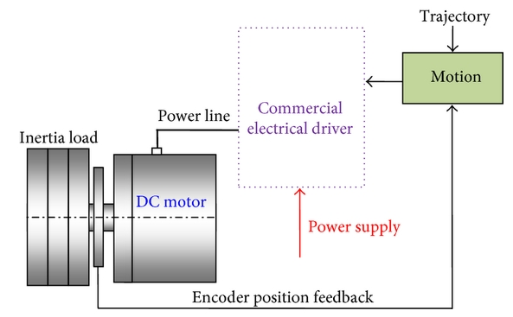 | 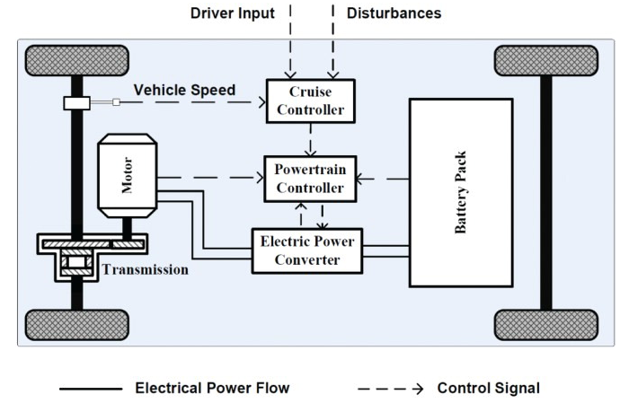

Figure 1: Typical control system

The design of the control system of a motor drive may be a challenging task especially when high performance is required as a function of load and input variations. The objectives of this task are:

- Model and simulate a DC motor drive (or any other motor) in the Matlab/Simulink environment.
- Tune the current and speed controllers using a model-based approach. PID controllers provide robust and reliable performance for most systems if the PID parameters are tuned properly.
- Explain effects of the pulse-width modulation (PWM) on control performance.

A report is to be written on this assignment in groups of two (or alone). Submit your report as a PDF file to the BrightSpace portal as indicated in the instructions.

The report should be clearly and consistently written. The requested diagrams describing the models and simulation results should be included in the report. Submit also the generated Simulink models.

Literature Review
Conduct a literature review to investigate the above topic. You may need to investigate at least five papers, summarize their outcomes and include them as references for your case (1-2 pages).

Topology
Select one of the following motor: DC, induction, and/or synchronous and draw the entire block diagram. Physical parameters can be fixed. Based on KVL, and Newton’s second law, governing equations may be derived. Applying the Laplace transform, the above modeling equations can be expressed in terms of the Laplace variable s to find the motor transfer function.

See one example below
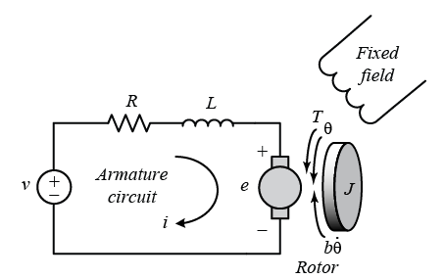

Building the Robust Control Model (Case Work)
Usually, the motor is fed from a four-quadrant DC-DC converter (H-bridge), whose DC-bus voltage is Udc. Ideal power switches are assumed. Hence, the converter can be modelled using the equivalent circuit shown in the following figure

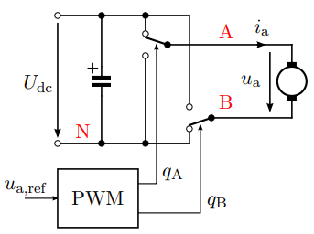 | 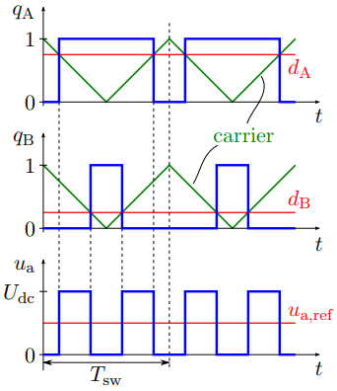  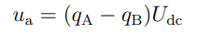

Control of real processes includes uncertain parameters (perturbations), which have to be considered in the adequate control design. In order to carry out the robust design procedure, first, a classic closed-loop identification technique is applied and then, the parametrization by internal model control is used.

Current control
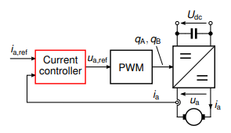 | 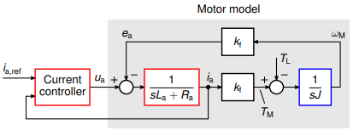

Current and speed controller
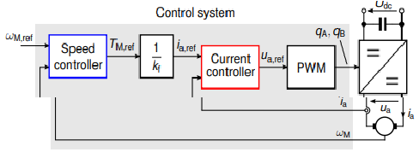 | 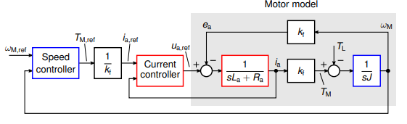

After designing a classic control system according to certain design criteria, implement the robust control system by adding a pre-filter to the entire system.

Robust Control Simulation (Lab Work)
Simulate the model using Simulink or any other simulator to generate results especially the output response to load and input signal variations.

In first simulation, all parameters of motor should be fixed and connect the system in open loop, for example, without feedback.

In second simulation, use same parameters of motor and connect the system in closed loop with PI controller.

In third simulation, design a filter to obtain a robust control system and test the topology for the same parameters and design criteria

Conclusion
Summarize the work and discuss the results.

