ELG4157 Lab 1 (10 marks)
State Space Modelling, Control, and Simulation of a DC-DC Converter
(Copy and Paste of any Kind is not Accepted)

Student 1
Student 2
TA

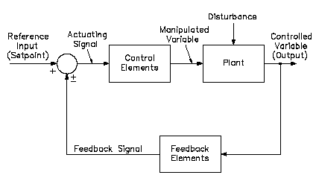 | 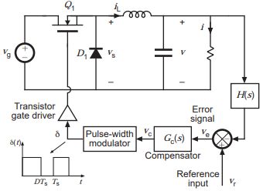

Figure 1: Typical control system (left) and actual control system for a buck converter (Sample)

The design of the control system of a power converter may be a challenging task especially when high performance is required as a function of load and input variations. This challenge may further increase in the presence of input filters which are under damped to increase the converter efficiency. Consider yourselves two control engineers looking for a DC-DC converter for a project.

Literature Review
Conduct a literature review to investigate the above topic. You may need to investigate at least five papers, summarize their outcomes and include them as references for your case (1-2 pages).

Topology
Select one of the following topologies Buck; Boost; or Buck Boost. There are three main groups of control topologies in DC-DC conversion including voltage mode control, current mode control and average current mode control. You may adopt one topology.

State Space Modeling and Control (Case Work: 10 marks)
In modern control engineering, a state space representation is a mathematical model of a physical system as a set of input, output and state variables related by first-order differential equations. In this section draw and construct the model. You may follow the given steps:
- Use circuit analysis to derive separate state space equations for each switching state.
- Use the duty cycle (D) to derive time averaged state space and output equations.
- Solve the time average equations directly for the steady state voltage transfer ratio (Vo/Vs).
- Introduce a small AC perturbation on the duty cycle and determine the resulting AC perturbations in the state variables.
- Apply Laplace transform to the small signal AC equations.
- Calculate the transfer function in the Laplace domain.

State Space Simulation (Lab Work: 5 marks)
Simulate the model using Simulink or any other simulator to generate results especially the output response to load and input signal variations.

- Using the open-loop model and with calculated parameters, find the effect of variation of input voltage and switching frequency on transient and steady state performance of converter.

- Using the closed-loop model and with calculated parameters, find the effect of variation of input voltage and switching frequency on transient and steady state performance of converter.

Conclusion
Summarize the work and discuss the results.

