CSI4106, Spring 2008: Assignment 3
Handed in on: March 19th, 2008
Due on : April 9th, 2008

Part I (30%):

There was not enough time, in class, to cover all the kinds of learning systems I would like you to experiment with. For this reason, I will be asking to research and read about two well-known classifiers:

- k-Nearest Neighbours
- Naïve Bayes

For each of these classifiers, please describe, in English, how the classifier works and illustrate your description with concrete examples of their behaviour.

Part II (70%)

To begin with, please, download WEKA and its documentation from

http://www.cs.waikato.ac.nz/~ml/weka/

To use WEKA, your data should be in the .arff format. To read more about arff, please go to: http://www.cs.waikato.ac.nz/~ml/weka/arff.html

In this assignment, you will be comparing the performance of three types of classifiers:

- A decision tree (J48)
- K-Nearesr neighbour (IBk)
- Naïve Bayes (NaiveBayes)

(the words in parenthesis correspond to the names of these classifiers in WEKA).

This comparison will take place on four data sets from the UCI Repository:

- Iris
- Labor
- Weather
- Soybean

These four data sets should actually be available within the software package you download, in the .arff format.

Using WEKA is simple. Everything can be done with the graphical interface included in the package. When you run WEKA, you are given the choice of four user modes. I suggest that you use the mode “explorer” to start the graphical interface.

You will see several tabs, including two of them entitled “preprocess” and “classify”.
The “preprocess” tab is used to open your data file (already in .arff format). The “classify” tab (see picture below) will allow you to choose the algorithm, its parameters and the evaluation method. Click on “Choose” to choose a classification algorithm.

To modify the parameters of your algorithm, select the algorithm first and click “more” in order to obtain information about the algorithm and its parameters. Please, try to optimize the performance of your classifiers by modifying the parameters appropriately.

Choose 10-fold cross-validation as your evaluation method in the « test options » section on the left, and click on the “Start” button. The results will eventually appear on the right.

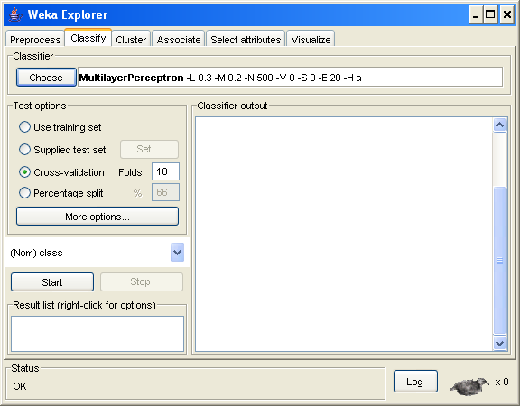

Once your experiments completed, I would ask you to report :
- The error rates obtained by each classifier on each domain
- The optimal parameters used in each experiment
- Your conclusions regarding the results you obtained

