SCHOOL OF INFORMATION TECHNOLOGY AND ENGINEERING

COURSE: SEG2106 | PROFESSOR: Gregor v. Bochmann
SEMESTER: WINTER 2012 | DATE: February 18, 2012
 | TIME: 10:00 to 11:30

MIDTERM EXAMINATION

Solutions

Name and Student Number: / _

Mid-Term Exam

There are three (3) types of questions in this examination.
Part 1 | Short answer questions | 21 marks
Part 2 | Development questions | 24 marks
Part 3 | Problem solving | 15 marks
Total |  | 60 marks

The space allocated for each question is limited. In case of necessity you may use the other side of the pages to continue.

Note: There is limited time. Do not spend too much time on the questions that give only two or three points.

Annex: Example of LTSA model specification and tool output

Annex B: Algebraic Equivalence Properties of Regular Expressions

Short-answer questions:
- [4 marks] The sequence diagram below shows an execution scenario where component A executes two sending and one receiving event, and component B executes two receiving events and one sending event.

Question (a): [2 marks] Write down the state machine models of A and B (showing the states and input and output interactions) which correspond to the execution scenario given by the sequence diagram.

Question (b): [2 marks] Could the concurrent execution of the two state machines of point (a) give rise to an execution scenario different than the one shown by the given sequence diagram ? – If yes, draw an example of such a sequence diagram, if no, explain why not.

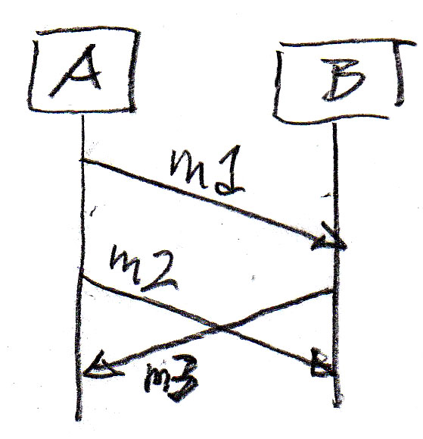 | Answer (a):  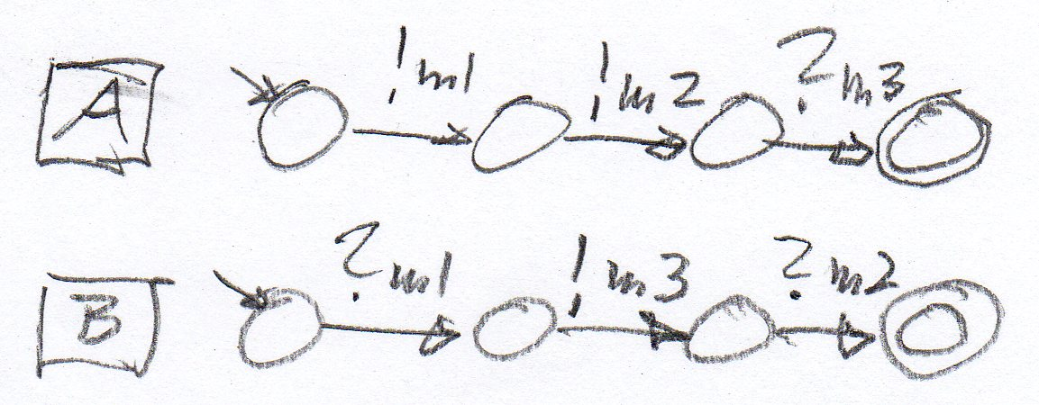

Answer (b): The two following answers are considered correct:
- YES – with the diagram below.
- NO – because B cannot receive m2 before sending m3
- [3 marks] The diagram below shows a UML State Diagram, where i is an input, x is an integer variable, and State 2 contains a entry action that generates an output o with an integer parameter equal to the current value of x.

Write down the sequence of x-values and output interactions generated when the state machines receives 8 consecutive i inputs.

Answer:
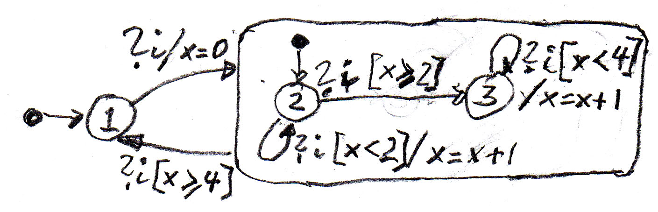
  input | Value of x | output
  i | 0 | o(0)
  i | 1 | o(1)
  i | 2 | o(2)
  i | 2
  i | 3
  i | 4
  i | 4
  i | 0 | o(0)

- [2 marks] Do the following two regular expressions define the same language ? (see also Annex B)
- ( a | b ) (a | b )* c
- (a | b )* a b c

Answer: (a) YES (b) NO
- [2 marks] Does the following regular expression define the same language as the accepting automaton shown here ?

- regular expression: b*a c* d (a b* a c* d)* e

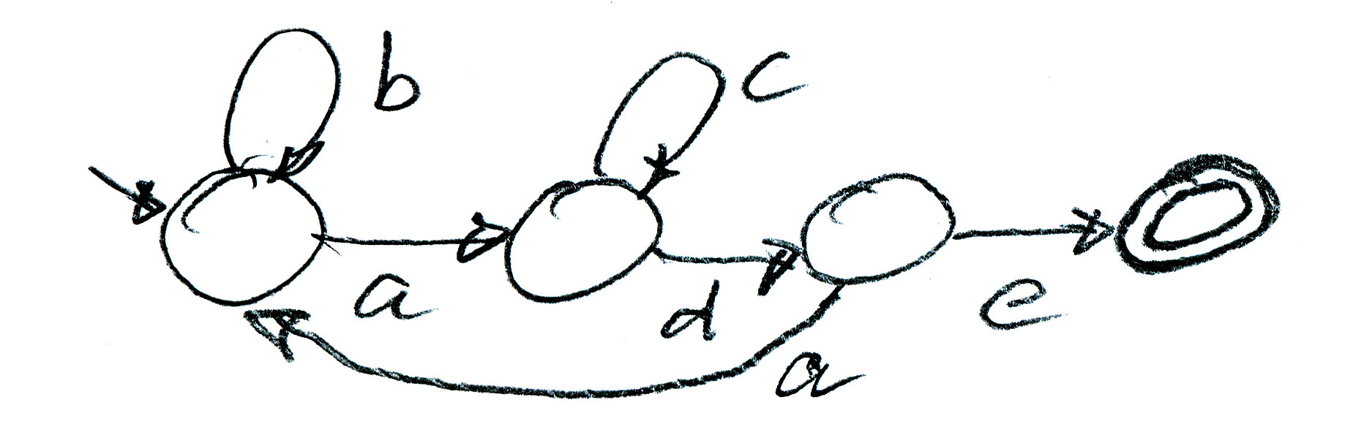

Answer: (a) YES (b) NO

- [5 marks] Below is an extract from a file destined as input to the LEX (or Flex) tool. Question (a): Explain in a few words, what is the meaning of the second line.

The regular expression ID defines all strings that start with a lower-case alphabetic character which may be followed by zero, one or more lower-case alphabetic or numeric characters.

Question (b): Explain in a few words, what is the meaning of the before-last line.

DIGIT represents a numeric character 0 through 9. The line states: when a string consisting of one or more DIGITs followed by a “.” and possibly followed by one or more DIGITs, the the C-statements in curly brackets should be executed.

Question (c): Explain in a few words, under what conditions “xxx” will be printed.

When one or more digits are encountered in the input string

Extract from LEX input file:
DIGIT [0-9]
ID [a-z][a-z0-9]*
%%
{DIGIT}+ {printf("xxx\n", yytext); }
{DIGIT}+"."{DIGIT}* {printf("yyy\n", yytext); }
{ID}

- [5 marks] The Annex contains the specification of a labeled transition system (LTS) – the telephone system from the Lab, slightly modified. It is written in the input format of the LTSA tool. It also contains the output produced by that tool when the command “CHECK” -- “progress” was executed.

Question (a): [2 marks] Explain in a few words the meaning of the output produced by the tool.

The behavior of the system contains a cycle without possible progress. The cycle is reached when pick_up2 is executed from the initial state. The cycle is the sequence of interactions puck_up1, dial, busy_tone.

Question (b): Considering the specification of the telephone receiving a call, please answer the following questions: (note: considering this telephone alone)

(b1) [1 mark] is the following sequence of interactions possible: pick_up2, busy_tone ?

YES

(b2) [1 mark] In which state is the phone after the sequence: pick_up2, hang_up ?

Phone2

(b3) [1 mark] In which state is the phone after the sequence: ring, pick_up2 ?

A state where the next interaction is hello. Also considered correct: The state Phone2 is reached after hello. (Note that hello is not a state).

Development questions

- [3 marks] Write down a regular expression that defines the regular language accepted by the following automaton:

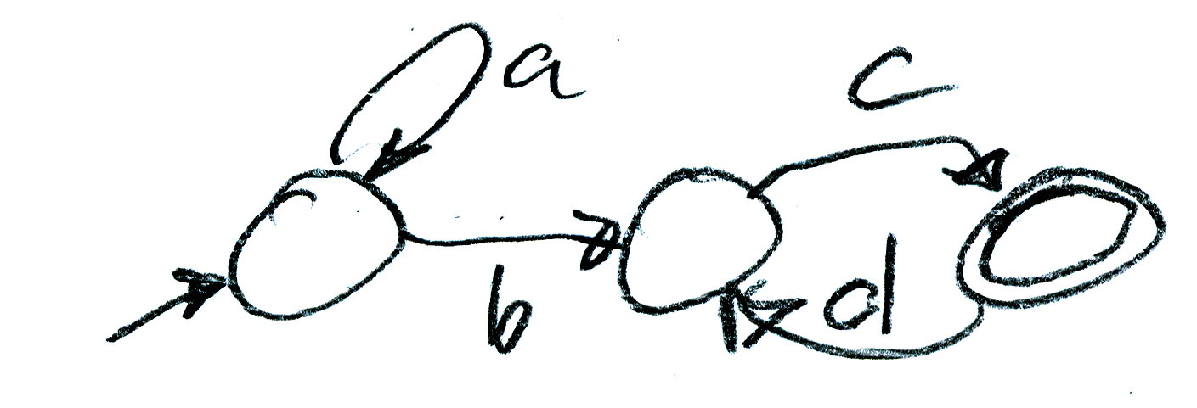 Answer: a* b c ( d c )*

or a* b (c d )* c

- [5 marks] Write down a regular expression that defines the language of all Java method declarations, such as “int get (Object o, float number)” . You may assume that the following definition is given:

id = alpha (alpha | digit)* -- expression for identifiers

Answer: id id “(“ [ ɛ | id id ( “,” id id )* ] “)”

- [2 marks] Is the following state machine a non-deterministic state machine ?

If yes, explain why, if no, explain why not.

Answer: YES, because it contains a spontaneous transition ɛ

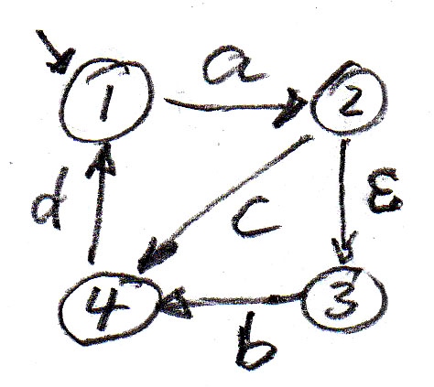

- [2 marks] We consider the following accepting automaton.

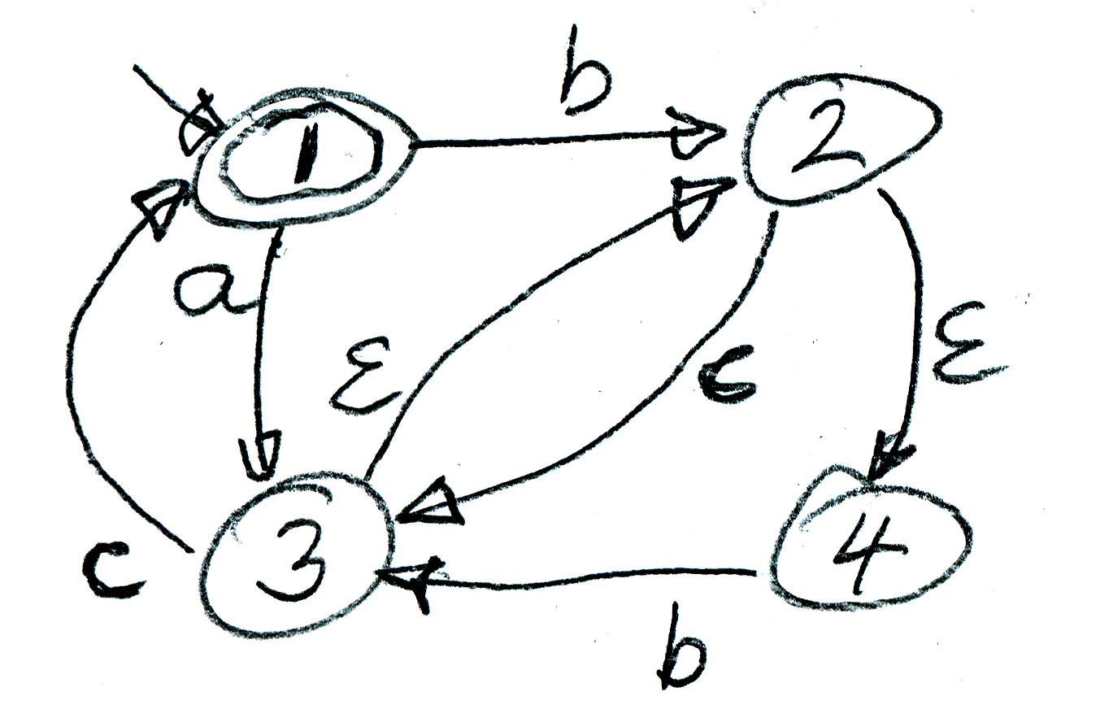

Question (a): What are the states in which the accepting automaton could be after having read the input sequence “ a b c “ ?

Answer: {1, 2, 3, 4}

Question (b): Would this input string be accepted ? - YES NO

- [6 marks] The diagram below shows an architecture diagram showing two state machines A and B that communicate with one another by exchanging the messages m1 and m2. They also exchange messages with the environment, as indicated by the architecture diagram. In addition, the figure below shows the dynamic behavior of the two state machines. Both have the same behavior.

Architecture diagram Behavior diagram

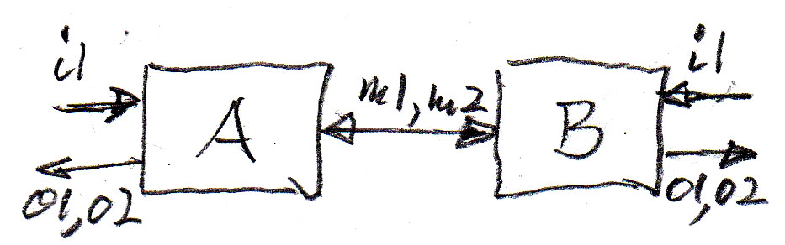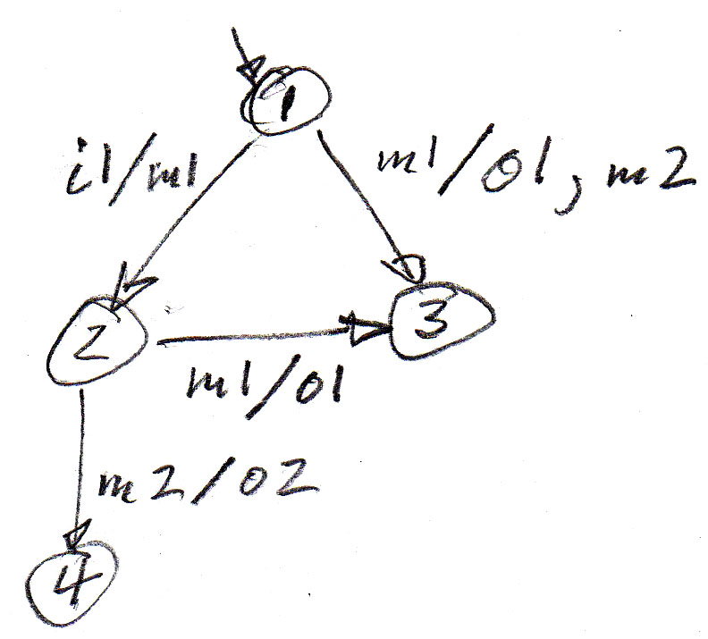

Question (a): [3 marks] Write down a sequence diagram showing the environment of the two machines and the two state machines, as well as the messages exchanged for the following scenario: A receives an i1 input from the environment.

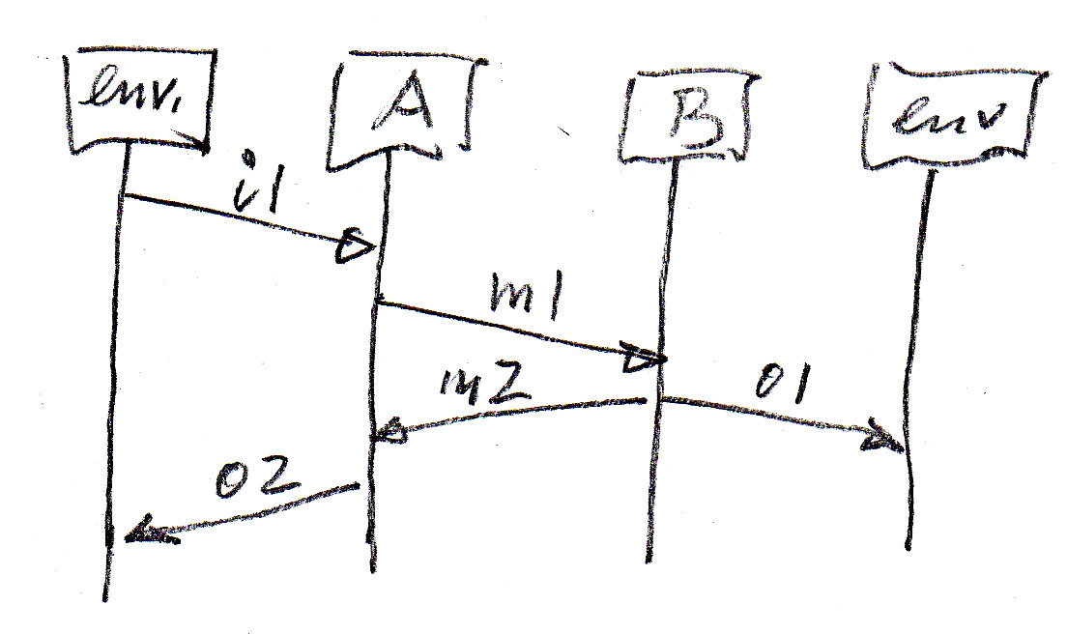

Question (b): [3 marks] The same, for the case that both machines receive an i1 input from their environment at the same time.

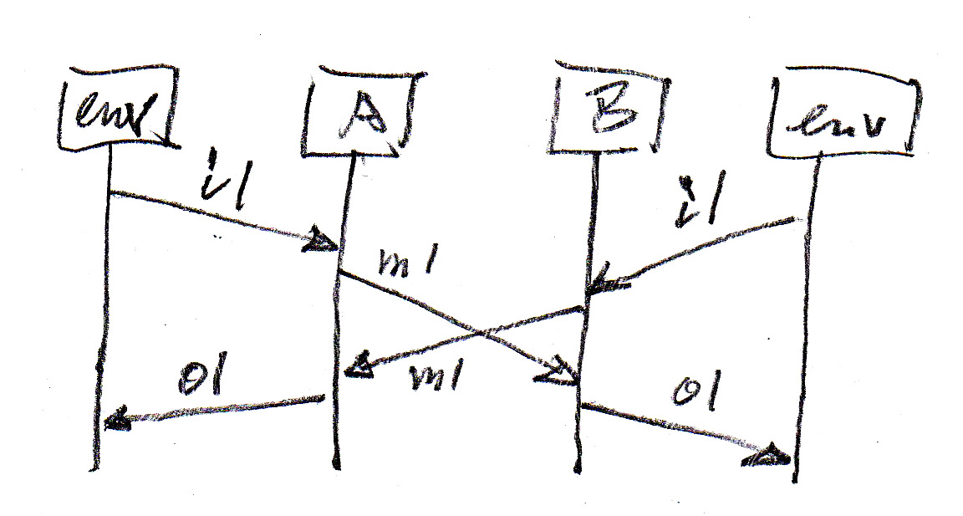

- [6 marks] Reachability analysis - We consider two communicating state machines A and B with the behaviors shown in the diagrams below (left side). Please continue the reachability analysis shown by the diagram on the right side. Do you identify any design problem in the behavior of the two machines ?

Question (a): [2 marks] what are the possible global transitions that could occur from the global state ( : 2 | a : 1 ) reached after a was sent ?

!c by A , ?a by B, and !b by B

Question (b): [4 marks] What is the state reached from the global state ( b : 1 | : 2 ) when the next transition is the sending of an a by machine A ? – and which transitions are possible from that state (leading to which subsequent global states) ? – Please show your answer by continuing the diagram on the right side. You may add some comments.

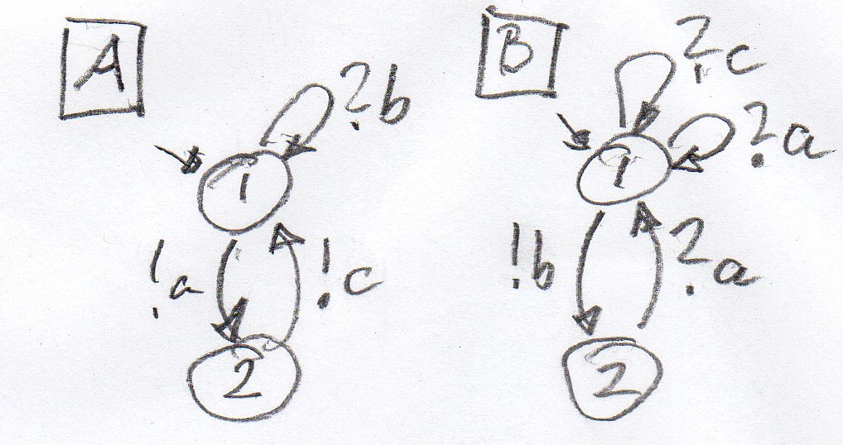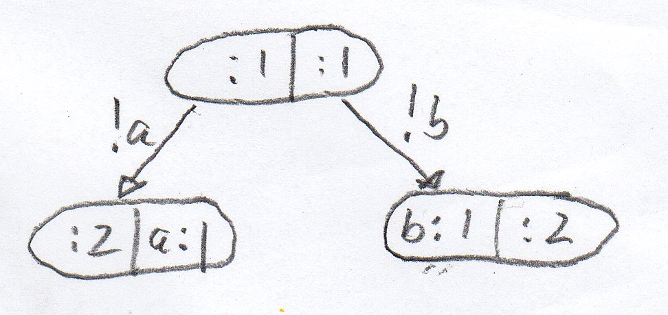

The following is the minimum reachability exploration required to answer question (b). Additional state exploration was not necessary. Which states would be reached by the transition under question (a) was not part of the question. Such additional information did not give you any additional points. 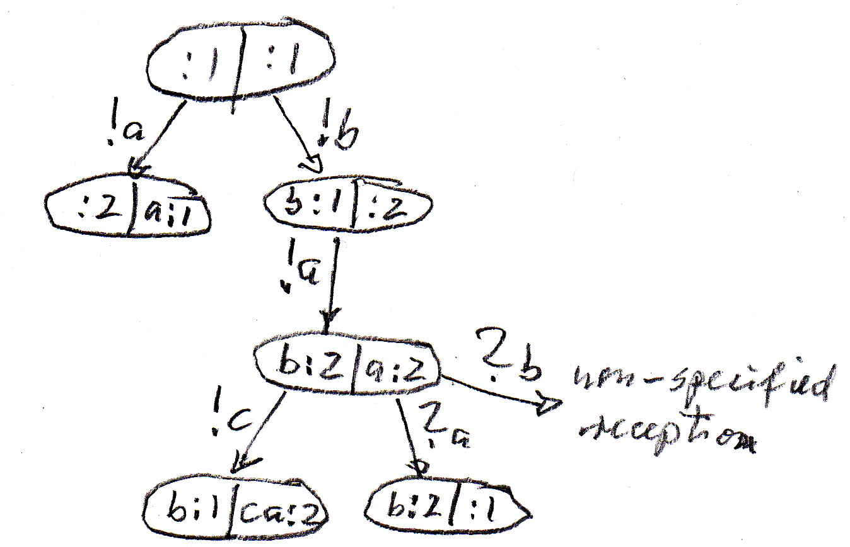

Problem Solving

- [15 marks] A new drink dispenser works as follows: The user enters some coins, then he pushes a button to select either a bottle of juice or a bottle of water. If the user entered enough money, the selected bottle will be provided to the user, unless there are no bottles left within the machine. Any unused money will be returned. The user may at any point in time cancel the operation and any money entered will be returned. The machine is connected to the Internet, and a bottle delivery person who replaces the sold bottles, or a manager may access the machine over the Internet and perform the following operations: If the machine is in the idle state, then the machine may be put into the standby state. In this state, the following operations can be performed: (a) read the numbers of juice and water bottles left in the machine, (b) update the number of bottles stored in the machine.

Question (a): [3 marks] Write down a conceptual model of this drink dispenser machine and its environment, using an entity-relationship diagram or a UML Class diagram.

Question (b): [3 marks] Define the interfaces of the dispenser machine and the interactions that occur at these interfaces.

Question (c): [7 marks – 2 for formalizing variables, 2 for standby operations, 3 for normal operations (ignoring variables) ] Write down a model that defines the dynamic behavior of the dispenser machine using a UML State machine diagram.

Question (d): [2 marks] Explain what assumptions you have made about the dynamic behavior of the machine – aspects that are not specified in the description above.

(b) for instance:
(1) User interface:
(a) input to Dispenser: coin, choiceJuice, choiceWater, cancel;
(b) output from Dispenser: pleasePay, returnCash, deliverDrink

(2) Interface for support person (over Internet):
(a) input to Dispenser: startSession, endSession, readValues, newValues(juice, water) ;
(b) output from Dispenser: values, newValuesOK.

(d) for instance:
(1) The cost of juice and water is the same.
(2) Each coin has the same value – one unit of money.
(3) When a choice button is pressed and not enough money was inserted, then all money is returned and the dispenser goes back to the idle state.
(a)
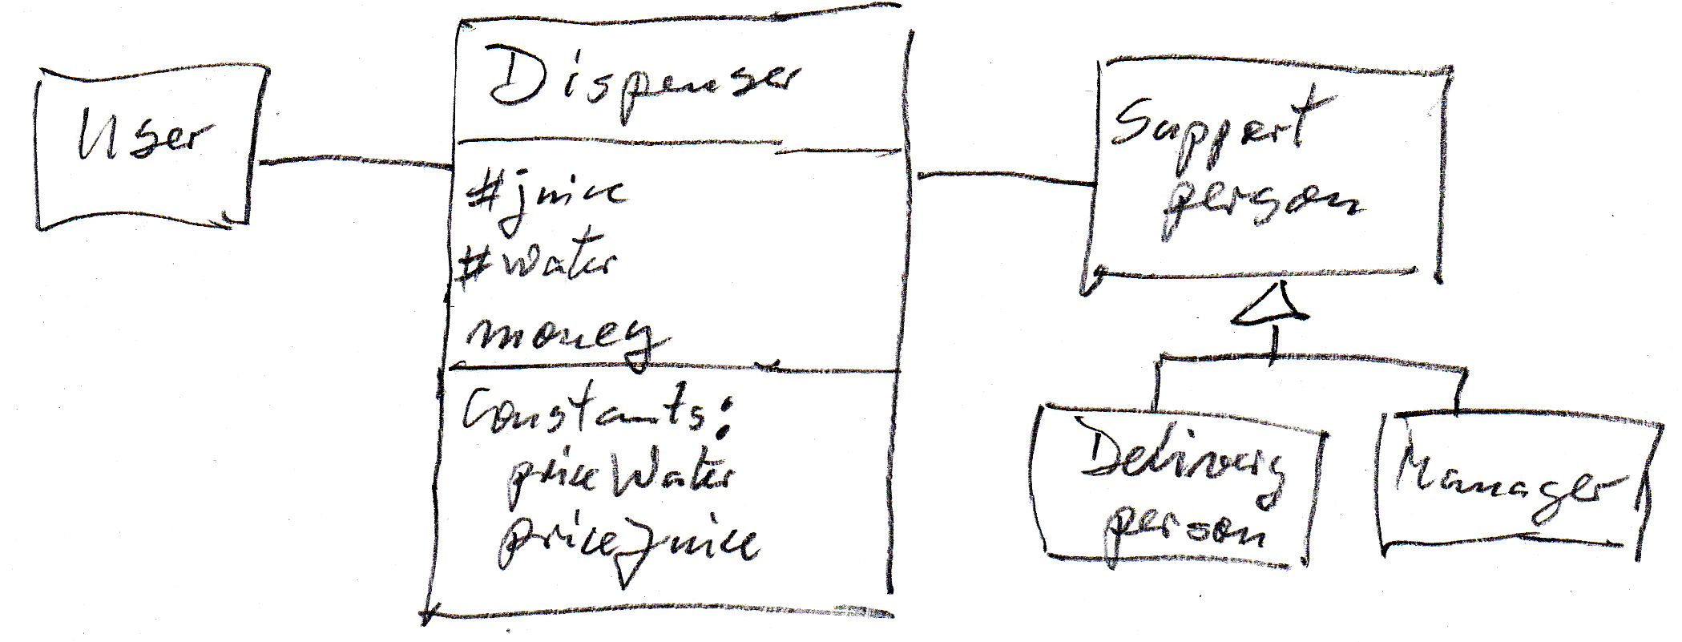

(c)
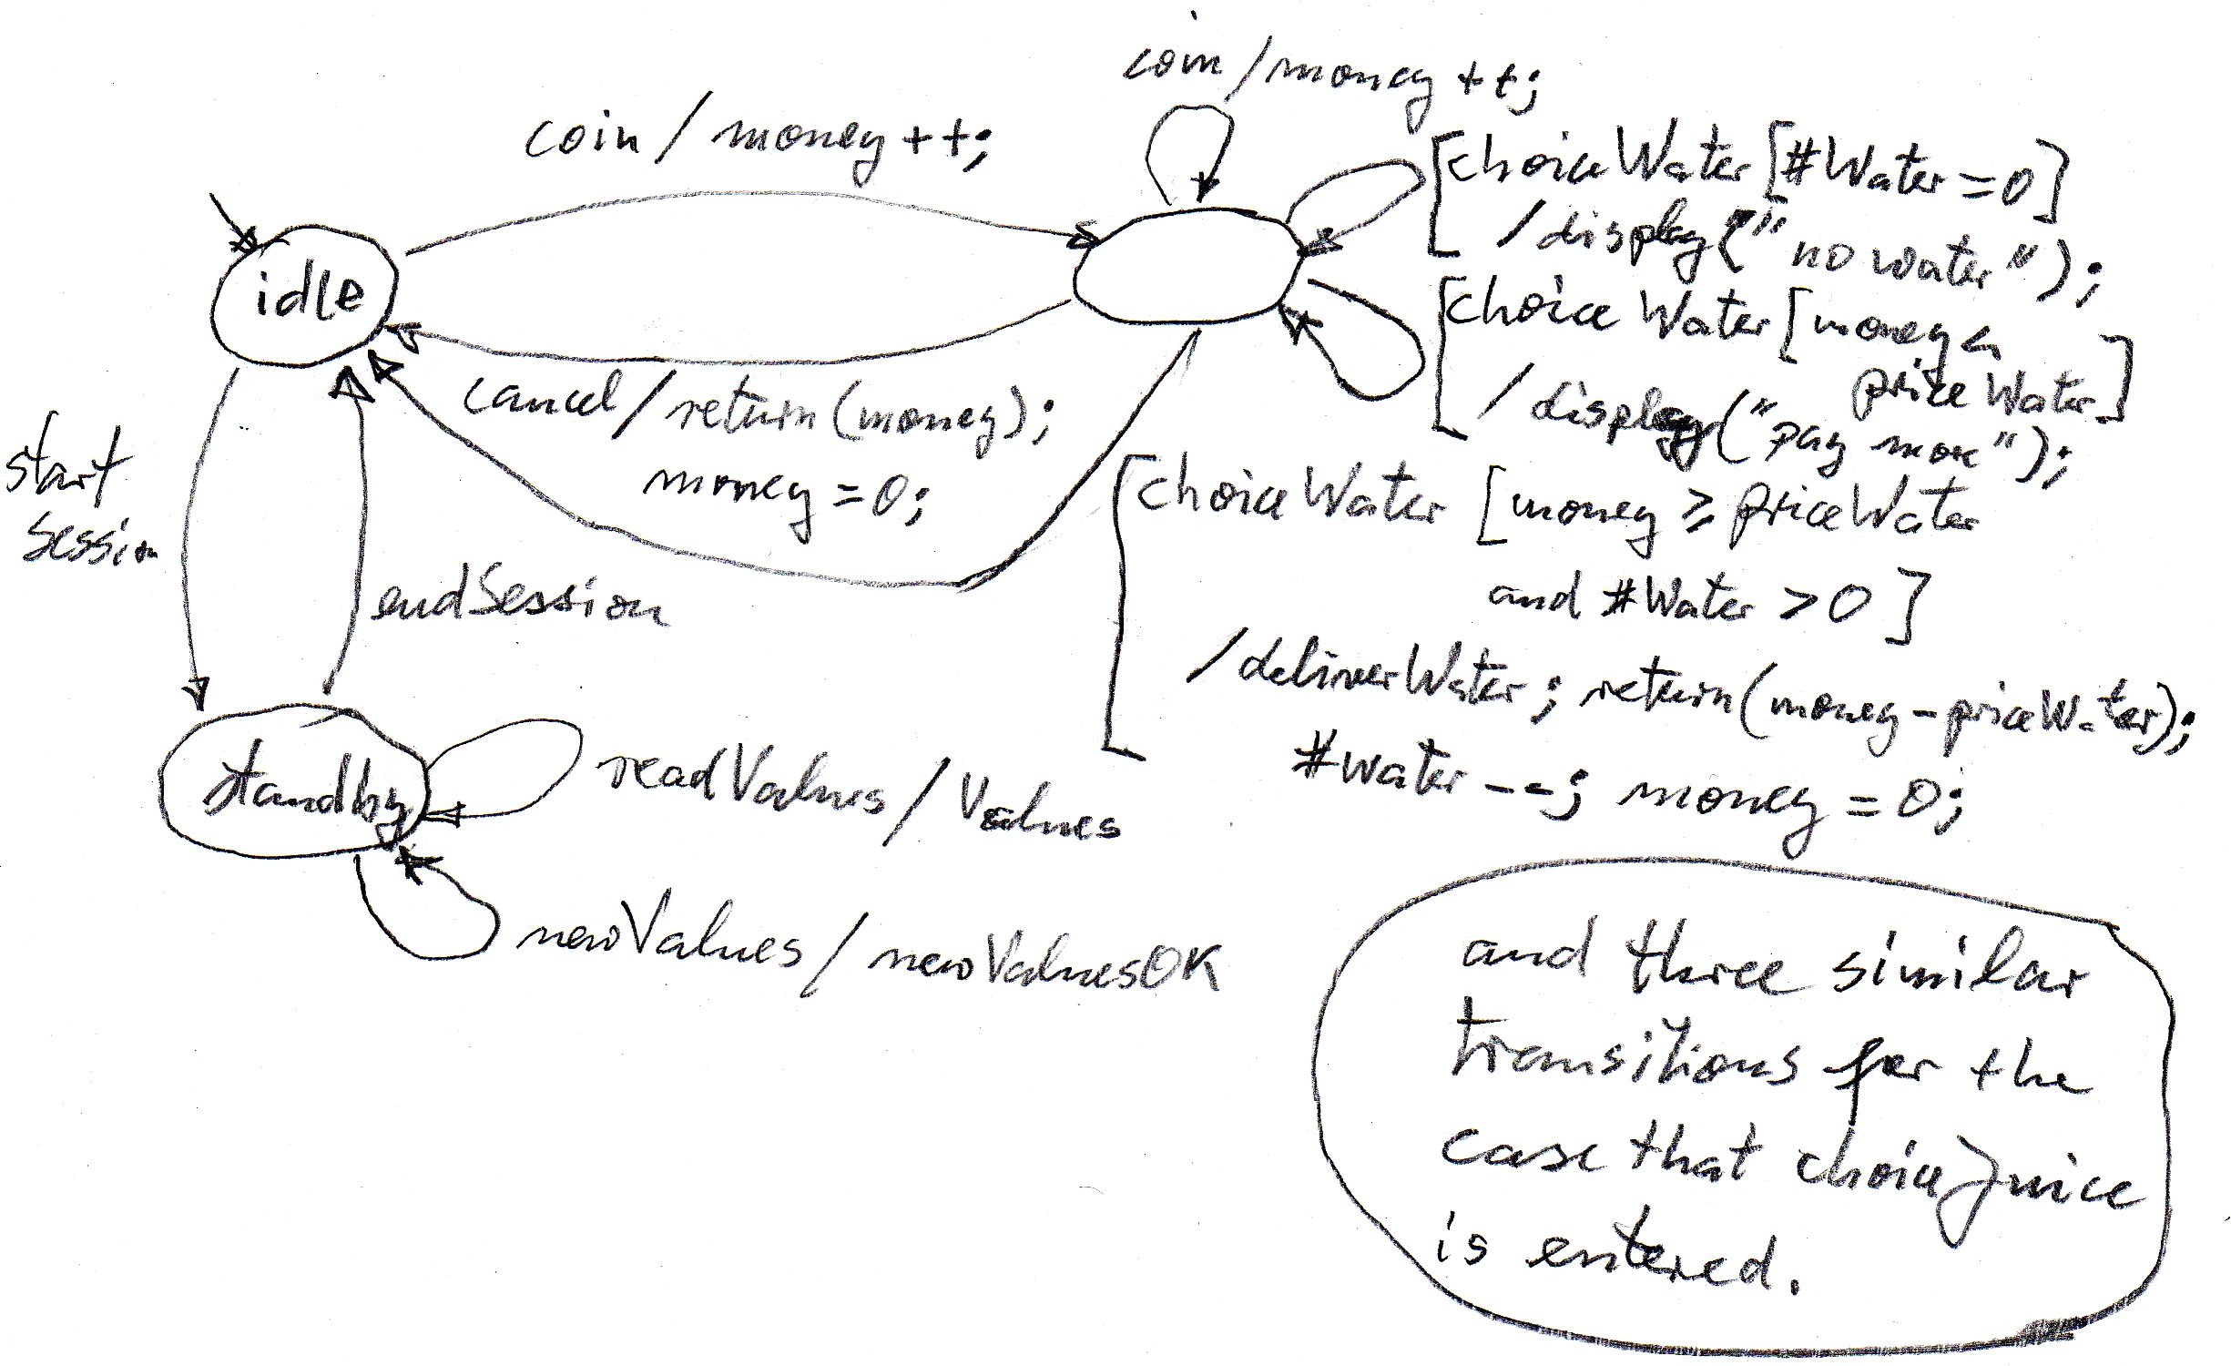

Annex : Example of modeling an LTS using the LTSA tool

Specification of the telephone system

// the side initiating the call
PHONE1 = (pick_up1 -> dial -> WAIT),
WAIT = (ring_back -> hello -> TALKING1 | busy_tone -> PHONE1),
TALKING1 = (talk -> TALKING1 | hang_up -> PHONE1).

// the side receiving the call
PHONE2 = (ring -> pick_up2 -> hello -> TALKING2 | pick_up2 -> BUSY),
BUSY = (hang_up -> PHONE2 | busy_tone -> BUSY),
TALKING2 = (talk -> TALKING2 | hang_up -> PHONE2).

SWITCH = (dial -> CHECK),
CHECK = (ring -> ring_back -> SWITCH | busy_tone -> SWITCH).

||PHONE_SYSTEM = (PHONE1 || PHONE2 || SWITCH).

Output of the LTSA tool when doing “CHECK” -- “Progress”
- note that no deadlock is detected by the tool -

Progress Check...

-- States: 4 Transitions: 5 Memory used: 4472K

Finding trace to cycle...

Finding trace in cycle...

Progress violation for actions:

{hang_up, hello, pick_up2, ring, ring_back, talk}

Trace to terminal set of states:

pick_up2

Cycle in terminal set:

pick_up1

dial

busy_tone

Actions in terminal set:

{busy_tone, dial, pick_up1}

Progress Check in: 1ms

Annex B: Algebraic Equivalence Properties of Regular Expressions

