SCHOOL OF ELECTRICAL ENGINEERING AND COMPUTER SCIENCE

COURSE: SEG-2106 | PROF: Gregor v. Bochmann
Software Construction | DATE: April 18, 2012
SEMESTER: WINTER 2012 | TIME: 19:00 – 22:00
 | ROOM: SITE G0103

FINAL

EXAMINATION

No documentation allowed

Name

Student Number

- There are three (3) types of questions in this examination.
Part 1 | Simple answers | 8 marks
Part 2 | Small problems | 48 marks
Part 3 | Problem solving | 18 marks
Total |  | 74 marks

- The space allocated for each question is limited. In case of necessity you may use the other side of the pages to continue.
- Initial all the pages, except the appendixes.

List of Annexes:

Appendix A: Algebraic Properties of Regular Expressions

Appendix B: Elimination of left recursion

Appendix C: Computation of FIRST

Appendix D: Computation of FOLLOW

Appendix E: Non-recursive predictive parsing

Appendix F: Construction of a predictive parsing table

Simple answers [2 marks each]:

- [2 marks] Write down a regular expression that defines the regular language accepted by the following automaton (the initial state is the only accepting state):

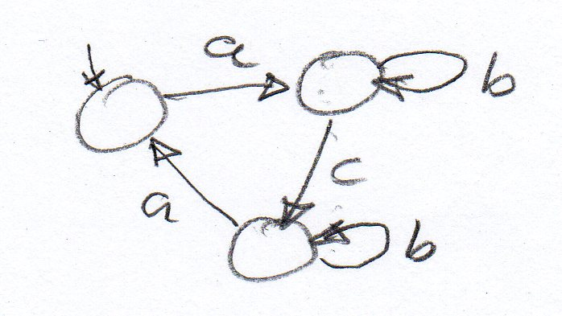 Answer:

- [2 marks] We consider the following accepting automaton.

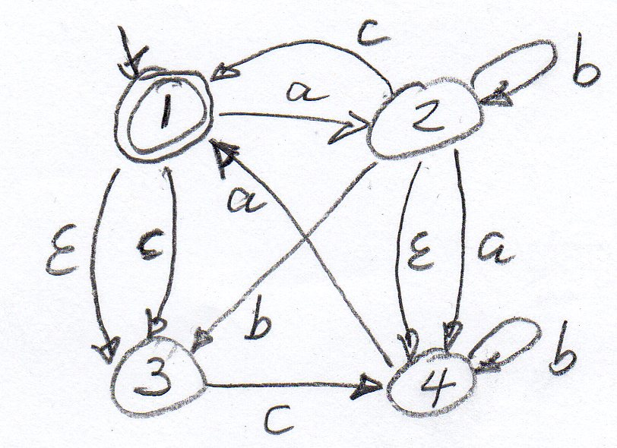

Question (a): What are the states in which the accepting automaton could be after having read the input sequence “ a b c “ ?

Answer:

Question (b): Would this input string be accepted ? - YES NO

- [2 marks] Concurrency: Readers and Writers access a shared resource. There is mutual exclusion, except that multiple Readers can access the resource simultaneously, but not when a Writer is using it.

Let us assume that reading takes 30 msec and writing takes 50 msec, and there are two readers and two writers. Let us assume that they try to access the resource at the following times:
  - Writer-1 tries to access the resource at time t = 0 (initially, the resource is free)
  - Reader-1 tries to access the resource at time t = 20
  - Writer-2 tries to access the resource at time t = 60
  - Reader-2 tries to access the resource at time t = 70

When do these four threads start and terminate their use of the resource ? Answers:

Writer-1 starts at 0 and ends at 50 msec.

Reader-1 starts at and ends at msec.

Writer-2 starts at and ends at msec.

Reader-2 starts at and ends at msec.

- [2 marks] Below is the Java code of a semaphore.

Question: What happens when a thread calls the acquire method when the value of the variable s is equal to zero ? – Explain in a few words.

public class Sema {
private int s;
public Sema(int permits) {s = permits;}

public synchronized void acquire() {
try {
while(s == 0){wait();}
s = s - 1;
} catch (InterruptedException e) {e.printStackTrace();}
}
public synchronized void release() {
s = s + 1;
notify();
}

}

Small Problems

- [4 marks] We consider a system consisting of two state machines, called A and B, which communicate by message passing over a network. Each transition of a machine may be associated with the reception of a message m (written ?m) or with the sending of a message m (written !m).
  - What does it mean when one says that the behavior of these machines may lead to a non-specified reception ?

  - Could the behavior of the following two state machines lead to a non-specified reception ? – If YES, draw a sequence diagram that shows a scenario that leads to a non-specified reception; if NO, please explain why not (in a few words).

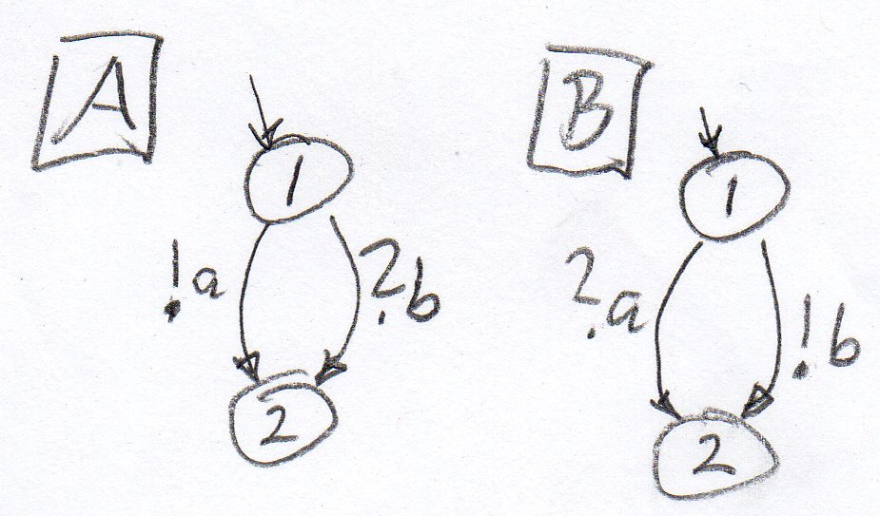

- [4 marks] Implementation design is the development phase during which the non-functional requirements are composed with the functional specification in order to select a software-hardware architecture that fits the requirements of the system.
  - What kind of hardware architecture is usually adopted in order to obtain a Web server of very high availability ?

  - What kind of hardware architecture is usually adopted in order to obtain a fail-safe reactive system (that should never give a wrong response to a given input) ?

- [4 marks] The account numbers of the customers of a bank have the following form: The number either starts with an “A” followed by a number of two digits between 08 and 22, followed by “-“ and then 3 decimal digits, or it starts with a “B” and then 1 to 2 alphabetic characters followed by “-“ and 2 decimal digits.
  - Please write down a regular expression that defines the language of all valid account numbers of this bank. You may assume that the following definitions are given:

digit = 0 | 1 | 2 | 3 | 4 | 5 | 6 | 7 | 8 | 9

alpha = A | B | C | … | Z

Answer:

- [4 marks] We assume that a server has an exponential service time with an average of 0.02 seconds. The arrival rate of requests at the server is on average 25 requests per second. Please calculate the expected (average) response time of the server, and the expected average queue length of the server. You may use the following formulas for queuing models:
  - Tr = Ts / (1 – utilization) -- where Tr is the average response time and Ts is the average service time
  - w = ρ**2 / (1- ρ) -- where w is the average number of requests that are waiting to be processed, and ρ is the utilization of the server

- [6 marks] Using the approach discussed in class, convert the non-deterministic automaton below into an equivalent deterministic automaton.

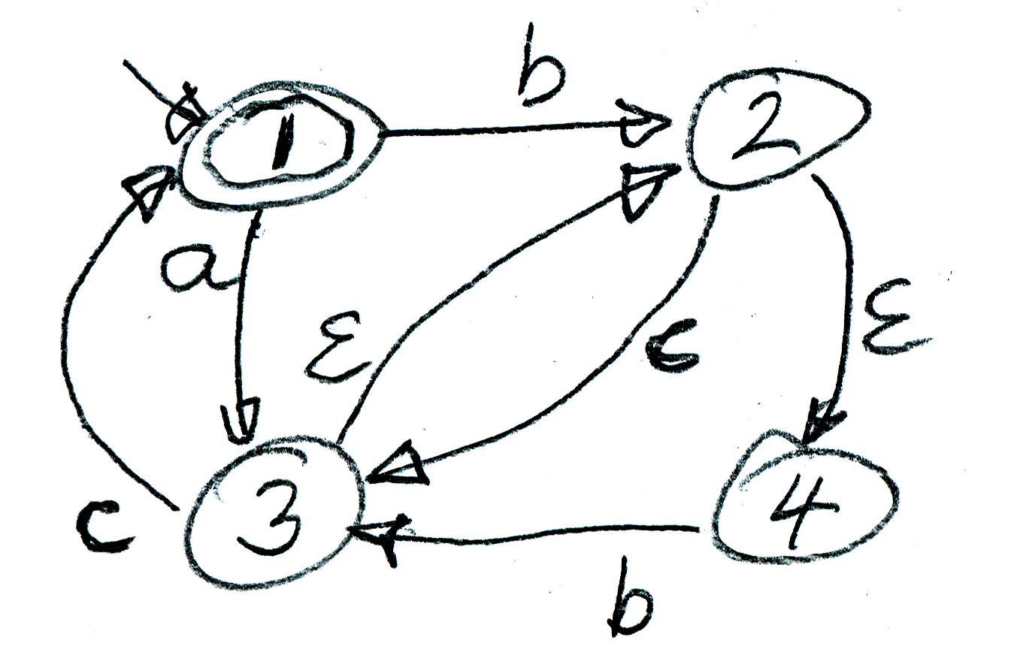

- [4 marks] The following grammar has left recursion. Find an equivalent grammar (that generates the same language) without left recursion. (Note: refer to Appendix B for possible methods).

S → S A | B

A → c | A a

B → b B | c

- [4 marks] Consider the grammar with the following syntax rules. Use left-factoring to find equivalent rules that satisfy the LL(1) constraints.

S → a B a A | a B b c | A
A → a A | B
B → b a | b B

- [4 marks] Write down a context-free grammar that generates sentences of the following form: one “a” at the beginning, then one or more “b” followed by a “c”, and then the same number of “a” as there were “b”s, and finally one “c”.

.

- [4 marks] Show that the following grammar is ambiguous.

S → a A | b B

A → A + A | B

B → b

- [10 marks] We consider the following grammar (similar to the Pascal grammar):
PRO → S $
S → id := EXP | if EXP then S ELSE
ELSE → else S | ε
EXP → const
The starting symbol of this grammar is PRO and its terminals are :=, id, if, then, else, const and $.

- Compute the sets FIRST and FOLLOW for all the non-terminals in the above grammar. Note: Appendices C, D and F contain related definitions and algorithms.
- Build a parsing table for the grammar. – Question: is the grammar LL(1) ? – Explain in a few words.

Problem Solving

- [10 marks] Readers and Writers

Readers and Writers access a shared resource. There is mutual exclusion, except that multiple Readers can access the resource simultaneously, but not when a Writer is using it.

The program below implements a resource manager that controls the access to a shared resource for readers and writers. A reader (writer) calls the respective acquire method before accessing the resource, and calls the respective release method afterwards.

public class ResourceManager {
private int nR = 0;
private boolean actW = false;

public synchronized void acquireR(){ -- for readers
while (actW) try {wait();} catch(InterruptedException e){}
nR ++;
}
public synchronized void releaseR(){
nR --;
notifyAll();
}

public synchronized void acquireW(){ -- for writers
while (actW || (nR != 0)) try {wait();}
catch(InterruptedException e){}
actW = true;
}
public synchronized void releaseW(){
actW = false;
notifyAll();
}

}

It could happen that readers are accessing the resource continuously (new readers coming in before all active readers finish accessing the resource). In this case, writers have to wait indefinitely.

Question: It is your task to modify the definition of the ResourceManager class in such a way that writers will never have to wait indefinitely. The idea is to allow new readers into the resource only when no writer is waiting.

Note: It is suggested that you introduce an additional variable that counts the number of waiting writers, and that you modify the acquireW method by first incrementing this counter before checking whether the calling writer has to wait.

You may indicate your proposed changes by annotating the program above and/or by writing the modified method definitions below (or on the next page).

- [8 marks] Writing a recursive descent parser

We assume the following grammar, where Prog is the root:

Prog → Stat $

Stat → ID ;

Stat → while Exp do Stat

Assuming syntax analysis by recursive procedures, as seen in a lab and Assignment 3, it is your task to write the Java method parse_Stat() that perform the syntax analysis for the nonterminal Stat. (Note: this grammar is LL(1)).

We assume that the class Syner (see below) contains the methods for parsing the different non-terminals of the grammar. The method for parsing the non-terminal Prog is already given below. The method parse_Exp() for parsing the non-terminal Expr is supposed to be given as well. It is assumed that a suitable lexical analyzer exists (variable lex in the program below). You may assume that suitable definitions of Java constants are given which represent the different lexical units, such as DOLLAR, ID, SEMI, WHILE, and DO.

Reminder: Prog → Stat $

Stat → ID ;

Stat → while Exp do Stat

class Syner {
private Lexer lex;

public Syner(String inputFile) {
lex = new Lexer(inputFile);
// read the next token (here it is the first one)
// and place it into lex.token
lex.getNext();
}

public void parse_Prog() throws IOException {
parse_Stat();
// check that the dollar sign follows Stat
if(lex.token != lex.DOLLAR)
{errorMessage("DOLLAR token expected!");}
}

public void parse_Stat() throws IOException {

Appendix A: Algebraic Properties of Regular Expressions

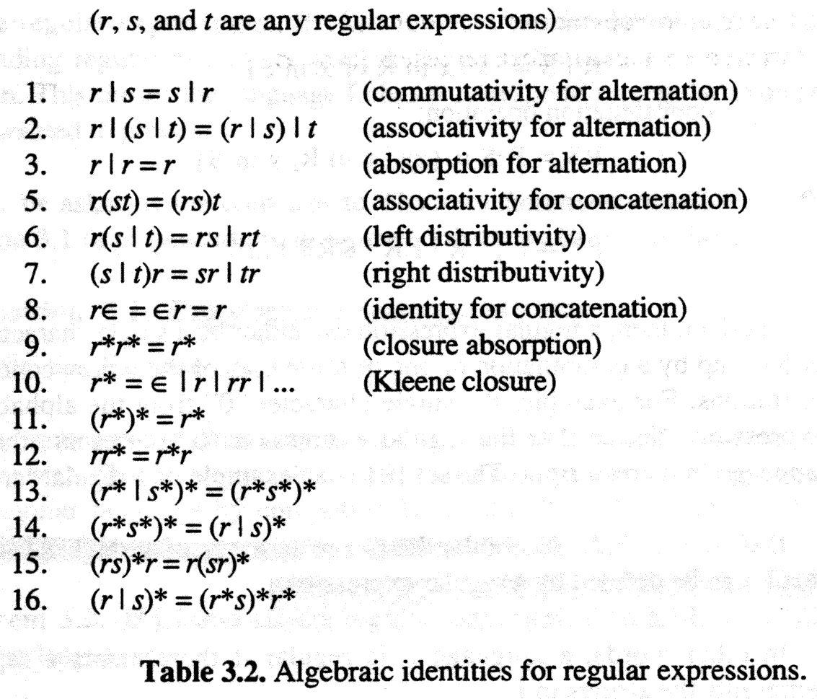

Appendix B: Elimination of left recursion

can be replaced by

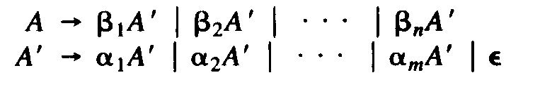

Appendix C: Computation of FIRST

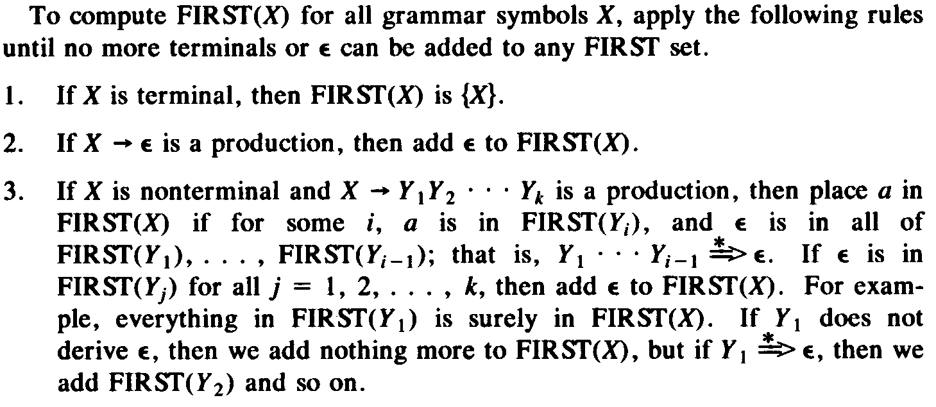

Appendix D: Computation of FOLLOW

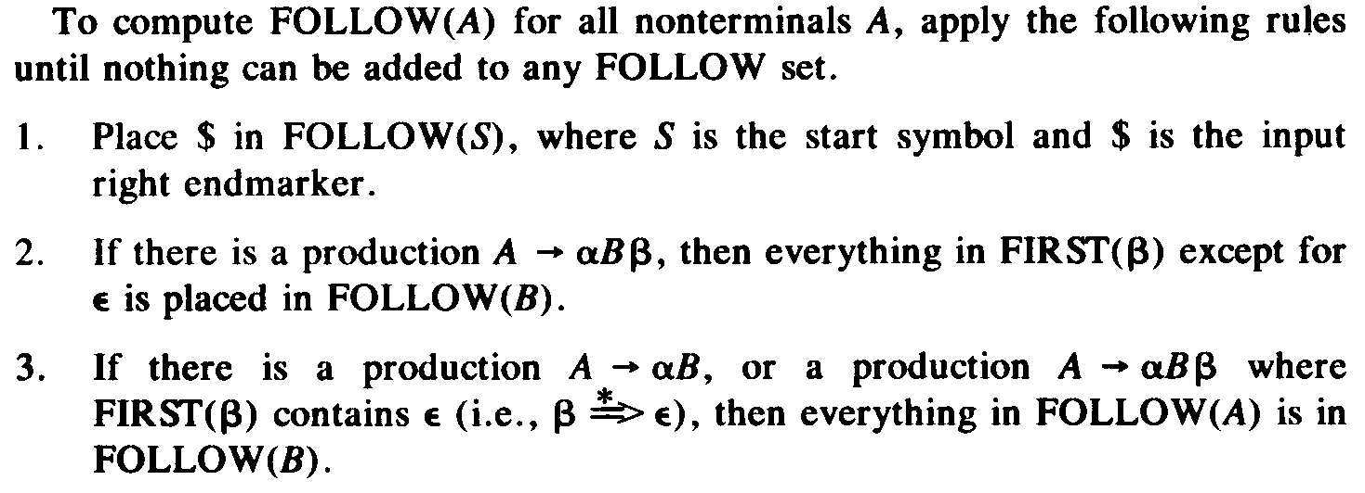

Appendix E: Nonrecursive predictive parsing

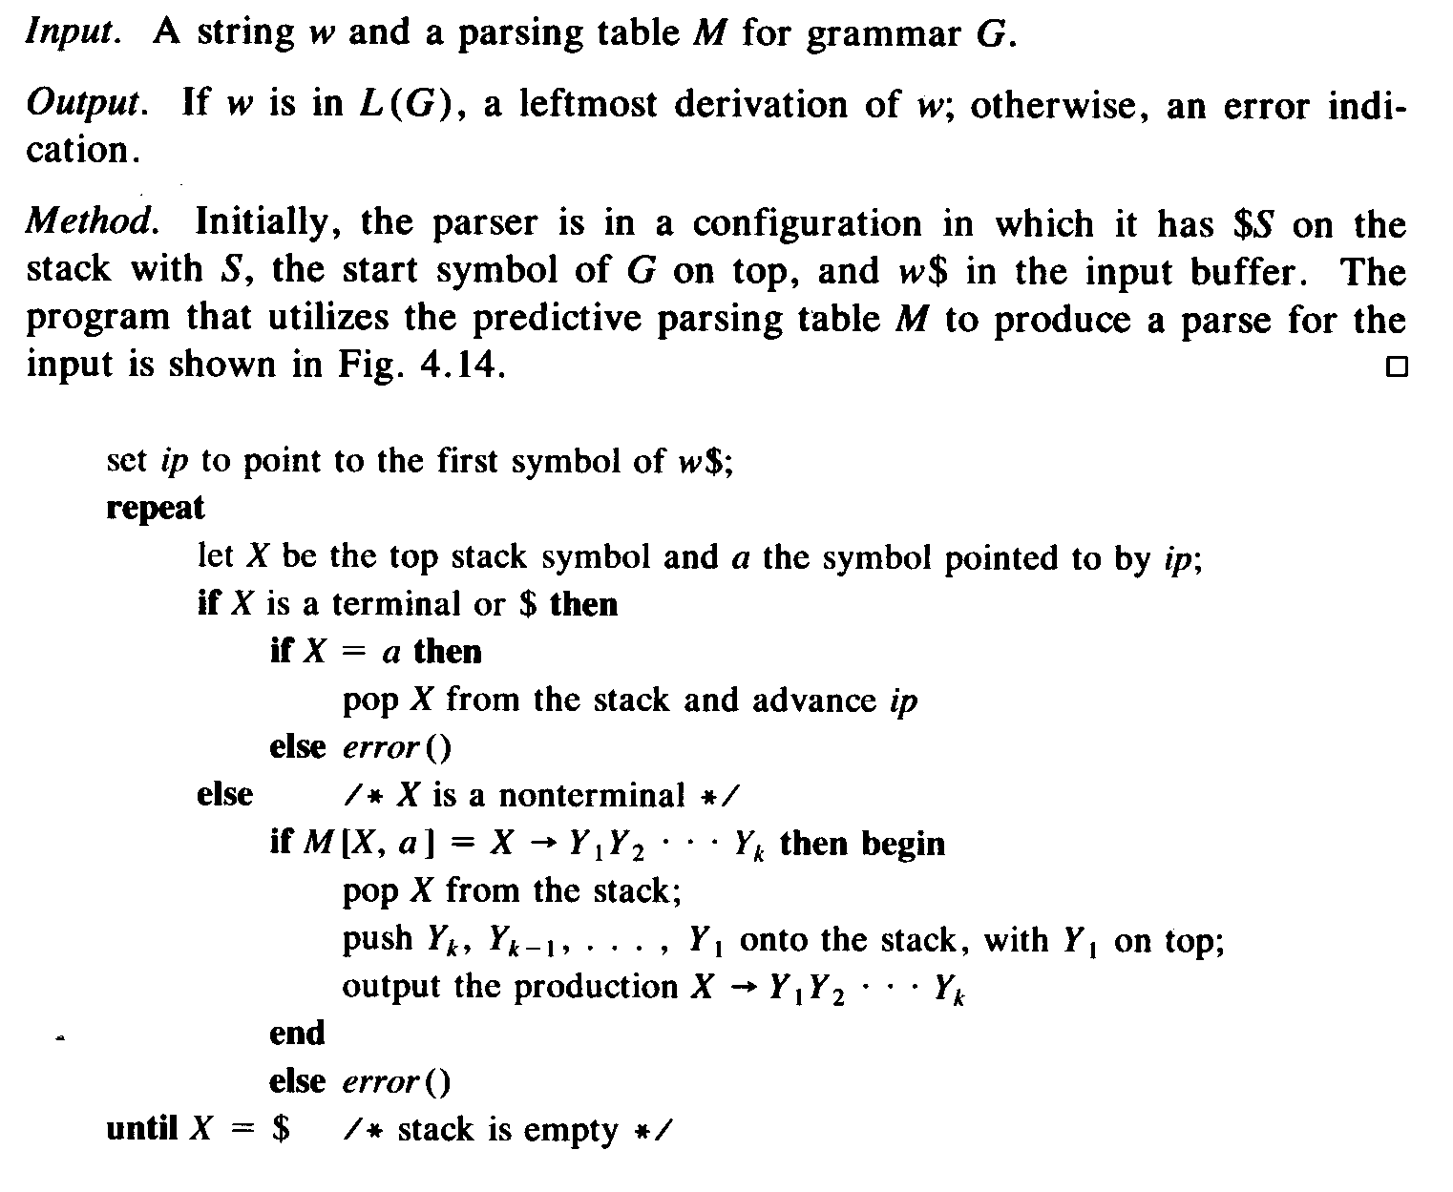
- Appendix F: Construction of a predictive parsing table

