Instructions

The following instructions will solve the problem concerning “nmake failed” obtained when you try to build/launch artifacts in Telelogic Tau 4.2.

- Go to the following location: C:\Program Files\Telelogic\TAU_4.2\bin and create a shortcut in the Desktop of the program ‘VCS.EXE’.

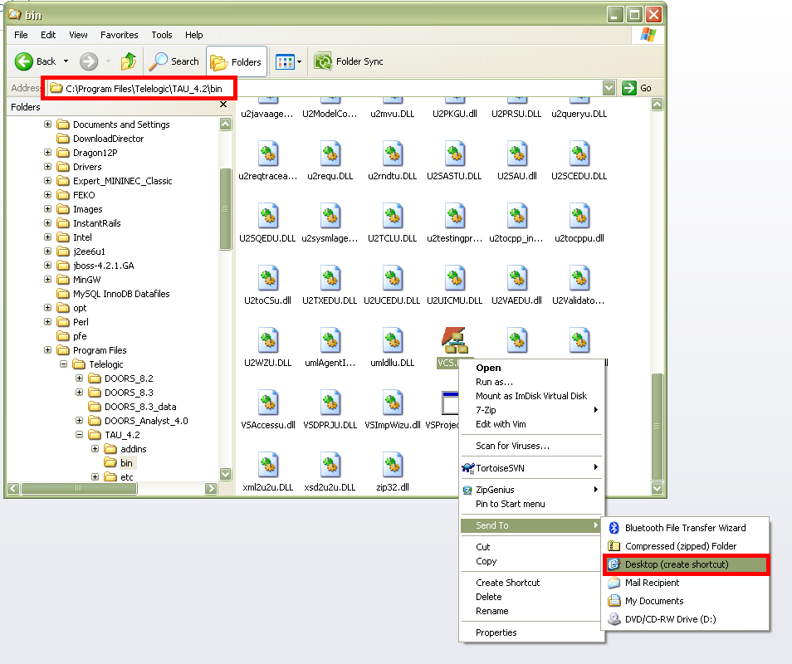

- Right click on the shortcut that has been created in the Desktop and open the properties.
- Copy & Paste the following line (including the quotation marks) in the target field.

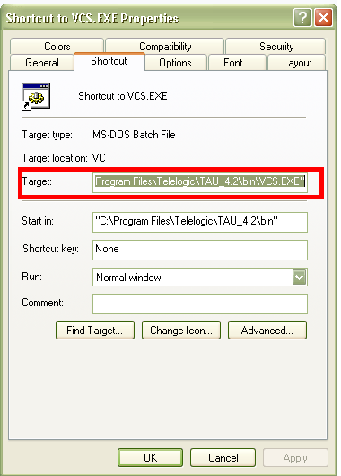
"C:\Program Files\Microsoft Visual Studio 10.0\VC\vcvarsall.bat" && "C:\Program Files\Telelogic\TAU_4.2\bin\VCS.EXE"

Every time you need to use Telelogic Tau double click on the shortcut created.

Telelogic TAU should be opened now together with a batch program needed for the compilation and simulation of artifacts.

