Mid-Term Exam -- SEG 2101 with Solutions
Wednesday, Febr. 28, 2001 (8:30 - 11:30)

No documentation allowed.

Question 1 (25 points)
The specification of the “Daemon Game” in SDL is given in Annex A1 (the version presented in class). For this question, we consider a similar, but different game, called "Daemon with Jackpot Game". This game also involves a daemon that sends Bump messages. Instead of checking whether the number of Bump messages received is even or odd (as in the original "Daemon Game"), the game process of the "Daemon with Jackpot Game" counts the number of Bump messages received since the last Probe message from the user (or since the beginning of the game, if the user has not yet sent any Probe message). When the next Probe message is received, the following decision is made concerning the winning or loosing of the user:
- If the number of Bump messages since the last Probe is equal to the Jackpot Number (JN) then the user wins a jackpot, that is, the user's score is increased by a value equal to JN.
- If the number of Bump messages is smaller, the user looses one point, that is, the score is decreased by one.
- If the number of Bump messages is bigger than JN, then the score of the user remains unchanged.

The value of JN is chosen initially by the user when he/she starts the game. The value of JN must be larger or equal to 5.

Question (a): Explain in a few words:
- Keeping the same structure of processes as in the original Daemon Game shown in Annex A1, how could the value of JN, chosen by the user, be communicated to the game process that implements the game for the particular user ?

Solution: One way would be to add a parameter JN to the Newgame signal and an additional parameter NJ to the parameters of the process Game. When the user wants to start a new game, he/she would provide the value of the JN parameter of the Newgame signal; this signal would be received by the Monitor process which would use the value to initialize the JN parameter of the newly created Game process. Within the Game process, the value of this parameter would be accessible to the Game process behavior.

- What changes should be made to the SDL specification in Annex A1 in order to communicate the value of JN (according to the scheme explained under (1) above) ? -- Explain the list of required changes:

Solution:
- add the parameter to the Newgame signal definition
- add the parameter to the formal parameters of the Game process definition
- define the value of this parameter when the Game process is created

Question (b): Write an SDL specification for the Game process which implements the "Daemon with Jackpot Game" (as explained above). Please write your specification on Annex A2, which includes already some of the items from Annex A1 which could be reused without any change.

The diagram below shows a solution. The declaration of the JN parameter of the Game process is also shown. The variable B counts the number of Bump messages. There was no specified requirement concerning feedback to the user when the Jackpot was won; therefore this is not included in the SDL behavior provided below.
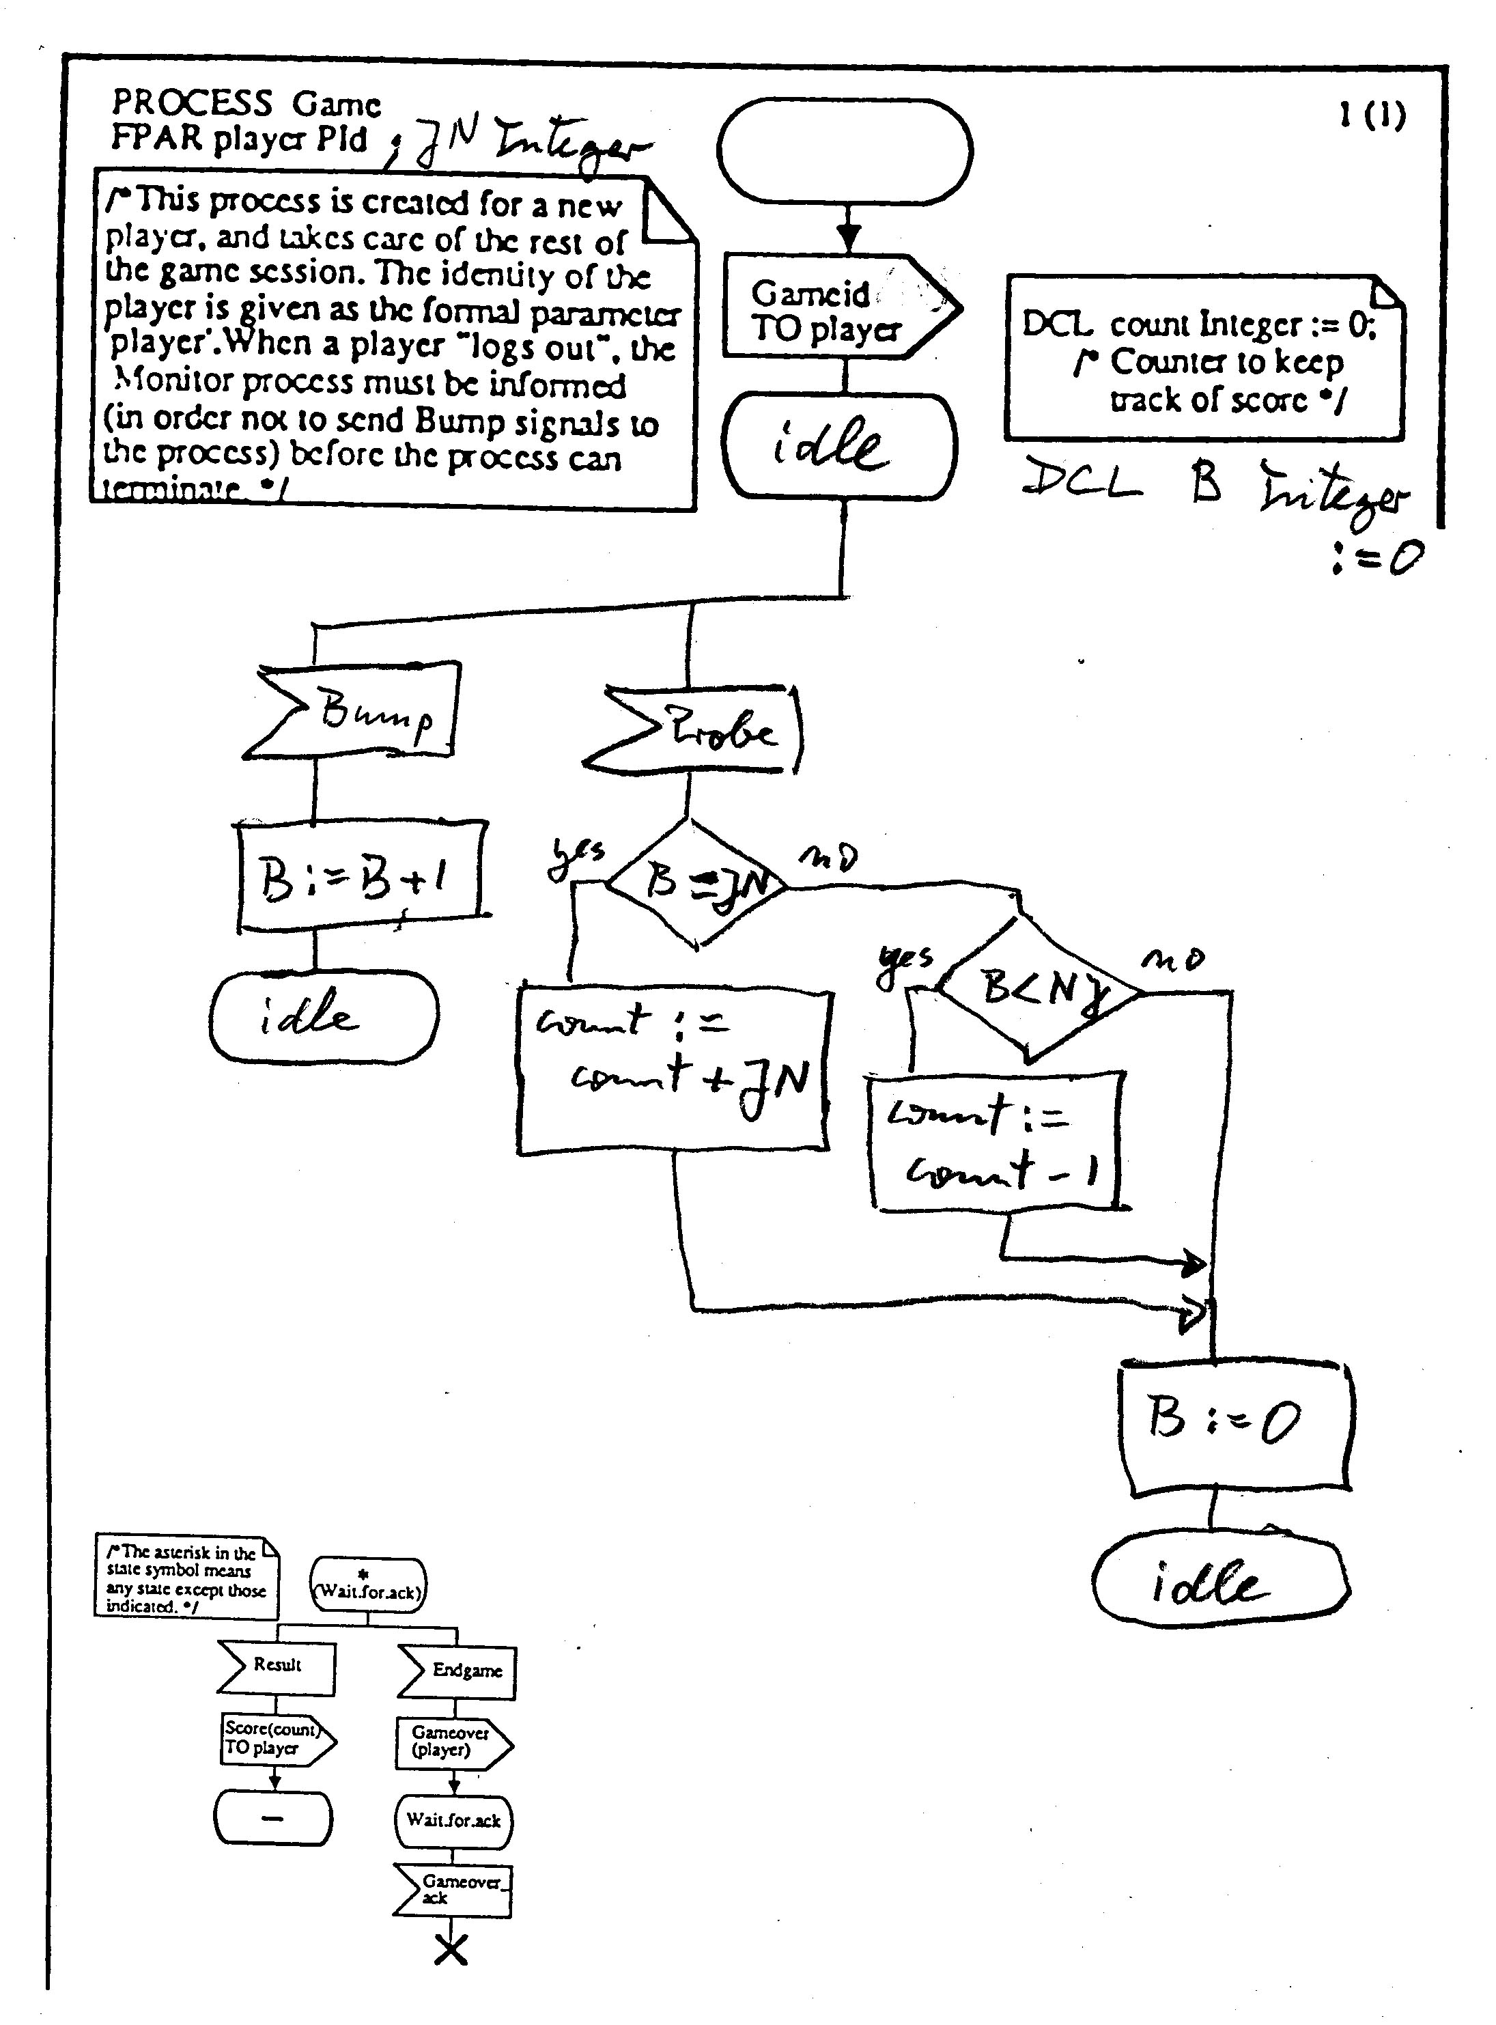

Question (c): Draw a diagram showing a single MSC describing the behavior of the Daemongame SYSTEM (including a game process implementing the "Daemon with Jackpot Game") for the use case where the user wins the jackpot when he/she sends the first Probe message and then terminates the game.

To describe the behavior of the DeamonGame SYSTEM, we should consider this SYSTEM as a black box. Its environment are the user and the Daemon, as indicated in the first page of the Daemon Game SDL specification of Annex A. Below is the MSC for the case that JN is chosen to be 5. Some interactions for asking the score and terminating the game are also included.
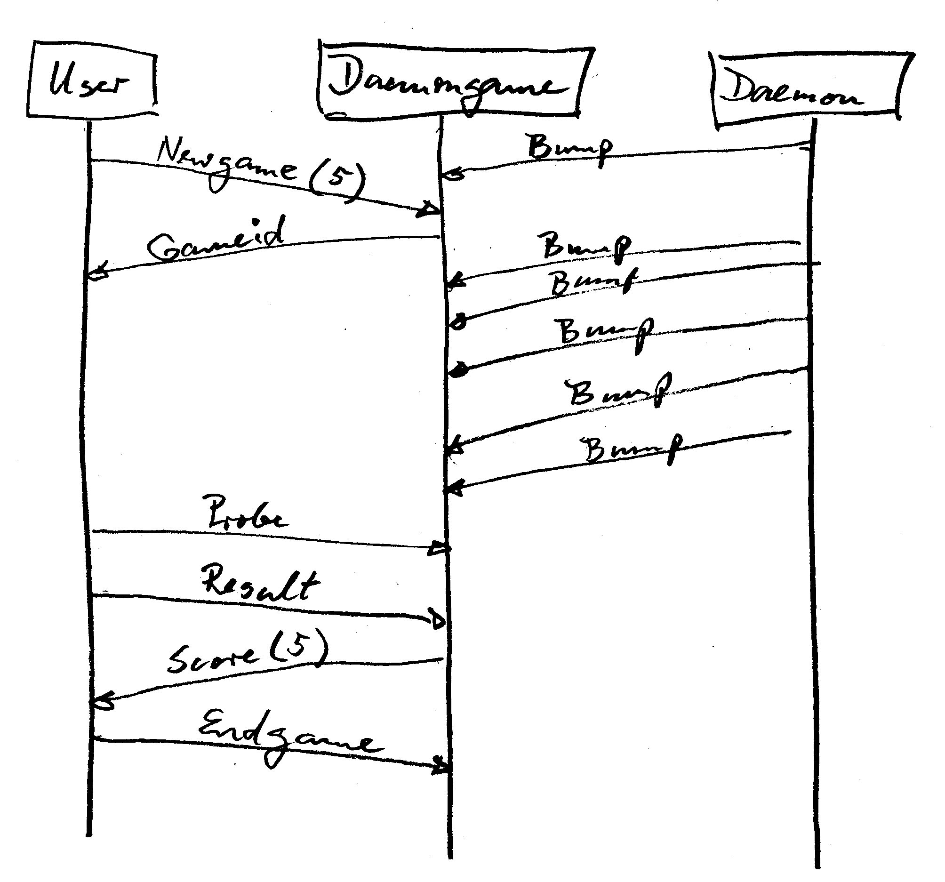

Question 2 (12 points)

We consider the Access Control system as discussed in the book by Braek and Haugen. It includes a PanelControl process which, on the one side, controls the user interface consisting of a card reader, a key pad and a display panel, and on the other side, communicates with the LSControl control units by sending the code of the user and receiving validity control messages from the LSControl. An SDL specification of the behavior of this process is given in Annex B (which is taken from the book, however, there are some minor changes).

Questions (a): According to the SDL behavior defined in Annex B), what are the SDL signals received/sent by the PanelControl process?
(the following list includes those signals which are exchanged in the part of the behavior which is crossed out):
Signals received from the user: Cid, Digit

Signals received from the other parts of the system: OK, ERR, NOK

Signals sent to the user: ERR, OK, NOK, ReleaseCard

Signals sent to the other parts of the system: Code

Questions (b): Draw a diagram showing a single MSC (involving the interactions of the PanelControl process with its environment) which covers all the behavior branches of the SDL specification in Annex B, except those branches that have been crossed out.

The diagram below shows a solution. The user is shown as a single entity. One could also partition the user interface into Display, Panel and CardReader, and show these entities as separate vertical lines.
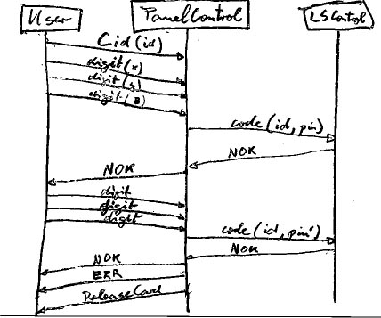

Question 3 (15 points, 3 per sub-question)
We consider the following grammar:
S -- > a a S | a a a S | B
B -- > b | B b

Question 3(a): Explain in a few words what are the sentences generated by this grammar. Answer: The sentences generated by this grammar have the following form: …

A sentence starts with zero, two or more “a”, which are followed by 1 or more “b”. (no sentence contains only one “a”)

Question 3(b): Write down a syntax tree for the sentence " a a a b b b"
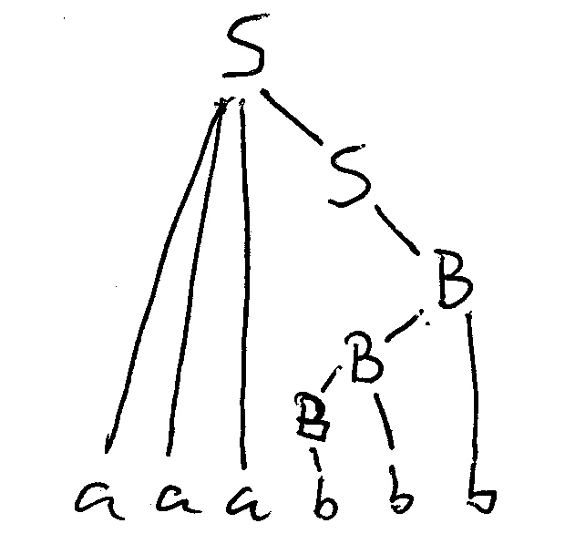
Question 3(c): Is the grammar ambiguous ? - Explain why or why not.

Yes, because there is a sentence that allows for two different syntax trees; for instance the sentence a a a a a b allows the following syntax trees:
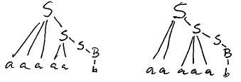

Question 3(d): Is the grammar LL(1) ? - Explain why or why not.

No, because the First of the first two alternative rules for the nonterminal S are not disjoint; First (aaS) = {a} and First (aaaS) = {a}; their intersection is {a}.

Question 3(e): Is the language generated by this grammar regular ? - Explain your answer. If your answer is yes, give a regular expression that describes the same language.

Yes, the language generated is regular; the following regular expression defines the same language: (epsilon + aa) a* b b*.

Note: The above grammar which defines the language is not regular, because it includes production rules that are not of the form Z -> x Y or Z -> Y. The grammar is context-free. However, this context-free grammar happens to define a language which can also be defined by a regular grammar or a regular expression; therefore the language is regular.

Extra Question: What do you think: Is it possible that an ambiguous grammar is LL(1) ?

The answer seems to be NO (however, I have no formal proof). The reasoning is as follows: Syntax trees may be constructed in different orders; we may as well adopt the top-down approach from left to right (as is used in LL(1) analysis). If there are several possible syntax trees (because the grammar is ambiguous) then there must be a point during the tree construction where two different productions could be applied and lead to two complete (different) syntax trees. This, however, is a contradiction to the assumption of LL(1), since in LL(1) analysis, there is at most one way of selecting the next production to be applied to build the next part of the syntax tree.

Question 4 (10 points)

Question (a): Please write down a grammar which generates the language consisting of all sentences of the form a^{n} c^{m} b^{2n} , where n and m are non-zero positive numbers.
Note: the notation " a^{n} " denotes n consecutive"a" characters. Therefore a sentence of this language consists of one of more "a" characters, followed by one of more "c" characters, followed by a certain number of "b" characters, where the number of "b" characters is twice the number of "a" characters.

A possible grammar is the following:
S --> a S b b | a C b b
C --> c C | c

Question (b): What do you think about using the LEX tool to build a lexical analyser that recognizes the sentences of the above language as tokens) ? - Is this feasible ? - Please, discuss in a few words.

Lex is a tool for generating analyzers for regular languages. However, the above language is not regular; there cannot exist any regular grammar that defines this language (or any finite state automaton that accepts exactly this language), because one needs a counter to count the number of “a” at the beginning of a sentence in order to compare this number with the number of “b” at the end of the sentence. A finite state automaton can only count up to a finite number (limited by the number of states of the automaton). Therefore no finite state automaton can count far enough for all possible sentences defined for this language (with arbitrarily large values of “n”).

Therefore we cannot find a regular expression for the language which we could give as input to Lex to generate an analyzer for the language.

However, we may still use Lex by giving it a simplified regular expression of the form (a⁺ c⁺ b⁺) and introduce a C-statement incrementing a counter by two which is executed when an “a” is encountered, and introduce another C-statement decrementing the same counter by one which is executed when a “b” is encountered. Before returning the token, another C-statement should check that the value of the counter is equal to zero (assuming that it was initialized to zero).

Question 5 (6 points)

Please give a regular expression for the language accepted by the following accepting automaton (with initial state 1 and only accepting state 2):
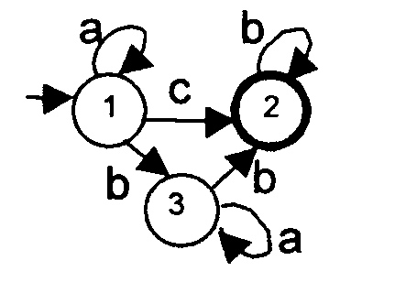
The corresponding regular expression is: a* ( c + b a* b ) b*

Question 6 (6 points)

Draw a state transition diagram representing an automaton that accepts exactly the language defined by the following regular expression: a b* c (a + b)*
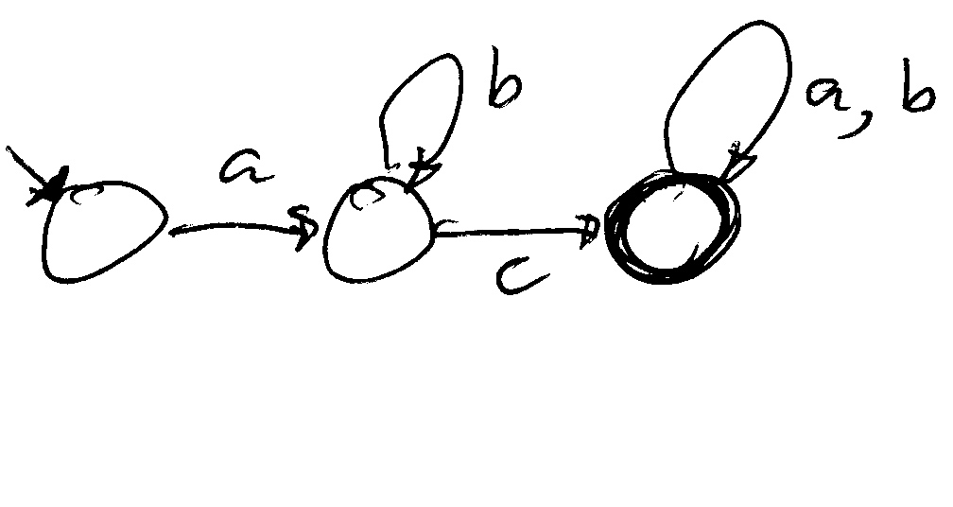
Question 7 (6 points)

In class, we discussed the following grammar:
E --> V | C | SE | E + SE | E – SE (Note : the V | C | should not be there)
SE --> V | C | ( E )
V --> a | b
C --> 0 | 1 | 2
where E represents an expression involving only the operators + and -, and SE represents a simple expression which is a variable (V), a constant (C) or an expression in parenthesis.

Please extend the above grammar in such a way that the generated language includes expressions in which array elements may occur as variables, using the notation "arrayVariable [ index ] ". For instance, the following expression should be valid: " 2 + a [ b + 1] ".
Please write here the changed and new production rules:
Additional rule: SE --> V [ E ]
Or you could also propose the following additional rule: V --> V [ E ] . This latter rule allows multi-dimensional arrays like in Java, e.g. a [2] [3]

Question 8 (20 points)

We consider the following grammar (which, I think, corresponds to the Java syntax for assignment and IF statements):
B --> { SL }
SL --> empty | S ; SL
S --> V = E | if ( E ) B EP
EP --> empty | else B
Where B is the root symbol and stands for "bracket", SL stands for "statement list", S stands for "statement" which may be an assignment statement (using the nonterminals V ("variable") and E ("expression") or an IF-statement. EP stands for "else part". The terminals are {, }, (, ), ; , =, if, and else, as well as ID (the identifiers for variables) and INT (the integer constants).

Question (a) : Show that this grammar is LL(1).

Step 1 : Calculate the First sets
First(S) = {ID, if}
First(else B) = {else}

Step 2: Calculate the Follow sets
Follow(EP) = Follow (S)
Follow(S) = {;}
Follow(SL) = { “}” }
Note: the occurrence of SL at the end of the second rule for SL (second line of grammar) does not contribute any new value to Follow(SL)

Step 3: Check the LL(1) conditions for the grammar
First line of grammar: nothing to verify
Second line of grammar: verify that First(S;SL) is disjoint from Follow(SL). This is true since First(S;SL) = First(S) = {ID, if} while Follow(SL) = { “}” }
Third line of grammar: verify that the First of the two alternatives are disjoint, that is, First(V = E) is disjoint from First(if ( E ) B EP), which is evident since we obtain {ID} and {if}, respectively
Forth line of grammar: verify that First(else B) is disjoint from Follow(EP). This is true; we have {else} is disjoint from {;}

Question (b): We now consider the creation of a compiler that does the syntactic analysis of the above grammar. The recursive descent approach is to be used. We assume that it has been decided to define the following recursive analysis procedures for this language:
  - B (corresponding to the nonterminals B and SL)
  - S (corresponding to the nonterminals S and EP)
  - E (corresponding to the nonterminal E)

It is your task to write the body of the procedure B.

We assume that the syntactic procedures of the compiler use an object lex which offers a method nextT() which reads the next lexical token and an attribute t which always contains the last token read. We assume that at the entrance to a syntactic procedure the first token (by which the sequence generated by the nonterminal starts) is already read. We also assume that the following constants have been declared; they represent the tokens corresponding to the terminals of the language: ID, INT, BRACEOPEN, BRACECLOSE, IF, ELSE, SEMIC, etc.

There are several kinds of procedures one could write. The following solution defines a procedure called B which includes the analysis of the syntax rules for B and for SL. It assumes that procedures analyzing the syntax rules for the nonterminal S already exist. This procedure needs a loop which is executed as many times as the second alternative of the syntax rule of SL is encountered. (Note: the latter syntax rule is recursive, this recursion can be translated into a loop, because this is simple right recursion). Another solution would be to write two procedures, one procedure, called S, analyzing the single syntax rule for S, which calls another procedure, called SL, which analyzes the syntax rules for SL (and calls itself recursively, since the second syntax rule for SL is recursive).

Here is the solution with a single procedure B:
public void B() {
if (lex.t == BRACEOPEN) {
lex.nextT();
while (lex.t != BRACECLOSE) {
S();
if (lex.t ==SEMIC) {lex.nextT();}
else {error();}
}
lex.nextT();
}

Note that we assume that the next token is already read when we enter the procedure, and when we return we have to ensure that the next token (which should belong to the Follow of B) is already read. The same applies to the way the procedure S() is written.

