COURSE: SEG2101 | PROF: Jiying Zhao
Software Construction | DATE: April 28, 2006
SEMESTER: WINTER 2006 | TIME: 09:30 – 12:30

Solutions prepared by Robin Tropper, April 2008

FINAL

EXAMINATION

Name
Student Number

Final Exam

- There are three (3) types of questions in this examination.
Part 1 | Multiple choice | 16 marks
Part 2 | Short answer | 52 marks
Part 3 | Problem solving | 18 marks
Total |  | 86 marks
- The space allocated for each question is limited. In case of necessity you may use the other side of the pages to continue.
- Initial all the pages.
- Submit back all the pages.

- Multiple choice questions [2 marks each, please circle the best answer]:
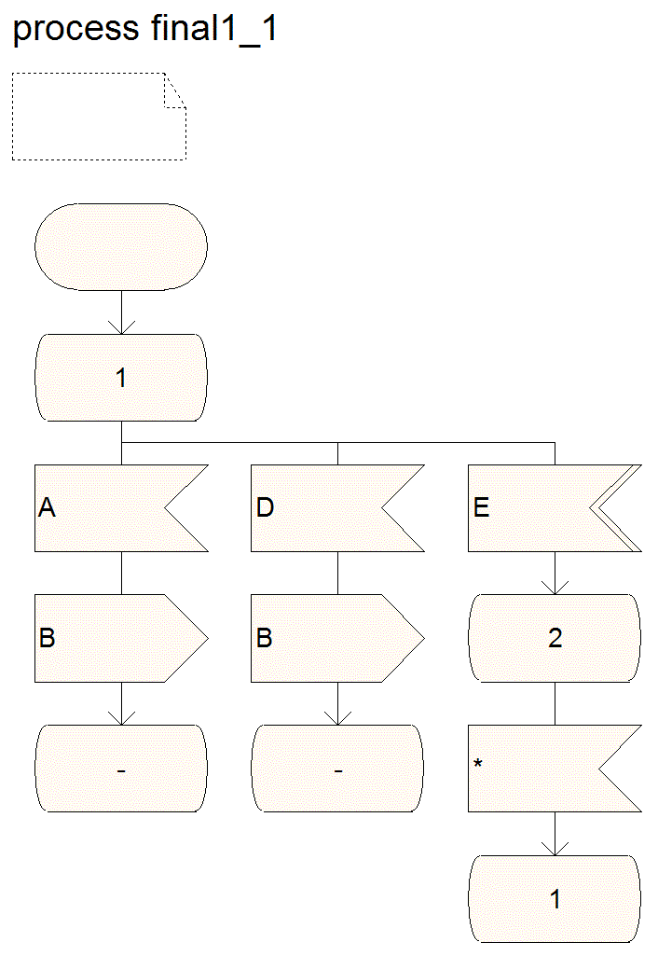 | 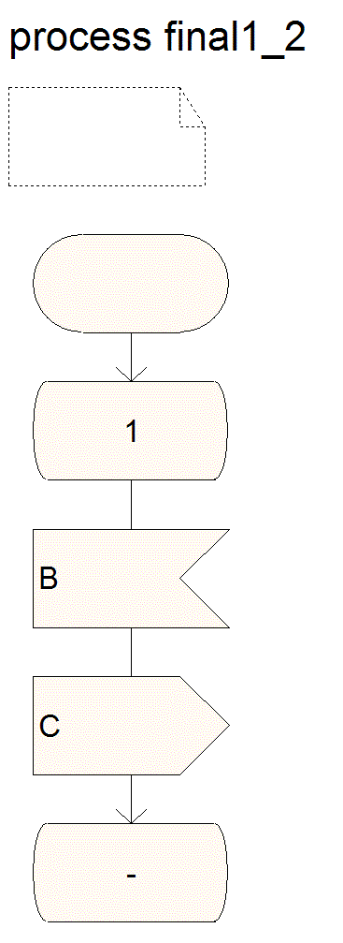 | 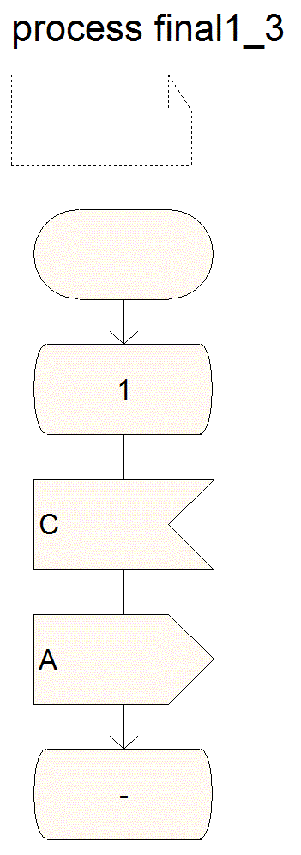

- Refer to the diagram above. Signal D and E are from the environment. Which of the following is not correct?
- Suppose final1_1, final1_2, and final1_3 have been just initialized. When there is no signal sent from the environment, final1_1, final1_2, and final1_3 will not be able to output any signals. | - Suppose final1_1, final1_2, and final1_3 stay at state 1 and are not generating any signal. When signal D is sent from the environment, final1_1, final1_2, and final1_3 will start to output signals.
- When final1_1, final1_2, and final1_3 start generating signals and there is no further signal sent from the environment, the three processes will not stop and will generate signals endlessly. | - Whenever signal E is sent from the environment, the three processes will always stop generating signals.  - At least one of the above (a,b,c,d) is wrong.

- Refer to process final 2. In 100 time unites, how many T2 signal(s) will be generated?
ASSUMPTION : after
initialization and after E
is sent, no other signal
is sent from environment
=> state 2 is waiting for
any signal, but none arrive.
All processes shown will halt.
- 0 | - 1
- 2 | - 3

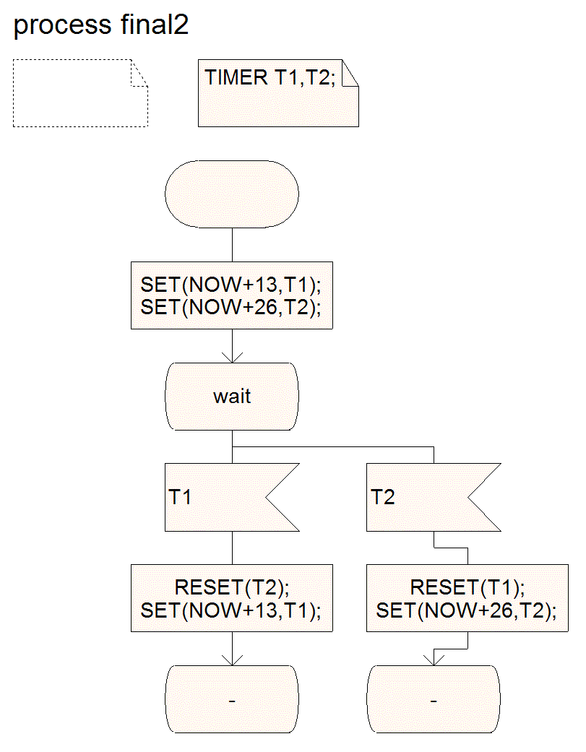
T2 will be reset (becoming inactive) when T1 expires the first time.
- Refer to the diagram below (final3_1 and P2). Signals A and B are from the environment. Sinal C is to the environment. Long time after inputting signal A, the user inputs signal B. What value will be returned by the signal C (the integer value carried by C)?
- 0 | - 1
- 2

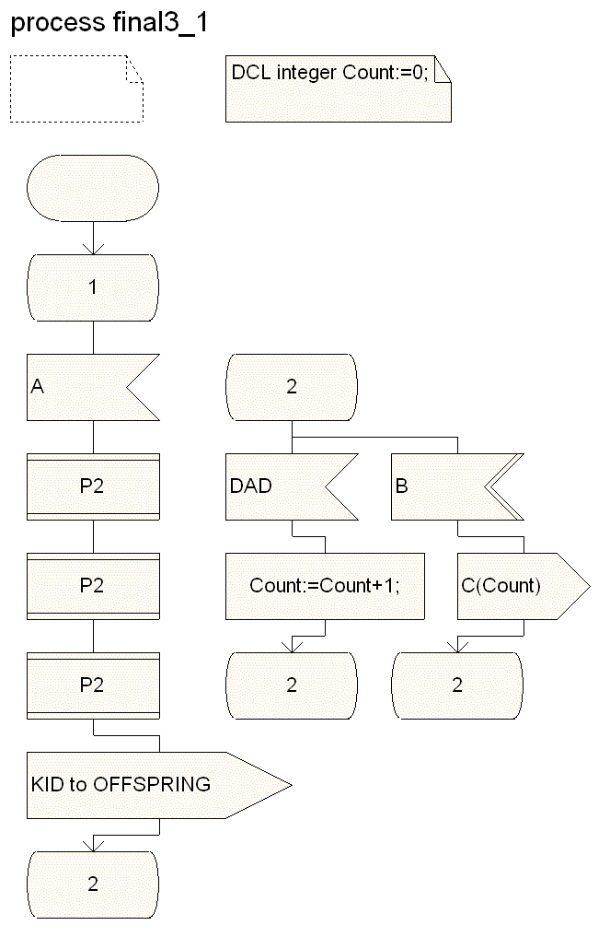 | 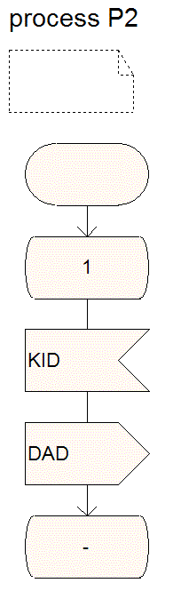  The message KID is sent to the last offspring (the last process instance created at this point by the process final2_1. The process has created 3 instances at this point, only the last one will receive this signal. Therefore only this last one will return a DAD message and the counter will be incremented only once

- Refer to the grammar below.

S --> NP VP
NP --> N
NP --> Det N
Det --> the
N --> man
N --> dog
N --> cat
VP --> V NP
V --> bites
V --> catches

The grammar belongs to which of the following?
- Regular grammar | - Context-free grammar
- Context sensitive grammar | - Unrestricted grammar

- Consider the following grammar rules:
S → 0 A 0 S | 1 0
A → 1 | 0 S 0 A
Which of the following strings is not a member of this language?
- 001001010 | - 10
- 01010 | - 0010110 --- 0010 requires 0 after

- Which of the following is not described by the regular definition below?
D → [1234567890]
N → D+ ( . D+ )? (E( +|- )? D+ )?
- 1.894 | - .894E-4
- 1.894E+4 | - 1.894E4

- Which of the following cannot be recognized by the following NFA?

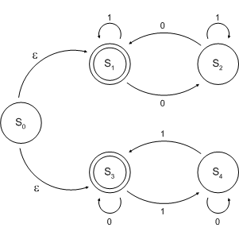

- An empty string | - 00001111
- 10101010 | - 01010111

- Let ={a,b}, which of the following is not correct? (where r, s and t are regular expressions)
- Regular expression (a|b)(a|b) denotes {aa,ab,ba,bb}. | - r**=r*
- r|(s|t)=(r|s)|t | - (a|b)* is not equal to (a|b)**

- Short-answer questions
- [8 marks] A SDL block named COUNTER consists of one process COUNTP. There is one input signal (PULSE) to the process, and one output signal (OVERFLOW) from the process. Whenever an input signal PULSE is received, the process COUNTP will add 1 to its variable $c$. The initial value for the variable $c$ is 0. The counting range is from 0 to 99. That is, the value of $c$ goes from 0 to 1 to 2, …, to 99, when it reaches 100 it resets to 0, then the counter will continue to count from 0 to 99 repeatedly. Whenever the value of $c$ is reset from 100 to 0, an output signal OVERFLOW will be generated.

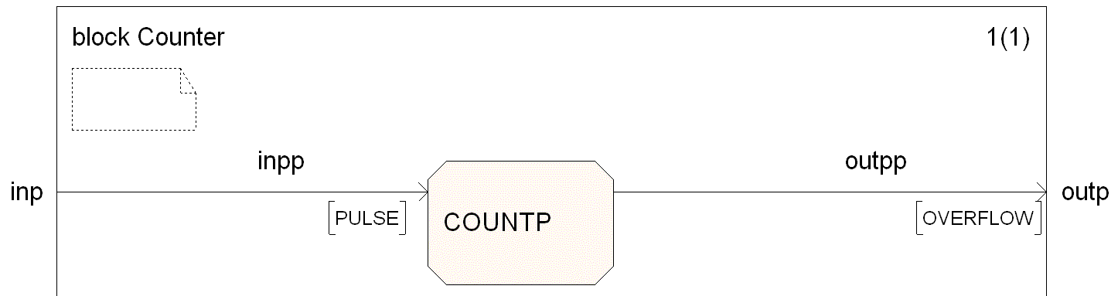
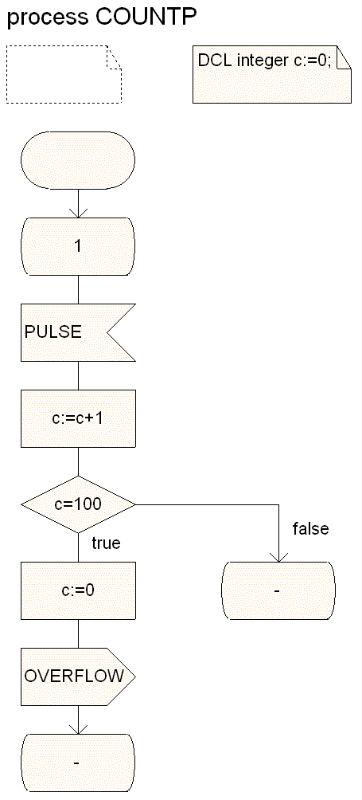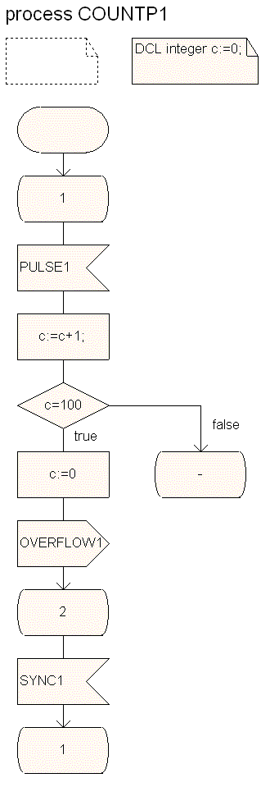

Now you are asked to implement a block similar to COUNTER. That is, you should design a new block, called B-COUNTER, slightly more complex than block COUNTER. The B-COUNTER block should contain four processes (instead of a single one). Three of the four processes (namely, COUNTP1, COUNTP2, and COUNTP3) are the same as process COUNTP except for the names of the input and output signals (see COUNTP1). That is, each of these three processes counts input signals (namely, PULSE1, PULSE2, and PULSE3 are respectively the inputs for COUNTP1, COUNTP2, and COUNTP3) and generate an output signal (namely, OVERFLOW1, OVERFLOW2, and OVERFLOW3 are respectively the output signals from COUNTP1, COUNTP2, and COUNTP3) when the counter reaches 100. COUNTP1, COUNTP2, and COUNTP3 wait for a signal SYNC1, SYNC2, and SYNC3, respectively, from the fourth process before going back to state 1. The fourth process (namely, BARRIER) takes OVERFLOW1, OVERFLOW2, and OVERFLOW3 as inputs, and sends an OVERFLOW signal to the environment when the three OVERFLOW1, OVERFLOW2, and OVERFLOW3 signals have been received. BARRIER sends a SYNC1, SYNC2, or SYNC3 signal to COUNTP1, COUNTP2, or COUNTP3 when it receives an OVERFLOW1, OVERFLOW2, or OVERFLOW3, respectively. After sending out OVERFLOW, the process BARRIER goes back to the previous state to get ready for the next iteration.

- Draw the SDL structure diagram of the B-COUNTER block. Draw all processes, channels, signal routes, signals, adding labels, as appropriate.
- Draw the SDL behavior diagram for the process BARRIER in the BLOCK B-COUNTER. Draw all states, inputs, and outputs, adding labels, as appropriate.
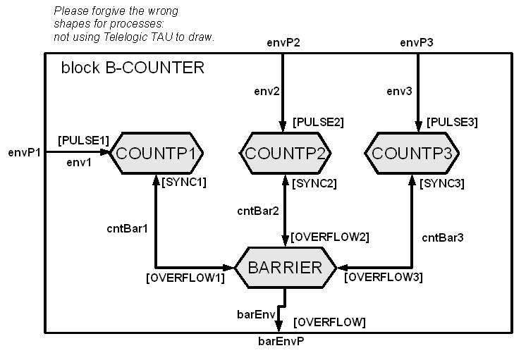

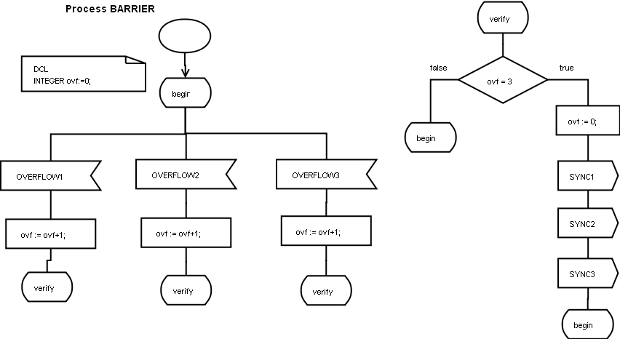

- [4 marks] Refer to the following figure.
  - Draw the Transition Chart (TC) for process P1.
  - Draw a global reachability graph showing at least five (5) global states starting from the global state 2
  - 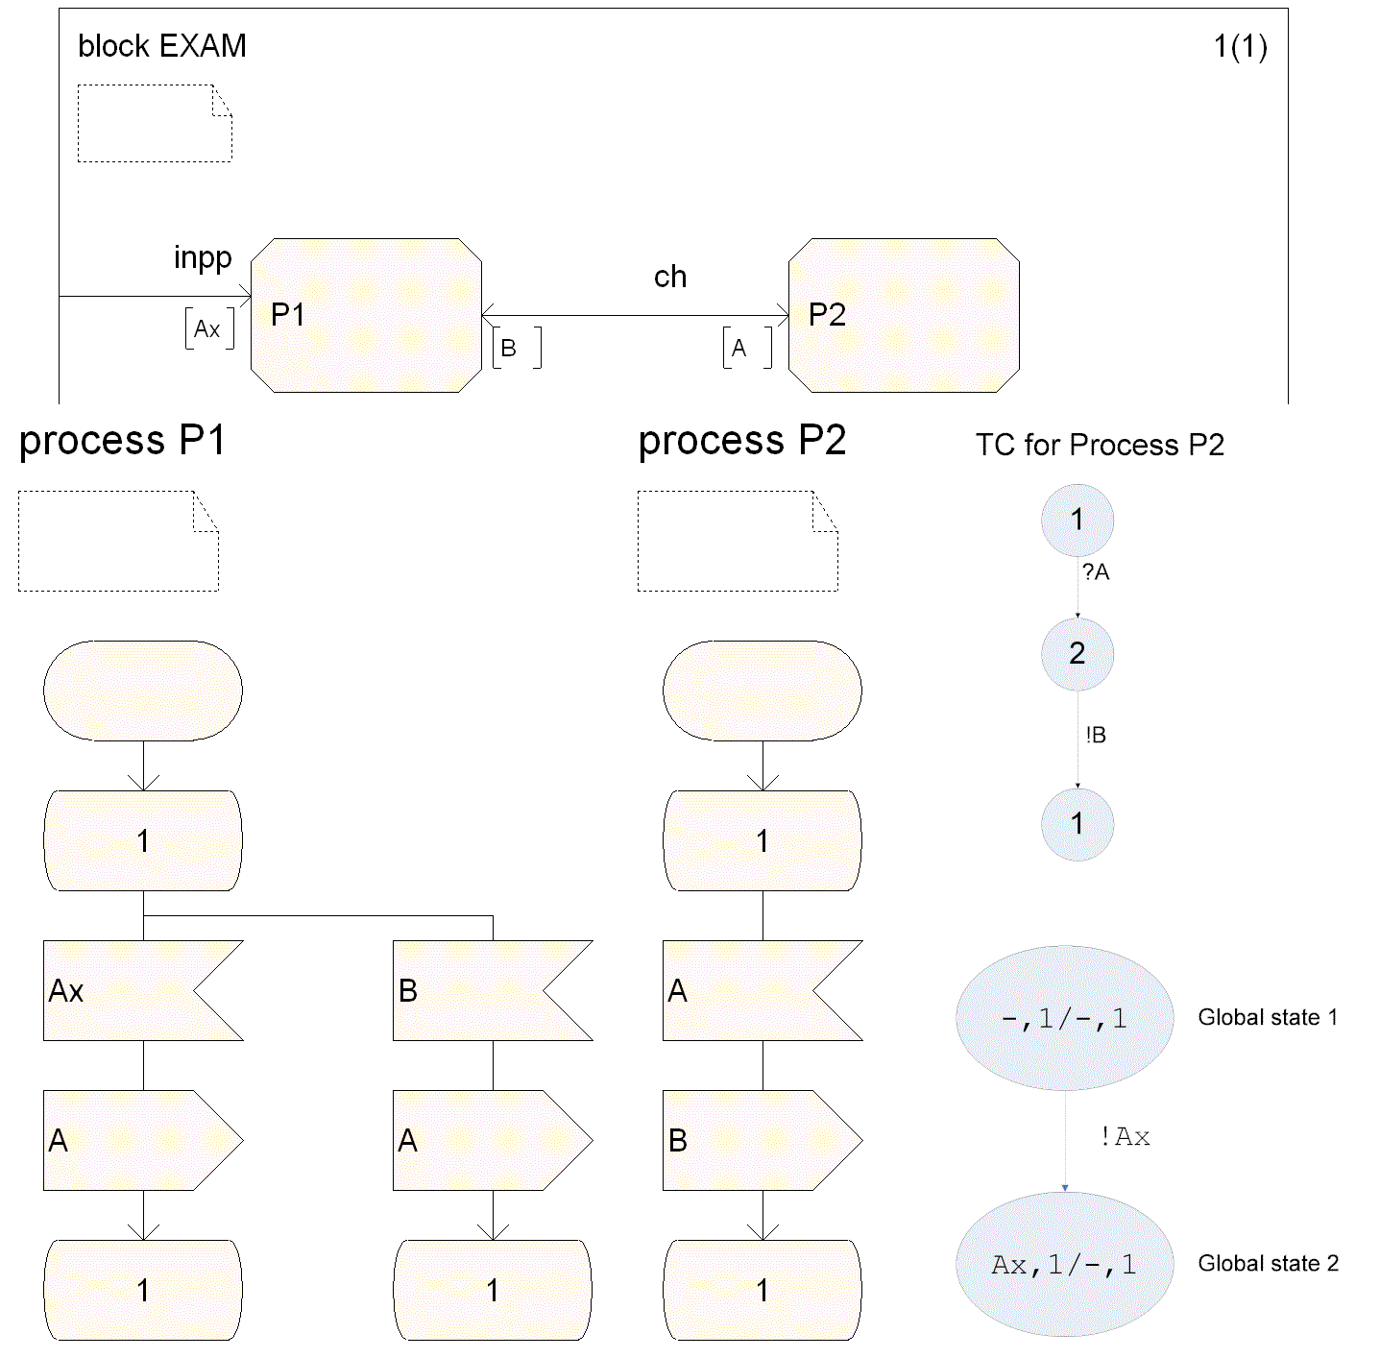

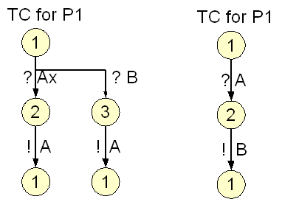

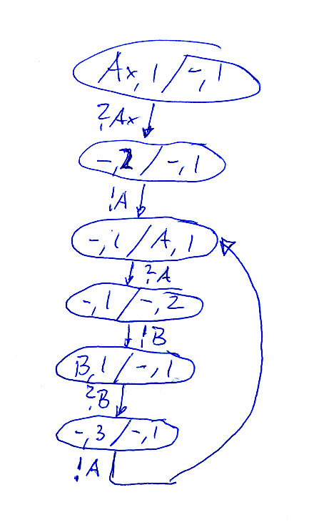

- [4 marks] Write the corresponding regular expression for the following finite state machine.

[1* ( 0 1* 0 )* 1*] | [0* ( 1 0* 1 )* 0*]

- [6 marks] Closely follow Algorithm 3.2 (attached as Appendix A) to convert the following NFA into a DFA by showing the intermediate steps.
Non-deterministic:
State 2 has 2 'b'
transitions.
For verification later -
this machine realises the
regular expression:
a b? (ba)*
Start with e-closures from beginning:
A = { 1, 3 }

From there, e-closure on any state arrived at with an 'a'
Note, the other way
with {x,y,z} in the resulting
nodes is the exact same
thing, just a different notation.
B = { 2, 4 } - stop

From A, e-closure on any state arrived at with a 'b'
C = {} : not used

From B, e-closure on any state arrived at with an 'a'
D = {} : not used

From B, e-closure on any state arrived with a 'b'
E = { 3, 4 } - stop
 | Transitions
States | 'a' | 'b'
A | B
B | - | E
E | B | A
----------- all states visited : finish-up -------------

From E, e-closure on any state arrived at with 'a'

F = { 4 } - stop & redundant : use B

From E, e-closure on any state arrived at wit a 'b'
G = { 3 } - redundant : use A

Final result:

Verification :
a b? (ba)*
yes, realized.
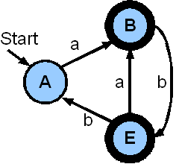

- [4 marks] The following grammar has left recursion (refer to Appendix B for possible methods). Find an equivalent grammar (that generates the same language) without left recursion.
<expression> → <expression> + <factor>
<expression> → <expression> - <factor>
<expression> → <factor>

<expression> → <factor> <Exp'>
<Exp'> → + <factor> <Exp'> | ℇ
<Exp'> → - <factor> <Exp'> | ℇ

- [4 marks] Consider the following grammar (0 and 1 are terminals). Left-factor the grammar.

<expr> → <term> ADD <expr> | <term> SUB <expr> | <term>
<term> → <factor> MUL <term> | <factor> DIV < term > | <factor> | NUM

Note: ADD, SUB, MUL, DIV, and NUM are terminals.

<expr> → <term> ( a | b | ε )
a → ADD <expr>
b → SUB <expr>
<term> → <factor> MUL <term> | <factor> DIV < term > | <factor> | NUM

NOTE : cannot factor more directly, BUT:

<term> → c | d
c → <factor> ( e|f )
e → MUL <term>
f → DIV < term >
d → NUM

- [4 marks] Show that the following grammar is ambiguous.

S → A | S + A | S + + A
A → a | ε

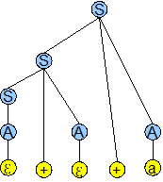
“++a” is given by :

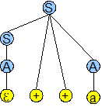

or by :
- [10 marks] Refer to Appendices C, D and F. Given the following grammar:

S → id = c ;
S → if (c) {LS} E
LS → S LS
LS → ε
E → else {LS}
E → ε

- Compute the sets FIRST and FOLLOW for all the non-terminals in the above grammar.
- Build a parsing table for the grammar.
- Is the grammar LL(1)? – Explain.

Important note:
The following solution is wrong – please ignore it.
Gregor v. Bochmann, April 15, 2009

RECALL : productions are of the form
X → aSb where a and b can be strings of characters
Therefore, there are 4 terminals :
- “id = c ;”
- “if (c) {”
- “else {”
- “}”

First( S ) = { “id = c ;”, “if (c) {” }
First( LS ) = First( S ) = { “id = c ;”, “if (c) {“ }
First( E ) = { “else {”, ε }

//add 'before root' production to satisfy follow rules :
PRE → S$

Follow( S ) = First( LS ) //because S on right side is only followed by non-terminal LS
= { $, “id = c ;”, “if (c) {” }
Follow( LS ) = {“}”} //straight-forward
Follow( E ) = Follow( S ) //because E on right is only followed by void
= { $, “id = c ;”, “if (c) {” }

Refer to T.A.'s notes for “plain-language” explanation.
Another walk-through example can be found at:
www.jambe.co.nz/UN/FirstAndFollowSets.html

b)
 | “id = c ;” | “if (c) {” | “else {” | “}”
S | S → id = c ; | S → if (c) {LS} E
LS |  |  | E → else {LS}
E |  |  |  | S → if (c) {LS} E

c)
Yes, the two conditions for LL(1) are satisfied (please check course notes).

- [8 marks] Refer to Appendix E. The table below is the parsing table for the following LL(1) grammar:

S→(L) | a
L→SL’
L’→,SL’ | ε

 | ( | a | ) | , | $
S | S→(L) | S→a
L | L→SL’ | L→SL’
L’ |  |  | L’→ε | L’→,SL’

Seek the moves made by a nonrecursive predictive parser on the input ”(a,(a,a))”, by filling the following table.
Stack | Input | Output
S$ | (a,(a,a))$ | S → (L)
(L)$ | (a,(a,a))$
L)$ | a,(a,a))$ | L → SL’
SL')$ | a,(a,a))$
SL')$ | a,(a,a))$ | S → a
aL')$ | a,(a,a))$
L')$ | ,(a,a))$ | L' → ,SL'
,SL')$ | ,(a,a))$
SL')$ | (a,a))$ | S → (L)
(L)L')$ | (a,a))$
L)L')$ | a,a))$ | L → SL'
SL')L')$ | a,a))$ | S → a
aL')L')$ | a,a))$
L')L')$ | ,a))$ | L' → ,SL'
,SL')L')$ | ,a))$
SL')L')$ | a))$ | S → a
aL')L')$ | a))$
L')L')$ | ))$ | L → ε
ε)L')$ | ))$
)L')$ | ))$
L')$ | )$ | L → ε
ε)$ | )$
)$ | )$
$ | $ | ACCEPT!

For an explanation, please refer to the link:

http://web.cs.wpi.edu/~kal/PLT/PLTex4.4.html

Note that they “flip” the characters in the Stack column in order to eliminate from the right. Here, I am eliminating terminals from the left, so no need to flip.
- Problem Solving
- [10 marks] Define a Java class representing a monitor that controls the access to a resource for reader and writer processes. We consider the following problem: A resource is used by two different kinds of processes. The Reader processes access the resource without changing its content. The Writer processes access the resource and update the content of the resource. In order to provide a consistent view of the resource to the Readers, no Writer should access the resource while some reader uses the resource. It is also required that at most one Writer process has access to the resource at any given time.

It is assumed that the Readers and Writers use a monitor Database to synchronize their access to the resource. The monitor offers the following methods: startRead(), endRead(), startWrite(), endWrite(); they are used as follows: Before accessing the resource, a Reader will call startRead(), then it will access the resource and then call the method endRead(). Similarly, a Writer will first call startWrite(), then it will update the resource and then call the method endWrite().

The following is the incomplete program. Your task is to complete method startRead() and startWrite(). Please give Writers priority over Readers. That is, if a writer is waiting no new reader may enter the resource (even if other readers are currently using the resource).

public class Database
{
private void readerCount;
//missing : ensure no writer is waiting
private volatile int writerCount;

private boolean dbReading;
private boolean dbWriting;

public Database()
{
readerCount = 0;
writerCount=0;
dbReading = false;
dbWriting = false;
}

public synchronized void startRead()
{
while( dbWriting || dbReading ){ // ERROR: the text “|| dbReading” should be deleted.
wait();
}
//notify does not mean no writer is waiting
// => ensure no writer is in queue:
while( writerCount > 0 ){
wait();
}
//at this point, readerCount should necessarily be == 0
++readerCount;
dbReading = true;
}

public synchronized int endRead()
{
--readerCount;
if (readerCount == 0){
dbReading = false;
}
notifyAll();
System.out.println("Reader Count = " + readerCount);
return readerCount;
}

public synchronized void startWrite()
{
++writerCount; //>0 => writers in queue :no reading permitted

//if ressource is used by ANYONE, wait
while( dbWriting || dbReading ){
wait();
}

dbWriting = true;

//the notify all in end Write might have set dBWriting to false
//either way, set it to true to prevent other
//readers/writers to access the resource
}

public synchronized void endWrite()
{
dbWriting = false;
--writerCount;
notifyAll();
}

}
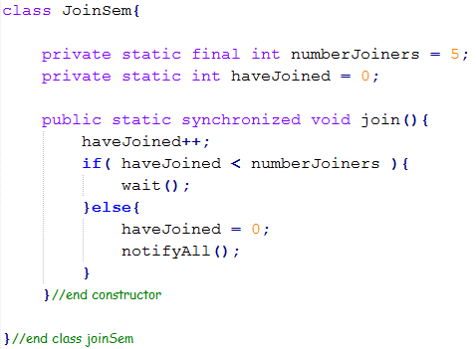
- [8 marks] The following is a multithreading program. In order to provide fairness to all the five threads, you are asked to modify the run method of the classes PrintChar and PrintNum so that any of the 5 threads must stop before the for loop and cannot proceed until all other threads reach this point. This can be implemented in a way similar to a semaphore or a monitor. Please write the class that provides the needed method(s) and make the necessary modification to the following program.
join

public class TestRunnable
{
public static void main(String[] args)
{
Thread printA = new Thread(new PrintChar('a',100));
Thread printB = new Thread(new PrintChar('b',100));
Thread printC = new Thread(new PrintChar('c',100));
Thread print100_1 = new Thread(new PrintNum(100));
Thread print100_2 = new Thread(new PrintNum(100));
Many solutions possible.

Proposed : a semaphore-like
class that notifies all 5 only
when all 5 have requested to 'join'.

Here, the 'protected ressource'
(by definition of semaphore)
is simply the ability to continue.
print100_1.start();
print100_2.start();
printA.start();
printB.start();
printC.start();
}
}

class PrintChar implements Runnable
{
private char charToPrint;
private int times;

public PrintChar(char c, int t)
{
charToPrint = c;
times = t;
}

public void run()
{
JoinSem.join();
for (int i=1; i < times; i++)
System.out.print(charToPrint);
}
}

class PrintNum implements Runnable
{
private int lastNum;

public PrintNum(int n)
{
lastNum = n;
}

public void run()
{
JoinSem.join();
for (int i=1; i <= lastNum; i++)
System.out.print(" " + i);
}
}

- Appendix A: Algorithm 3.2
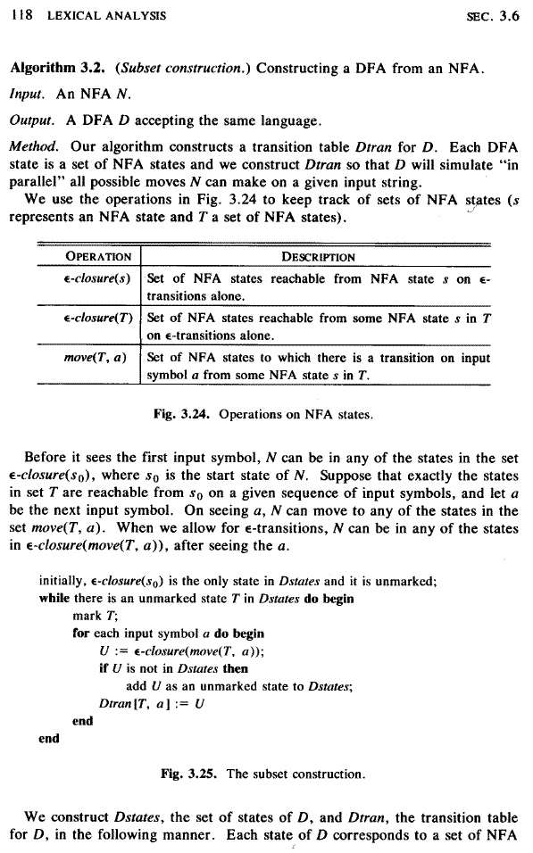
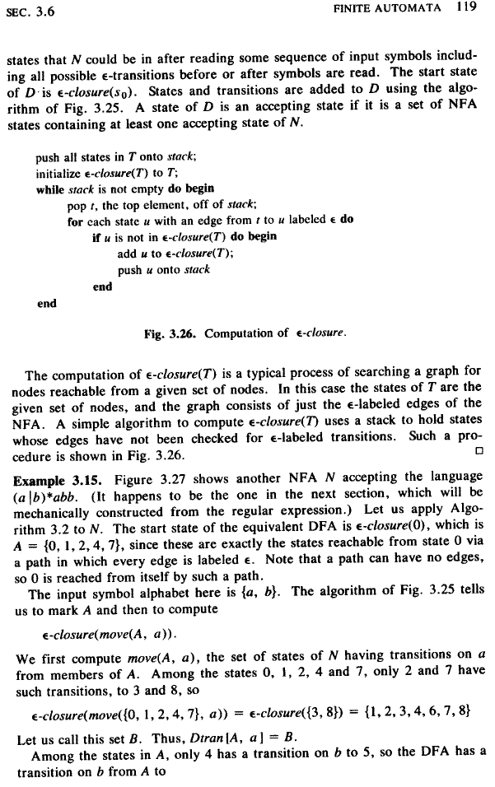
- Appendix B: Elimination of left recursion
can be replaced by
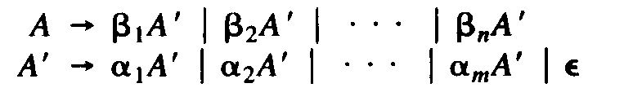

- Appendix C: Computation of FIRST
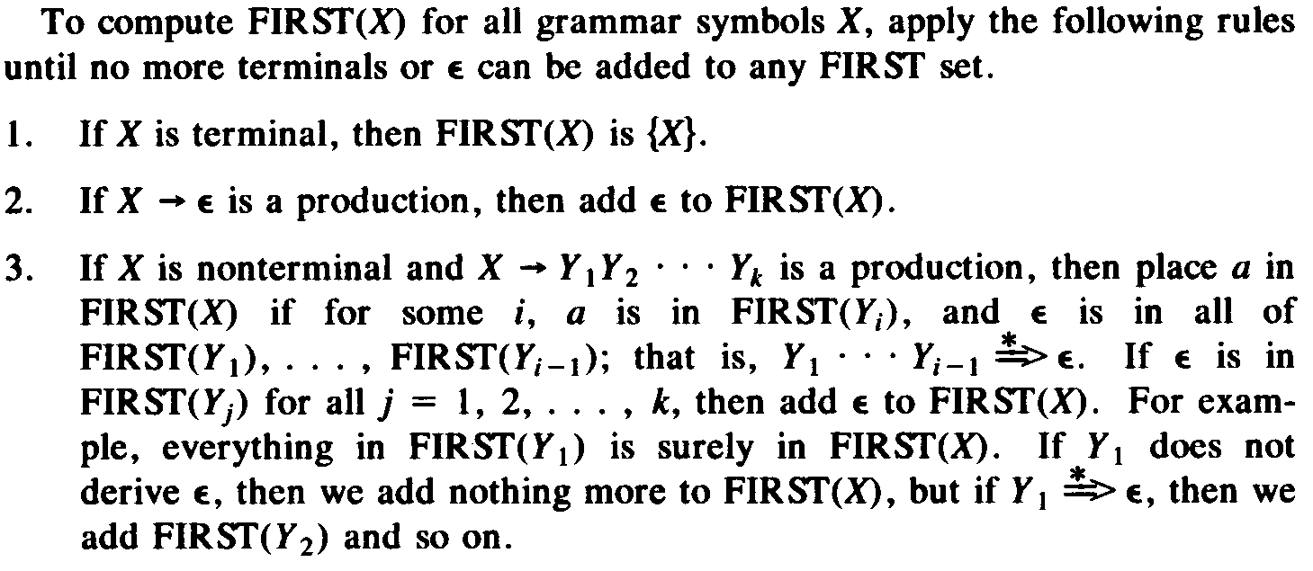

- Appendix D: Computation of FOLLOW
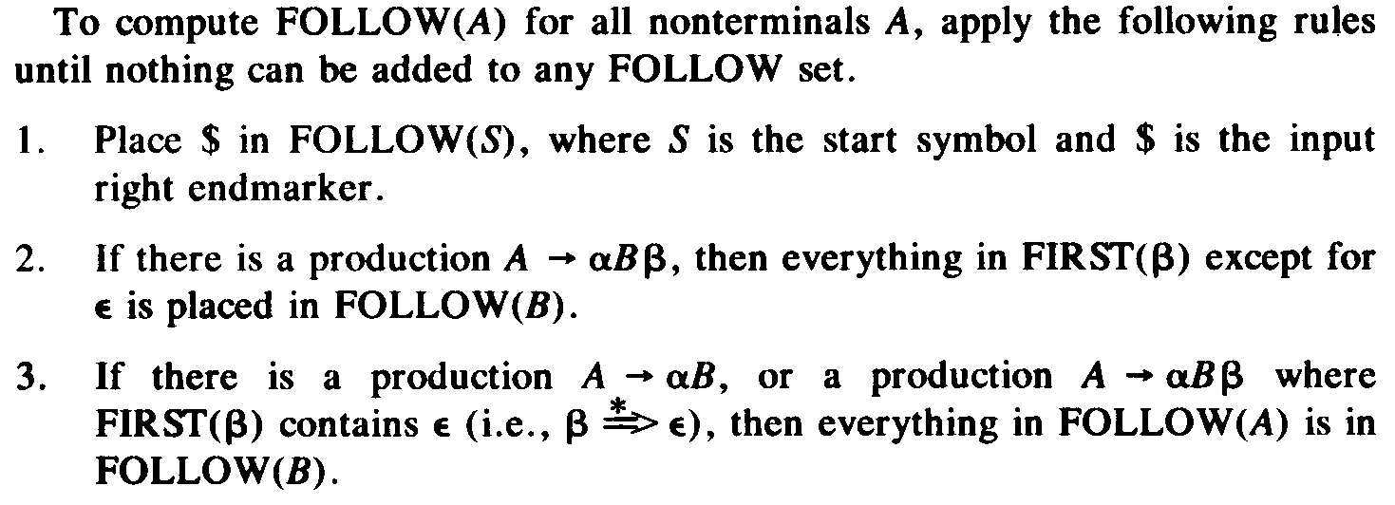

- Appendix E: Nonrecursive predictive parsing
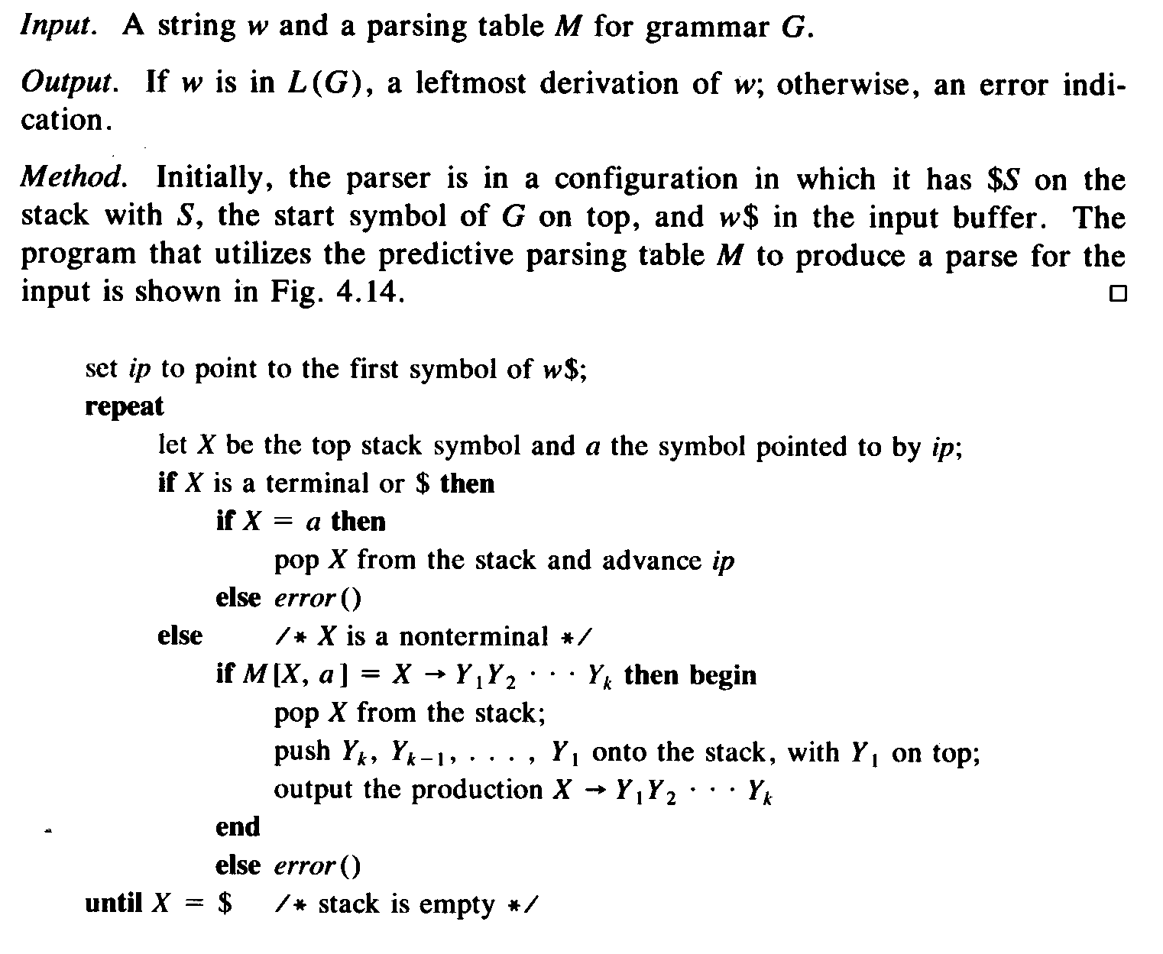
- Appendix F: Construction of a predictive parsing table
