COURSE: SEG2101 | PROF: Jiying Zhao
Software Construction | DATE: April 28, 2006
SEMESTER: WINTER 2006 | TIME: 09:30 – 12:30

FINAL

EXAMINATION

Name
Student Number

Final Exam

- There are three (3) types of questions in this examination.
Part 1 | Multiple choice | 16 marks
Part 2 | Short answer | 52 marks
Part 3 | Problem solving | 18 marks
Total |  | 86 marks
- The space allocated for each question is limited. In case of necessity you may use the other side of the pages to continue.
- Initial all the pages.
- Submit back all the pages.

- Multiple choice questions [2 marks each, please circle the best answer]:
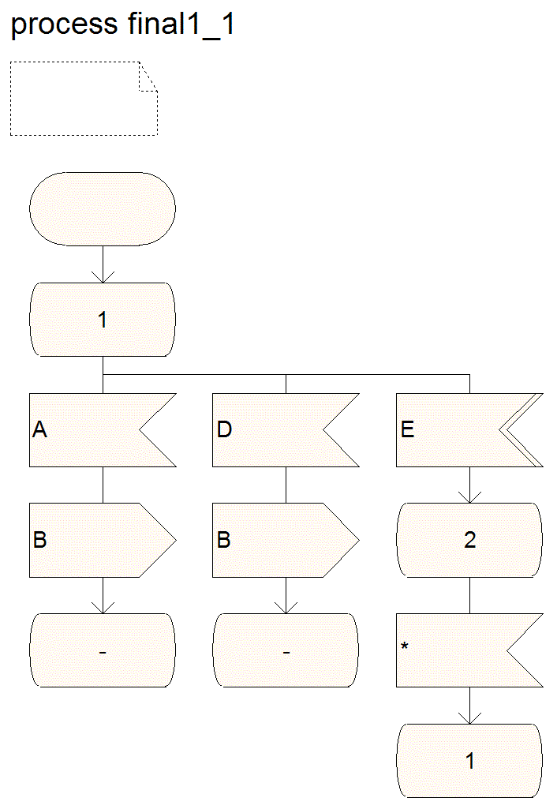 | 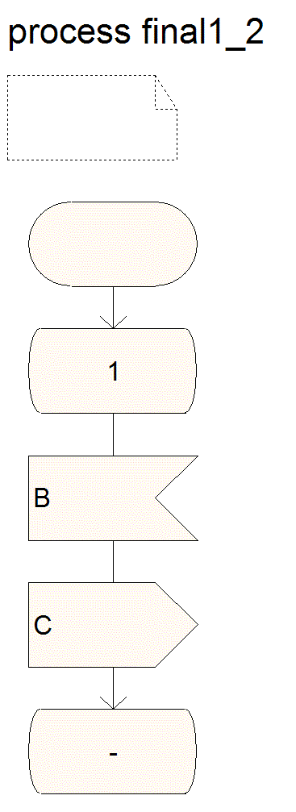 | 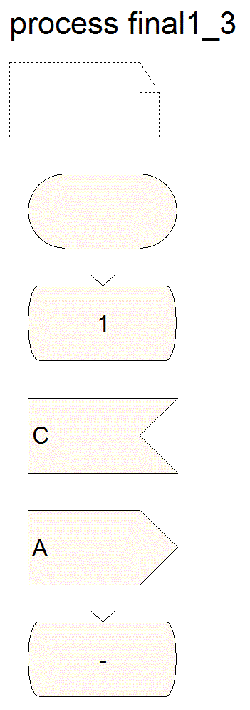

- Refer to the diagram above. Signal D and E are from the environment. Which of the following is not correct?
- Suppose final1_1, final1_2, and final1_3 have been just initialized. When there is no signal sent from the environment, final1_1, final1_2, and final1_3 will not be able to output any signals. | - Suppose final1_1, final1_2, and final1_3 stay at state 1 and are not generating any signal. When signal D is sent from the environment, final1_1, final1_2, and final1_3 will start to output signals.
- When final1_1, final1_2, and final1_3 start generating signals and there is no further signal sent from the environment, the three processes will not stop and will generate signals endlessly. | - Whenever signal E is sent from the environment, the three processes will always stop generating signals.  - At least one of the above (a,b,c,d) is wrong.

- Refer to process final 2. In 100 time unites, how many T2 signal(s) will be generated?
- 0 | - 1
- 2 | - 3

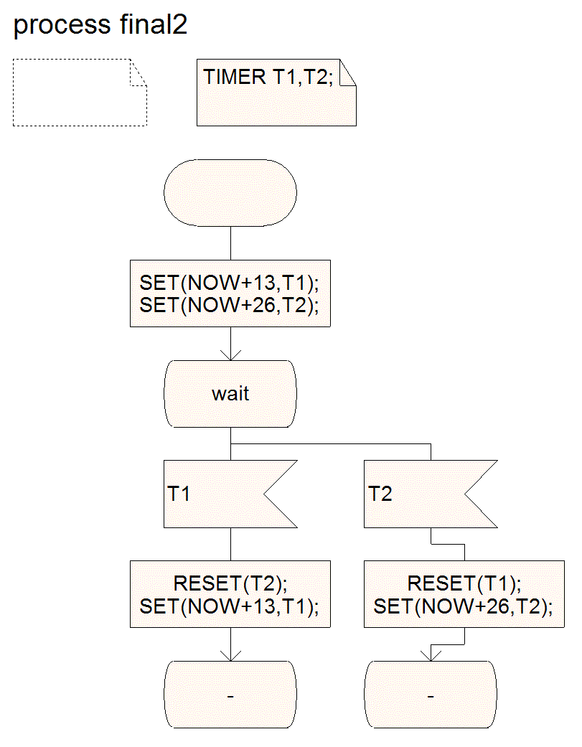
- Refer to the diagram below (final3_1 and P2). Signals A and B are from the environment. Sinal C is to the environment. Long time after inputting signal A, the user inputs signal B. What value will be returned by the signal C (the integer value carried by C)?
- 0 | - 1
- 2 | - 3

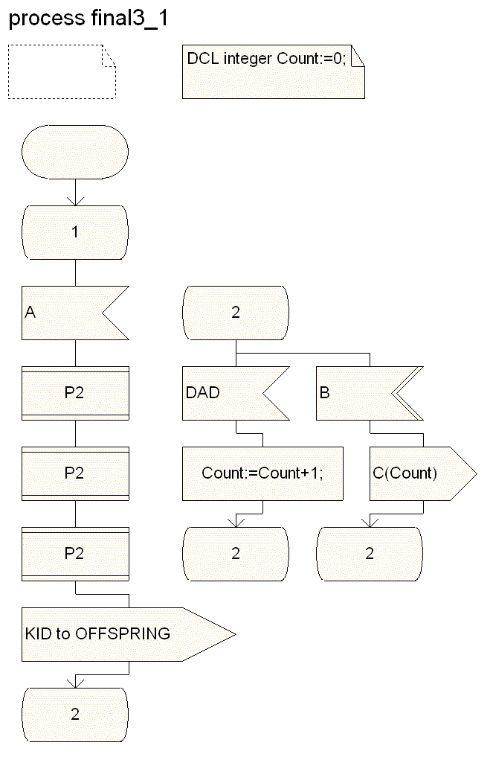 | 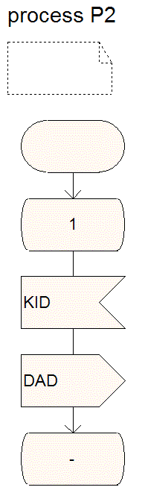

- Refer to the grammar below.

S --> NP VP
NP --> N
NP --> Det N
Det --> the
N --> man
N --> dog
N --> cat
VP --> V NP
V --> bites
V --> catches

The grammar belongs to which of the following?
- Regular grammar | - Context-free grammar
- Context sensitive grammar | - Unrestricted grammar

- Consider the following grammar rules:
S → 0 A 0 S | 1 0
A → 1 | 0 S 0 A

Which of the following strings is not a member of this language?
- 001001010 | - 10
- 01010 | - 0010110

- Which of the following is not described by the regular definition below?

D → [1234567890]

N  D+ ( . D+ )? (E( +|- )? D+ )?
- 1.894 | - .894E-4
- 1.894E+4 | - 1.894E4

- Which of the following cannot be recognized by the following NFA?

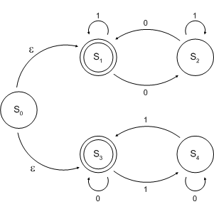

- An empty string | - 00001111
- 10101010 | - 01010111

- Let Σ={a,b}, which of the following is not correct? (where r, s and t are regular expressions)
- Regular expression (a|b)(a|b) denotes {aa,ab,ba,bb}. | - r**=r*
- r|(s|t)=(r|s)|t | - (a|b)* is not equal to (a|b)**

- Short-answer questions
- [8 marks] A SDL block named COUNTER consists of one process COUNTP. There is one input signal (PULSE) to the process, and one output signal (OVERFLOW) from the process. Whenever an input signal PULSE is received, the process COUNTP will add 1 to its variable $c$. The initial value for the variable $c$ is 0. The counting range is from 0 to 99. That is, the value of $c$ goes from 0 to 1 to 2, …, to 99, when it reaches 100 it resets to 0, then the counter will continue to count from 0 to 99 repeatedly. Whenever the value of $c$ is reset from 100 to 0, an output signal OVERFLOW will be generated.

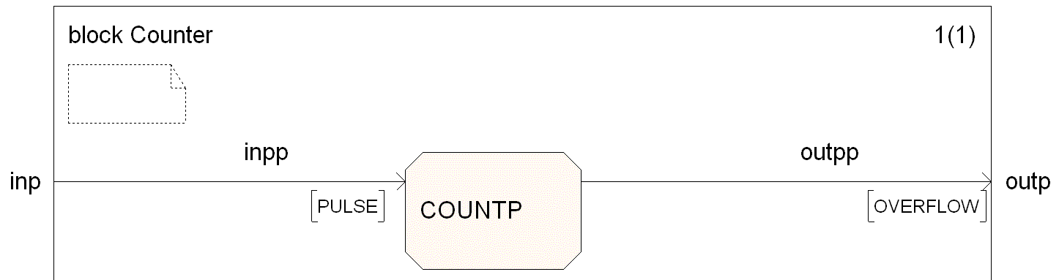

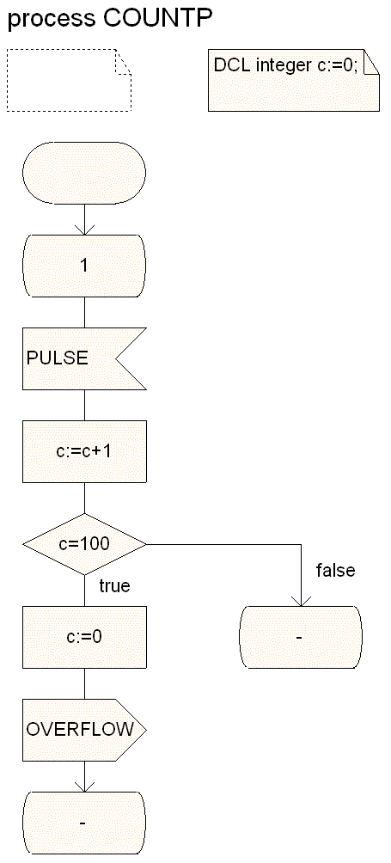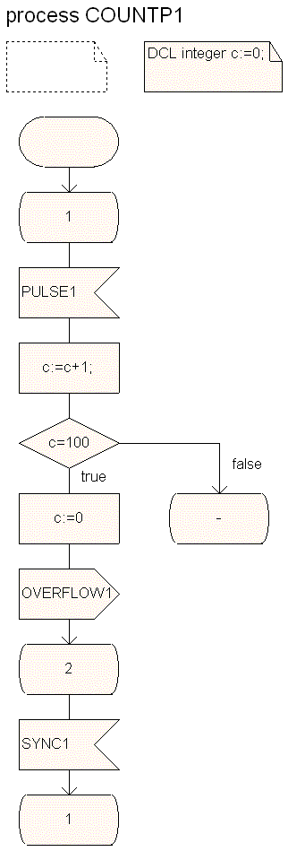

Now you are asked to implement a block similar to COUNTER. That is, you should design a new block, called B-COUNTER, slightly more complex than block COUNTER. The B-COUNTER block should contain four processes (instead of a single one). Three of the four processes (namely, COUNTP1, COUNTP2, and COUNTP3) are the same as process COUNTP except for the names of the input and output signals (see COUNTP1). That is, each of these three processes counts input signals (namely, PULSE1, PULSE2, and PULSE3 are respectively the inputs for COUNTP1, COUNTP2, and COUNTP3) and generate an output signal (namely, OVERFLOW1, OVERFLOW2, and OVERFLOW3 are respectively the output signals from COUNTP1, COUNTP2, and COUNTP3) when the counter reaches 100. COUNTP1, COUNTP2, and COUNTP3 wait for a signal SYNC1, SYNC2, and SYNC3, respectively, from the fourth process before going back to state 1. The fourth process (namely, BARRIER) takes OVERFLOW1, OVERFLOW2, and OVERFLOW3 as inputs, and sends an OVERFLOW signal to the environment when the three OVERFLOW1, OVERFLOW2, and OVERFLOW3 signals have been received. BARRIER sends a SYNC1, SYNC2, or SYNC3 signal to COUNTP1, COUNTP2, or COUNTP3 when it receives an OVERFLOW1, OVERFLOW2, or OVERFLOW3, respectively. After sending out OVERFLOW, the process BARRIER goes back to the previous state to get ready for the next iteration.

- Draw the SDL structure diagram of the B-COUNTER block. Draw all processes, channels, signal routes, signals, adding labels, as appropriate.
- Draw the SDL behavior diagram for the process BARRIER in the BLOCK B-COUNTER. Draw all states, inputs, and outputs, adding labels, as appropriate.

- [4 marks] Refer to the following figure.
  - Draw the Transition Chart (TC) for process P1.
  - Draw a global reachability graph showing at least five (5) global states starting from the global state 2.

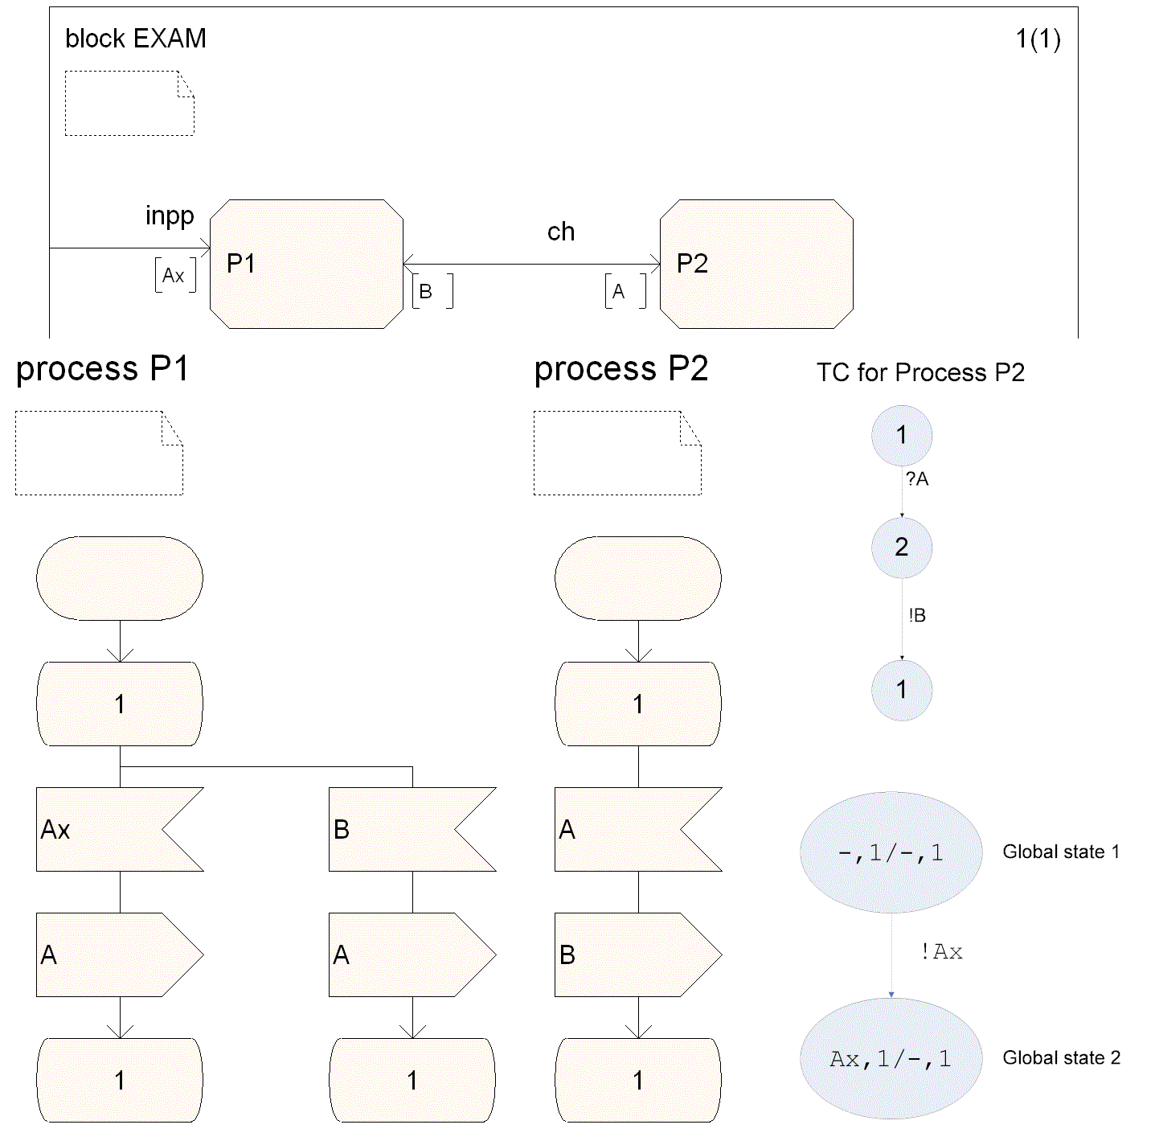

- [4 marks] Write the corresponding regular expression for the following finite state machine.

- [6 marks] Closely follow Algorithm 3.2 (attached as Appendix A) to convert the following NFA into a DFA by showing the intermediate steps.

- [4 marks] The following grammar has left recursion (refer to Appendix B for possible methods). Find an equivalent grammar (that generates the same language) without left recursion.

<expression> → <expression> + <factor>

<expression> → <expression> - <factor>

<expression> → <factor>

- [4 marks] Consider the following grammar (0 and 1 are terminals). Left-factor the grammar.

<expr> -> <term> ADD <expr> | <term> SUB <expr> | <term>
<term> -> <factor> MUL <term> | <factor> DIV < term > | <factor> | NUM

Note: ADD, SUB, MUL, DIV, and NUM are terminals.

- [4 marks] Show that the following grammar is ambiguous.

S → A | S + A | S + + A

A → a | ε

- [10 marks] Refer to Appendices C, D and F. Given the following grammar:

S → id = c ;
S → if (c) {LS} E
LS → S LS
LS → ε
E → else {LS}
E → ε

- Compute the sets FIRST and FOLLOW for all the non-terminals in the above grammar.
- Build a parsing table for the grammar.
- Is the grammar LL(1)? – Explain.

- [8 marks] Refer to Appendix E. The table below is the parsing table for the following LL(1) grammar:

S→(L) | a
L→SL’
L’→,SL’ | ε

 | ( | a | ) | , | $
S | S→(L) | S→a
L | L→SL’ | L→SL’
L’ |  |  | L’→ε | L’→,SL’

Seek the moves made by a nonrecursive predictive parser on the input ”(a,(a,a))”, by filling the following table.
Stack | Input | Output
 | (a,(a,a))$

- Problem Solving
- [10 marks] Define a Java class representing a monitor that controls the access to a resource for reader and writer processes. We consider the following problem: A resource is used by two different kinds of processes. The Reader processes access the resource without changing its content. The Writer processes access the resource and update the content of the resource. In order to provide a consistent view of the resource to the Readers, no Writer should access the resource while some reader uses the resource. It is also required that at most one Writer process has access to the resource at any given time.

It is assumed that the Readers and Writers use a monitor Database to synchronize their access to the resource. The monitor offers the following methods: startRead(), endRead(), startWrite(), endWrite(); they are used as follows: Before accessing the resource, a Reader will call startRead(), then it will access the resource and then call the method endRead(). Similarly, a Writer will first call startWrite(), then it will update the resource and then call the method endWrite().

The following is the incomplete program. Your task is to complete method startRead() and startWrite(). Please give Writers priority over Readers. That is, if a writer is waiting no new reader may enter the resource (even if other readers are currently using the resource).

public class Database

{

private int readerCount;

private boolean dbReading;

private boolean dbWriting;

public Database()

{

readerCount = 0;

dbReading = false;

dbWriting = false;

}

public synchronized int startRead()

{

}

public synchronized int endRead()

{

--readerCount;

if (readerCount == 0)

dbReading = false;

notifyAll();

System.out.println("Reader Count = " + readerCount);

return readerCount;

}

public synchronized void startWrite()

{

}

public synchronized void endWrite()

{

dbWriting = false;

notifyAll();

}

}
- [8 marks] The following is a multithreading program. In order to provide fairness to all the five threads, you are asked to modify the run method of the classes PrintChar and PrintNum so that any of the 5 threads must stop before the for loop and cannot proceed until all other threads reach this point. This can be implemented in a way similar to a semaphore or a monitor. Please write the class that provides the needed method(s) and make the necessary modification to the following program.

public class TestRunnable
{
public static void main(String[] args)
{
Thread printA = new Thread(new PrintChar('a',100));
Thread printB = new Thread(new PrintChar('b',100));
Thread printC = new Thread(new PrintChar('c',100));
Thread print100_1 = new Thread(new PrintNum(100));
Thread print100_2 = new Thread(new PrintNum(100));

print100_1.start();
print100_2.start();
printA.start();
printB.start();
printC.start();
}
}

class PrintChar implements Runnable
{
private char charToPrint;
private int times;

public PrintChar(char c, int t)
{
charToPrint = c;
times = t;
}

public void run()
{
for (int i=1; i < times; i++)
System.out.print(charToPrint);
}
}

class PrintNum implements Runnable
{
private int lastNum;

public PrintNum(int n)
{
lastNum = n;
}

public void run()
{
for (int i=1; i <= lastNum; i++)
System.out.print(" " + i);
}
}

- Appendix A: Algorithm 3.2

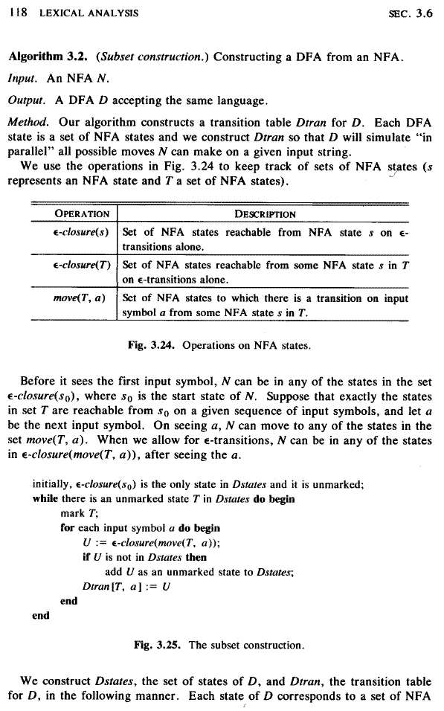

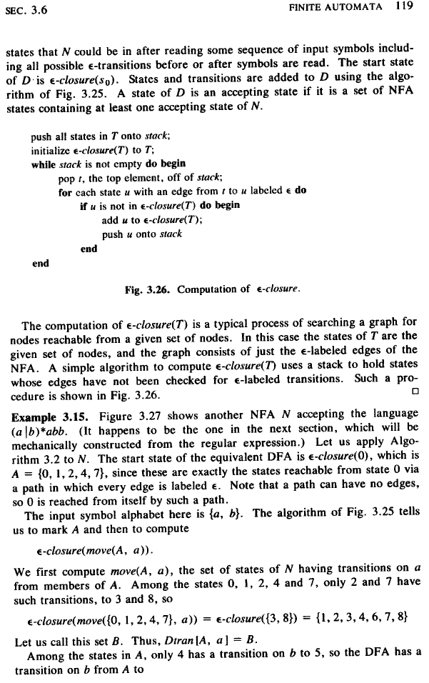
- Appendix B: Elimination of left recursion

can be replaced by

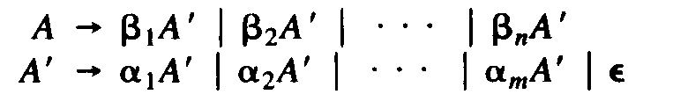

- Appendix C: Computation of FIRST

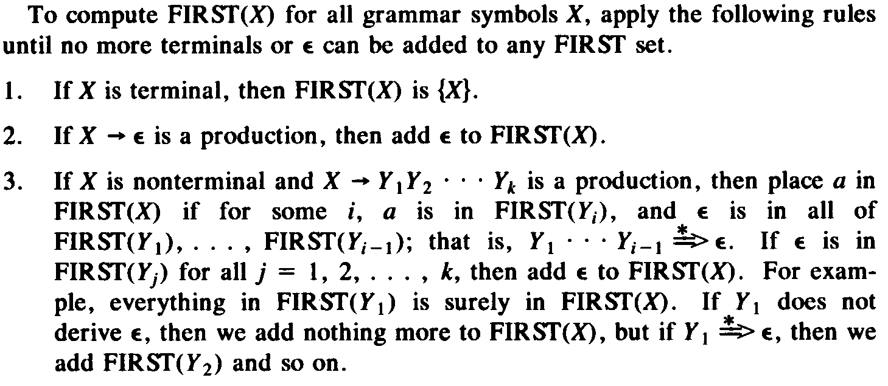

- Appendix D: Computation of FOLLOW

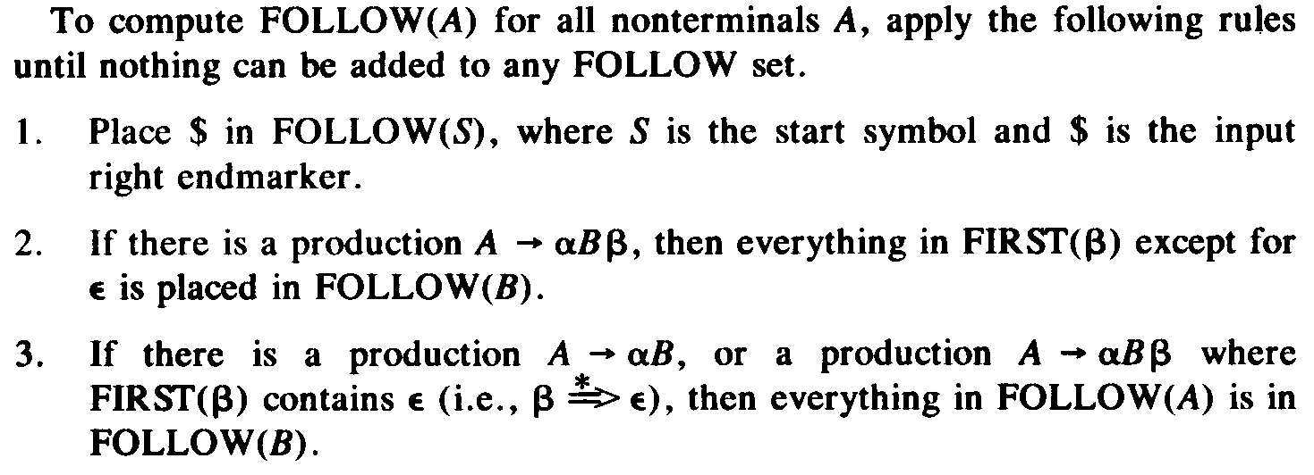

- Appendix E: Nonrecursive predictive parsing

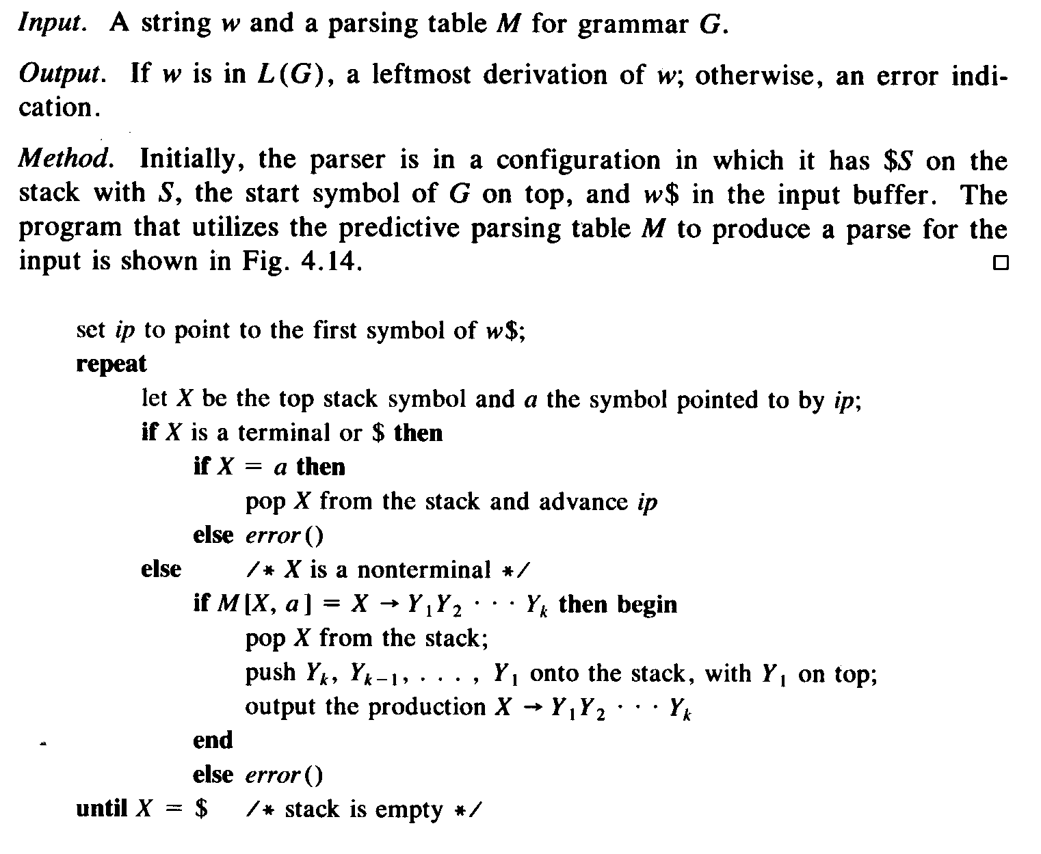
- Appendix F: Construction of a predictive parsing table

