COURSE: SEG-2106 | PROF: Gregor v. Bochmann
Software Construction | DATE: April 14, 2011
SEMESTER: WINTER 2011 | TIME: 09:30 – 12:30
 | ROOM: DMS 1150

FINAL

EXAMINATION

No documentation allowed

Name
Student Number

- There are three (3) types of questions in this examination.
Part 1 | Simple answers and multiple choice | 10 marks
Part 2 | Small problems | 50 marks
Part 3 | Problem solving | 20 marks
Total |  | 80 marks

- The space allocated for each question is limited. In case of necessity you may use the other side of the pages to continue.
- Initial all the pages, except the appendixes.

List of Annexes:

Appendix A: Algebraic Properties of Regular Expressions

Appendix B: Elimination of left recursion

Appendix C: Computation of FIRST

Appendix D: Computation of FOLLOW

Appendix E: Non-recursive predictive parsing

Appendix F: Construction of a predictive parsing table

Simple answers and multiple choice (circle the best answer) [2 marks each]:

- For each of the following strings, please indicate whether it is accepted by the non-deterministic automaton below?

- 101001101 YES NO | - 00001111 YES NO
- 00100111 YES NO | - 00110001 YES NO

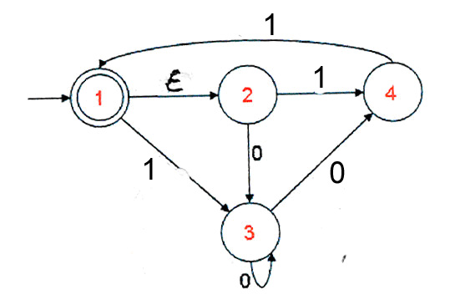
- We assume the alphabet A={a,b}. Which of the following is not correct? (Note: r, s and t are regular expressions) – Note: Appendix A contains a list of equalities for regular expressions.
- ( a a* b ) is not equal to ( a b | a* a a b ) | - ( r | a )+ = ( a | r ) ( r* | a* ) *
- ( s | t ) r is not equal to ( r s | r t ) | - ( s | a | b )* = ( s* a* b* )*

- Concurrency: Readers and Writers access a shared resource. There is mutual exclusion, except that multiple Readers can access the resource simultaneously, but not when a Writer is using it. Let us assume that reading takes 20 msec and writing takes 30 msec, and that Reader-1 tries to access the resource at time t=0 (initially, the resource is free). Then Writer-1 tries to access the resource at time t=5, and Reader-2 tries to access the resource at time t=10. When do these three threads start and terminate their use of the resource ? – Answers:

Reader-1 starts at 0 and ends at 20 msec.

Writer-1 starts at and ends at msec.

Reader-2 starts at and ends at msec.

- Concurrency: Why is it more difficult to verify (or test) that a program works correctly when the program contains concurrency, as compared with a sequential program ? – Explain in a few words.

- We consider a simulation program which simulates 10 workers that, during their work process, have to use from time to time a cutting tool. There are three identical cutting tools available on the shop floor. When using a tool, the worker needs exclusive access to the tool. - Question: How can a semaphore be used in the simulation program to ensure that the mutually exclusive access to the three tools is maintained ? – Explain in a few words.

Small Problems

- [6 marks] We consider a system consisting of two components C1 and C2 that have the same behavior and exchange messages between one another. There are two types of messages, a request message R and an acknowledgement message A. The behavior of the two components is modeled by the state machines below (left). The figure on the right side is the beginning of the reachability analysis graph which shows the global system behavior: Each transition of the reachability graph corresponds to a transition of one of the two components.

Please complete the reachability graph for the case that component C1 sends an R message while component C2 waits for the reception of this message (the beginning of this behavior is already shown in the diagram below (right); and also include the case that both components start by sending an R message to the other party. Please provide your comments concerning the validity of this system design.

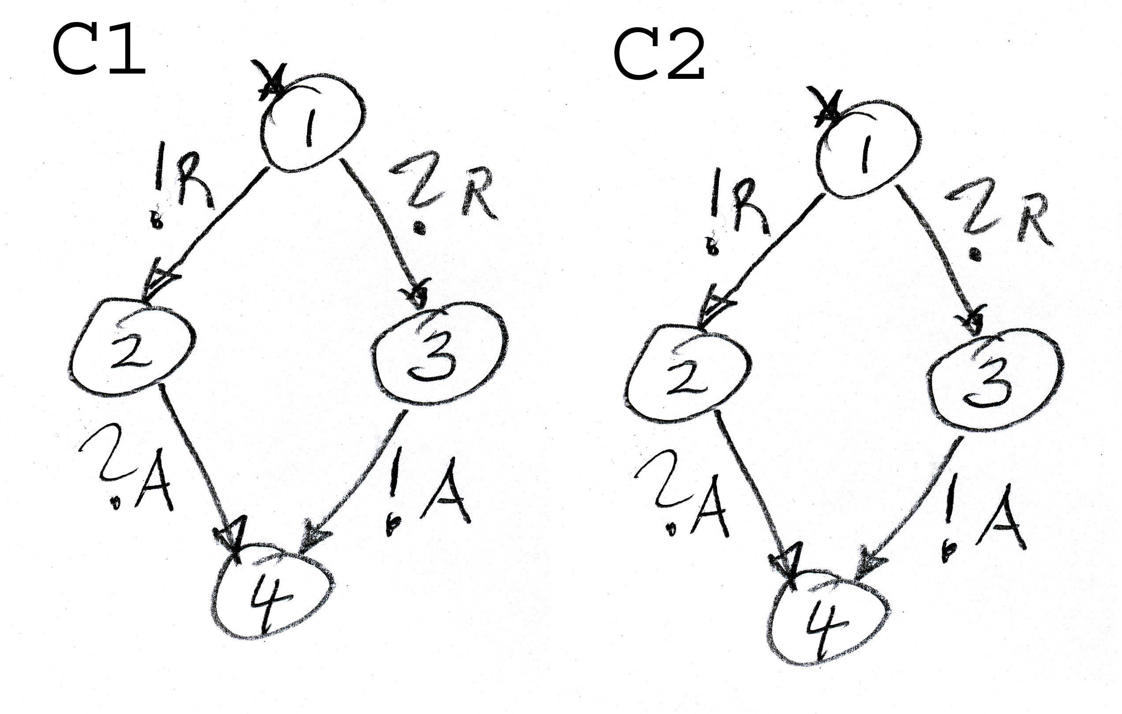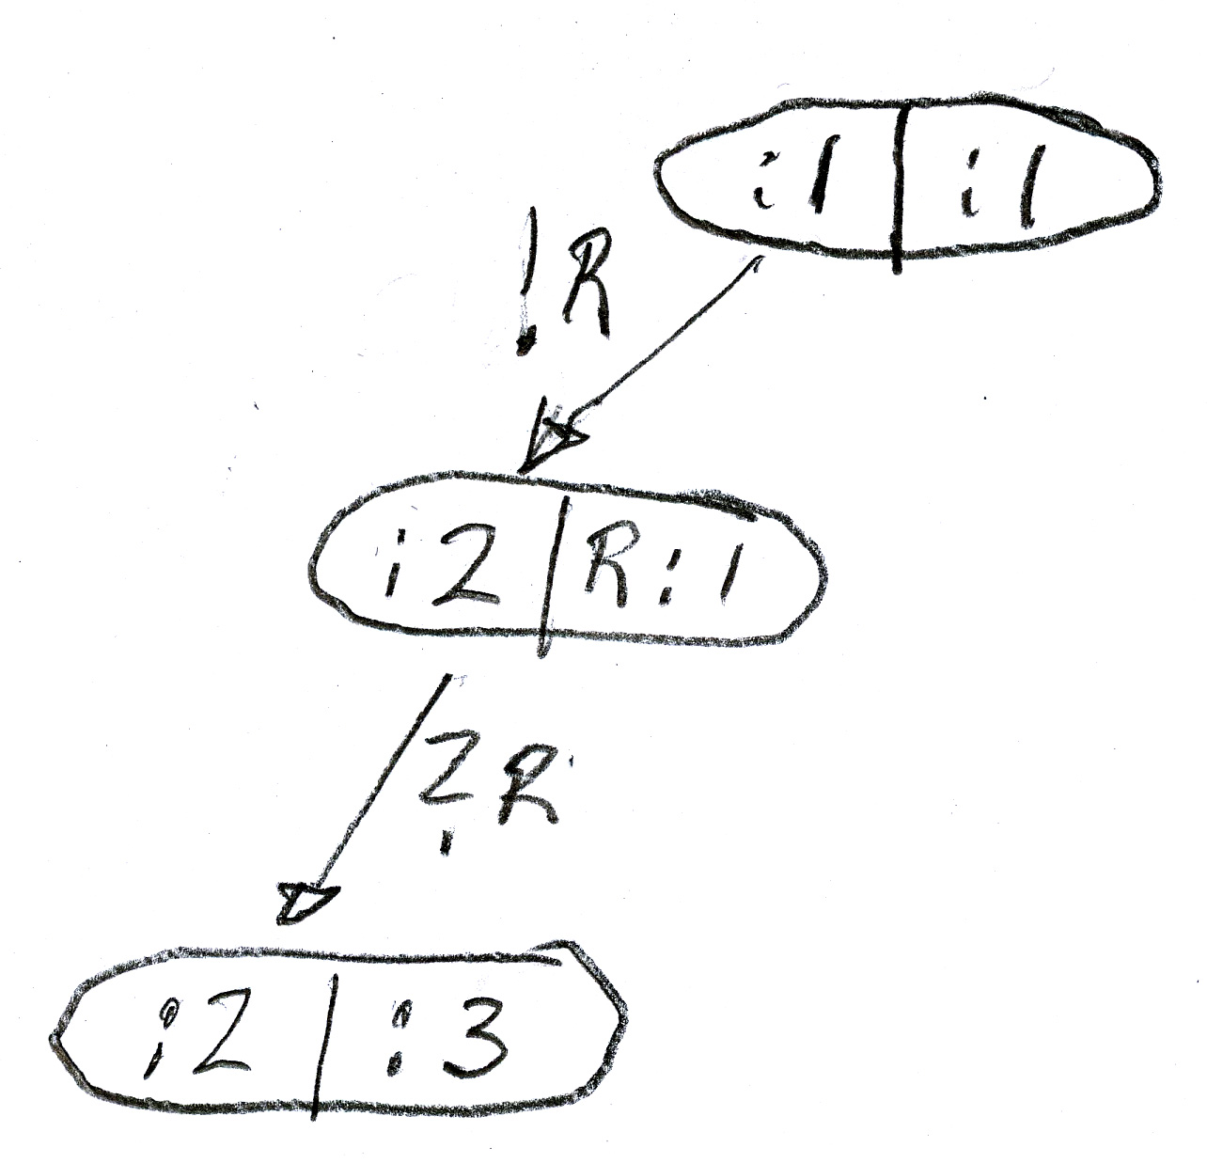

- [4 marks] Implementation design is the development phase during which the non-functional requirements are composed with the functional specification in order to select a software-hardware architecture that fits the requirements of the system. Often one can choose between a centralized implementation and a distributed implementation of the main system functions. Identify at least two advantages and two disadvantages of a distributed implementation approach (as compared to a centralized implementation).

(A) Advantages:

(B) Disadvantages:

- [4 marks] We saw that the tag that starts an element in an XML document has in general the following form:

<nameOfElement nameOfFirstAttribute= “attributeValue” nameOfSecondAttribute= “attributeValue” et cetera >

where the number of attributes may be zero. Write down a regular expression that represents this general form of a starting XML tag. You may use the following definitions of sets of characters:

charName = … // characters that can be used in the names of elements and attributes

charString = … // characters that can be used in the values of attributes

- [4 marks] We assume that a server has a exponential service time with an average of 0.1 seconds. The rate of arrival of requests at the server is on average 5 requests per second. Please calculate the expected (average) response time of the server, knowing that for queuing models the formula “ Tr = Ts / (1 – utilization) “ applies (where Tr is the response time and Ts is the service time). What is the expected average queue length of the server ? – Please explain in a few words.

- [6 marks] Using the approach discussed in class, convert the non-deterministic automaton below into an equivalent deterministic automaton.

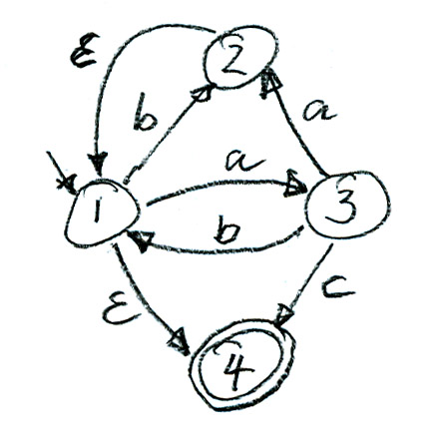

- [4 marks] The following grammar has left recursion. Find an equivalent grammar (that generates the same language) without left recursion. (Note: refer to Appendix B for possible methods).

S → A a | a S

A → B | A b | a

B → B b | c

- [4 marks] Consider the grammar with the following syntax rules. Use left-factoring to find equivalent rules that satisfy the LL(1) constraints.

S → <assign> | <method call>
<assign> → ID = <expr> ;
<method call> → ID ( ) ;

- [4 marks] Write down a context-free grammar that generates sentences of the following form: one or more “a” at the beginning, then two “c” followed by zero, one or more “b” and finally the same number of “a” as at the beginning.

- [4 marks] Show that the following grammar is ambiguous.

S → a B | a A

A → a A | b S | c

B → c B | a A | a

- [10 marks] Given the following grammar:

Pro → { L } // the program is followed by $ (meaning end of file)
L → ε | S L
S → id = Exp ; | if ( Exp ) { L } ELSE
ELSE → else { L }
Exp → const

The starting symbol of this grammar is Pro and its terminals are ;, =, (, ), {, }, id, if, else, const and $.

- Compute the sets FIRST and FOLLOW for all the non-terminals in the above grammar. Note: Appendices C, D and F contain related definitions and algorithms.
- Build a parsing table for the grammar. – Question: is the grammar LL(1) ? – Explain in a few words.

Problem Solving

- [10 marks] Define a shared Java class that represents a special kind of deposit box.

General description: There are two types of workers: providers and consumers. Each provider performs an infinite loop: repeatedly creating an object and depositing it in the box. Each consumer also executes an infinite loop repeatedly taking an object from the box and consuming it. The access to the box should be controlled in such a way that there are two phases: depositing phase and taking phase. During the depositing phase the providers deposit objects in the box; when the number of objects in the box reaches 100, then the taking phase starts, and the providers have to wait while the consumers empty the box; when the box becomes empty again, the depositing phase starts again.

Please write a Java program that simulates the deposit box system described above. The code for the provider class is given below. You may assume that a similar code for consumers is also given. There should be two providers and three consumers. There should be one instance of a box Class which supports the methods void deposit(BoxObject o) and BoxObject take(). The body of these methods should include in their bodies the necessary statements for scheduling the phases of operation of the box, as described above.

The following is the incomplete program. Your task is to complete the main method and the class Box. You may introduce variables as you think are appropriate for solving this problem.

Complete this Java program:

public class BoxMain {
public static void main(String [] args) {
Box box = new Box();
Producer p1 = new Producer(box);
Producer p2 = new Producer(box);
Consumer c1 = new Consumer(box);
Consumer c2 = new Consumer(box);
Consumer c3 = new Consumer(box);

} }
public class Producer extends Thread {
private Box mybox;
public Producer(Box b) {mybox = b;}

public void run(){
while (true) {
// create a new object ...
BoxObject oneObject = new BoxObject();
mybox.deposit(oneObject);
}
}

}

// the Consumer class is similar

public class Box {
private BoxObject[] content;

public Box(){content = new BoxObject[100];}

- [10 marks] Writing a recursive descent parser

We assume the following grammar, where Prog is the root:

Prog → List $
Stat → ID := Exp ;
List → Stat List | ε

Assuming syntax analysis by recursive procedures, as seen in a lab and Assignment 3, it is your task to write the Java methods parse_Stat() and parse_List() that perform the syntax analysis for the nonterminals Stat and List, respectively. (Note: this grammar is LL(1)).

We assume that the class Syner (see below) contains the methods for parsing the different non-terminals of the grammar. The method for parsing the non-terminal Prog is already given below. The method for parsing the non-terminal Expr is supposed to be given as well. It is assumed that a suitable lexical analyzer exists (variable lex in the program below). You may assume that suitable definitions of Java constants are given which represent the different lexical units, such as DOLLAR, ID, ASSIGN, SEMI, etc.

class Syner {
private Lexer lex;

public Syner(String inputFile) {
lex = new Lexer(inputFile);
// read the next token (here it is the first one)
// and place it into lex.token
lex.getNext();
}

public void parse_Prog() throws IOException {
parse_List();
// check that the dollar sign follows the List
if(lex.token != lex.DOLLAR)
{errorMessage("DOLLAR token expected!");}
}

public void parse_Stat() throws IOException {

public void parse_List() throws IOException {

Appendix A: Algebraic Properties of Regular Expressions

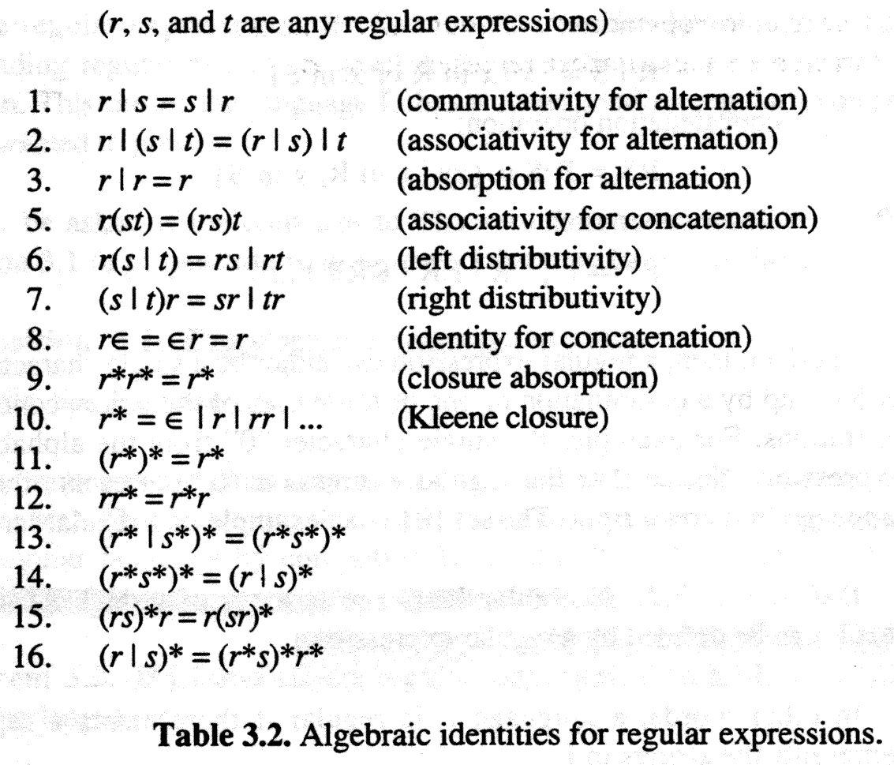

Appendix B: Elimination of left recursion

can be replaced by

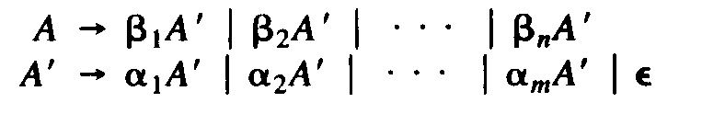

Appendix C: Computation of FIRST

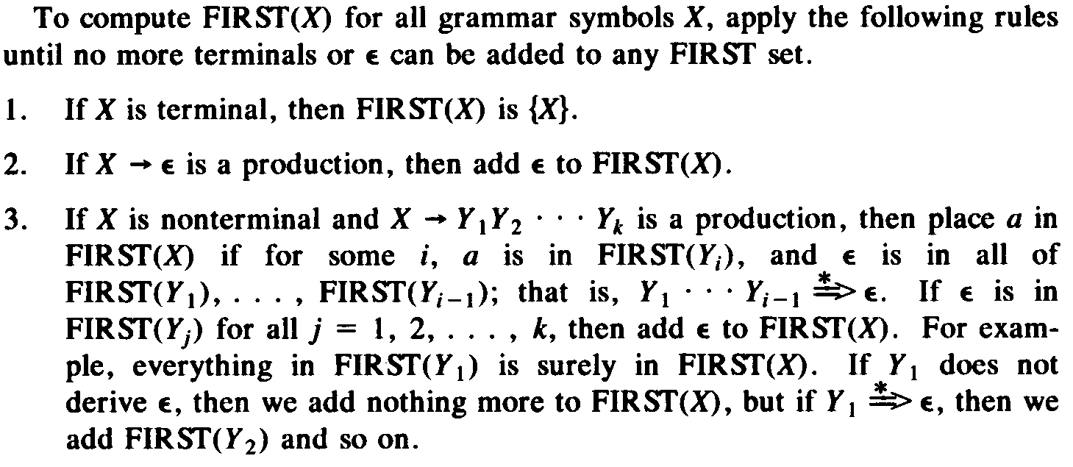

Appendix D: Computation of FOLLOW

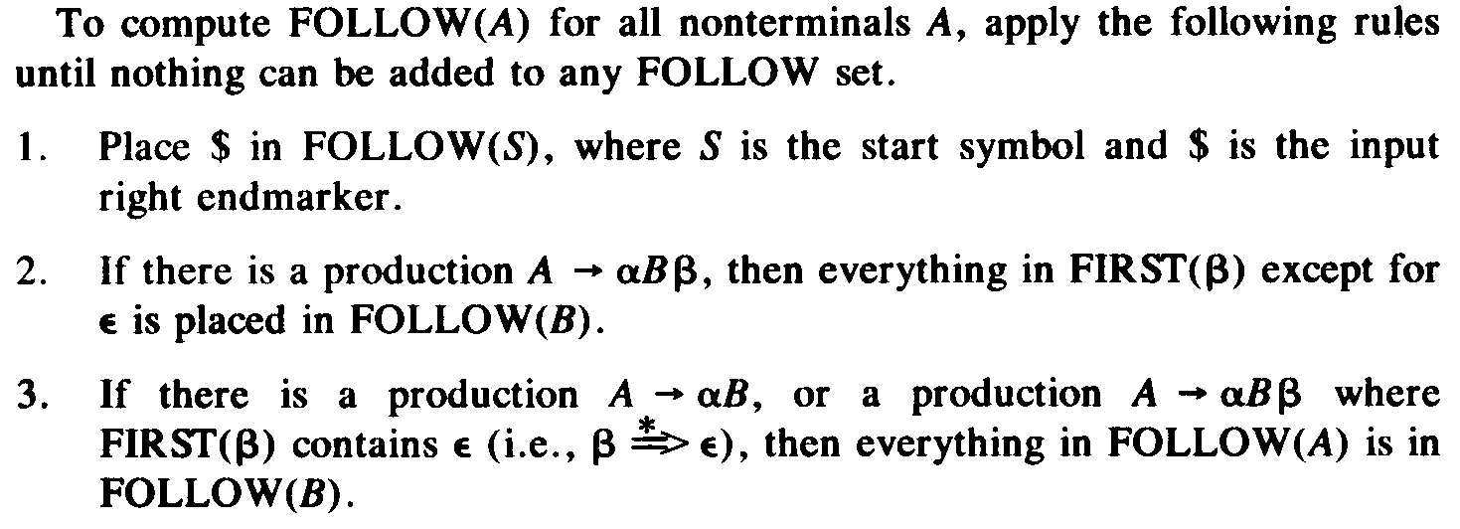

Appendix E: Nonrecursive predictive parsing

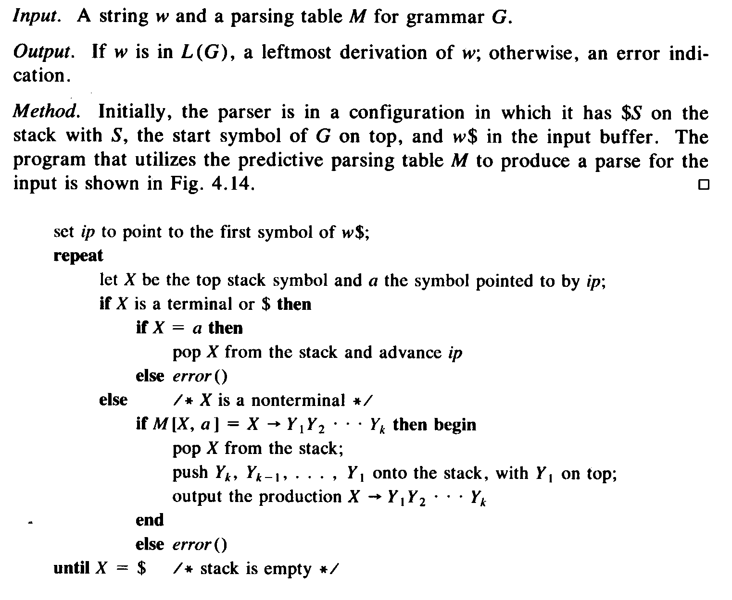
- Appendix F: Construction of a predictive parsing table

