
SCHOOL OF INFORMATION TECHNOLOGY AND ENGINEERING

Course: SEG2101A/SEG2101B | Professor: Jiying Zhao
Semester: Winter 2005 | Room: STE5019
 | Phone: (613)562-5800 x 6667
 | Email: jzhao@uottawa.ca

Assignment 4: Concurrency
Due: April 11, 2005 @ 12:00 Noon
Posted on: March 21, 2005

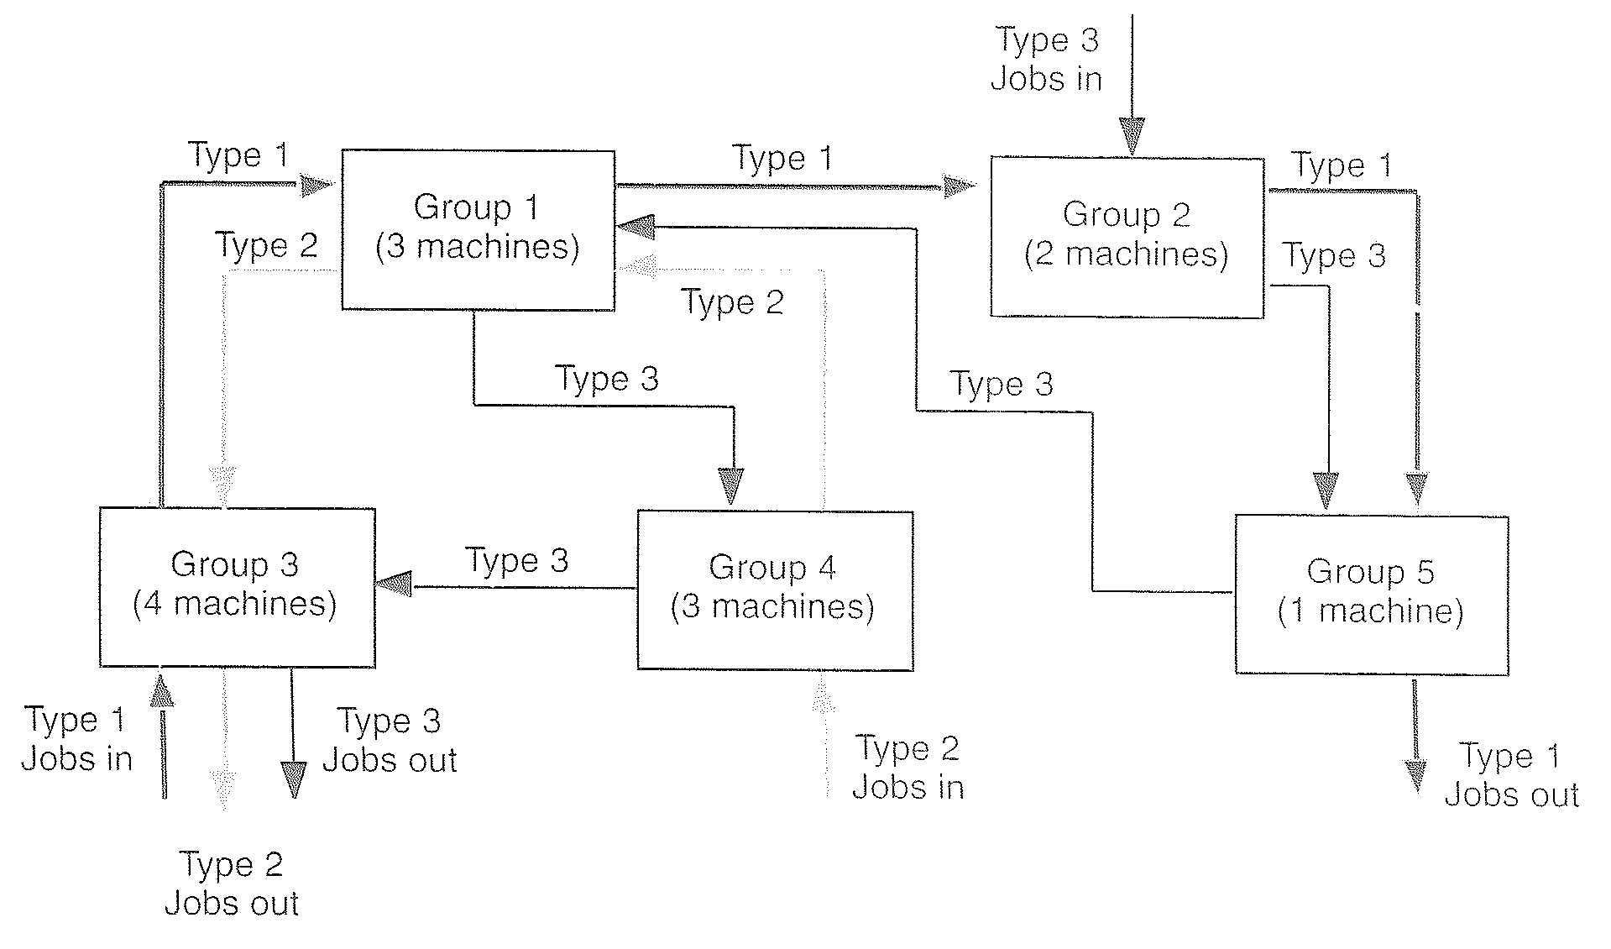
Figure 1: A schematic of the job shop.

- Statement of the Problem:
A particular job shop is comprised of five different machine groups. Each group consists of a specific number of machines of a given kind, as listed in Table 1. For example, Group 1 consists of three machines; Group 2 consists of two machines; and so on. Within any group, the machines are identical to each other. It does not matter which machine in a group is used to carry out a step on a unit of work-in-process.

Table 1: Size of machine group in the job shop.
Group number | No. of Machines in the group
1 | 3
2 | 2
3 | 4
4 | 3
5 | 1

Three types of products, or jobs, are produced at the job shop. These job types are designed as Type 1, Type 2, and Type 3. Each job type requires that steps be performed at specified kinds of machines in a specific sequence. The total number and kind of machine groups each job must visit, and the corresponding visitation sequences, are shown in Table 2. For example, jobs of Type 1 must visit a total of four machines groups, in this order: Group 3, then Group 1, then Group 2, and finally Group 5.

Table 2: Visitation sequence and expected step times for the three job types.
Job type | No. of machines to be visited | Visitation sequence | Expected step time (hours)
1 | 4 | 3 | 0.50±0.10
1 | 4 | 1 | 0.60±0.10
1 | 4 | 2 | 0.85±0.10
1 | 4 | 5 | 0.5±0.10
2 | 3 | 4 | 1.10±0.2
2 | 3 | 1 | 0.80±0.2
2 | 3 | 3 | 0.5±0.2
3 | 5 | 2 | 1.20±0.15
3 | 5 | 5 | 0.25±0.15
3 | 5 | 1 | 0.70±0.15
3 | 5 | 4 | 0.90±0.15
3 | 5 | 3 | 1.00±0.15

Figure 1 shows a schematic representation of the job shop. Each machine group is pictured as a rectangle, with the count of the number of machines in that group indicated in parentheses. The paths followed by the three types of jobs moving through the shop are also shown in this figure.

Table 2 also lists the expected step times required by each job type at each machine group it must visit. These step times follow a Uniform distribution. See Notes for further description about the Uniform distribution.

The uniformly-distributed job inter-arrival time (Type 1, Type 2, and Type3) is 0.2±0.1 hours. 50% of the jobs are of Type 1, 30% of Type 2, and 20% of Type 3. The service order at all machine groups is FCFS (First Come, First Served).

There is a storage facility (STORAGE) that has 10 spaces for storing the intermediate products produced by Type 1 jobs leaving machine Group 3. Each Type 1 job will produce two (2) intermediate products when leaving Group 3. Each storage space in STORAGE can store one intermediate product. Both Type 2 jobs and Type 3 jobs are consumers for the products produced by Type 1 jobs. They both have to wait for one (1) available product in STORAGE. They each consume one (1) intermediate product and enter Group 3.

Build a model in Java for the job shop. Instead of starting with model devoid of work-in-process initially, bring eight (8) jobs (of randomly determined types) into the model at time 0.0. Assume that no steps have yet been performed on them. Simulate the operation of the shop for 25 consecutive 8-hour shifts, assuming any discontinuities that might occur in the transition between shifts can be ignored.

- Tasks:
- Simulate the job shop to determine the residence time (from the time a job is generated to the time it leaves the job shop) of each of the three jobs, and the utilization statistics for the five machine groups. Statistics on the number of jobs waiting for a resources and the waiting time of jobs of different types are also required.
- Look into the results of the simulation concerning the length of the queues. Which machine group(s) appear to be bottleneck(s) in the job shop? If you could add one machine to the job shop, what kind of machine would you be inclined to add? Add one machine to the bottleneck group and redo step 1.

- Hand-in
- Report on the system design, assumptions, considerations, results, analysis.
- Program on both paper and floppy disk.

- Notes:
- A uniform distribution can be described by indicating its average value A and the half-width of the range (the half-range, B) over which its values vary. The uniform distribution then can be described by A±B, that is, [A-B, A+B), which can be obtained by using A-B+2*B*R, where R is a random number between zero and one. In Java, the java.util.Random class can be used to generate a random number. nextFloat() returns the next pseudorandom, uniformly distributed float value between 0.0 and 1.0 from this random number generator's sequence.
- The following example program generates random numbers between 0.0 (inclusive) and 1.0 (exclusive):

import java.util.*;

public class Main{
public static void main(String[] args)
{
float num1;
Random g = new Random(0);
num1 = g.nextFloat();
System.out.println("ramdom number = " + num1);
}
}

Students may work in groups of 2.
This assignment is adapted from a case study in the textbook by Thoms J. Schriber, An Introduction to Simulation Using GPSS/H, John Wiley and Sons, 1991, pp. 280-282.

