Performance evaluation
Lab 8
This lab deals with performance. Our work consists of evaluating, measuring and comparing the performance of two implementations of the same general design, one implemented in Java and the other in SDL.
JOSEPH MOLOKO 4270005 KENNETH KAVUNA 4303818
3/27/2008

Our work consists of evaluating, measuring and comparing the performance of two implementations of the same general design, one implemented in Java and the other in SDL.

We consider a simple application simulating the behavior of a set of concurrent producers and consumers of messages. The producers create messages that are stored in a common buffer; the consumers take the messages from that same buffer. For simplicity, we assume that the capacity of the buffer is a single message.
- Clearly, a producer can deposit a message in the buffer only when the latter is not full; in our case, only when it is empty.
- A consumer can read a message from the buffer when it is not empty.
- The producers wait in line when the buffer is full (or when another producer enters a message into the buffer).
- The consumers wait in line when the buffer is empty (or when another consumer takes a message from the buffer).
- After a producer / consumer have finished his operation, it will wake up a consumer / producer in line (if there is one).

After compiling and running the Performance Evaluation project downloaded from the TA’s website we realized that nothing happens. WHY?
The program does not do anything and appears to wait forever. We realized that the problem was due to the fact that a loop that counts and limit how many elements are pushed into the list was missing in the Class genProducer and genConsumer.
The following modifications were done to the program in order to:
- Count the number of writes and reads that are performed.
- Control the number of producers and consumers generated.
- A consumer / producer should start to work on the next message without waiting.
The part in the rectangle shows the modified part of the program.
Consumer Class

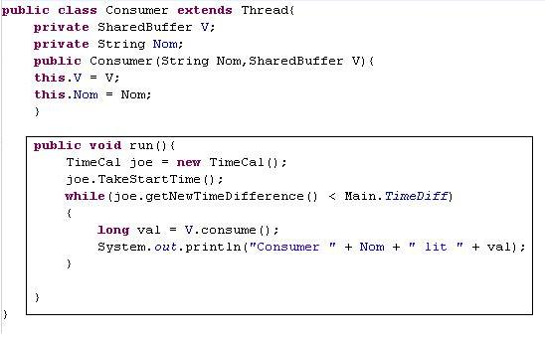

Producer Class
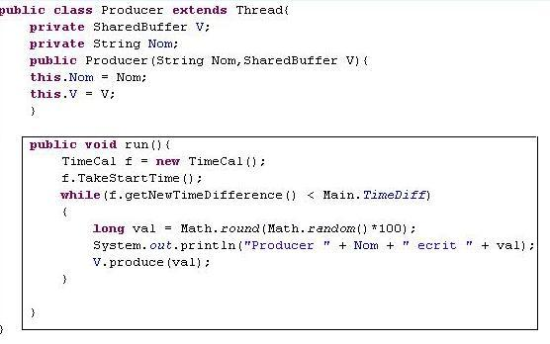
genConsumer Class
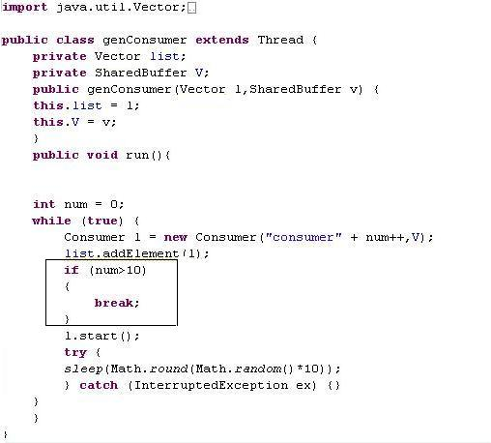
genProducer
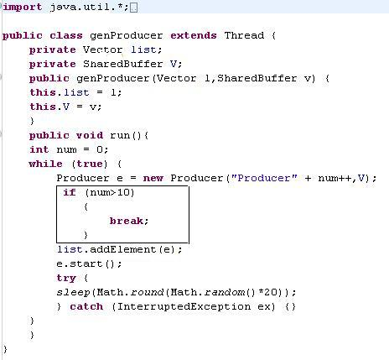
SharedBuffer Class
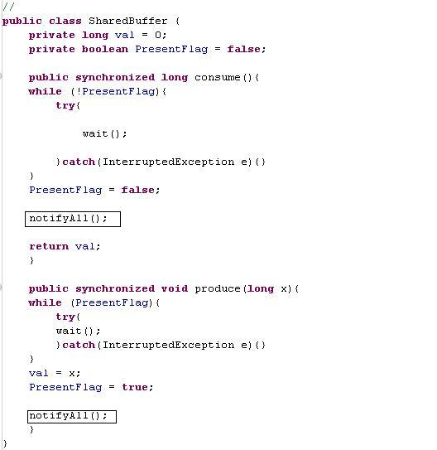
TimeCal Class
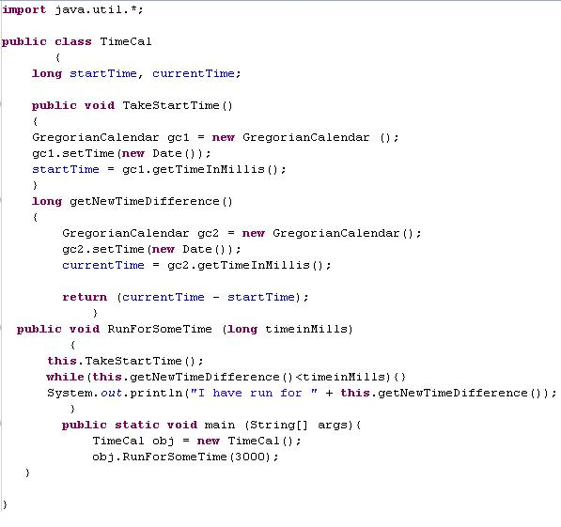

- Count the number of write and read operations over a certain time period for 10 producers and 10 consumers.
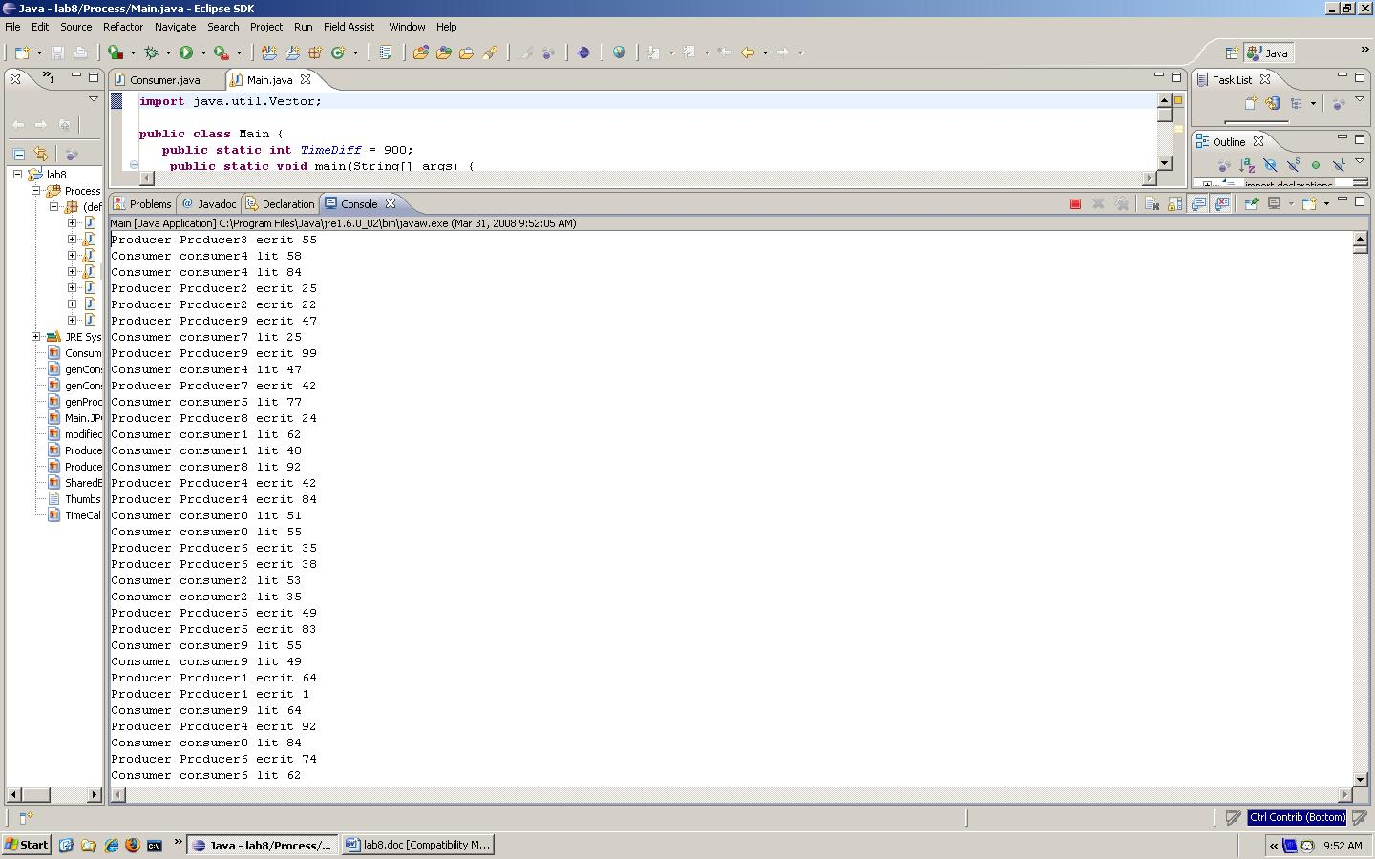

- Same for 20 producers and 20 consumers.
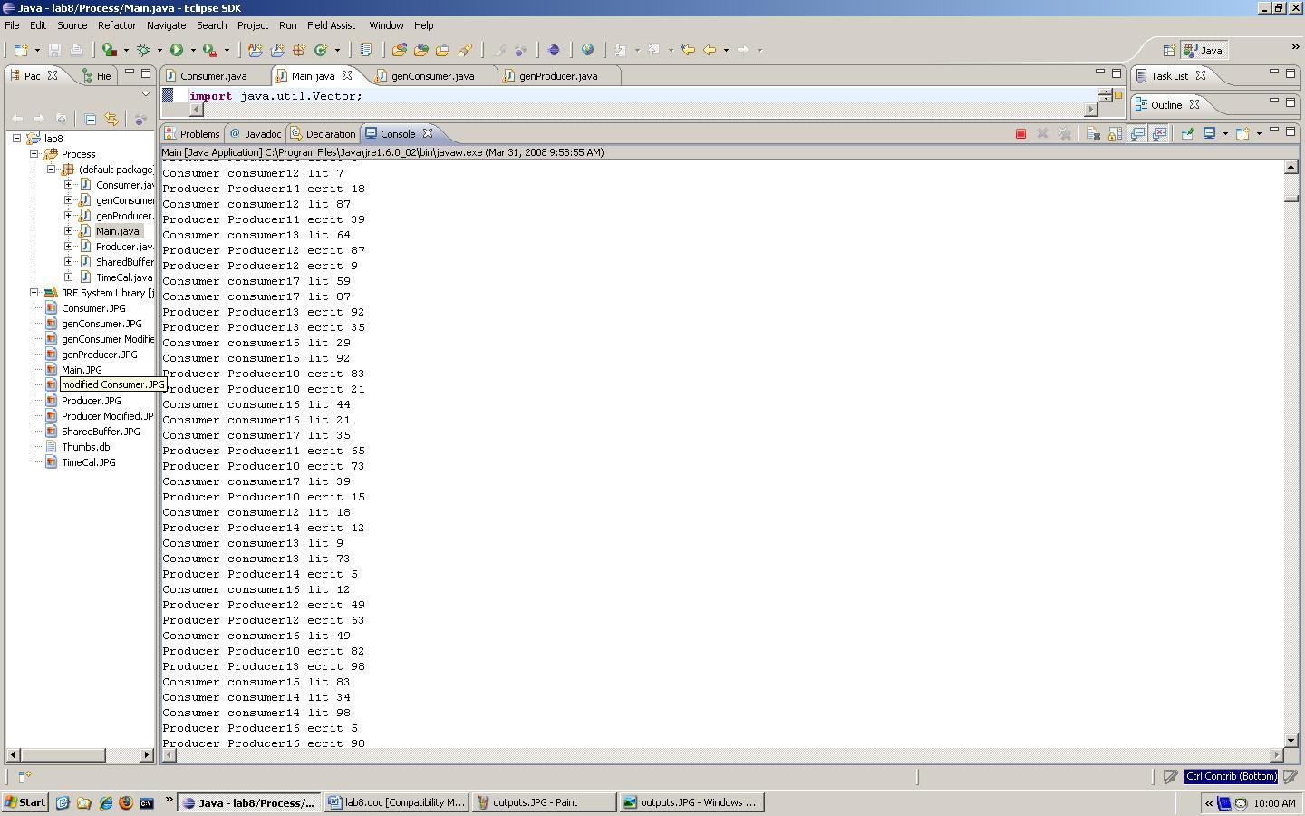

We used the Telelogic TAU tool to design and implement a version of the above system in SDL. Then we did the same performance measurements.
Consumer
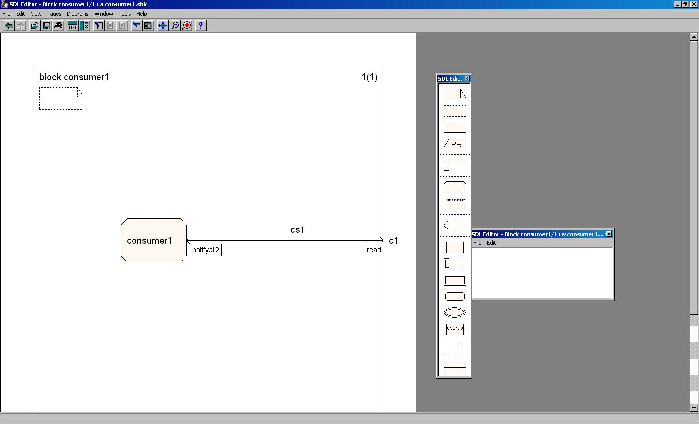
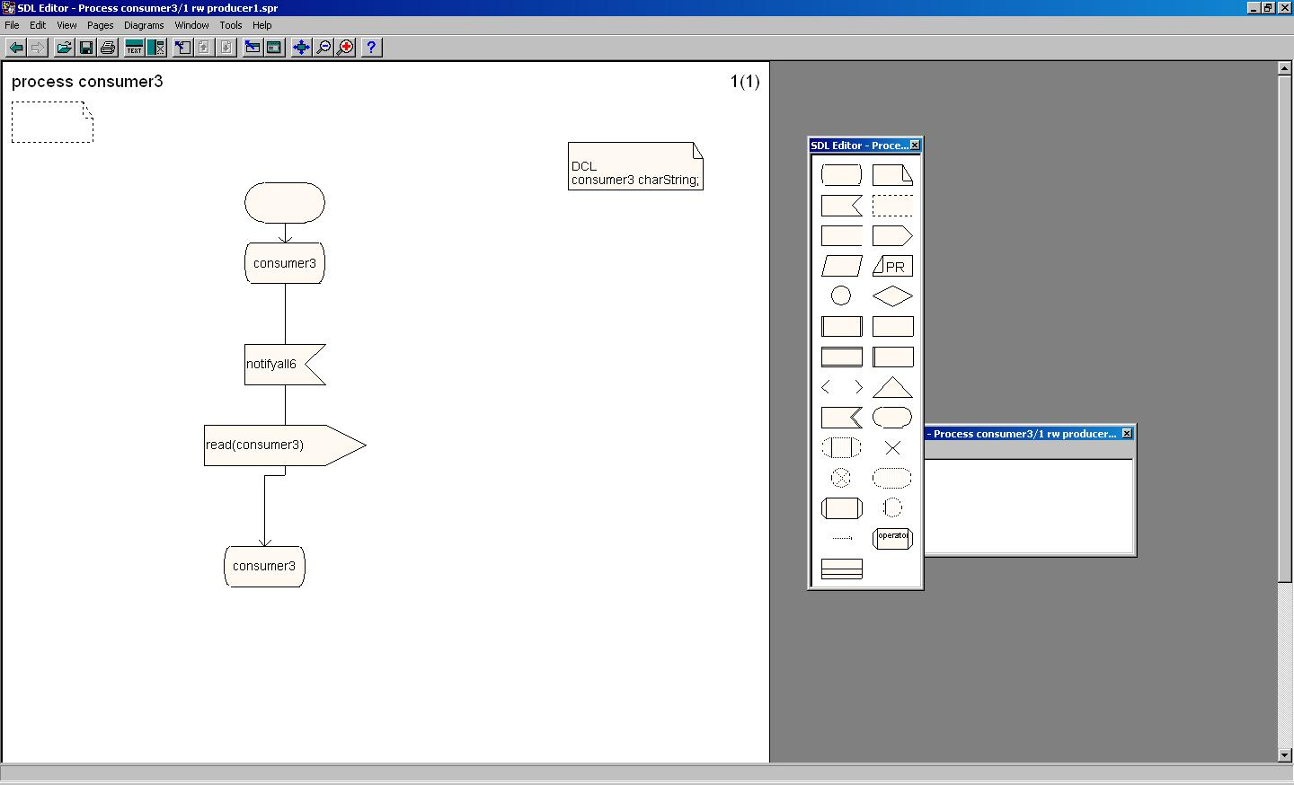

Producer
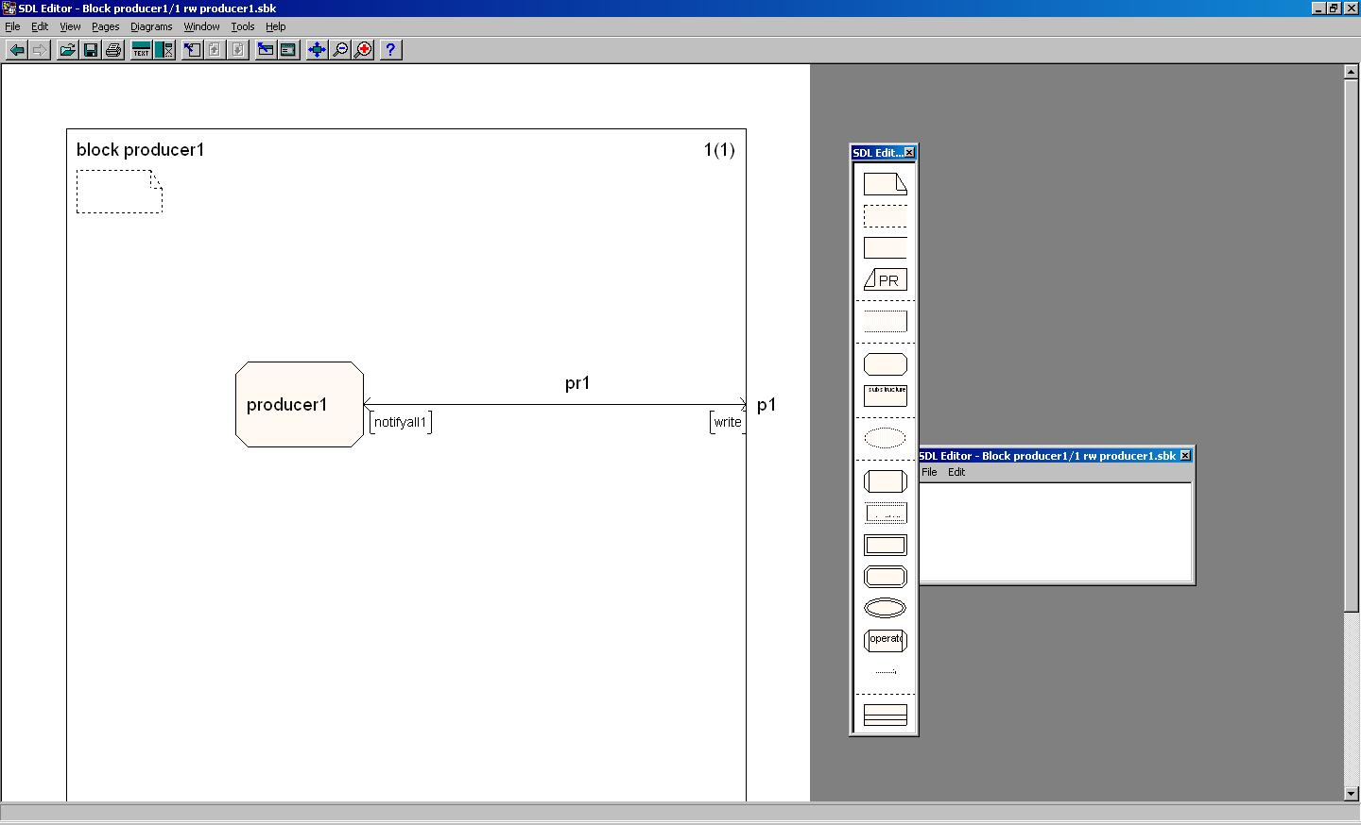
SharedBuffer
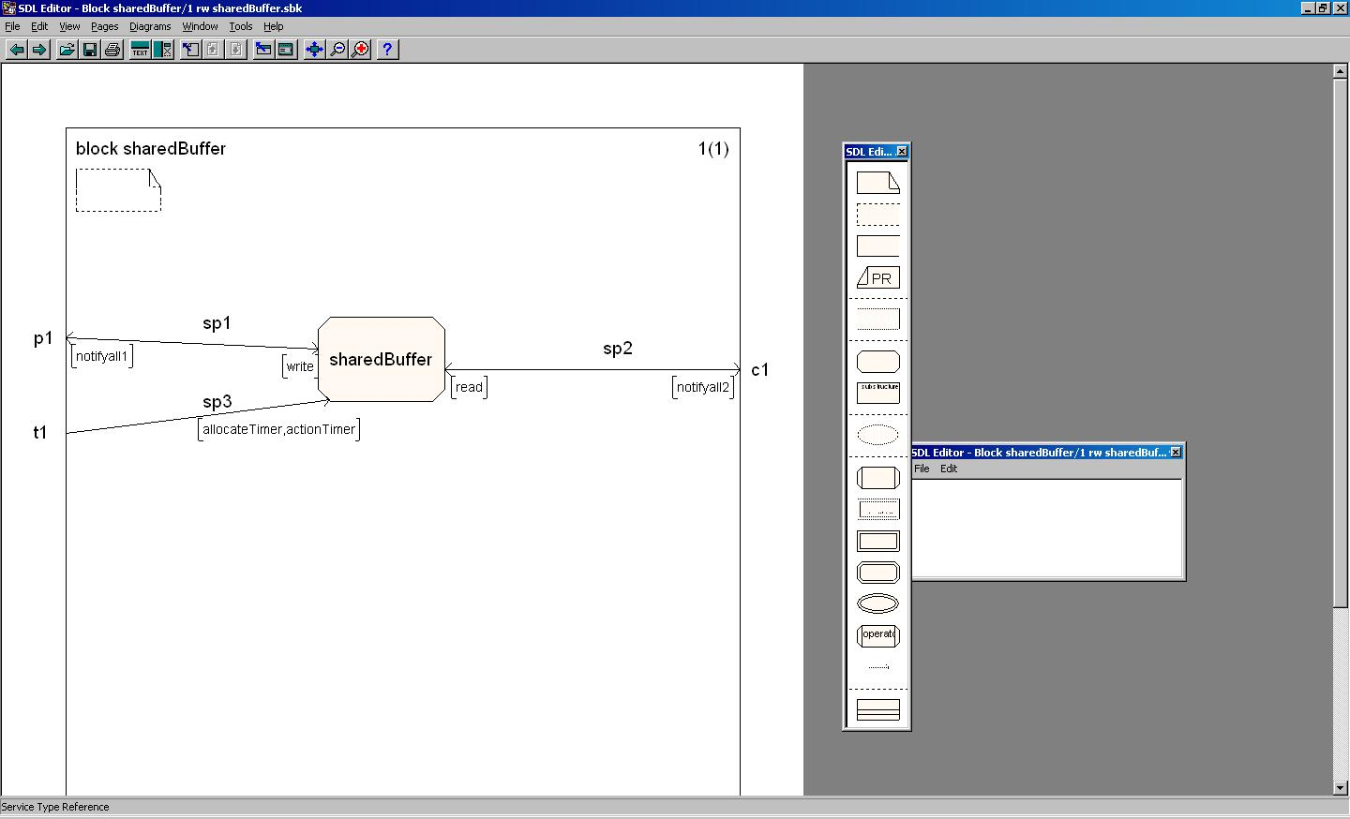

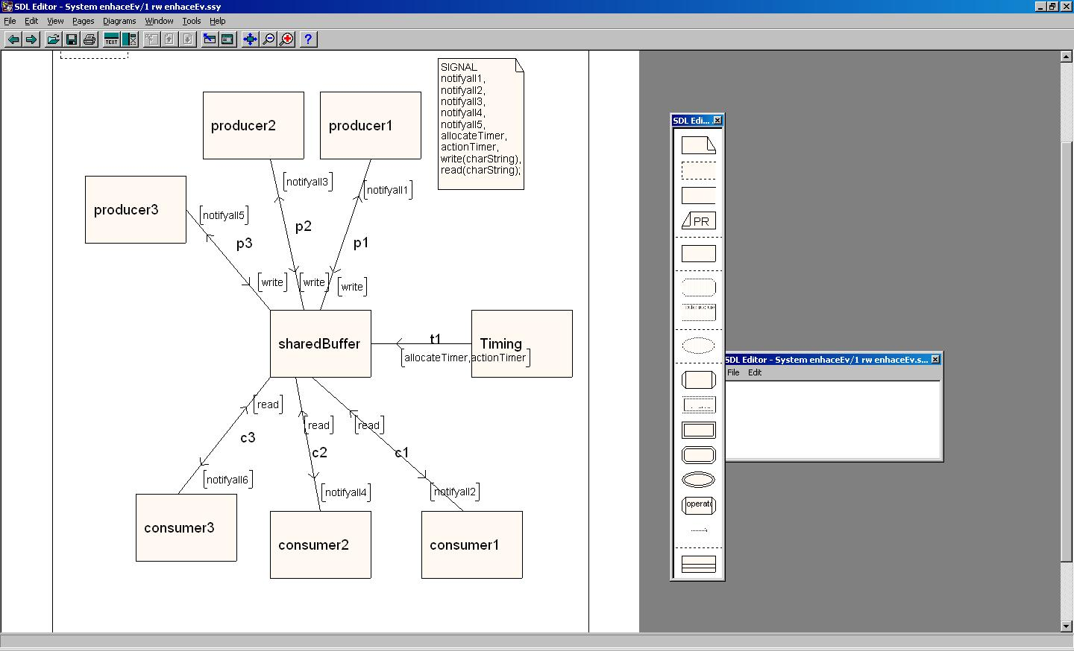
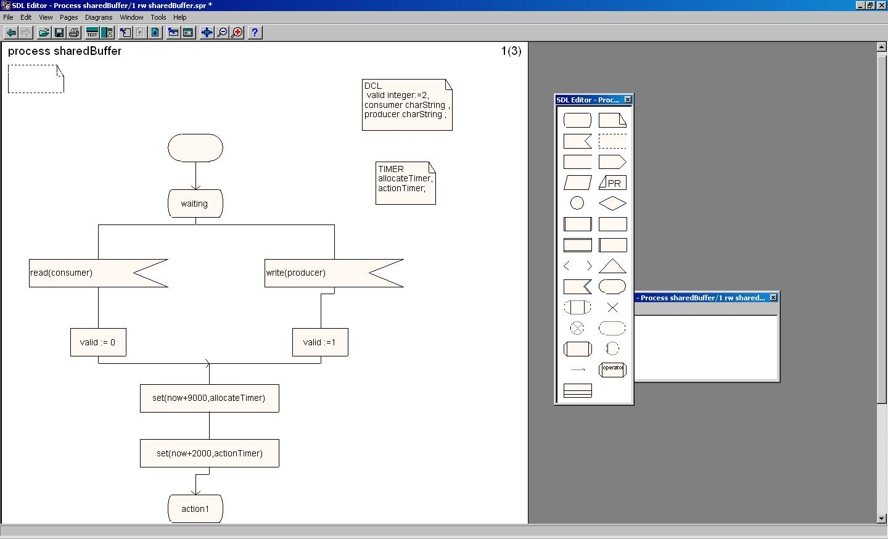
We validated the above system and the results are shown below:
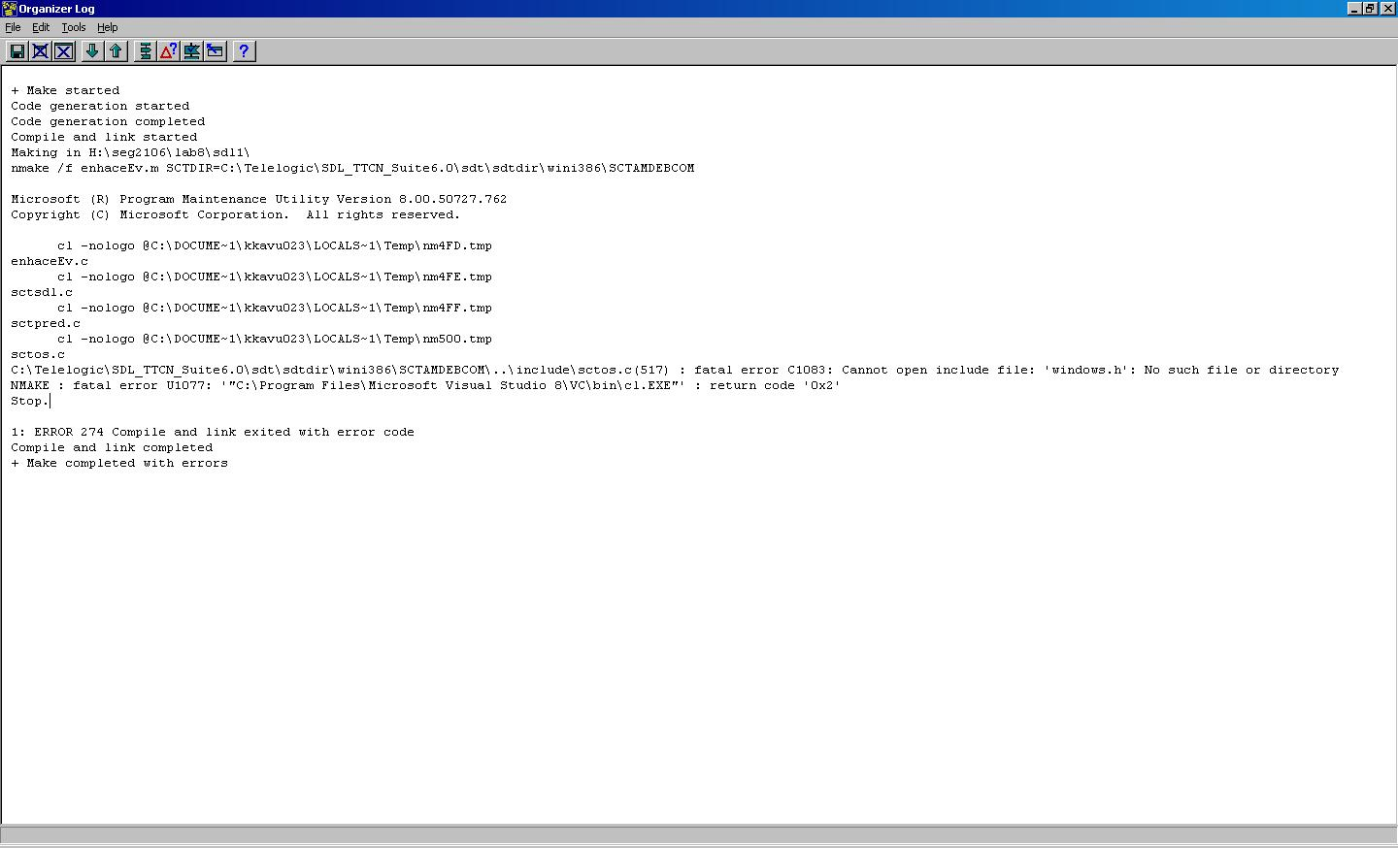

The System was well implemented in java than in sdl. This was due to complications caused by SDL. The version that we are using in the lab does not have the TIMER working. And we kept having an error which I showed above on the validation part, with that error we were not able to make the MSC. It was a very complicated lab especially on the SDL part.

We did learn a lot on this lab, about concurrency, It was very educative lab. I enjoyed doing this lab with java that did with SDL. If given another chance I will work at knowing how to implement this system in SDL well. The objectives of this lab were met.

