SEG2106

LAB 3 REPORT

STUDENT NAME: JOSEPH MOLOKO STUDENT NAME: KENNETH KAVUNA
STUDENT ID: 4270005 STUDENT ID: 4303818

Regular Expressions
Let us consider languages over an alphabet consisting of two letters: V= {a, b}. Give the regular expressions corresponding to the informally defined languages below;
- All words starting with aa.
Solution
aa (a+b)*
aa (a+b)*

- All words containing aa.
Solution
((aa)* (a|b)*)*

- All words containing an even number of letters.
Solution
((aa)* (b)*)*

- All words containing an even number of letter a.
Solution
((a|b) (a|b))*

- All words which length is a multiple of 5.
Solution
((a|b) (a|b) (a|b) (a|b) (a|b))*

- All words containing three consecutive a.
Solution
((aaa)* (b)*)*

- All words which do not contain three consecutive a.
Solution
^ (aaa) ((a|b)* (a|b)*)

Automata
For each regular expression below, give an accepting automaton that accepts the language defined the regular expression:
- L = (a |b) c ex. {ac, bc}
Solution
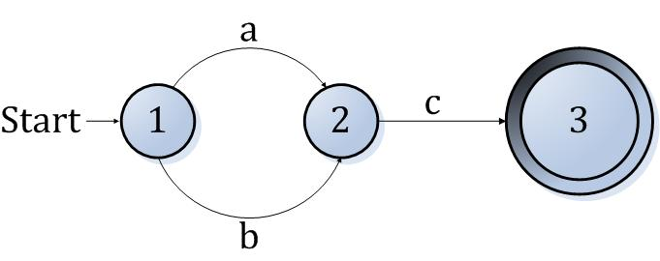
- L = a* b ex. {b, ab, aab, aaab, ...}
Solution
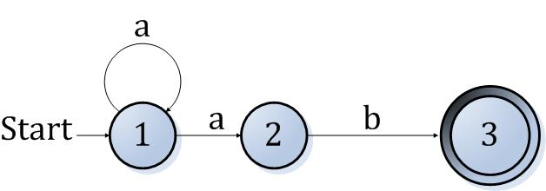
- L = a* (a b c)*
Solution
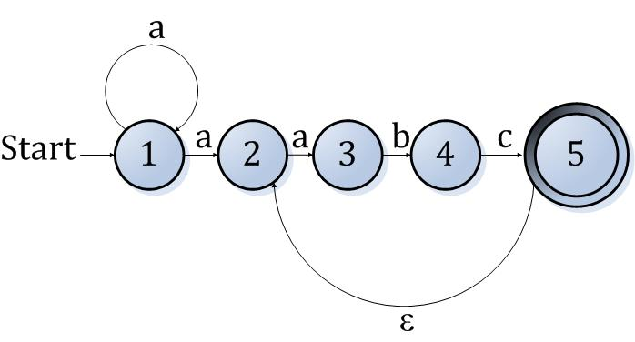
L = (a | b)*
Solution
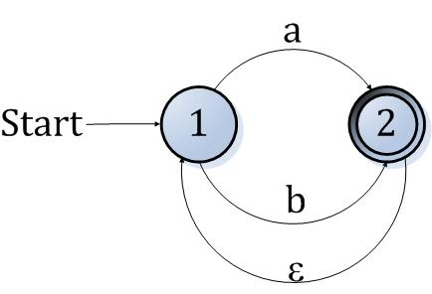

- L = (a | b) c* c b b*
Solution
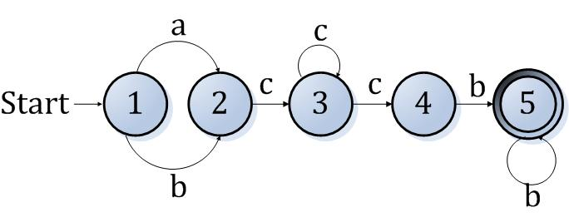

Programming a recognizer in Java

import java.io.*;
import java.io.BufferedReader;
public class lexAnalyser
{
static String state;
public static void main( String[] args ) throws IOException{
boolean match=true;//boolean for checking if the string in matched
BufferedReader stdin = new BufferedReader(
new InputStreamReader(System.in));
while(true){
System.out.println("Enter a word to match or press ENTER to exit");
String word= stdin.readLine();
if(word.length()>0)
analyze(word);
else
break; //terminate the program
}

}
static String a;
static String b;
public static void analyze(String word){
String temp= word.trim();// remove empty spaces at the end of the string
int i = 0;
boolean matcher = false;
for(i=0;i<temp.length();i++)
{
char ch= temp.charAt(i);

if(ch=='a'){
state = a;
if(i== (temp.length()-1))
{
matcher = false;
}
}
else
{
if(ch =='b')
{
if(!(i==(temp.length()-1)))
{
matcher = false;
break;
}
else matcher = true;
}
else
matcher = false;
break;
}
}

if(!matcher) {
System.out.println("NO-the given string is not matched");
System.out.println("------------------------------");

}

if(matcher) {
System.out.println("YES-the given string is matched");
System.out.println("-------------------------------");

}

}

}

}
else
matcher = false;
break;
}
}
if(!matcher) {
System.out.println("NO-the given string is not matched");
System.out.println("------------------------------");
}

if(matcher) {
System.out.println("YES-the given string is matched");
System.out.println("-------------------------------");
}
}
}

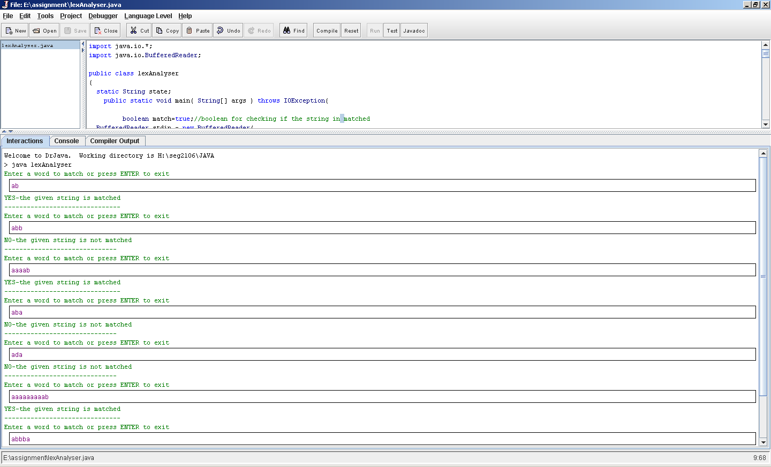

Introduction
The format of an email starts with a letter followed by letters or numbers or at least one dot. Then’ @’ follows then number, letters or one dot between two letters or numbers
The regular expression:
\b[A-Z0-9._%+-]+@[A-Z0-9.-]+\.[A-Z]{2,4}\b
From the above expression choose the first a-z before the second a-z or 0-9 or “.”, ‘@.
After the ‘@’ character numbers, letters or dots can follow each other .That will be our valid email.
The inputs which are going to be used to test are as follows: We expect the results to output only the valid email.
  - Here are some examples of valid e-mail addresses:
    - bochmann@site.uottawa.ca
    - groupe.seg-2501@site.uottawa.ca
    - bill@microsoft.com
    - localhost@127.0.0.1
  - Here are some examples of invalid e-mail addresses that should be ignored:
    - seg2501
    - seg@
    - seg@seg@qc.ca
    - groupe@.qc.ca
    - .@site.uottawa.ca
    - groupe@site..uottawa

The results found were not the same as the expected, the program compiled well. It was able to read correct numbers of lines from the input. Problem that was encountered was outputting correct results of the emails; this might have been due to our expression. But I feel that our expression was correct.

This lab was very informative and interesting. We learned to translate regular expressions to Java program, worked with lexical analyzer. This was enjoyable.

