SEG 2106
Assignment 1: Alarm Clock
Submitted by: Mark Bloess, 4218518
Professor: Gregor Bochmann

Table of Contents

1. Domain Analysis……………………………..…………………………………………………………………….………………..3
1.1 Statement of purpose…………………………………………………………………………………..……………………..3
1.2 Dictionary of used terms…………………………………………………………………….……………………………....3
1.3 Conceptual model………………………………………………………………………………………………………………..4
2. Assumptions………..………………………………………………………………………………………….………………….....4
2.1 Assumptions…………………………………………………………….…………………………………………………..……...4
3. Use cases………………………………………………………………………………………………………………………………...4
3.1 Use cases Names…………………………………………………………………………………………………………….….…4
  - Use cases MSC charts…………………………………………………………………………………………………………..5
3.2.1 SETTIME………………………………………………………………………………………………………………..5
3.2.2 SETALARM……………………………………………………………………………………………………..………8
3.2.3 ALARMONOFF……………………………………………………………………………………………….…….11
3.2.4 CONFIGUREALARM……………………………………………………………………………………….…….13
3.2.5 ALARMINTENSITY………………………………………………………………………………………….….…15
3.2.6 SNOOZE…………………………………………………………………………………………………….…………17

4. Functional design of the system in SDL………………….………………………………………………………..………..18
4.1 Alarm Clock SDL structure……………………………………………………………………………………………………18
4.2 SDL Diagram of the System………………………………………………………………………………………………….19
4.2.1 AlarmClock System………………………………………………………………………………………………19
4.2.2 AlarmBlock Block…………………………………………………………………………………………………20
4.2.3 Buttons Process……..……………………………………………………………………………………………21
4.2.4 Memory Process..….……………………………………………………………………………………………22
4.2.5 Control Process..…….……………………………………………………………………………………………25
4.2.6 Display Process..…….……………………………………………………………………………………………28

5. Simulation and validation of the system………………………………………………………………………...…………29

1.1 Statement Of Purpose:
To create an alarm clock consisting of a panel of buttons and a digital screen for displaying the time. Using the buttons the User can set the clock time, the alarm time, turn the alarm on and off, change the intensity of the alarm, change the type of alarm, and snooze the alarm.
1.2 Dictionary Terms:
Ringer:
Type of alarm that make a ringing sound
Radio:
Type of alarm that plays the radio.

Snooze:
Turns off the alarm for a period of 5 minutes.
User:
The person operating the clock.
Alarm:
Noise made at a specified time.
Time:
The Time set by the user.
Alarm Intensity:
Three different volume levels of the alarm.
Alarm Clock:
The entire system.

Hour:
There are 24 Hours in a day.

Minute:
There are 60 Minutes in an Hour.

1.3 Conceptual Model

The User interacts with the Clock with eight buttons on it. Here is the conceptual model using SOON notation:
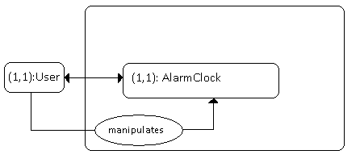

2.1 Assumptions:
- Assume the Clock time can only be increased until it loops back.
- The Ringer intensity can only be increased until it loops back to 1.
- Assume it is a 24 hour clock.
- The only buttons are a button to set the time, one to set the alarm, one to increase minutes, one to increase hours, one to switch between ringer and radio, one to increase ringer intensity, a snooze button, and one to turn off the alarm. So, 8 buttons total.
- The Alarm Clock must be plugged in or be running on battery power.
- The User must understand the outputs on the clock display.
3.1 Use Case Names:
- SETTIME
- SETALARM
- ALARMONOFF
- CONFIGUREALARM
- ALARMINTENSITY
- SNOOZE

3.2 Use Case MSC:
3.2.1 SET TIME: The User shall press the setTime button which will allow the User to adjust the Time. The User shall then press the Hour button which will increase the Hour by 1. The User shall press the Hour button as many times and the User wishes. If the Hour reaches 23, the next time the User presses the Hour Button the Hour will loop back to 0. The User shall then press the Minute button which will increase the Minute by 1. The User shall press the Minute button as many times and the User wishes. If the Minute reaches 59, the next time the User presses the Minute Button the Minute will loop back to 0. The User shall press the setTime button again to end the setTime use case. 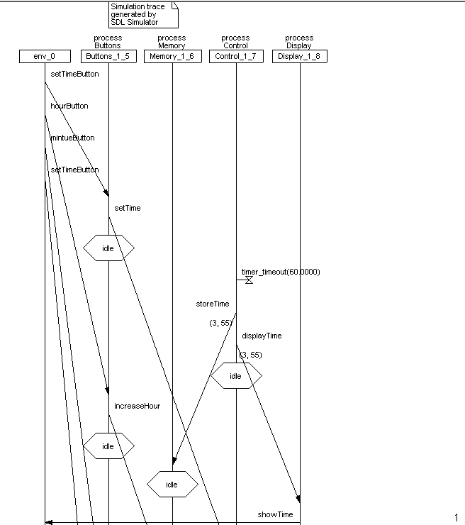
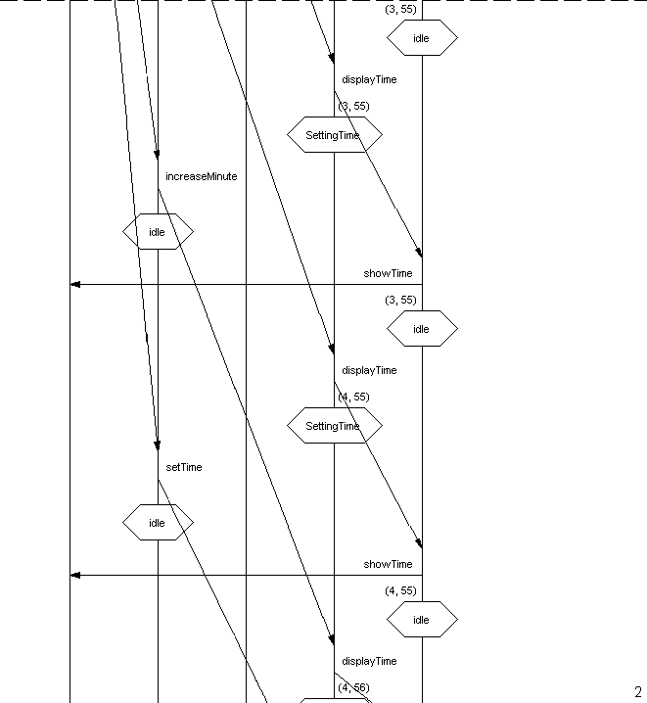
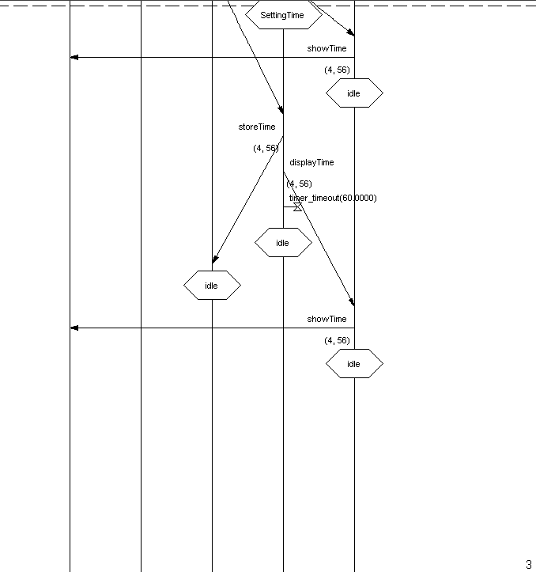

3.2.2 SETALARM: The User shall press the setAlarm button which will allow the User to adjust the Time. The User shall then press the Hour button which will increase the AlarmHour by 1. The User shall press the Hour button as many times and the User wishes. If the AlarmHour reaches 23, the next time the User presses the Hour Button the AlarmHour will loop back to 0. The User shall then press the Minute button which will increase the AlarmMinute by 1. The User shall press the Minute button as many times and the User wishes. If the AlarmMinute reaches 59, the next time the User presses the Minute Button the AlarmMinute will loop back to 0. The User shall press the setAlarm button again to end the setAlarm use case.
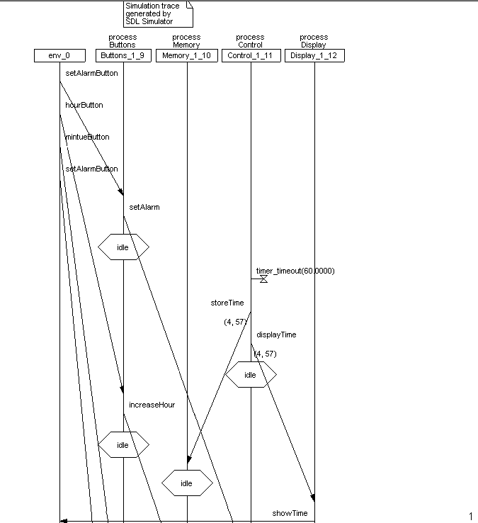
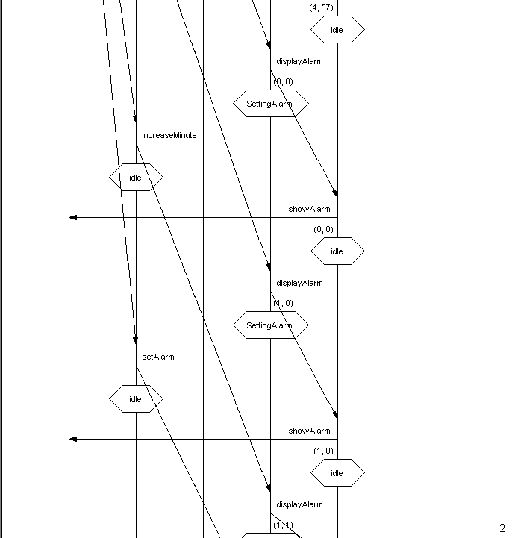
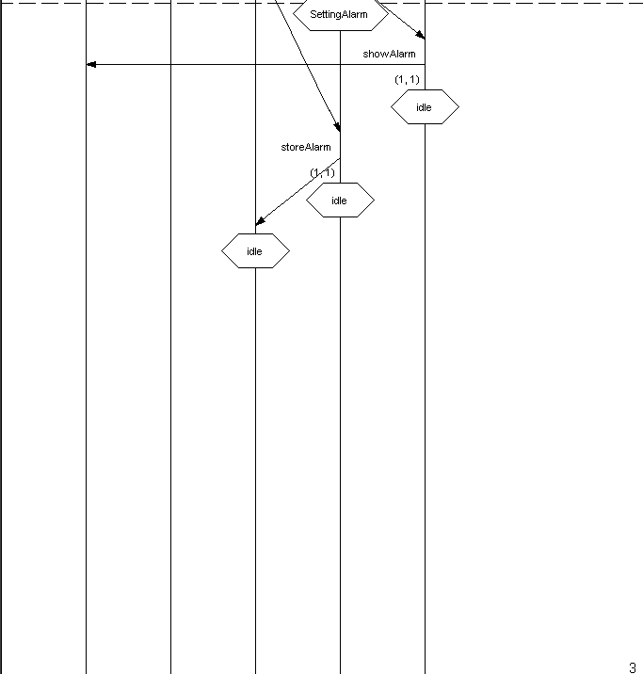

3.2.3 ALARMONOFF: The User Shall Press the AlarmOn Button to change the alarm status to On. If the alarm is already On then the alarm will be turned off.
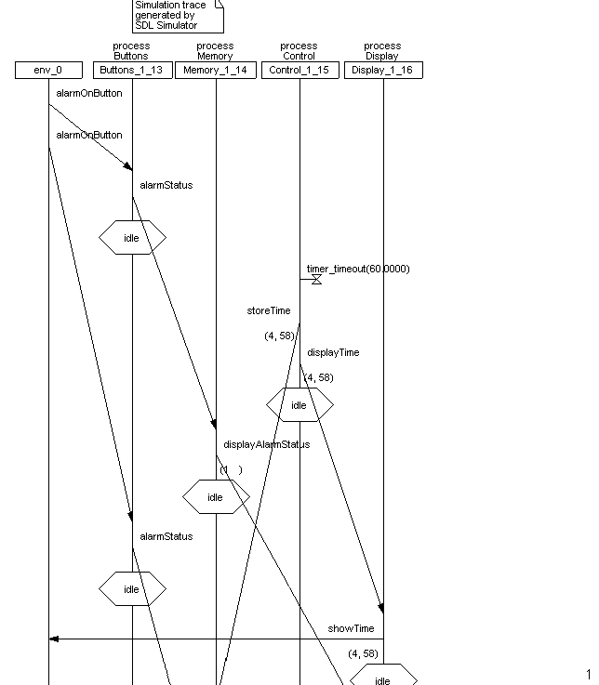
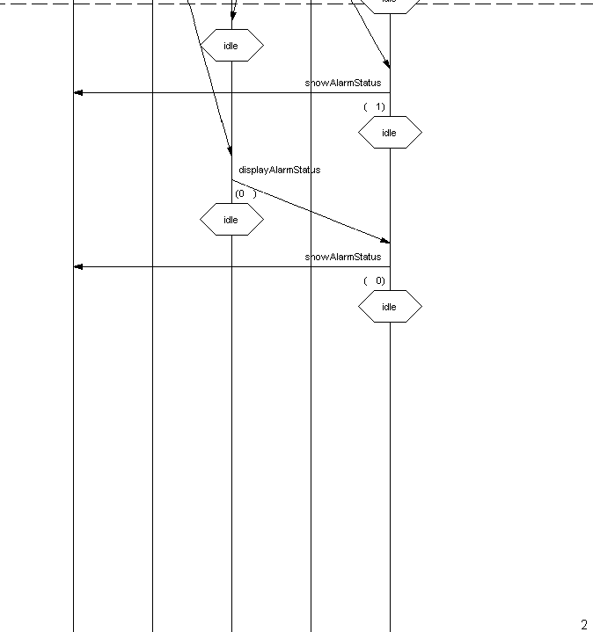
3.2.4 CONFIGURE ALARM: The User shall press the alarmType button to change the type of alarm that will go off. The alarmType button will cause the type to alternate between Radio and Ringer.
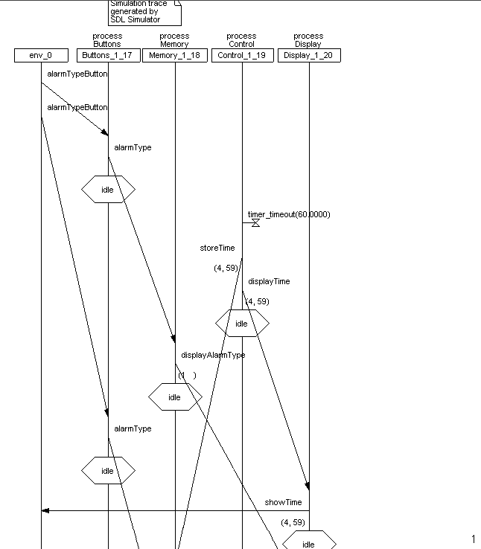
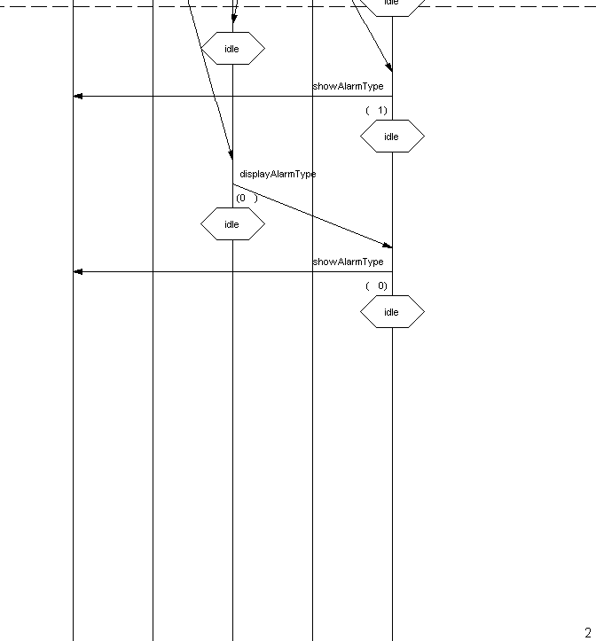

3.2.5 ALARMINTENSITY: The User shall press the alarmIntensity button to change the intensity of the alarm. Pressing the button once will increase the intensity by 1. When the alarm intensity reaches 3, the next time the alarmIntensity button is press the alarm intensity will return to 0.
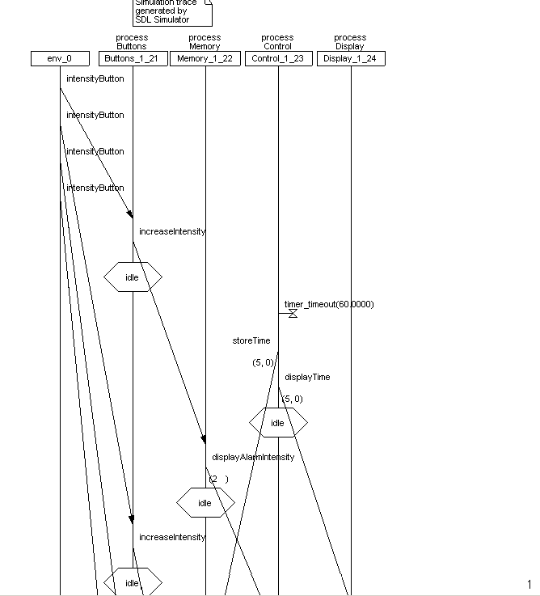
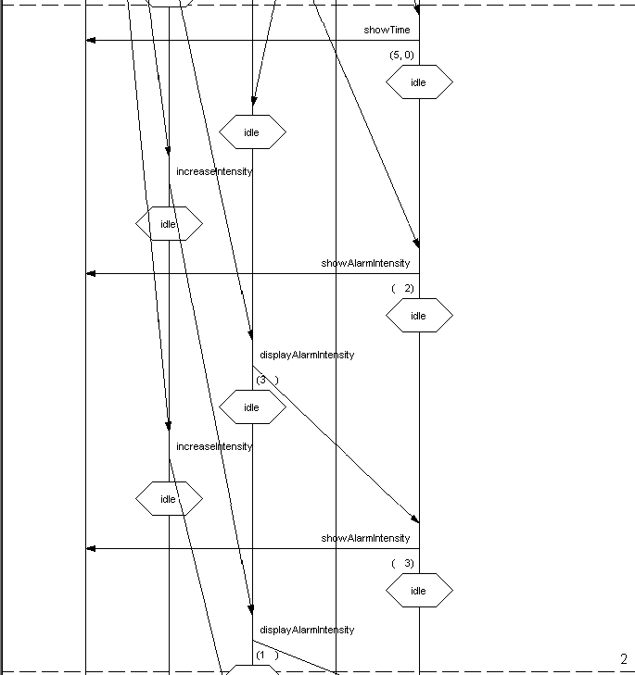

3.2.6 SNOOZE: The User shall press the snooze button to silence the alarm for 5 minutes. After 5 minutes the alarm will begin to sound again.
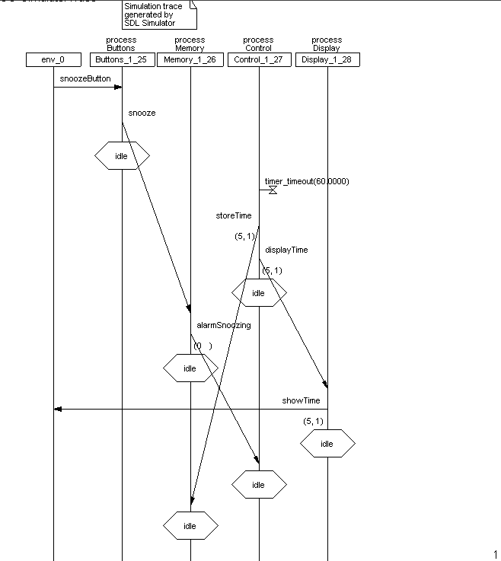

4.1 Structure of the Alarm Clock System:
The system consists of:
- 1 system
  - AlarmClock
- 1 block
  - AlarmBlock
- 4 processes
  - Buttons
  - Control
  - Display
  - Memory

The following is the structure to the above design:
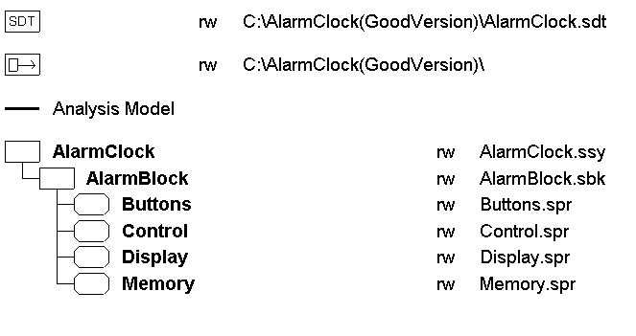

4.2 SDL Models
4.2.1 AlarmClock System
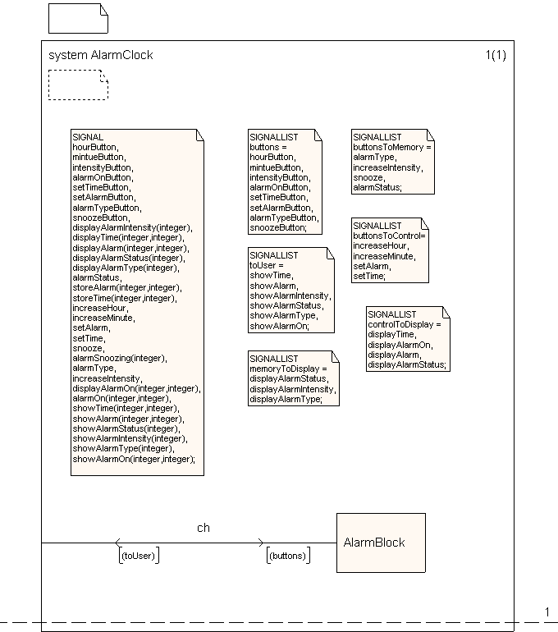

4.2.2 AlarmBlock Block
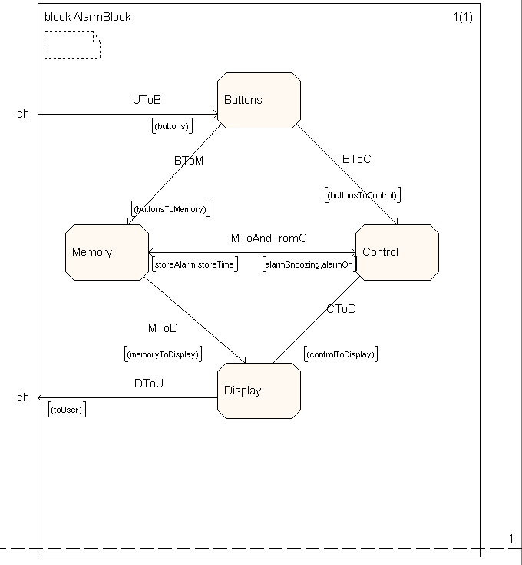

4.2.3 Buttons Process
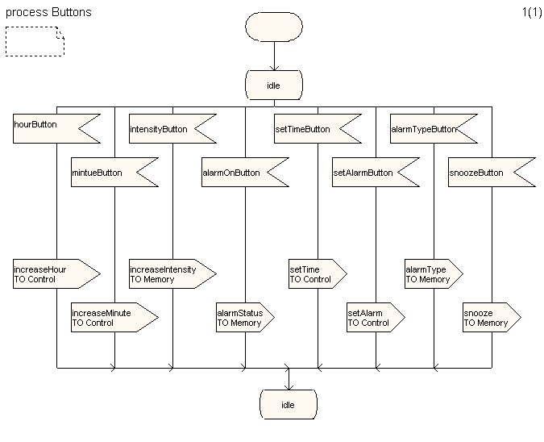

4.2.4 Memory Process
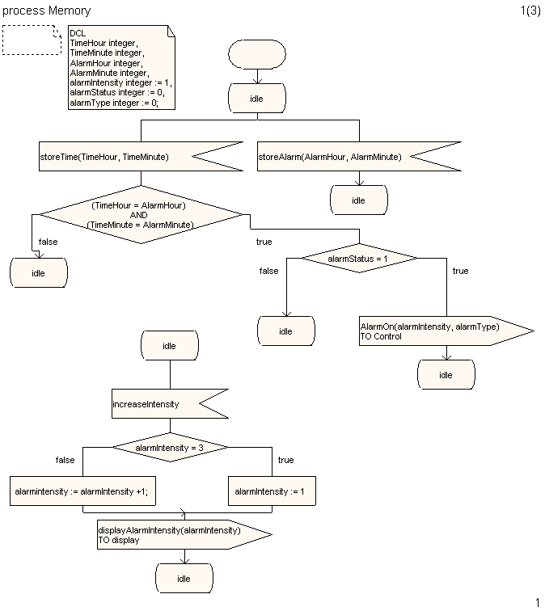

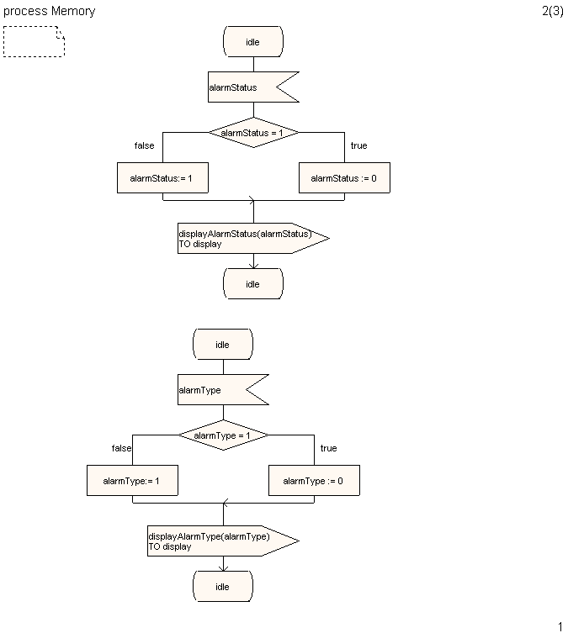

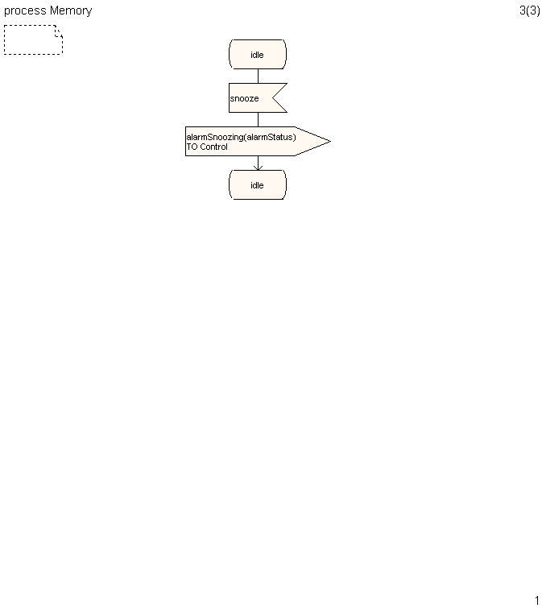

4.2.5 Control Process
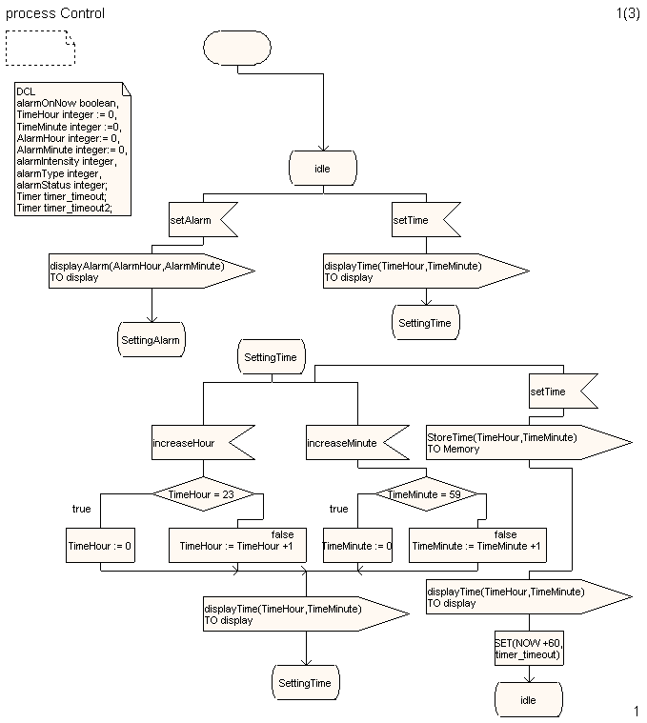

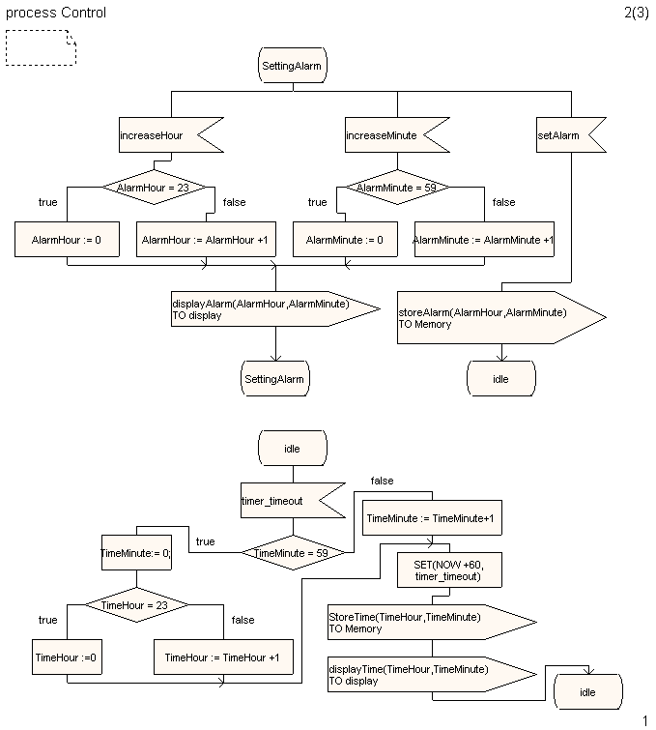
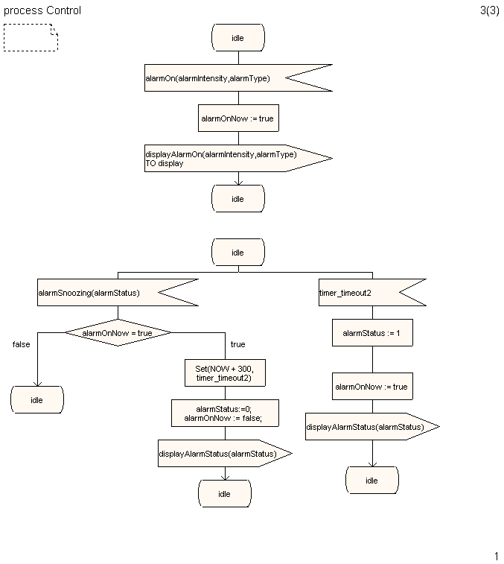

4.2.6 Display Process
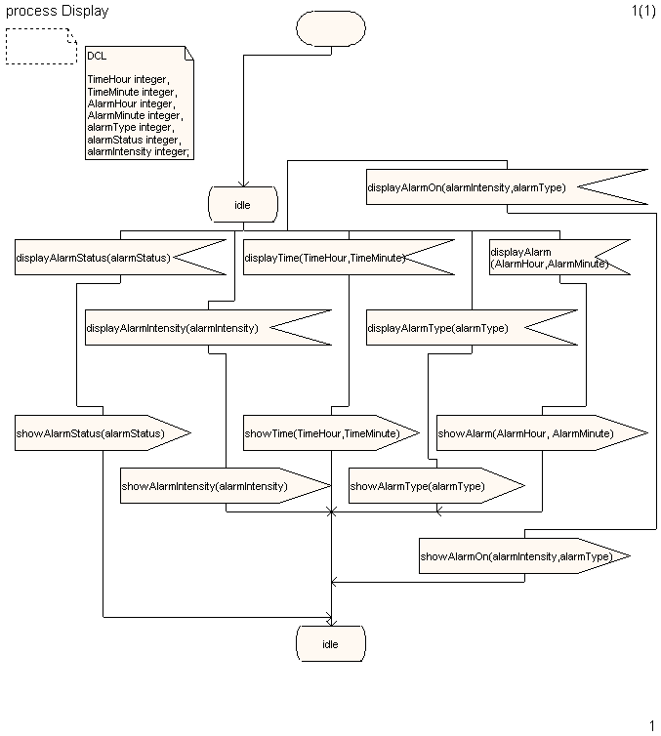

5. Simulation and Validation:
The Simulation of the Alarm Clock system executed properly and can be seen in all of the simulations corresponding to the Use Cases. The Hours and Minutes increment and are displayed. The alarm Type can be changed by the user between either radio or ringer. The alarm Intensity can also be changed by the user and will return to 0 after the third intensity. The Snooze silences the alarm for 5 minutes and then the alarm will continue. The alarm can be turned off so that even if the alarm time and clock time are the same the alarm will not sound. The Display receives all necessary information and passes it on to the User.
The Validation of the Alarm Clock system runs without any errors. There are a few warnings however. The main warning is that the snooze timer continues for a long time. It is meant to go for 5 minutes, but I think the timer may not increment at a steady rate of 1 per second. This could cause it to take an extra long time. Other than that the system seems to perform flawlessly. The validation confirms that the system is correct as far as syntax goes.

