ELG- 7187C – 2009 : Some exercises (second part of the course)

Question 1: Petri nets

(a) The figure below shows a Petri net that is (i) unbounded (the number of tokens at a place is not bounded), and (ii) may reach a deadlock. Explain in a few words why this Petri net has these properties.
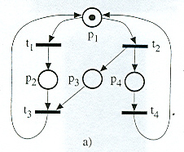

(b) The figure below shows another Petri net that is bounded and without deadlocks. Explain in a few words why these properties hold for this Petri net. Note: you may perform an analysis of all reachable configurations (states) of the Petri net.
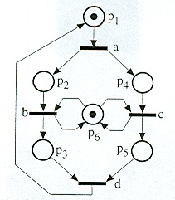

Question 2: Performance

Explain in a few words how functional state machine models (such as labeled transition systems, I/O Automata, communicating finite state machines, or Petri nets) could be extended to model performance properties. Explain the nature of the most important modeling paradigms for modeling statistical performance properties and for modeling hard real-time properties.

Question 3: Performance

Below is a description in UPPAL (formalism of Timed Automata) of a mutual exclusion protocol based on a shared variable id. The behavior shown in the figure below is executed by all processes that want to access a shared resource (“critical section”) under mutual exclusion. Try to do a sort of reachability analysis for a system consisting of two such processes, taking into account the time duration modeled by the timer variables x (local to each process).

Question 4: Protocol derivation

Please design a protocol including 3 entities that realize the communication service defined below. Please write down the behavior of the three entities M1, M2, and M3 that perform the operations of the protocol at the access points 1, 2 and 3 shown in the architectural diagram on the left. Their behavior should be such that they exchange messages with one another in order to synchronize the execution of the service primitives a, b, c, d, and e in the order specified by the transition diagram on the right.
As indicated in the figure, the interactions a and b take place at access point 1, c takes place at access point 2, and d and e take place at access point 3.
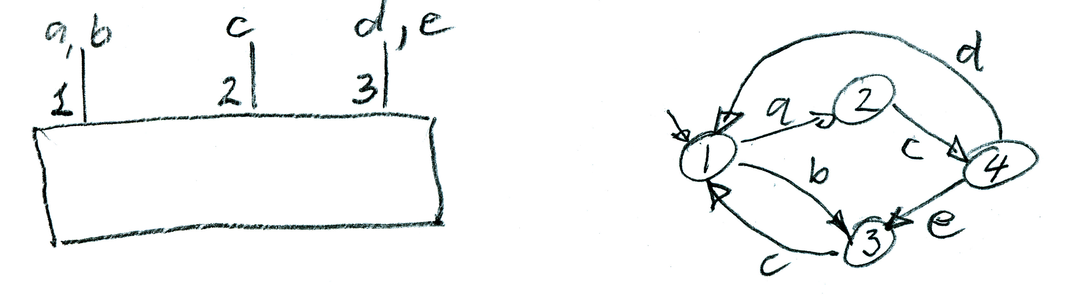

More questions on reachability analysis

Question A: Labeled transition systems

The figure below shows two labeled transition systems (LTS) A and B. B is non-deterministic. A uses the alphabet {a, b, c, d} and B uses only the labels {c, d}.
We consider the system consisting of A and B communicating through rendezvous for the interactions c and d, while the interactions a and b only involve the component A. Perform a reachability analysis to find the behavior of this composed system. Do you detect any design flaws, such as deadlock, unspecified reception, non-executable transition or livelock ? – Please discuss.
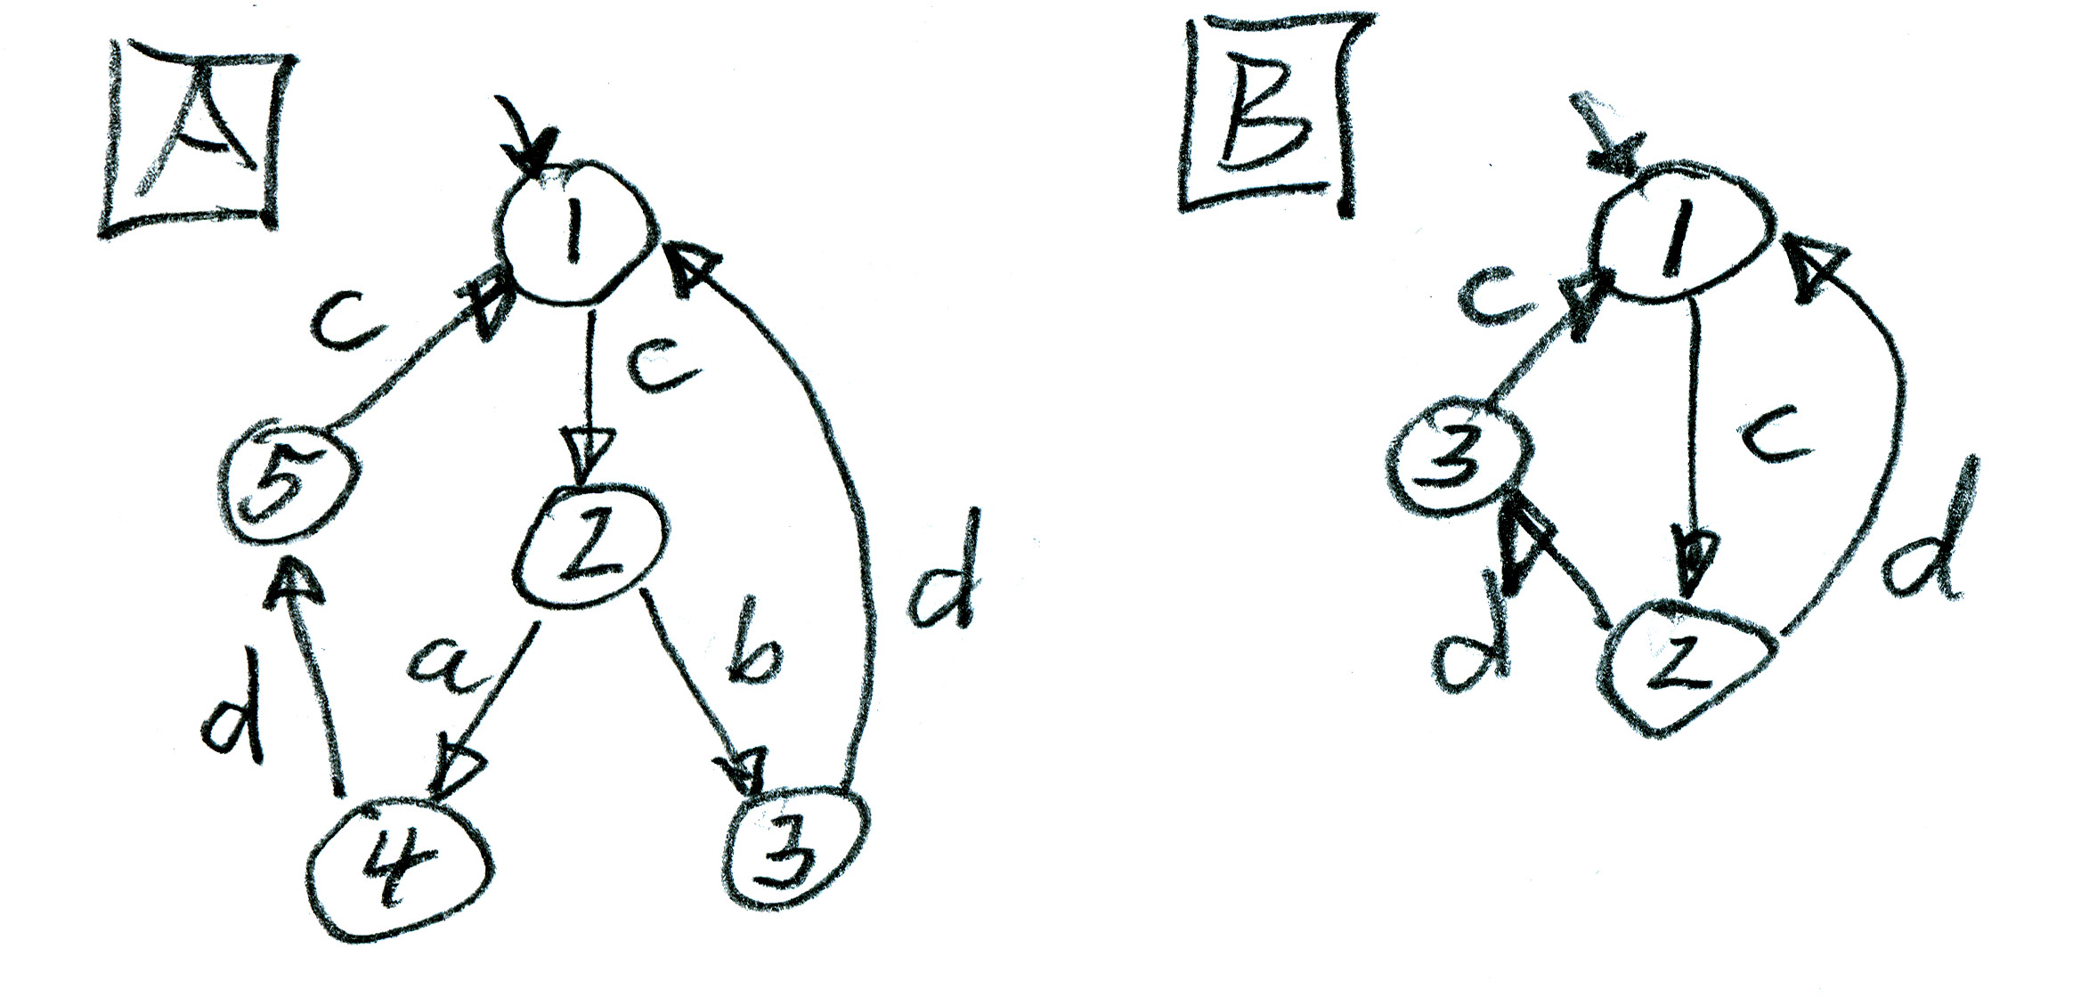

Question B: Reachability analysis for communicating FSMs

Below are the specifications of two protocol entities A and B that exchange messages a, b, c, and d through buffered communication channels.
Please, perform a reachability analysis for the two protocol entities A and B, and analyse the global behavior of these two entities. Do you detect any design flaws, such as deadlock, unspecified reception, non-executable transition or livelock ? – Please discuss.
If you find any design flow, please propose some suitable changes to the protocol specifications in order to eliminate the flaw.
