C-6.8: Adapt the Euler tour scheme in order to compute the balance factor (the difference between heights of its left and right subtrees) of each node in a binary tree.

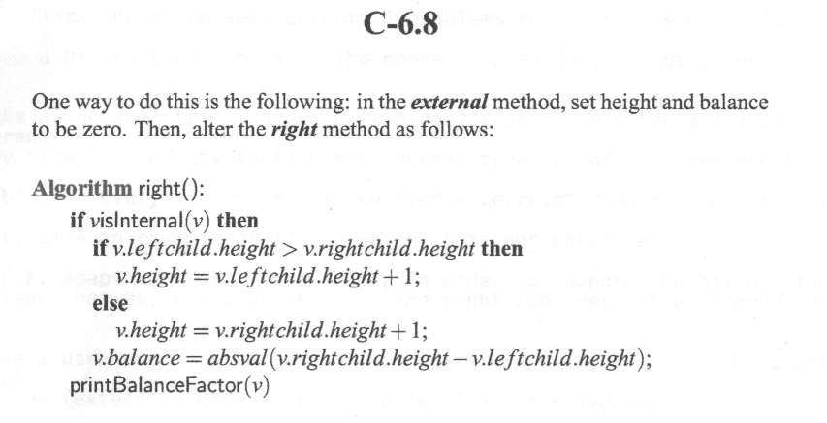
Below is an example about the height of each node. Simple formula for height of the node is 1+max(height of left or right).

When you visit the node from right using Euler tour, you guarantee that you visited all the nodes below it (its children). Thus just check if the left or the right children of this node has higher height, then this node height is just one plus that height and the balance factor can be calculated by taking the difference of the two children heights.

