We want to change
General tree ➔ Binary tree

Idea: the nodes on the same level starting from left to right will be child for one after another.

Examples:
General:
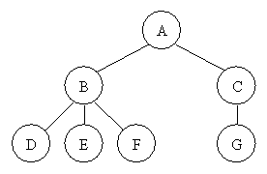

Binary:
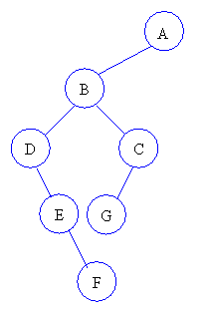

* Think about a binary tree of one node and two children?!
Is it possible to: Binary tree ➔ General tree

