Purchasing Dell computers at EECS

The following outlines the steps to be followed by EECS professors and researchers who wish to order Dell computers.
Before you start, you must have a Dell Premier account that is properly linked to EECS at uOttawa. If you do not have one or are not sure, contact Michel Racine (michel@eecs.uottawa.ca)
Login to http://premier.dell.com/; once logged in, you will get a page similar to this one:

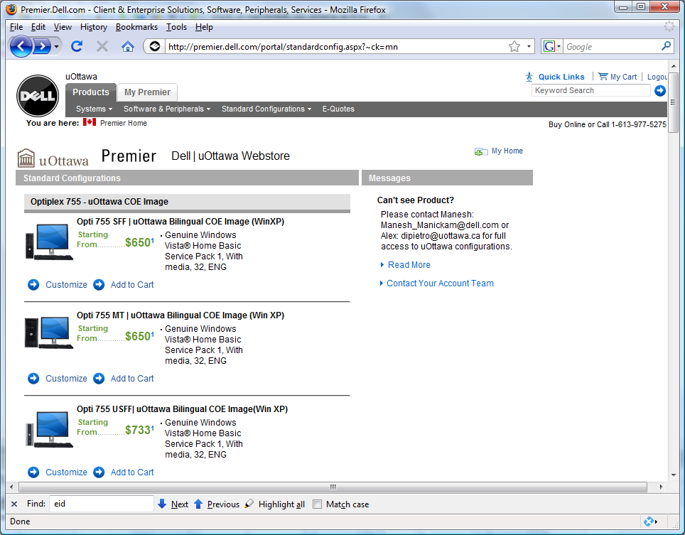
Select to customize the model you want (desktop/laptop). SFF means Small Form Factor, MT means Medium Tower, USFF means Ultra Small Form Factor.
Once you have completed the selection process, select ‘Add to Cart’. You can then continue to shop, or finalize your order. To do so, select ‘Save as E-quote’ (do not proceed to Checkout).
Fill in your name and information in the ‘Contact’ section:
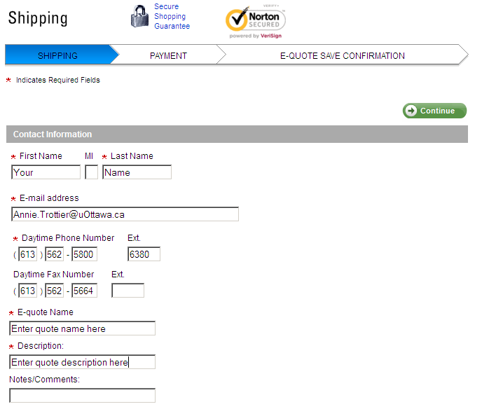
The authorized buyer can be set to ‘Richard Mandia’ from the pull down menu; once selected, the ‘Authorized Buyers’ fields will be populated appropriately.
Fill in the ‘Ship To’ section with Martin Demers’ information (see below). 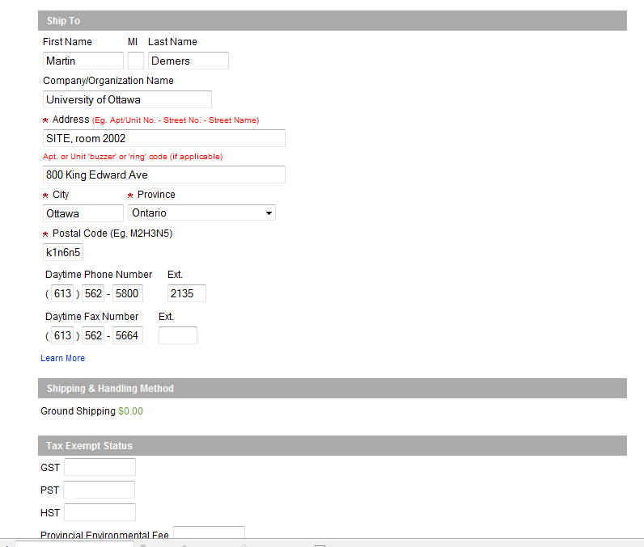
Select Continue.
Review the order details, then fill in the information for EECS’s Financial Officer in the Billing Information (see below):
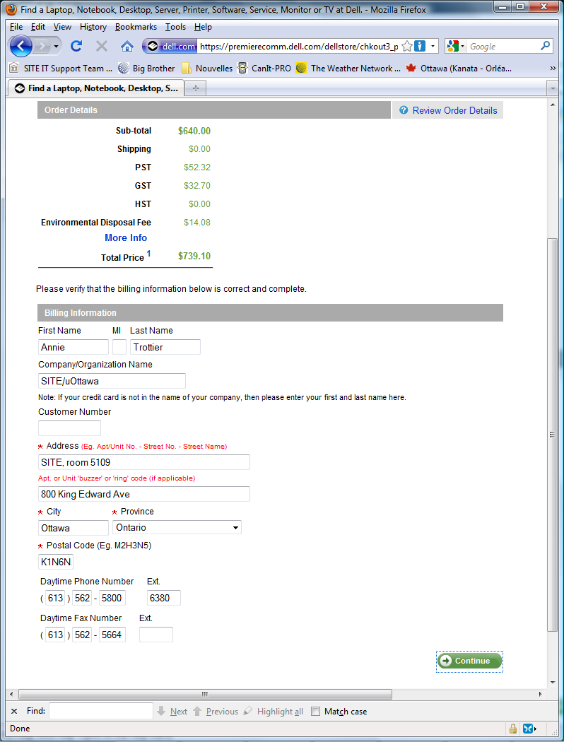

Select Continue; your order is the processed and you will receive an notification email. To complete the order process, you need to forward this email to Annie Trottier, EECS’s Financial Officer, along with the cost center that is to be used for the purchase.
She will submit your order to Dell.
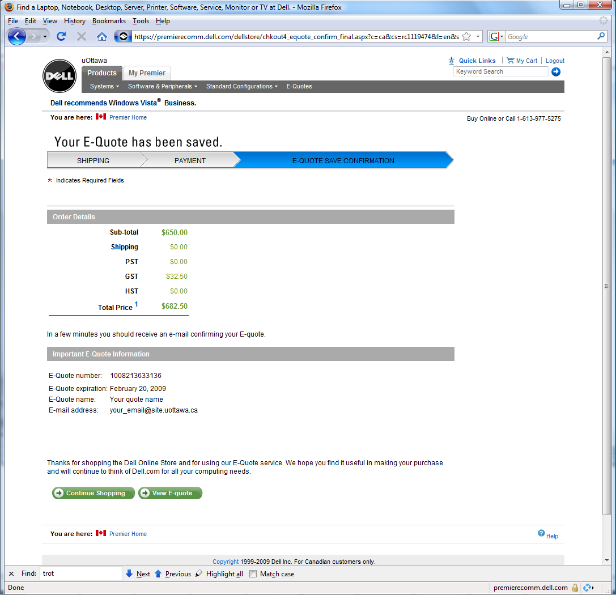

Cheers!

