ELG4125 Case Journaling

Student Name
Student Number

This journaling document contains several tasks related to the ELG4125 project.
Each task will be submitted and graded individually and according to the dates indicated.

A Typical “Whole” Power System
(This block diagram describes the building blocks of a particular project therefore; it should be used as a guide only when you draw the block diagram of your project)

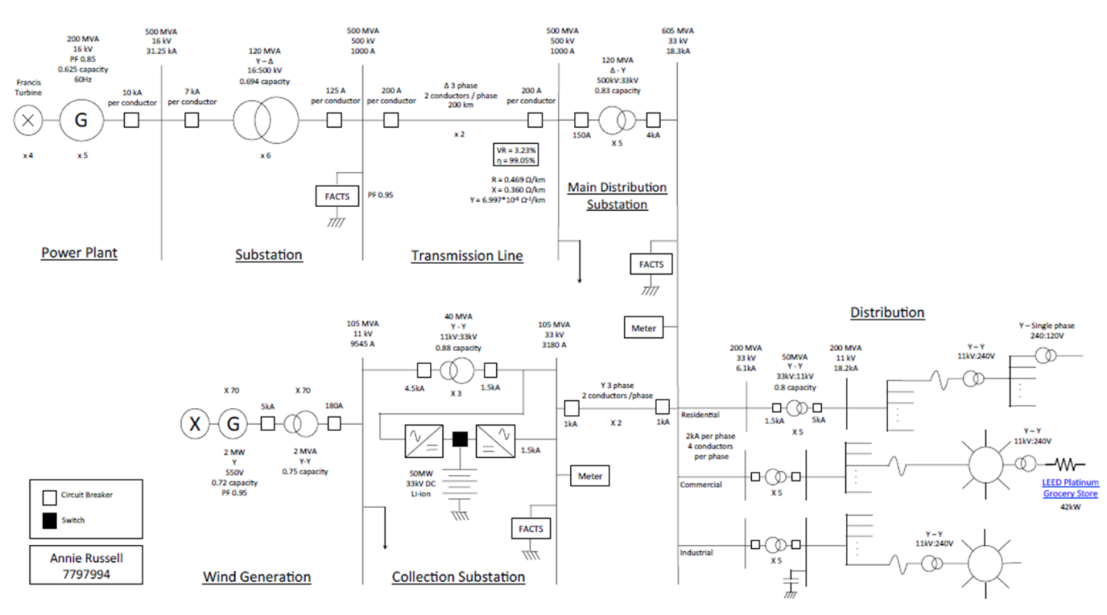

Case Statement

Consider a power plant (Wind Farm) of 1GVA that delivers a transmission line system with a voltage of 500 kV. The transmission line feeds the city of Ottawa that is 200 km away from the wind farm. University of Ottawa represents one of the loads in the city of Ottawa with a thermal power plan. It is proposed to turn the campus into a microgrid with the addition of 500 kVA solar power. For this case it is required to provide a complete design work for the above power system.

Case Block Diagram

Individual Submission 1: Wind Farm, Substation, and Transmission System
Design and size the required wind farm including wind turbines, components, and specifications

Design and size the required transmission substation including transformers, other components, and specifications.

Design and size the required transmission system including towers, circuits, conductors, insulators, and other specifications. Calculate the related efficiency and voltage regulation

Submission 2: Distribution System and Protection

Submission 3: uOttawa as a Microgrid

Final Submission: on Final Exam Day
(Rearrange the Entire Case in a 10-page e-Portfolio)

