ELG3336 Journaling the Design/Build Project
(Based on the concept of CDIO: Conceive-Design-Implement-Operate)

Student Name
Student Number

This journaling document contains several tasks related to the ELG3336 project.
Each task will be submitted and graded individually and according to the dates indicated.

A Typical “Whole” Mechatronics System
(This block diagram describes the building blocks of a particular project therefore; it should be used as a guide only when you draw the block diagram of your project)

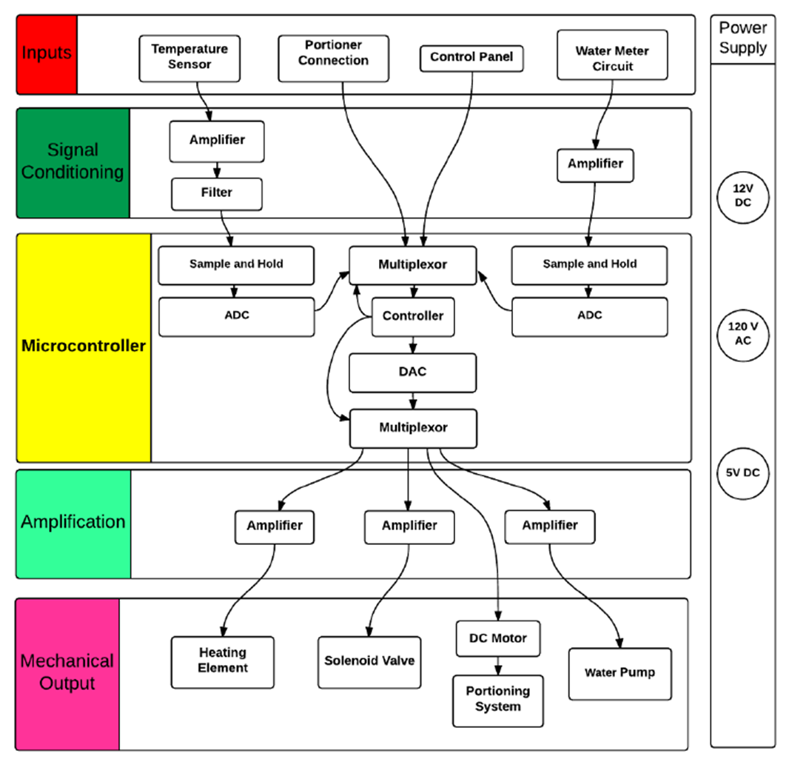

Submission 1: Project Proposal (5 marks)

Proposed Title of the Project:

Mechanical Engineering Team:
Name | Email

TA Supervisor:
Name | Email

Engineering design is the application of math, science and engineering principles to the creation and development of systems components and processes.

Project Details and Brief Design

Problem Statement
Clearly and concisely identify the problem.

Design Build Statement
The design statement is challenging; it is about taking action to address the need and to solve the problem. It must specify the degree to which you will carry out the solution. The design statement may also contain an underlying theme or very important constraint.

Constraints
These are guidelines that must be followed. Examples include time, budget, aesthetics, codes, safety, and physical attributes.
1
2
3
4
5
6
7

Generated Concept
Brainstorming and preliminary sketches

Item | YES or NO
Prototype
Presentation
Demonstration of Prototype
Video
Required Facilities
1
2
3
4

Knowledge Areas and Simulation Tools Needed for Project
1
2
3
4

Estimated Budget
Item | Cost

Submission 1 (5 marks)
(October 21, 2018)

Write a statement that describes your project (about 200 words).
Draw a block diagram that clearly describes the project you are building.
Write the specifications of the sensor(s) and microcontroller used in the project.
Design suitable amplifier, filter, multiplexer, and analog to digital converter although these circuits may exist in the Arduino.
Determine the design criteria and draw the corresponding circuits.
Design Criteria:
- What exactly is the context and scale of the problem?
- How to solve the problem?
- Why your approach is the right one?
- Always pay attention to the Quality of presentation in terms of effectiveness, tools, and questions answered.

Submission 2
(To be Determined)

Submission 3
(To be Determined)

