ELG2336 Test 1
Name: Number
This is your test 1 draft. Print and bring it to the classroom on February 1, 2018. Test requirement and values will be given at the beginning of the test.
Question 1 (2 marks):
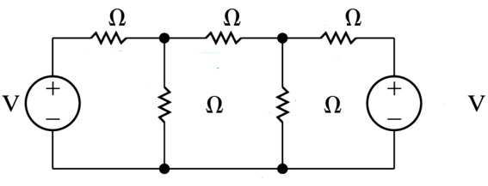

Question 2 (3 marks):
