Preparation for the final for ELG7187

Question 1

- Is the number of L1 cache misses larger or smaller in a multithread processor in comparison with RISC processor? Assume that both processors have L1 caches that are of same size and type.

- How does MESI protocol reduce the amount of bus transactions in comparison with MSI protocol?

- The trade-off in on-chip network design is the amount of buffer space compared to wire bandwidth. In traditional off-chip networks, the wire bandwidth is at a premium, but on-chip buffering is relatively inexpensive. With on-chip networks, the wiring bandwidth is high, but the buffer space takes up silicon area, the critical resource. Another aspect of on-chip networks that affects buffering is that they are more reliable than interchip networks. How are these facts used to decide about the type of switching and router design?

- Draw schematically the architecture of a hardware performance counter. Describe each component.

- Why are cache controllers designed to support parallel tags in caches?

- Would you select circuit switching or packet switching network for the streaming data application?

- Describe how crossbar slicing works. If we use 2 3x3 switches instead of 1 5x5 switch, how can this help in performing X-Y routing? Draw configuration of these 2 3x3 switches.

- Why is operating system usually involved if communication is done through the shared memory and not to be involved if the communication is done through the direct communication?

Question 2
Consider a shared memory system with two processors A and B. Each processor has a cache that is direct-mapped and has 64 blocks with block size of 16 bytes. The words are 4 bytes. The cache is initialized with all zeros.
The following sequence is executed
- Processor A writes a word 11 to the address 1200
- Processor B reads a word from the address 1208
- Processor A writes a word 33 to the address 1200
- Processor B writes a word 44 to the address 1208
- Processor A reads a word from the address 1208

Give the state of the cache controller and the contents of the caches and the memory (x) after each step, if
(a) no cache coherence support is available
(b) basic MSI write-back invalidation protocol is used (Figure 1).

a) | State of A’s cache | Content in A’s cache | State of B’s cache | Content in B’s cache | Content of memory locations 1200-1215
- Processor A writes a word 11 to the address 1200
- Processor B reads a word from the address 1208
- Processor A writes a word 33 to the address 1200
- Processor B writes a word 44 to the address 1208
- Processor A reads a word from the address 1208

b) | State of A’s cache | Content in A’s cache | State of B’s cache | Content in B’s cache | Content of memory locations 1200-1215
- Processor A writes a word 11 to the address 1200
- Processor B reads a word from the address 1208
- Processor A writes a word 33 to the address 1200
- Processor B writes a word 44 to the address 1208
- Processor A reads a word from the address 1208

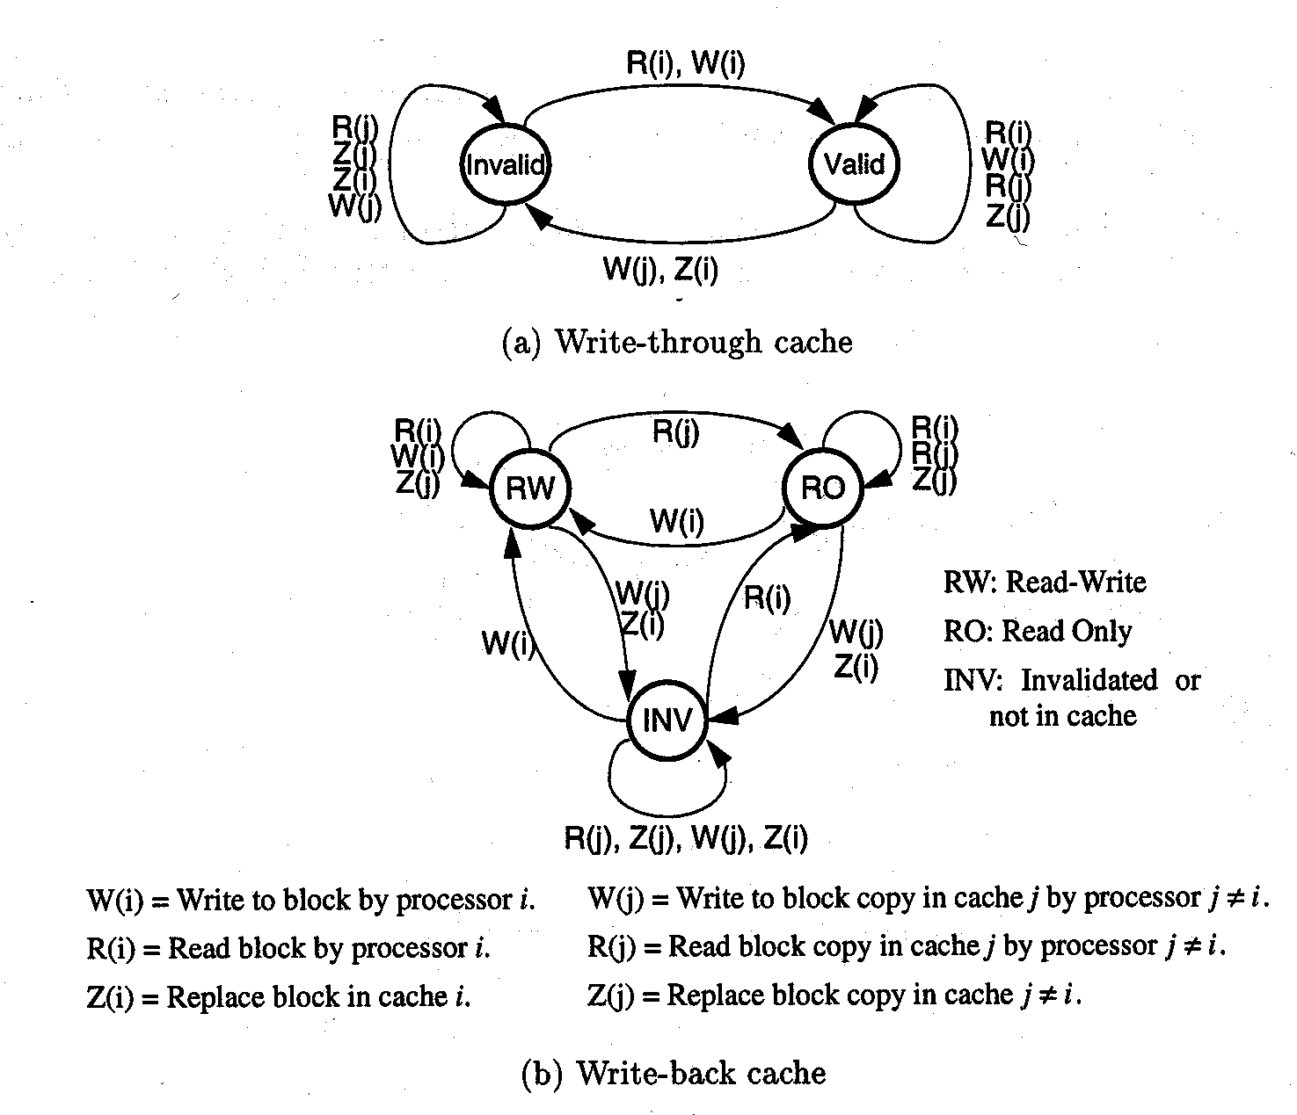
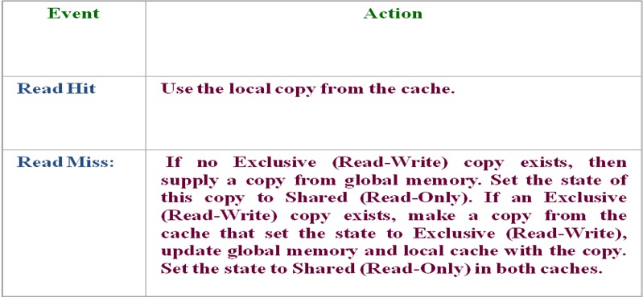
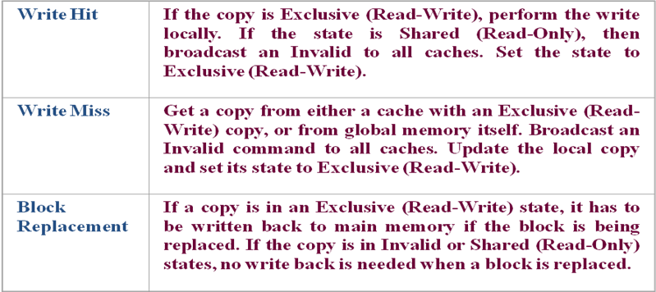
Figure 1 State machine and the table for write-back write invalidate cache coherence protocol

Question 3
You are writing an image processing code snippet, where the image is represented as a 2-d array of pixels. The basic iteration in this computation looks like:

for i = 1 to 1024
for j = 1 to 1024
newA[i,j] = (A[i,j-1]+A[i-1,j]+A[i,j+1]+A[i+1,j])/4;
Assume A is a matrix of 4-byte single precision floats stored in row-major order (i.e A[i,j] and A[i,j+1] are at consecutive addresses in memory). Assume that there are no array index out of bound errors. A starts at memory location 0. You are writing this code for a 32 processor machine. Each processing element has a 32 Kbyte direct-mapped cache and the cache blocks are 64 bytes. Assume that write through protocol is used and that no cache coherence mechanism is implemented.

- You try assigning 32 rows of the matrix assign 32 contiguous rows of the matrix to each processor. What is the actual ratio of computation to bus traffic that you expect? Please explain what you consider to be a bus transaction and how many bytes are involved in one transaction. State any other assumptions.
- Is there a need for adding synchronization primitives to this program? Why or why not?
- Find the number of bus transactions in case write-invalidation write back cache coherence protocol (for example MSI shown in Figure 1)?

QUESTION 4

- a) Consider a parallel multiprocessing system on chip in which processors have 2 levels of caches (L1 and L2). Caches are inclusive. A snooping invalidate cache coherence protocol is used. Is L1 or L2 cache controller responsible for enforcing coherence within the chip. Why?
b) Let’s assume now that cashes are non-inclusive i.e. the data might be read from the memory directly to L1 cache. How would cache coherence be maintained in this case?

- Why would we need a writeback buffer in case of block replacement? Does this cause a problem with sequential consistency? How is that problem addressed?

- In case the Store Conditional (SC) instruction fails, bus will not be accessed. How is that achieved? In order to support that feature, do we need to modify cache controller? How?

- Could adaptive routing affect memory consistency? How? If yes, how can this problem be addressed?

- If the processor has only 2 performance counters, how it is possible to monitor more than 2 events? How is that implemented in practice? After the information from the performance counter is obtained (for example the number of TLB misses in a multiprocessor shared memory system) what can be done/improved?

- In a dynamic Non-Uniform Cache NUCA cache (multi/manycore with distributed L2 cache), a block can be placed in one of many different physical banks. Hence, finding the block is a non-trivial problem. Please suggest some efficient ways to find the block.

QUESTION #5

The fetch-and-add atomic operation can be used to implement barriers, semaphores and other synchronization mechanisms. The semantics of fetch-and-add is such that it returns the value before the addition. Use the fetch-and-add primitive to implement a barrier operation suitable for a shared memory multiprocessor. To use the barrier, a processor must execute: BARRIER(BAR, N), where N is the number of processes that need to arrive at the barrier before any of them can proceed. Assume that N has the same value in each use of barrier BAR. The barrier should be capable of supporting the following code:
while (condition) {
Compute stuff
BARRIER(BAR, N);
}
1. A proposed solution for implementing the barrier is the following:
BARRIER(Var B: BarVariable, N: integer)
{
if (fetch-and-add(B, 1) = N-1) then
B := 0;
else
while (B <> 0) do {};
}

What is the problem with the above code? Write the code for BARRIER in a way that avoids the problem.

QUESTION #6

Consider the distributed shared-memory system illustrated in Figure 1. Each processor has a single direct-mapped cache that holds four blocks each holding two words. To simplify the illustration, the cache address tag contains the full address and each word shows only two hex characters, with the least significant word on the right. The cache states are denoted M, S, and I for Modified, Shared, and Invalid. The directory states are denoted DM, DS, and DI for Directory Modified, Directory Shared, and Directory Invalid. The simple directory protocol is described in Figures 2 and 3.

For each part of this problem, assume the initial cache and memory state in Figure 1. Each part of this exercise specifies a sequence of one or more CPU operations of the form:
P#: <op> <address> [ <-- <value> ]
where P# designates the CPU (e.g., P0), <op> is the CPU operation (e.g., read or write), <address> denotes the memory address, and <value> indicates the new word to be assigned on a write operation.

Part I: What is the final state (i.e., coherence state, tags, and data) of the caches and memory after the given sequence of CPU operations has completed? Also, what value is returned by each read operation?
a. P1: read 110
b. P15: read 128
c. P0: write 120 <-- 80
d. P15: write 120 <-- 80
e. P0: replace 110
P1: read 110
f. P1: write 110 <-- 80
P0: replace 110
g. P1: read 110
P0: replace 110

Part II: Directory protocols are more scalable than snooping protocols because they send explicit request and invalidate messages to those nodes that have copies of a block, while snooping protocols broadcast all requests and invalidates to all nodes. Consider the 16-processor system illustrated in Figure 1 and assume that all caches not shown have invalid blocks. For each of the sequences below, identify which nodes receive each request and invalidate.
a. P1: write 120 <-- 80
b. P1: write 110 <-- 88
c. P15: write 118 <-- 90
d. P15: write 108 <-- 98

Figure 1 Multiprocessor with directory cache coherence

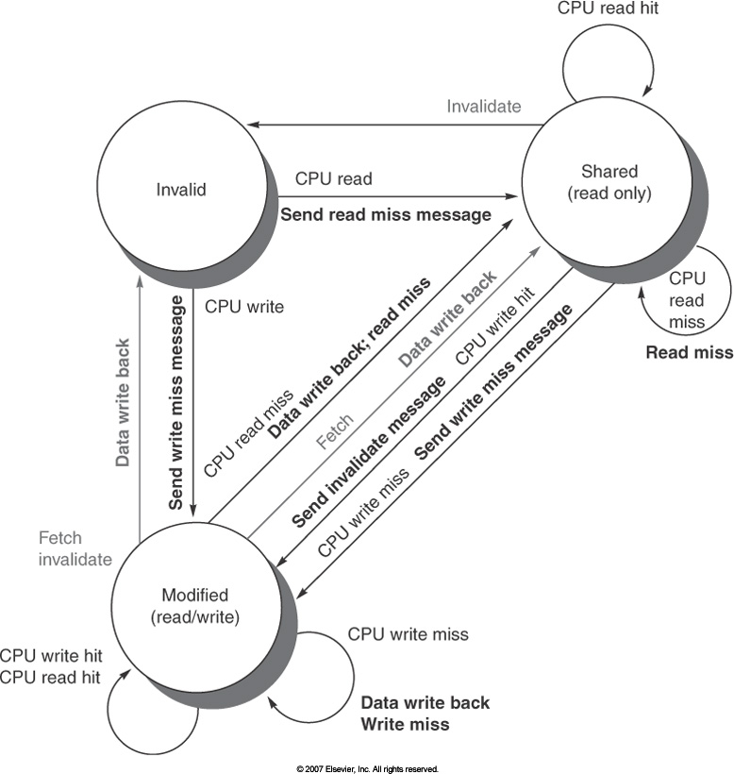

Figure 2 State transition diagram for an individual cache block in a directory-based system. Requests by the local processor are shown in black and those from home directory are shown in gray.

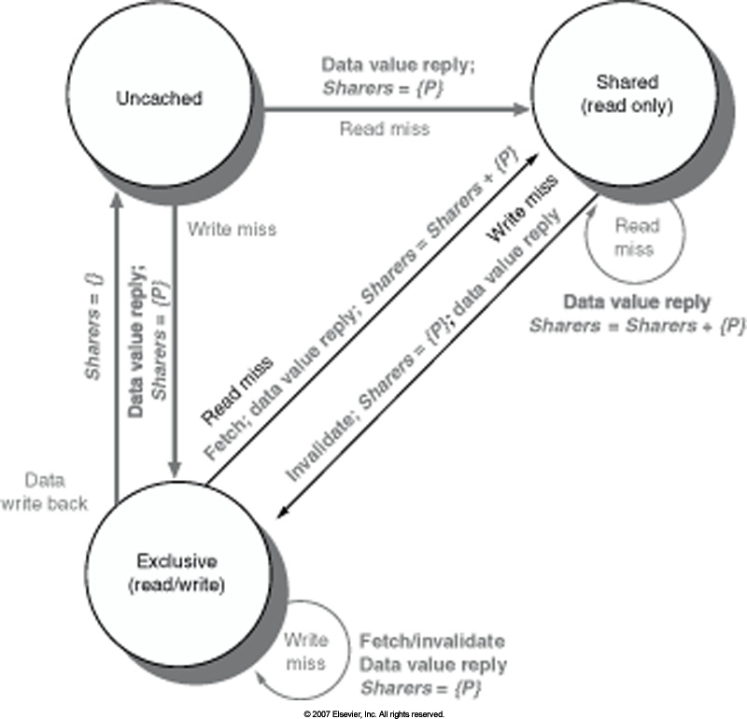

Figure 3 State transition diagram for the directory. All actions are shown in grey because they are all externally caused. Bold indicates actions taken by the directory in response to the request.

QUESTION 7

- Consider the 3x3 mesh following the with West-First Turn Model Algorithm like in Table 4.3 of [Jerger]- http://www.morganclaypool.com/doi/abs/10.2200/S00209ED1V01Y200907CAC008?journalCode=cac . Modify that table to support 4x4 mesh.
- Describe and draw cycle by cycle the propagation of a packet containing a head flit, and 4 body flits from the node (1,0) to (2,2).
- Now, let us zoom in and look only at the pipeline activity of one router. The router in each node looks like the one in Figure 6.1 from [Jerger]. Assume basic 5 stage pipeline of the router with no output buffers. Describe activities in each stage of the pipeline and show how different it is for header flit and for body flits. Assume the following implementation: single fixed-length queue buffer, with crossbar designed using crossbar slicing with round robin arbiter and separable allocator.

