
Université d’Ottawa · University of Ottawa

École d'ingénierie et de technologie School of Information Technology
de l'information (EITI) and Engineering (SITE)

CEG 4131 Computer Architecture III: QUIZ 4

Date: Nov 28th | Professor: Dr. M. Bolic
Duration: 60 minutes | Session: Fall 2006-2007
Total Points = 100 points

Note: Closed book exam. Cheat-sheets are not allowed. Calculators are allowed.

Name: _______________________Student ID:_______________

QUESTION #1 (7 points each, total 42)
Explain the following terms:
- Virtual channels versus physical channels.

A virtual channel is a logical link between two nodes. It is formed with a flit buffer in the source node, a physical channel between them, and a flit buffer in the receiver node. There are more than one virtual channels between two nodes. However, fewer number of physical channels are time-shared by all the virtual channels.

- Buffering flow control using virtual cut-through routing.

When two packets reach the same node and they request the same outgoing channel, the cut-through routing scheme uses a packet buffer to temporarily store one of the received packets. When the channel becomes available later, the stored packet will be transmitted then.

- How does one node in the message passing network know that the next node has the flit buffer full?

By using techniques called backpressure - inform the nodes to stop transmitting because all the flit buffers are full.

- If we compare a program that deals with arrays written for the vector and for the scalar processor, we can see that the vector program has the smaller number of instructions and it also executes the smaller number of operations. Why?

Smaller number of instructions: One vector operation replaces the whole loop.
Smaller number of operations: There is no loop overhead any more (increment of indexes and check if the loop is finished)

- What does “stride” mean in vector processor terminology?

Load/store operations move groups of data between registers and memory. Stride=1 means that elements are loaded/stored sequentially to/from the memory. Stride=n means that every n-th element is loaded/stored sequentially to/from the memory.

- What is node duplication and when is it used?
Node duplication is used when communication delay is large in comparison with computation. The idea is to execute multiple copies of the sender tasks on the processors in order to reduce communication overhead.

QUESTION #2 (total 28)

The following task graph is clustered and scheduled for execution on 2 processors. Draw the Gantt chart of the schedule on 2 processors. What is the total execution time?

Total execution time is 10

Here (a,1) means that node a needs one clock cycle to execute its function. The number next to the edge represents communication delay. Assume that communication delays between nodes in the same cluster are zero.

QUESTION #3( 10 points each, total 30 points)

Vector processor architecture is given in the figure bellow. Vector register file is organized as 8 scalar register files. Each scalar register file has 64 64-bit registers and it has 1 write and 2 read ports.

- Why is the output of each functional unit connected to the input of all other functional units?

In order to allow for forwarding.

- How many convoys are needed to implement the following sequence of instructions (Y=aX+Y) on this architecture? Here, X and Y are 64 element arrays and Y is a constant. Assume that floating point multiplication is done on Functional Unit 1 and floating point addition on Functional Unit 2.

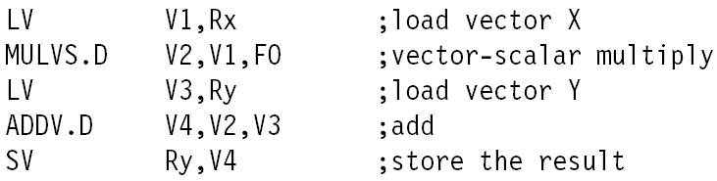

There is one convoy:
LD,LD can start at the same time
LD, MULVS, ADDV and SV are chained and start after their startup time.

- The start-up times are 12 for LV and SV, 7 for MULVS and 6 for ADDV. What is the total execution time needed to execute Y=aX+Y from question b)?

12+7+6+12+64=101

