
Université d’Ottawa · University of Ottawa

École d'ingénierie et de technologie School of Information Technology
de l'information (EITI) and Engineering (SITE)

CEG 4131 Computer Architecture III: QUIZ 4

Date: December 2nd | Professor: Dr. M. Bolic
Duration: 30minutes | Session: Fall 2005-2006
Total Points = 100

Note: Closed book exam. Cheat-sheets are not allowed. Calculators are allowed.

Name: _______________________Student ID:_______________

QUESTION #1 (each question is 8 points, total 32)

Only one answer is correct a, b, or c. Choose one answer?

1. Which of the following statements is false?
- Node duplication reduces the overall number of computational operations in the system.
- Node duplication reduces communication delays.
- Node duplication is used to reduce the idle time.

2. Conflict resolution techniques for PRAM such as priority, common, arbitrary and combining are used for the following model:
a) EREW exclusive read, exclusive write
b) CREW concurrent read, exclusive write
c) CRCW concurrent read, concurrent write

Explain the following:
3. If we compare a program that deals with arrays written for the vector and for the scalar processor, we can see that the vector program has the smaller number of instructions and it also executes the smaller number of operations. Why?

The number of instructions is reduced because the whole loops can be replaced with one (or several) instruction. The number of operations is reduced as well because the operations needed to handle the loop such as incrementing indexes do not need to be executed in software.

4. Explain how scheduling inforest/outforest task graphs works.

The level of each node in the task graph is calculated as given above and used as each node’s priority.

Whenever a processor becomes available, assign it the unexecuted ready task with the highest priority.

QUESTION #2 (a, b 17 points, total 34 points)

Task graph is shown bellow together with the execution and communication times.
a. Draw Gantt chart with communication when this program is executed on two processors. Schedule program on these processor so that the overall time is minimized. What is the total time needed?
b. Which technique will help eliminating communication time? What is the total time needed?

a
b
c
x
T
ask Graph
T
ask
Execution time
a
b
c
10
15
15
y
Arc
Communication
(a,b)
y=5
(a,c)
x=10

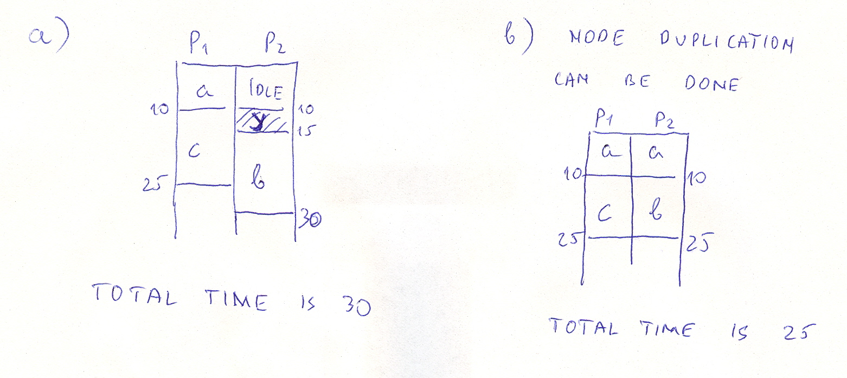

QUESTION #3 (a, b, 17 points each, total 34 points)

Consider a vector program given bellow for Y=X*Z+Y. All vectors have length of 64. Suppose that the hardware have 2 load/store units capable of performing 2 loads, or 2 stores, or 1 load and 1 store vector operation at the same time, one pipelined vector multiplier and one pipelined vector adder. Suppose that chaining is not allowed and that the start-up times are 12 for LV and SV, 7 for MULV and 6 for ADDV.
a. How many convoys do we have?
b. What is the total execution time?

LV V5,Rz ;load vector Z
LV V1,Rx ;load vector X
MULV V2,V1,V5 ;vector multiply
LV V3,Ry ;load vector Y
ADDV V4,V2,V3 ;vector add
SV Ry,V4 ;store the result

There are 4 convoys:
- LV , LV
- MULV, LV
- ADDV
- SV

Total execution time is the time to process 4 convoys (4*64) and start-up time.
- Start-up time is 12
- Start-up times are 7 and 12 – we have to choose the worst start-up time (12)
- 6
- 12

Total time: 4*64+12+12+6+12=298

