
Université d’Ottawa · University of Ottawa

École d'ingénierie et de technologie School of Information Technology
de l'information (EITI) and Engineering (SITE)

CEG 4131 Computer Architecture III: QUIZ 3

Date: Nov 14th | Professor: Dr. M. Bolic
Duration: 60 minutes | Session: Fall 2006-2007
Total Points = 100 plus 4 bonus points

Note: Closed book exam. Cheat-sheets are not allowed. Calculators are allowed.

Name: _______________________Student ID:_______________

QUESTION #1 (6 points each, total 30)
Define, compare and comment on the following (within 1-3 sentences each):

- What is the difference between virtual cut through and wormhole routing?

Virtual cut through requires the large buffers to store the whole packet in case of blocking. With wormhole routing, several routers are blocked in case of blocking while in the virtual cut through routing the whole packet will be stored in one router.

- Why are snoopy cache protocols difficult to implement when multiple processors are connected using static interconnection networks?

Because snoop protocols are based on broadcasting which is naturally implemented using buses and it is much more difficult to implement using static networks.

- What is the difference between adaptive and oblivious routing?

- Oblivious: So named because it ignores the state of the network when determining a path. Unlike deterministic, it considers a set of paths from a source to a destination, and chooses between them.

- Adaptive: The routing algorithm changes based on the state of the network

- What type of routing is weighted random routing?

Oblivious routing

- Does MPI support MPMD programming? How?

Yes. We can use rank like this:
Use MPI_Comm_rank:
if (my_PE_num = 0)
Routine1
else if (my_PE_num = 1)
Routine2
else if (my_PE_num =2)
Routine3 . . .

QUESTION #2 (total 40)
Consider a multiprocessor system with two processors (P1 and P2) and each processor has a cache. Also, consider the fo1lowing sequence of requests. Initially, there is no copy of variable X in any of the caches and X=10.
At time t1: processor P1 reads variable X.
At time t2: processor P2 reads variable X.
At time t3: processor P2 updates X; X = X + 2.
At time t4: processor P1 updates X; X = X*2.
At time t5: processor P2 reads variable X.
t5>t4>t3>t2>t1
Show the state and the content of variable X in caches and memory after each of the preceding statements is executed for the following protocols:
(a) Two-state write-through write invalidate protocol (Figure 1).
(b) Basic MSI write-back invalidation protocol (Figure 2).

a) | State of P1’s cache | Content of x in P1’s cache | State of P2’s cache | Content of x in P2’s cache | Content of memory location x
1. Processor P1 reads variable X
2. P2 reads X
3. P2 performs operation X=X+2
4. P1 performs the operation X=X*2
5. P2 reads X

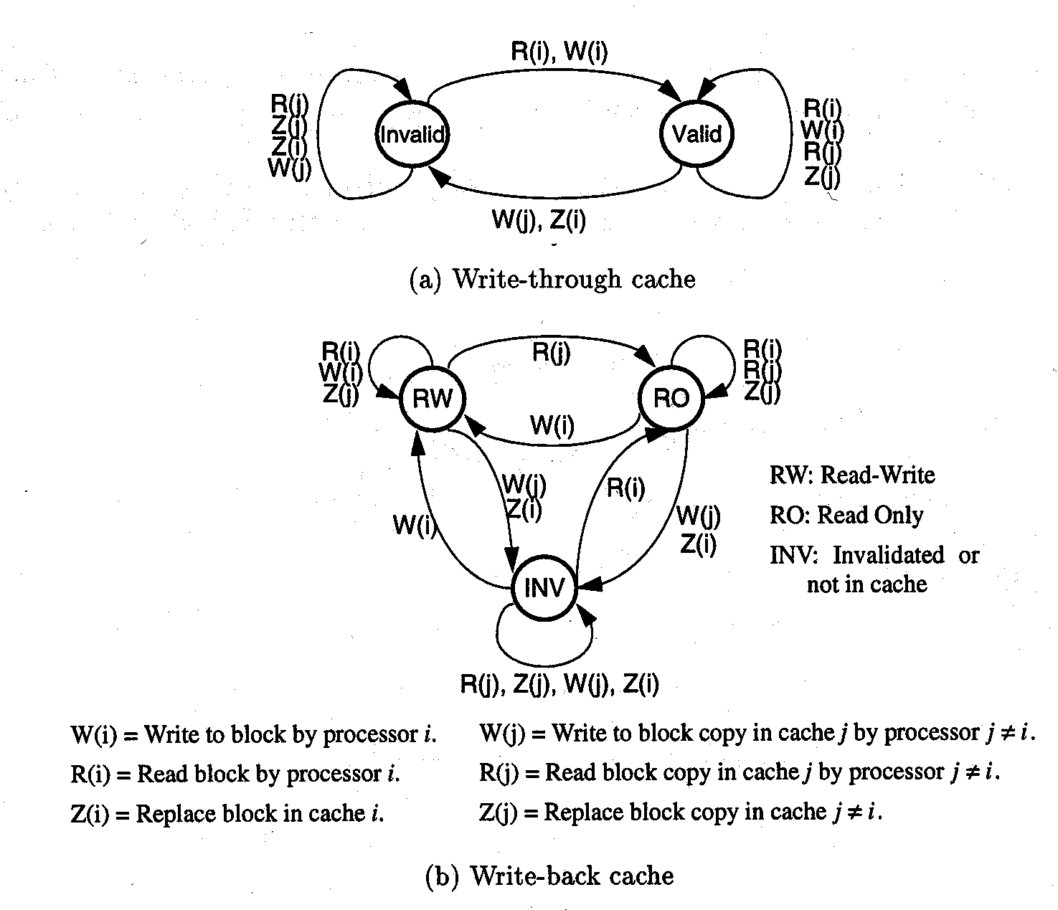
R = Read, W = Write, Z = Replace
i = local processor, j = other processor

Figure 1 State machine for write through write invalidate cache coherence protocol

b) | State of P1’s cache | Content of x in P1’s cache | State of P2’s cache | Content of x in P2’s cache | Content of memory location x
1. Processor P1 reads variable X
2. P2 reads X
3. P2 performs operation X=X+2
4. P1 performs the operation X=X*2
5. P2 reads X

Figure 2 State machine for write-back write invalidate cache coherence protocol

QUESTION #3( a) 10 points, b) 24 points, total 34 points)

- The following MPI program is given. What is the order of printing? Why?

#include <stdio.h>
#include "mpi.h"
main(int argc, char** argv)
{
int my_PE_num;
MPI_Init(&argc, &argv);
MPI_Comm_rank(MPI_COMM_WORLD, &my_PE_num);
printf("Hello from %d.\n", my_PE_num);
MPI_Finalize();
}

Random because there is no sync. primitives

b) A common communication pattern in scientific programs is to consider the nodes as elements of a two-dimensional array and then have communication to the nearest neighbor in a given direction as shown in figure bellow. Map an eight-by-eight array onto the 64 nodes of the following topologies a)bus, b) ring, c) 2D torus, and assume every link of every interconnect is the same speed. How long does it take each node to send one message to its northern neighbor and one to its eastern neighbor (like in the figure bellow)? Ignore nodes that have no northern or eastern neighbors.

