
Université d’Ottawa · University of Ottawa

École d'ingénierie et de technologie School of Information Technology
de l'information (EITI) and Engineering (SITE)

CEG 4131 Computer Architecture III: QUIZ 2

Date: November 21st | Professor: Dr. M. Bolic
Duration: 75 minutes | Session: Fall 2007-2008
Total Points = 100

Note: Closed book exam. Cheat-sheets are not allowed. Calculators are allowed.

Name: _______________________Student ID:_______________

QUESTION #1 (5 points each, total 35)
Circle the correct answer
a)Which of the following flow control strategies use buffer to store a packet being denied the channel?
- Blocking flow control
- Virtual cut-through routing
- Detour after being blocked

b) Which of the following routing mechanisms is not deterministic?
- E-routing on a hypercube
- X-Y routing on a 2D mesh
- Routing on the crossbar network

Define, compare and comment on the following (within 2-4 sentences each):
c) Why does deadlock occur? How can it be avoided?

Deadlock is defined as a situation in which a group of packets (flits) are unable to progress because they are waiting on other packets (flits) to release some mutually exclusive resource. Deadlock prevention involves breaking the cycle in the resource dependence graph.

d) What type of routing is weighted random routing?

Weighted random routing is a form of oblivious routing. It does not take the state of the network into account.

e) Why is the following code for implementing software lock non-atomic?
lock: ld register, location /* copy location to register*/
cmp register, #0 /* compare with 0 */
bnz lock /* if not 0, try again */
st location, #1 / * store 1 to mark it locked */
ret /* return control to caller */
and
unlock: st location, #0 /* write 0 to location */
ret /* return control to caller*/

This code is non-atomic because if two instruction lock routines start executing one clock cycle after the other, and if the mutex was unlocked, then it will happen that both routines get the lock.

f) What is the virtual channel and what is it used for? Does the number of physical channels correspond to the number of virtual channels?

Virtual channels are made by adding additional input buffers to the routers/switches.

The number of physical channels is usually smaller than the number of virtual channels.

g) What is “incremental parallelism” in shared memory systems?

Incremental parallelism means that the program is incrementally converted from the sequential version to the parallel one by placing proper instruction.

QUESTION #2 (20 points)

Consider a following program for parallel addition using a message passing parallel system. Assume that the array_to_sum is stored initially in the local memory of processor 0. Using the same logic as in the code for parallel addition, write a program for parallel multiplication Y = a × X on the message passing system. Assume that array X and scalar a are initially stored in the local memory of the processor 0 and all the elements of the array Y have to be printed by processor 0 after they are computed.

INITIALIZE; //assign proc_num and num_procs
if (proc_num == 0) //processor with a proc_num of 0 is the master,
//which sends out messages and sums the result
{
read_array(X, size); //read the array and array size from file
size_to_mul = size/num_procs;
for (current_proc = 1; current_proc < num_procs; current_proc++)
{
lower_ind = size_to_mul * current_proc;
upper_ind = size_to_ul * (current_proc + 1);
SEND(current_proc, a);
SEND(current_proc, size_to_mul);
SEND(current_proc, X[lower_ind:upper_ind]);
}
//master nodes sums its part of the array
for (k = 0; k < size_to_mul; k++) {
Y[k]= a*X[k];
printf(“Y[%d]= %d”,k, Y[k]);
}
for (current_proc = 1; current_proc < num_procs; current_proc++)
{
RECEIVE(current_proc, Y);
lower_ind = size_to_mul * current_proc;
for (k = 0; k < size_to_mul; k++) {
printf(“Y[%d]= %d”, lower_ind + k, Y[k]);
}
}
}
else //any processor other than proc_num = 0 is a slave
{
RECEIVE(0, a);
RECEIVE(0, size_to_mul);
RECEIVE(0, X[0 : size_to_mul]);
for (k = 0; k < size_to_mul; k++)
Y[k] = a*X[k];
SEND(0, Y[0 : size_to_mul]);
}
END;

QUESTION #3 (25 points)

- The cache coherence mechanism for a multiprocessor system used a MESI protocol. Consider a
system with two processors, P1 and P2, with the initial cache state shown in the following table. For this
problem, assume each cache holds only 4 lines and uses direct-mapped organization.

 | P1 |  | P2
Set | Line | State | Line | State
0 | L0 | M | L4 | I
1 | L1 | E | L5 | M
2 | L2 | S | L6 | S
3 | L3 | I | L7 | E

What is the state of each cache after the following sequence of memory references is completed?
Fill in the table below.
P2 reads line L0
P1 writes line L1
P2 writes line L2
P1 reads line L7

 | P1 |  | P2
Set | Line | State | Line | State
0 | L0 | S | L0 | S
1 | L1 | M | L5 | M
2 | L2 | I | L2 | M
3 | L7 | S | L7 | S

- Assume that the caches are returned again to the original state above. Describe a simple action by P2 that would leave an exclusive copy of line L2 in P1’s cache even though the cache state would be S.

There is an typo in the problem. It is not possible to have only two processors and to have L2 and L6 with their states set to shared. This typo does not affect the first part of the problem. So, whole 25 points will be given to part a).
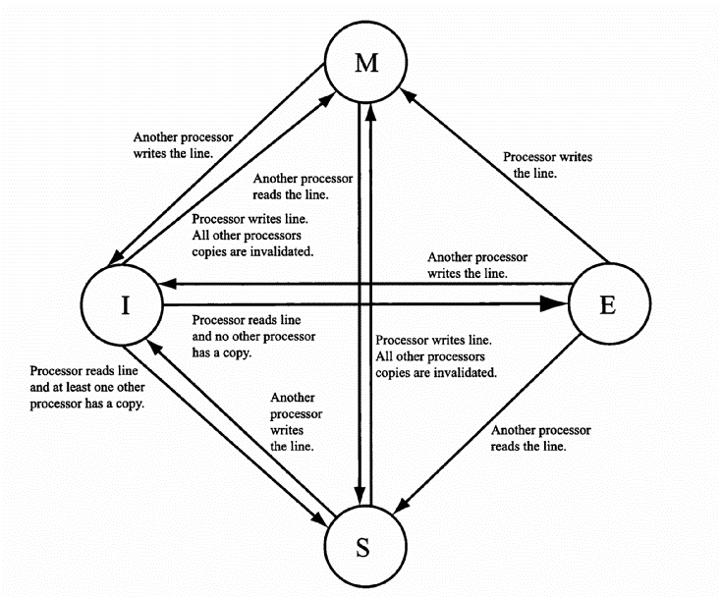
MESI cache coherence protocol

QUESTION #4 (20 points)

The following task graph is clustered and scheduled for execution on 2 processors. Here (A,4) means that node A needs 4 time units to execute its function. Also, (a,1) next to the edge means that node A is sending a message and that transmission takes 1 time unit. Assume that communication delays between nodes in the same cluster are zero.

1. Draw the Gantt chart of the schedule on 2 processors. What is the total execution time?
2. Propose at least one other clustering method that can reduce total execution time and draw the Gantt chart of the schedule on 2 processors.

