
Université d’Ottawa · University of Ottawa

École d'ingénierie et de technologie School of Information Technology
de l'information (EITI) and Engineering (SITE)

CEG 4131 Computer Architecture III: QUIZ 1

Date: September 30th | Professor: Dr. M. Bolic
Duration: 30minutes | Session: Fall 2005-2006
Total Points = 100

Note: Closed book exam. Cheat-sheets are not allowed. Calculators are allowed.

Name: _______________________Student ID:_______________

QUESTION #1 (a 27 points, b 15 points, total 42)

a) Select true (T) or false (F) for each of following statements

- As far as size (number of processors) is concerned, multicomputers with distributed memory are more scalable than shared-memory multiprocessors.
T F

- A program is executed on one processor and on the multiprocessor system. The total number of operations performed by n-processors in the multiprocessor system is greater than the number of operations performed by one processor.
T F

- Maximum efficiency for n-processor system is n.
T F

b) In the multiprocessing system below, LM is the local memory and P is the processor. Is this UMA or NUMA system? Why?

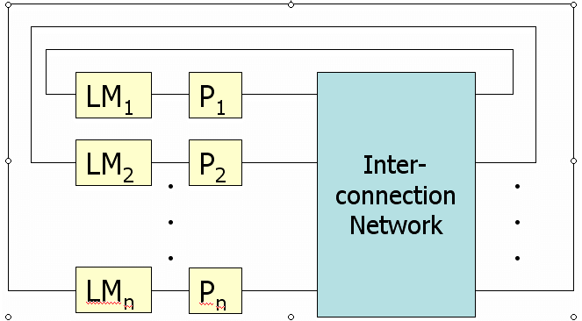 This is a NUMA system. It takes less time for P1 to access LM1 than to access, for example, LM2.

QUESTION #2 (a 25 points, b 33 points, total 58 points)

a) Consider an algorithm in which 1/a of the time is spent executing computations that must be done in sequential fashion. What is the maximum speedup achievable by the parallel form of the algorithm?

S=T(1)/T(n)
If we use very large number of processors then the time for execution of the program is equal to the sequential time T(n)=1/a

So, S=1/(1/a)=a

b) Total time for implementation of the program on sequential processor is T(1)=1ms. The program is modified so that it can be executed on multiprocessing system with n=10 processors. Parallelism profile is shown in the figure bellow. Assume that there is no overhead due to communication and synchronization. Find the speedup and efficiency of this parallel system in comparison with the sequential one.

T(1)=T(n)(0.25*1+0.25*2+0.25*10+0.25*1)=3.5T(n)
S=T(1)/T(n)=3.5
E=S/n=3.5/10=0.35

