
Université d’Ottawa · University of Ottawa

École d'ingénierie et de technologie School of Information Technology
de l'information (EITI) and Engineering (SITE)

CEG 4131 Computer Architecture III: QUIZ 1

Date: October 17th | Professor: Dr. M. Bolic
Duration: 75 minutes | Session: Fall 2007-2008
Total Points = 100 plus 5 bonus points

Note: Closed book exam. Cheat-sheets are not allowed. Calculators are allowed.

Name: _______________________Student ID:_______________

QUESTION #1 (5 points each, total 45)
Answer to the following questions
- What is the diameter of a 2D torus with p processors (assume that routing is bidirectional)?

The diameter is 2*diameter of the ring =

What is the bisection width of a star network with 33 processors (1 in the middle and 32 leaf processors)?

- How many nodes are there is 4-ary tree (4-ary means that each intermediate node has 4 children) which height is 3 (3 levels of links and 4 levels of nodes)?

- Let’s consider a single-bus system that uses split transactions. Do both masters and slaves have to compete for the bus by arbitration? Why?

Yes they need to compete for the bus. The reason is that the read or write transaction initiated by the master are not finished. The slave initiate new transaction when it has its data ready (read cycle) or when it is ready to accept new data and then it has to send the request to the arbiter to get the access to the bus.

- Explain different types of arbitration for buses.

  - Daisy chain arbitration – single grant is sent sequentially. Fairness is not guaranteed.
  - Arbitration with the independent request and grant - There are dedicated lines for grant and request signals from each processor.

- Let’s consider sending a message between two network nodes. List all the sources of latency through the communication link.

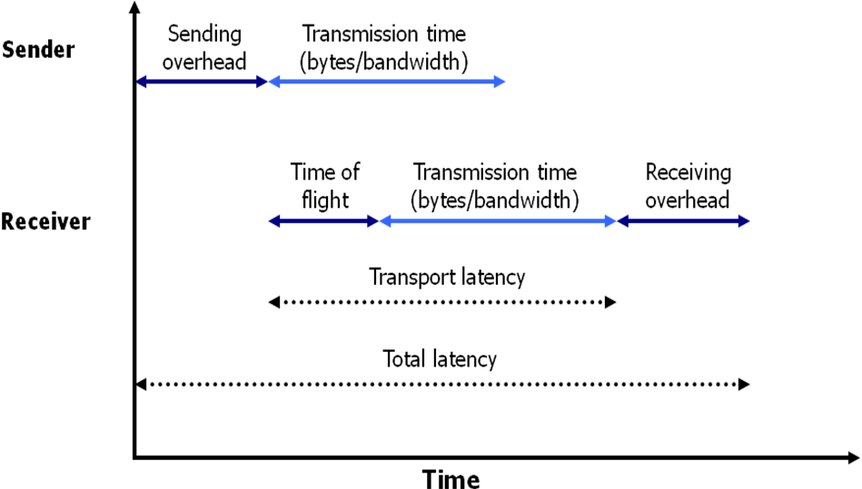

- Why do we need dirty bit for write-back caches?

In order to keep track if write operation was performed for each cache line. In case it was performed, the cache line has to be written back to the main memory.

- What is the maximum efficiency of a parallel processing system?

Maximum efficiency is 1.

- What is the reason of using tightly coupled memory for NIOS II processors?

The reasons are the following:
- Implementation of fast data buffers
- Implementation of fast sections of code
- Implementation of fast interrupt handler
- Critical loop
- Constant access time; guaranteed not to have arbitration delays

QUESTION #2 (25 points)

A common communication pattern in scientific programs is to have nearest neighbor elements of a two-dimensional array to communicate in a given direction. This pattern is sometimes called NEWS communication, standing for north, east, west, and south—the directions on a compass. Map an 8 × 8 array of elements one-to-one onto 64 end node devices interconnected in the following topologies: bus, ring, 2D mesh, 2D torus, and fully connected. How long does it take in the best case for each node to send one message to its northern neighbor, one to its eastern neighbor and one to its western neighbour, assuming packets are allowed to use any minimal path provided by the topology? Ignore elements that have no northern or eastern or western neighbors. To simplify the analysis, assume all networks experience unit packet transport time for each network hop—transmission time for each hop sum to one. Also assume the delay through injection links is included in this unit time, and sending/receiving overhead is null.

This communication pattern requires us to send 3 ⋅ (64 – 8) or 168 total packets— that is, 56 packets in each of the three communication phases: northward, eastward, westwards. The number of hops suffered by packets depends on the topology.
Here are the various cases:
_ Bus—The mapping of the 8 ⋅ 8 array elements to nodes makes no difference for the bus as all nodes are equally distant at one hop away. However, the 168 transfers are done sequentially, taking a total of 168 time units. The bisection
bandwidth is 1.
_ Ring—Assume the first row of the array is mapped to nodes 0 to 7, the second row to nodes 8 to 15, and so on. It takes just one time unit for all nodes simultaneously to send to their eastern neighbor (i.e., a transfer from node i to node i + 1). With this mapping, the northern neighbor for each node is exactly eight hops away so it takes eight time units, which also is done in parallel for all nodes. It takes 1 time unit to send to a node to the west. Total communication time is, therefore, 10 time units.

_ 2D mesh—There are eight rows and eight columns in our grid of 64 nodes, which is a perfect match to the NEWS communication. It takes a total of just 3 time units for all nodes to send simultaneously to their northern neighbors
followed by simultaneous communication to their eastern neighbors.

_ 2D torus—Wrap-around links of the torus are not used for this communication pattern, so the torus has the same mapping and performance as the mesh.

Fully connected – 3 time units

QUESTION #3 (1) 20 points, 2) 5 points, total 25)

Consider a program that performs multiplication of m numbers. Assume that multiplication operation takes 3 time units and that the loop overhead is negligible. Consider the execution of the program on 1 and on n processors implemented using a single shared bus. Assume that at the beginning, m/n input numbers were stored in local memories of the processors. Assume that the total time needed to transmit one message through the bus is 10 time units?
- What would be the speedup in case the program is implemented n processors?
- What is the efficiency?

Sequential program takes 3*m time units

Parallel program takes

m/n multiplication per processor performed in parallel so that partial multiplication results are formed.

There are several solutions
- Transfer all the data sequentially to processor 1 and perform sequential multiplication
Total time= 3*m/n+10*(n-1)+3*(n-1)
- Perform multiplications of partial results while data is transferred (pipelining)
Total time= 3*m/n+10*(n-1)+3

Speedup=3*m/(3*m/n+10*(n-1)+3)
Eficiency=Speedup/n

QUESTION #4 (10 points)

Consider simple comparison between 16x16 Omega network and 16x16 crossbar network. While the crossbar uses cross points, the Omega network is using 2x2 switching elements (SE). Assume that the cost of the SE is four times that of a cross point. Which network is more expensive and how many times if we assume that the cost of the Omega network is determined only by its switching elements and the cost of the crossbar network is determined only by its cross points.

16x16 crossbar has 256 cross points

16x16 Omega network has 4 switches per stage and 4 stages so that it has 16 switching elements.

Cost of crossbar/Cost of Omega= 256/(16*4)=4

