1) In what model of architecture for SIMD implementation does the central control unit manages the process of information?
Both architecture of true SIMD possesses the central controlling unit processor: distributed memory and shared memory. However, only the True SIMD with distributed memory is subjected to the central controlling unit to manage the data transfer from one processor to another.

2) In what occasion can we consider an instruction to be SIMD processable and unprocessable? In your explanation, provide a figure to explain visually.
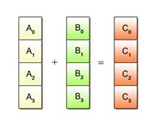
An instruction is consider SIMD processable when all the instruction being used by all processors are the same as follows.

Where an instruction is unprocessable is where each instruction being used for computation by multiple processors differs. The following figures show each processor possessing different instruction.
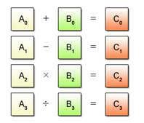

3) Provide a simple code that is implemented in sequential that can be sped up with SIMD implementation.
Most nested loop condition can be sped up with compiler SIMD support. The compiler supports could be auto-parallization or auto-vectorization.
int a[M][N];
foo (int x) {
int i,j;

for (i=0; i<M; i++) {
for (j=0; j<N; j++) {
a[i][j] = x;
}
}
}

4) List the four categories that a computer architecture can be classified under as per the Flynn Taxonomy?
- Single Instruction, Single Data (SISD)
- Single Instruction, Multiple Data (SIMD)
- Multiple Instruction, Single Data (MISD)
- Multiple Instruction, Multiple Data (MIMD)

5) Provide the issue that exists in SIMD architecture that can be fixed wit lock-step synchronization? Display an occasion where this issue may arise
Since all processors are running at the same time, there an existence of certain processors waiting for other processors to finish running a specific instruction. The following example shows the same instruction running on two different processors.
Processor 1 | Processor 2
INST 1 | INST 1
INST 2 | INST 2
IF (A > B) | IF (A > B)  this processor will not validate this condition and will jump to INST 4
INST 3 | INST 3
INST 3 | INST 4

6) Name both True SIMD Architectures
True SIMD distributed memory
True SIMD shared memory

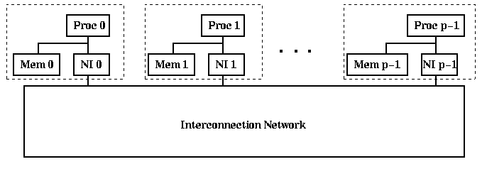
7) For each of the SIMD architectures, provide their associated block diagram
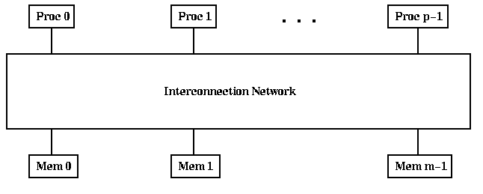
True SIMD : Distributed Memory
True SIMD : shared memory

8) Provide the different type of shared memory multiprocessors
- Uniform Memory Access (UMA)
- Non-Uniform Memory Access (NUMA)
- Cache-only Memory Architecture (COMA)

9) In interconnection network, what’s the difference between Packet Switching and Circuit Switching?
- Packet switching is the procedure for which the packet is responsible to find a path to the desire source
- Circuit switching is when a path has been designed for a packet to reach from the initial source to its destination
10) Provide the block figure for the following ring : Linear Array, Mesh, Hypercube
Linear Array

Mesh
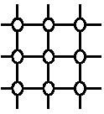

Hypercube
