Questions
Q1. Real-Time OS have tight timing requirement that are not well suited to networks-on-chip. Describe two possible solutions to this problem and discuss their drawbacks.
A1. Solution: Add more routers and links, Drawback: High silicon/power cost.
Solution: Reserve existing paths, Drawback: Will make contention go up.
Solution: Add priority level for traffic, Drawback: Complexifies the routing logic.
Q2. What is a VCI Split transaction? How is it supported by the different levels of services?
A2. A split transaction is when an initiator can send multiple requests without waiting for a response. Peripheral VCI does not offer support, Basic VCI supports it but need to receive responses in the same order that requests were sent and Advanced VCI supports it and can receive responses out of order.
Q3. Why is leakage power consumption such a problem in networks-on-chip?
A3. Link utilization in NoCs is usually low, which means that repeaters on the links are not utilized most of the time. While they aren’t doing anything, they still leak power and this power serves absolutely no purposes.
Q4. Name three different Quality of Service criteria.
A4. Throughput, Latency, Drop probability.
Q5. What type of topology does the SPIN network uses?
A5. Fat Tree Topology.

Problems
P1. On the following SPIN router, all flits belong to a packet of the same color and have for destination the highlighted output. Show how the routing procedure will go. Assume packets are form only from the flits that are shown on the figure, that the routing logic takes no cycles to go through and that all packets are coming from up the tree.
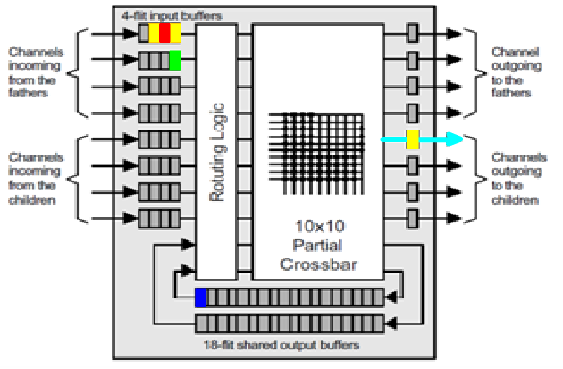
A1.
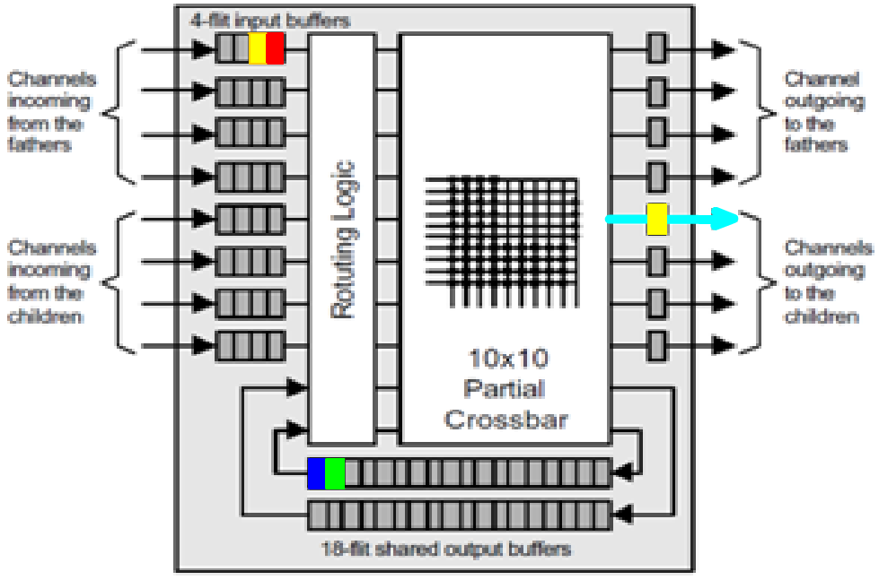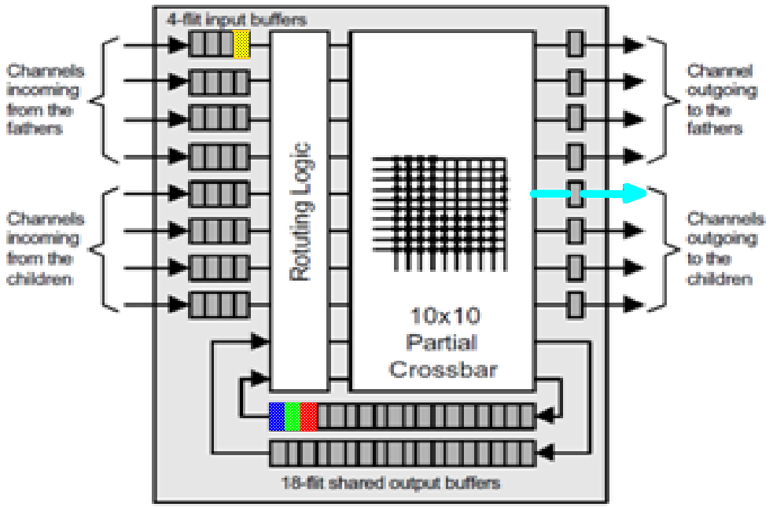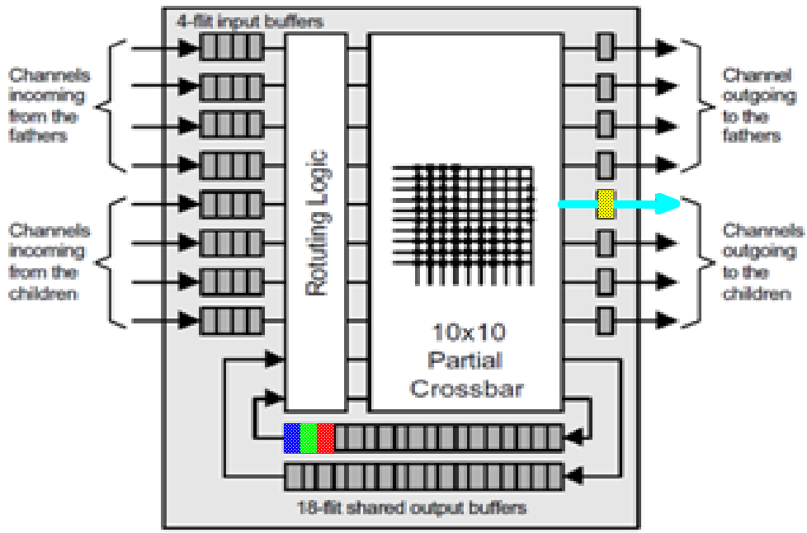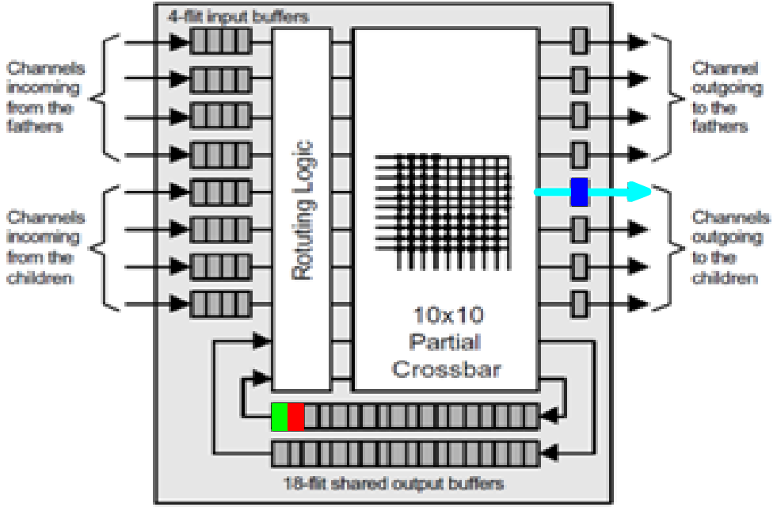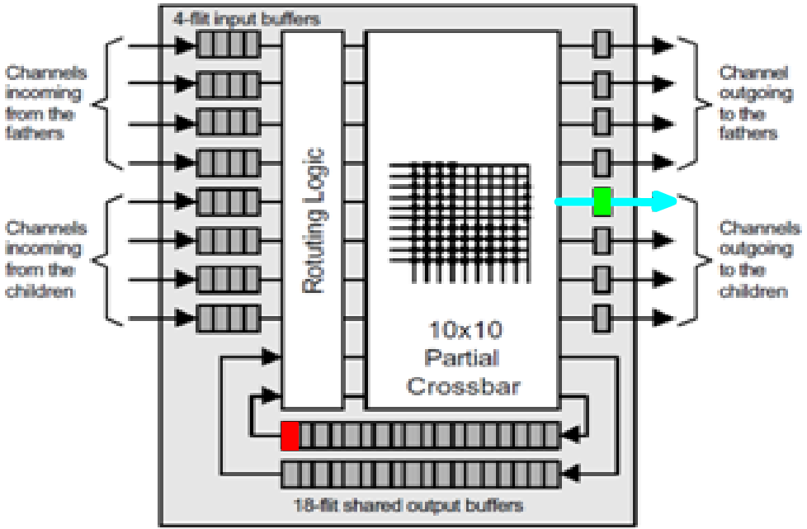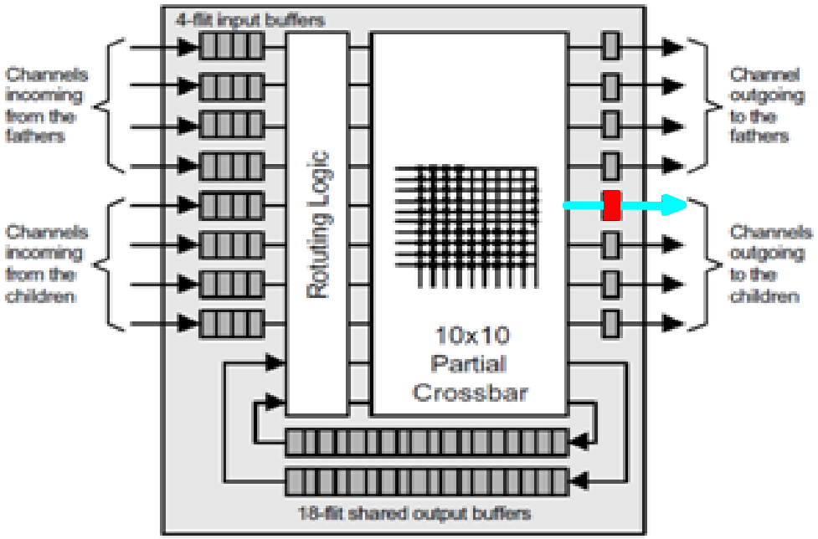

This solution is the only one possible if we follow the RSPIN routing rules. A channel is reserved as long as the trailer from a packet isn’t received. Following this rule, we cannot allocate the channel to another packet until yellow is finished transmitting. Packets are put in order in the same buffer as the blue one. Packets can’t be put in the second buffer because one shared buffer is reserved for packets coming from up going down and the other is for packets coming from down and going back down. Packets were identified as all coming from up the tree in the problem. Given this, the buffer that the blue one starts in is the one we use.

P2. Design a SPIN network where 8 memory banks and 4 processors are connected if each processor is allowed twice as much bandwidth as a memory bank.
A2.
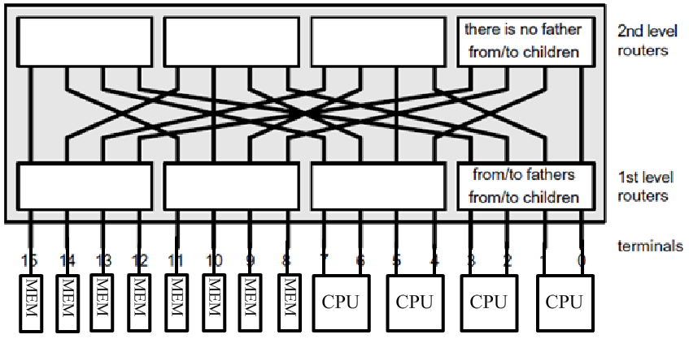
Placement in the network has not importance, equivalent choice exists.

P3. A VCI initiator is making one request to each of two targets, show how the transactions are resolved using PVCI and then using BVCI.
A3. PVCI : First request is sent to any of the two targets, but response must be received before the next request.
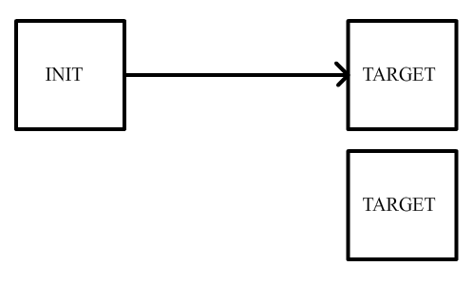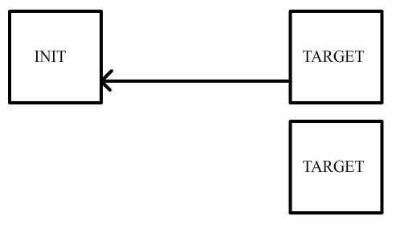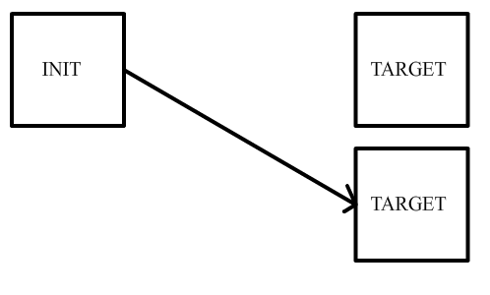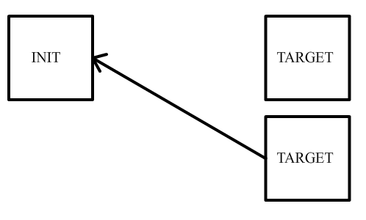
BVCI : First request is sent to any of the two targets, and response is received while the second request is sent.
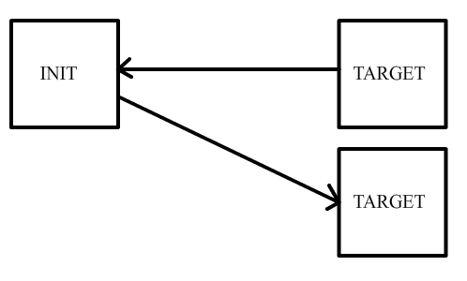
P4. Implement wave pipelining on the following link in order to reduce the appearing latency of the link down to 1ns.
A4. Wave Pipelining is implemented by simply inserting repeaters.
P5. Consider SPIN network of diameter 5 with a maximum link latency of 16 flit units. Draw the network and then calculate the input buffer size and the initial credit value of a link.
A5. For a SPIN network, we have $D={2*log}_{4}(n)$. For D = 5, we have number of terminals equals 32.
$L_{max}$ is related to $T$ by the following formula : $L_{max}=T/2$. For $L_{max}$ = 16, we have $T=32.$ Initial credit value is equal to buffer size, so $C_{0}=32.$

