Questions
- What are the differences between full-map, limited and chained directories?
Full-map directory: a bit for each processor in the system indicate whether the corresponding cache stores a copy of the block of data or not. This vector is stored for each cache block shared by one or more processors.
Limited directory: a limited number of pointers are stored for each cache entry storing processor addresses that share a copy of the block of data.
Chained directory: a single pointer to the head of the chain is stored in each entry.
- What are the sizes of a) full-map, b) limited and c) chained directories?
Full-map directory: for a system with N processors, a bit vector of size N is stored for each entry (N+1 if we count the single inconsistent bit)
Limited directory: for a system with N processors and M pointers, a total of M(log₂N) bits are stored for each entry (M(log₂N)+1 if we count the single inconsistent bit)
Chained directory: for a system with N processors, a total of log₂N bits are stored for each entry.
- What is the main advantage of non-uniform cache architecture (NUCA) over uniform cache architecture (UCA)?
NUCA exploit data locality while UCA does not. Accessing data in a UCA give a uniform load access time whether the data accessed is near the processor or not. Accessing data in an NUCA give better load access time when data is near the processor than when the data is farther.
- What is the main advantage of using distributed directories over centralized directories?
Distributed directories can be distributed in local tiles of the system (shared cache is extended to store directory information) while centralized directory are often located in the off-chip memory. Accessing directory information is then a lot faster when directory is distributed. Also, distributed directories can be static or dynamic, thus exploiting further data locality.
- Explain the difference between static-NUCA and dynamic-NUCA.
In static-NUCA, data is always mapped to a specific bank, while it can change location or migrate to other banks (dynamically mapped) in dynamic-NUCA.

Problems
- Consider a multiprocessor system with two processors (A and B) with their individual private caches. Cache coherence is maintained by a directory centralized in the off-chip memory. Full-map protocol is used with write-back write invalidate scheme. Given the following sequence of operations, give the state of the directory (presence vector) and caches (valid and private bits) for each step as well as the content of the memory (assume variable X is not cached with initial value of 3):
  - A reads variable X
  - B reads variable X
  - A updates variable X so that X = X + 1
  - B updates variable X so that X = X * 2
  - A reads variable X
In this problem, we assume that data is written back to memory in case of a write miss. In the case of a read miss, the data is sent by the sharing cache to the requester directly without going through the main memory.
Operations | Cache A |  | Cache B |  | State of directory |  | Content of memory
Operations | Valid | Private | Valid | Private | S.I.B.* | Presence vector | Content of memory
A: reads X | 1 | 1 | --- | --- | 1 | 01 | 3
B: reads X | 1 | 0 | 1 | 0 | 0 | 11 | 3
A: X = X+1 | 1 | 1 | 0 | 0 | 1 | 01 | 3
B: X = X*2 | 0 | 0 | 1 | 1 | 1 | 10 | 4
A: reads X | 1 | 0 | 1 | 0 | 0 | 11 | 4**
* S.I.B.: Single Inconsistent Bit
** Memory is not updated since data has been sent to cache A by cache B directly

- Consider a multiprocessor system with four processors (A, B, C and D) with their individual private caches. Cache coherence is maintained by a directory centralized in the off-chip memory. Limited directory protocol is used with two pointers with write-back write invalidate scheme. Assume LRU pointer replacement policy. Given the following sequence of operations, give the state of the directory (pointers) and caches (private and valid bits) for each step as well as the content of the memory (assume variable X is not cached with initial value of 3):
  - A reads variable X
  - D reads variable X
  - B reads variable X
  - D updates variable X so that X = X + 1
  - C updates variable X so that X = X * 2
  - A reads variable X

Operations | Cache A |  | Cache B |  | Cache C |  | Cache D |  | State of directory |  |  | Content of memory
Operations | V | P | V | P | V | P | V | P | S.I.B.* | P1 | P2 | Content of memory
A: reads X | 1 | 1 | --- | --- | --- | --- | --- | --- | 1 | A | --- | 3
D: reads X | 1 | 0 | --- | --- | --- | --- | 1 | 0 | 0 | A | D | 3
B: reads X | 0 | 0 | 1 | 0 | --- | --- | 1 | 0 | 0 | B | D | 3
D: X = X+1 | 0 | 0 | 0 | 0 | --- | --- | 1 | 1 | 1 | --- | D | 3
C: X = X*2 | 0 | 0 | 0 | 0 | 1 | 1 | 0 | 0 | 1 | C | --- | 4
A: reads X | 1 | 0 | 0 | 0 | 1 | 0 | 0 | 0 | 0 | C | A | 4**
*S.I.B.: Single Inconsistent Bit
** Memory is not updated since data has been sent to cache A by cache C directly

- The presence vectors shown below correspond to directory entries for some cache block using full-map directory protocol. Describe each step that happens in case of a write miss by cache 0.
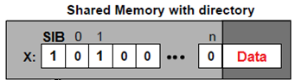
Write-miss:
- Cache 0 sends a write miss request to the shared memory
- Memory sends an invalidate signal to cache 1
- Cache 1 sends an ACK signal to memory with the data since it has private access to the block. It will update its private and valid bit to 0
- Memory updates its present bits (set for cache 0 and cleared for cache 1)
- Memory send the requested data to cache 0
- Cache 0 set its valid and private bits to 1 (he’s the only sharer of the block)
- Cache 0 can write to the block of data

- The presence vectors shown below correspond to directory entries for some cache block using full-map directory protocol. Describe the steps that happen in case of a write hit by cache 0 when its private bit is cleared:
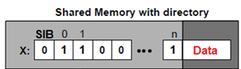

Write-hit:
- Cache 0 sends a privacy request to the shared memory
- Memory sends invalidate signal to other sharers of data, which is only cache 1 in this case
- The invalidate cache (cache 1) sends an ACK signal to the memory and sets its private and valid bits to 0
- The memory update its present bits (set for cache 0 and cleared for cache 1) and sets its single inconsistent bit to 1
- Memory sends an ACK signal to the requester (cache 0)
- Cache 0 sets its private bit to 1
- Cache 0 can write to the block of data

- The figure below represents the diagram for the standard MSI protocol. Some directory protocols used an extension of MSI which is called the MOESI protocol for private cache states as in the SGI Origin2000 architecture. It adds an “Exclusive” state to reduce the traffic caused by writes of blocks that only exist in one cache and an “Owned” state to reduce the traffic caused by write-backs of blocks that are read by other caches.

Exclusive state: a cache line in the exclusive state holds the most recent copy of the data. The copy in main memory is also the most recent copy of the data. No other processor holds a copy of the data. The cache line may be changed to the “modified” state anytime in order to modify the data.

Owned state: a cache line in the exclusive state holds the most recent copy of the data. The copy in main memory can be dirty. Only one processor may own a copy in the “owned” state; other processors must hold the copies in the “shared” state. The cache line may be changed to the “modified” state after invalidating other copies or to the “shared” state by writing modifications back to the shared memory.

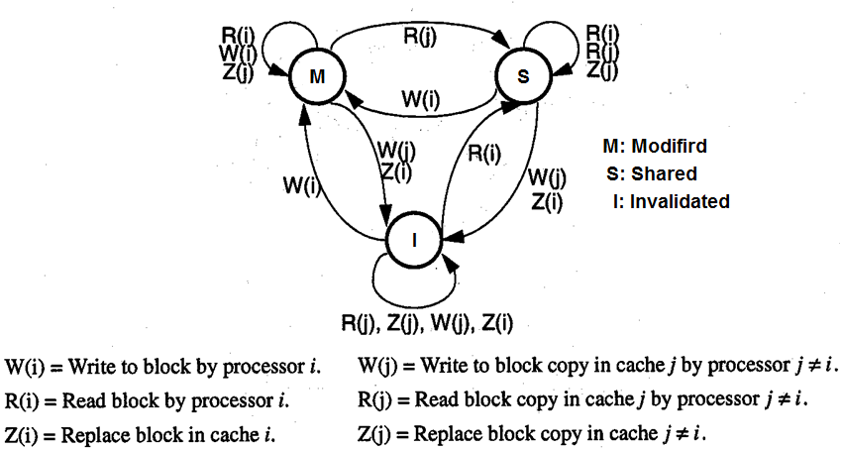

Figure 1: MSI protocol

Modify the MSI diagram so it represents the MOESI protocol.
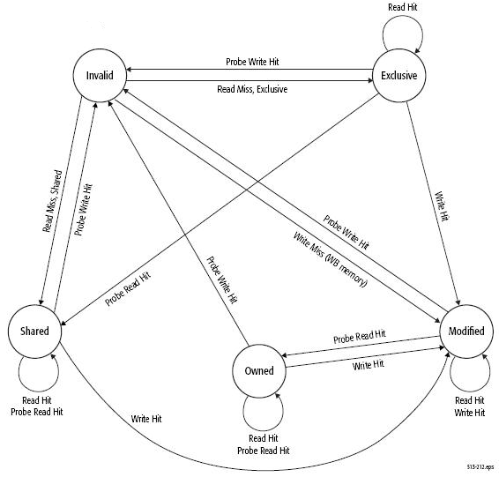
Figure 2: MOESI protocol

