Directory-Based Cache Coherence and Non Uniform Cache Architecture (NUCA)

Marc De Melo
School of Information Technology and Engineering
University of Ottawa
Ottawa, Ontario, Canada
mdeme077@uottawa.ca

Abstract—The number of cores or processors grows constantly in new architectures these days which are constructed based on scalable point-to-point interconnection networks. Shared memory systems imply that data must be coherent in the local caches. The use of directory-based cache coherence protocols becomes necessary as they are implemented to assure cache coherence for non-broadcasting networks. Many types of centralized and distributed directory protocols are explored; the full-map directory protocol, the limited directory protocol and the chained directory protocol. Non-uniform cache architectures (NUCA) will be explored as well since they help accelerate access to data stored in a cache by exploiting access time depending on data locality. Directories can be implemented in different ways; the directory can be located in the off-chip memory, in the off-chip memory as a duplicate tag directory or distributed among the local caches of the system. Directories located in the off-chip memory are slower to access than the ones located into the on-chip memory. Distributed directories are more used since on-chip centralized directories doesn’t exploit data locality. Different examples of real architectures are given as well.
Keywords - Full-map directory, limited directory, chained directory, centralized directory, distributed directory, non-uniform cache architecture, static NUCA, dynamic NUCA, cache coherence, directory protocol

Introduction
Chip multiprocessors (CMPs) integrate multiple CPUs on a single chip and the number of cores in a chip is growing significantly due to continued technology advances. Many multiprocessor systems these days implement shared main memory and private cache memory in each processing node to enable fast access to memory [1]. These scalable shared memory multiprocessors are constructed based on scalable point-to-point interconnection networks, such as a mesh or torus [2]. Caches are fast local memories holding copies of recently used data to provide a low-latency access path to the processor. When multiple processors maintain locally cached copies of a unique shared memory location, any local modification of this location can result in a globally inconsistent view of memory, leading to cache coherence problems [3]. To guarantee that all processors are always using the last updated version of some memory data, the use of cache coherence protocols is needed.

There are two major types of coherence protocols, broadcast-based and directory-based. Broadcast-based protocols resort to broadcasting messages for coherence actions using a “snooping” bus [1]. These protocols are not scalable to large multiprocessor systems because coherence messages use a lot of bus bandwidth when multiple processors are sharing the same data. However, directory-based protocols use hardware to keep track of which processors are sharing each block of data and are therefore more scalable than broadcast-based protocols [1].

This document will present in more detail the main directory-based protocols that are used as well as their implementations in CMPs architectures. The non-uniform cache architecture (NUCA) will be explored as well in details to illustrate the uses of distributed directories protocols.

Directory-Based Procotols
A cache coherence protocol consists of a set of states in the local cache, the states in the shared memory, and the state transitions caused by the messages travelling in the interconnection network to keep data coherency [3]. A directory is a list storing the location of all shared copies of each shared blocks of data. A directory entry for each block of data contains a vector or a list of pointers to specify the location of all the copies of the block and a single inconsistent bit to specify whether or not a single cache has write permission on the block. On a write or read request, the directory is consulted first to identify the CPUs that share the data. Directory-based protocols can be classified into two main categories; they can be either “centralized” or “distributed”.

Centralized directory protocols
Centralized directory protocols use a single directory to keep track of the shared memory content. Many types of protocols implement a centralized directory which can reside on either the off-chip (DRAM) or on-chip (SRAM) memory. The following sections will describe in more details the full-map directories and the limited directories protocols.

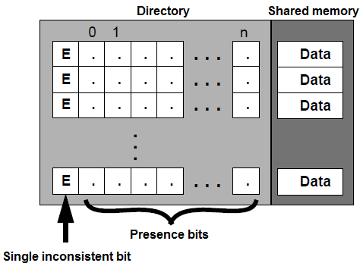
Figure 1: Full-map directory [4]

Full-map directories
Full-map directories store enough states associated with each block in global memory so that every cache in the system can simultaneously store a copy of any block of data [3]. Each directory entry stores N presence bits, where N is the number of processors in the system, as well as a single inconsistent bit, which specifies if a single processor has write access to the block of data.

Each presence bit represents the status of the block in the corresponding processor’s cache, a value of “1” indicating that the associate cache has a shared copy of the block. The single inconsistent bit is “1” when a single processor has a copy of the block, therefore having write access to this block. Each cache maintains two additional bits per entry; a valid bit and a private bit. The valid bit is “1” if the block is valid, and “0” if it is not. The private bit is “1” if the corresponding cache is the only one storing the block of data, therefore having exclusive write access to this block. The next sections examine in more detail how the protocol works.

Read-miss
In the case of a read miss, the requesting cache sends a read miss request to the memory. If the single inconsistent bit is cleared and there is no cache in the system storing the requested block of data, the memory will send the data to the cache. If the requested block is shared among many caches (the single inconsistent bit is cleared), one of the private cache will send the block of data to the requesting cache and the present bit will be set for this cache. The private bits stay cleared and the valid bits stay set for all caches sharing a copy of the block.
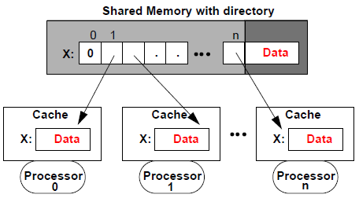
Figure 2: System state for a shared block of data [4]
If the single inconsistent bit is set (only one CPU has write access to the data) and there is a read miss from one of the CPUs, the memory will send an update request to the single cache storing the requested block of data. The cache sends the data to the requesting cache, clear its private bit since the data will be shared to more than one local cache and the single inconsistent is cleared in the directory (see figure 3).

Write miss
In the case that a write miss occurs from one of the CPUs (its valid bit is “0” or the data is not found), all entries in other caches sharing the data will be set to invalid. One the memory sent the invalidate signals, the invalidated caches will send acknowledgements to the memory. If the single inconsistent bit was set (only one cache has been invalidated), the invalidated cache will send the data to the memory to update the memory block as well. The directory’s presence bits are updated, the single inconsistent bit is set and the data is sent to the requesting cache. The valid and private bits of the cache entry for the requesting cache will both be set (see figure 4).

Write hit
In the case of a write hit, if the privacy bit of the requesting CPU is set, the writing can be done locally without any communication with the memory (since the copy is already dirty). If the privacy bit is cleared, meaning that there might be other copy of the data to other caches, the requesting cache will need to send a privacy request signal to the memory. The memory will send invalidate signals to all caches that store a copy of the data. The invalidated caches will send acknowledgements to the memory, who will update the presence bits and the single inconsistent bit in the directory. The memory will then send an acknowledge signal to the requesting cache so it can set its private bit to “1”. The CPU then has the unique permission of writing to the data.

Limited directories
Full-map directories are hardly scalable, since the space used to store the bit vectors for each entry in the memory increases with the number of processors in a system. Limited directories solve this problem by setting a fixed directory size. Instead of using bit vectors to store if every cache has a copy of some block of data or not, the limited directory uses a reduced number of pointers regardless of the number of processors. This technique help reduce the size of the directory and the search time since a limited number of caches can store the same block at a same time.

Limited directories work almost the same as full-map directories. The major difference resides in the pointer replacement that takes place when there is no more room for new cache requests. Depending of the replacement policy chosen by the designer, one of the caches will need to be evicted in order to allow a requesting cache to store the block of data. Let’s take for example the configuration shown in figure 6. The directory stores a maximum of two pointers, which are already pointing to both cache 0 and cache 1. If CPU n needs to perform a read operation on X, one of the two

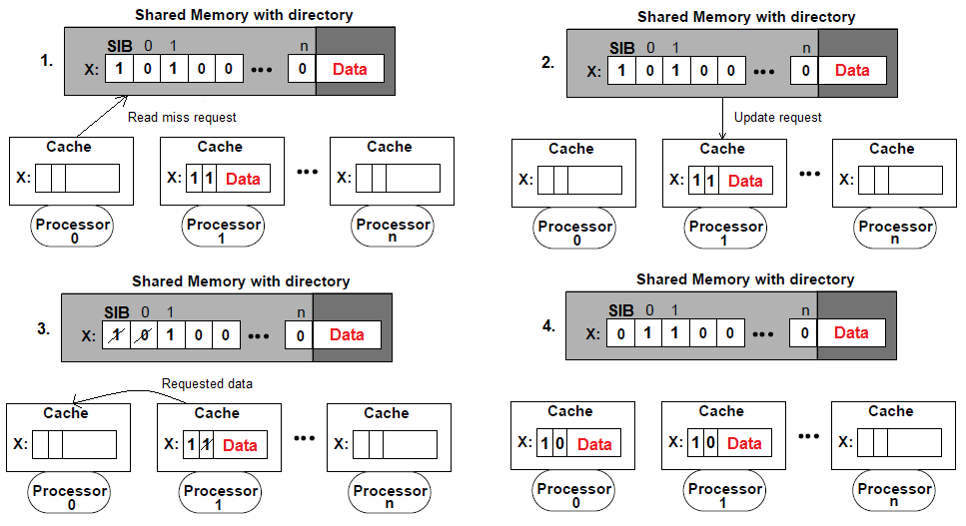
Figure 3: Read miss when single inconsistent bit (SIB) is set

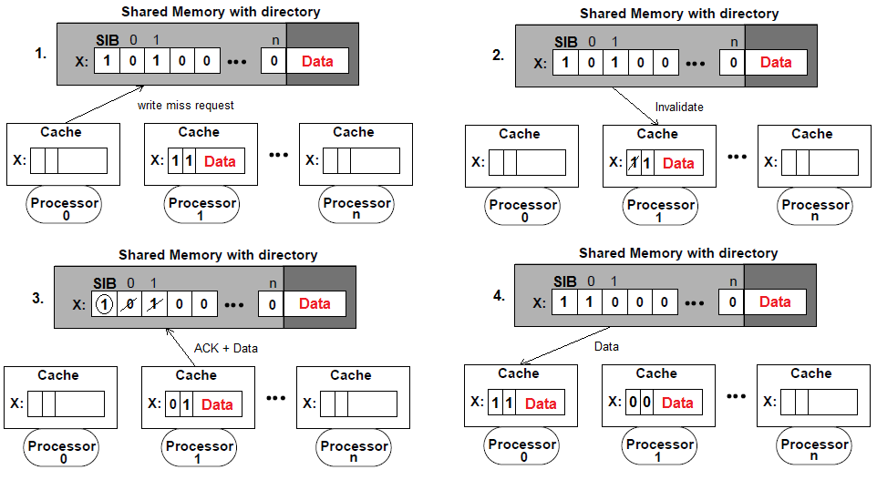
Figure 4: Write miss when single inconsistent bit (SIB) is set

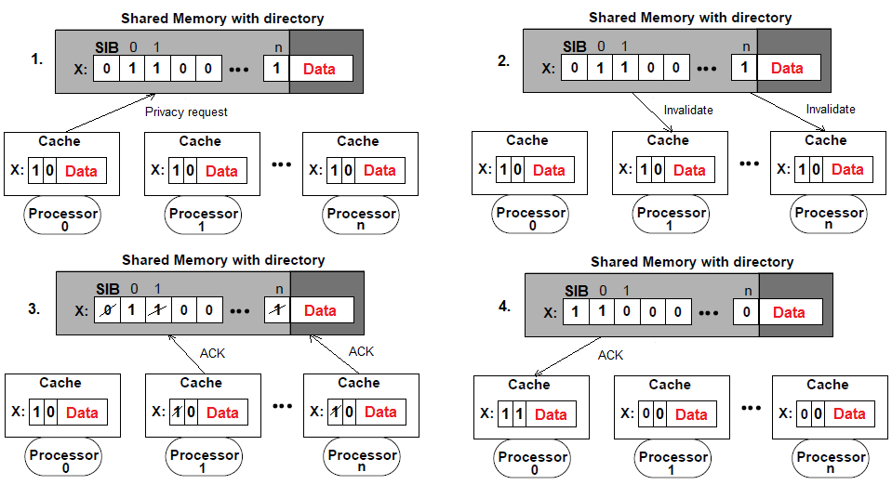
Figure 5: Write hit when private bit is cleared
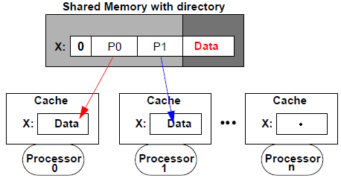
Figure 6: limited directory with two pointers [4]
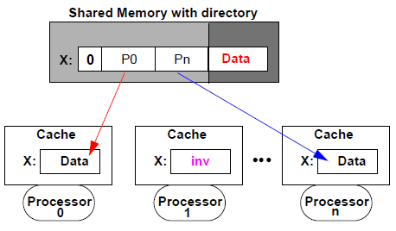
Figure 7: State of a limited directory after an eviction [4]
caches sharing the data will need to be evicted (depending on the chosen pointer replacement policy). Figure 7 shows the state of the system after such action.

Distributed directory protocols
Distributed directory protocols have the same functions as the protocols described in the sections above. However, the difference here is that the directory is not centralized in the memory; it is instead distributed or partitioned among the caches of the system (figure 8). In large systems where the number of cores is large, distributed directories are used since they are more scalable than their centralized counterparts.

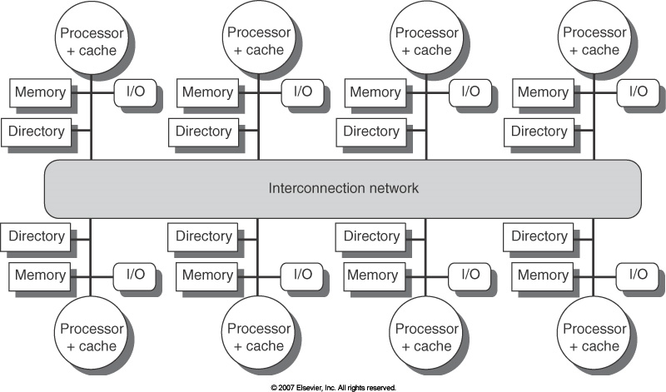
Figure 8: Distributed directory [5]

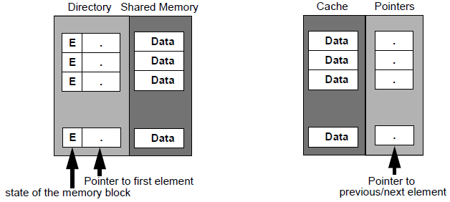
Figure 9: Chained directory and cache organizations [4]
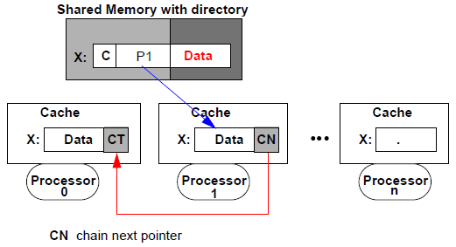
Figure 10: Chained directory (shared state) [4]

Chained directories are an example of distributed directory that work similar to the full-map directories as the number of processors that can share a copy of some block of data is not limited as in the limited directories. A chained directory makes use of a single or double linked list (see figure 9). Each directory entry stores a single pointer to a cache, who is pointing to the next cache storing the block of data and so on until the tail of the chained list (see figures 10). Different implementations of chained directories are used to manage the read and write requests such as the Scalable Coherent Interface (SCI) of the Stanford Distributed Directory (SDD) (not covered in this paper). In general, when a new cache makes a read request to the shared memory for some block of data, it becomes the new head of the list (the tail being the first cache reading the block). Only the head of the list has authority to invalidate other caches to have exclusive write access to data. If another cache needs to do a write request, it usually becomes the new head of the list.

Non-Uniform Cache Architecture
Processors these days incorporate multi-level caches on the processor die. Current multi-level caches hierarchies are organized into a few discrete levels [6]. In general, each level obeys inclusion by replicating the contents of the smaller level and reducing access to the lower levels in the hierarchy due to inclusion overhead. Large on-chip caches with a single, discrete latency are undesirable, due to the increasing global wire delays across the chip [6].

Uniform cache architectures (UCA) perform poorly due to internal wire delays and the restricted number of ports. Data
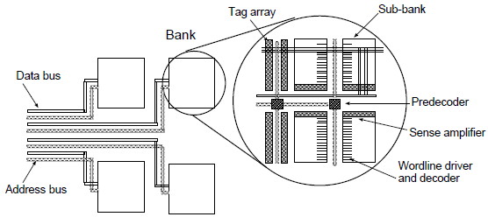
Figure 11: UCA and Static NUCA cache design [6]

residing closer to the processor could be accessed much faster than data residing physically farther, and the use of uniform cache architecture does not exploit this at all. This non-uniformity can be better exploited with the use of non-uniform cache architectures (NUCA). The following sections will describe in more details different types of non-uniform architectures after resuming the bottlenecks encountered by using traditional uniform cache architectures.

Uniform Cache Architecture (UCA)
Large modern caches are divided into sub-banks to minimize access time. Despite the use of an optimal banking organization, large caches of this type perform poorly in a wire-delay-dominated process, since the delay to receive the portion of a line from the slowest of the sub-banks is large [6]. Figure 11 shows an example of an UCA bank (and sub-banks) assuming a central pre-decoder, which drives signals to the local decoders in the sub-banks. Data are accessed at each-sub-banks and returned to the output drivers after passing through multiplexers, where the requested line is assembled and driven to the cache controller [6].

Figure 12a shows a standard L2 uniform cache architecture. Figure 12b shows a traditional multi-levels (L2 and L3) uniform cache architecture (ML-UCA). Inclusion is enforced here, consuming extra space [6]. As we can see, accessing the L3 cache takes a higher access time than accessing the higher level L2 cache.

Static NUCA
Much performance is lost when using uniform cache architecture. The use of multiple banks can mitigate this loss by allowing them to be accessed at different speed depending on the distance of the bank from the cache controller. In the static NUCA model, each bank can be addressed separately and is sized and partitioned into a locally optimal physical sub-bank organization [6]. Data are statically mapped into banks; the low-order bits determining to which bank it will be mapped.

There are two main advantages to the use of static NUCA. First, as shown in figure 12c, the banks closer to the controller have better average access time than the banks farther to the controller. Second, accesses to different banks may proceed in parallel, reducing contention [6]. As shown in figure 11, each addressable bank has two private channels, one going in each direction. These private channels allow banks to be addressed independently at its maximum speed. However, the numerous per-bank channels add area overhead to the array that constrains the number of banks [6]. Also, as technology advances, access time of each bank as well as routing delay increase; best organizations at smaller technologies use larger banks [6]. Overhead of larger and slower banks is smaller than the overhead caused by larger amount of wires for smaller, faster banks. This result in larger and slower banks as cache increases, preventing the static NUCA from exploiting faster and smaller banks architectures.

Switched static NUCA
The per-bank channel area constraint that we have when using static NUCA can be solved by using inter-bank networks. By using a 2D mesh with point-to-point links in the cache, most of the large number of wires required in the first static NUCA implementation can be removed by placing switches at each bank as shown in figure 13 [6]. As shown in figure 12d, average access time is reduced in the switched static NUCA compared to the basic static NUCA.

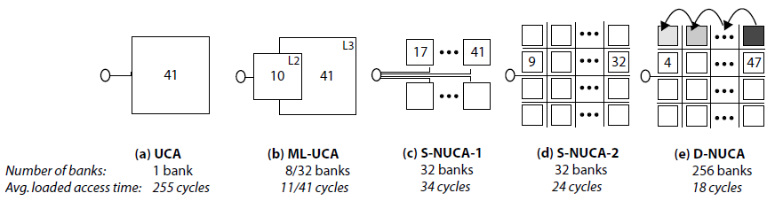
Figure 12: L2 cache architectures, assuming size of 16Mb with 50nm technology [6]

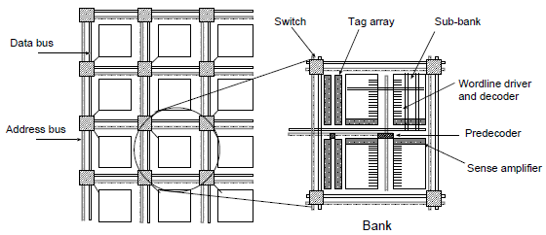
Figure 13: Switched NUCA design [6]

Dynamic NUCA
Even after implementing the previous multi-banked design, performance could still be improved by exploiting the fact that closer banks can be accessed faster than the farther ones. By allowing dynamic mapping of data into any banks, the cache could be managed in such a way that frequently used data could be stored in closer, faster banks than data that are used less frequently [6]. This way, data can be promoted and migrated to faster banks as they are frequently used [6].

Figure 12e shows that the average access time for closer banks can be faster than the ones from static architectures if frequently used data migrate among the banks until it is close to the cache controller. This technique allows the use of much more banks in the cache than the static implementations, achieving almost the same average load access time for the farthest bank in the dynamic architecture (256 banks in total for this example) and for the switched static architecture (32 banks, which is eight times less) [6].

Figure 14 shows a dynamic NUCA architecture with a die with eight cores, a private L1 cache and shared L2 cache [7]. Each core can access all banks in the shared cache. As we can see, banks that are closer to each core can be accessed faster, thus reducing the overall access time of data. Different hardware policies are evaluated when implementing dynamic NUCA that migrate data among the banks to reduce average cache access time and improve cache performance [6]. A dynamic NUCA model can be characterized by four policies that are involved in its behavior [7].

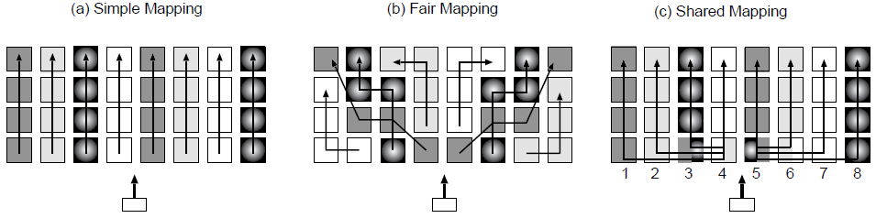
The first policy is the bank placement policy [7]. It determines where a data element is going to be placed in the NUCA cache memory when it comes from the off-chip
Figure 15: Mapping bank sets to banks [6]

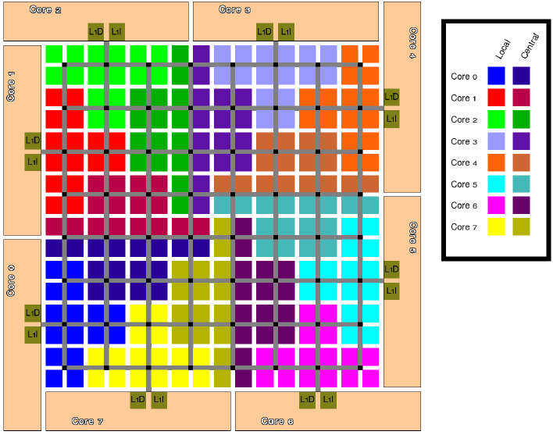
Figure 14: Organization of NUCA architecture [7]
memory of from other caches. Also, this policy determines in which set of banks the data will be located. Many types of mapping could be used such as simple mapping, fair mapping or shared mapping shown in figure 15 (not covered in this paper) [6].

The second policy is the bank access policy [7]. It determines the bank-searching algorithm in the NUCA cache memory space. It also determines if all banks should be accessed sequentially or in parallel. The first one is done by using incremental search, in which the banks are searched in order starting from the closest line until the requested line is found [6]. The second technique is done by doing multicast search, in which the requested address is multicast to some banks in the requested bank sets [6]. Some hybrid policies exists than mix the two mentioned solutions.

The third policy is the bank migration policy [7]. It determines if the data is allowed to change its placement from one bank to another. It also determines which data should be migrated, when it should be and to which bank it should go [7]. Promotion of banks is described by promotion details and promotion trigger (number of hits to a bank before a promotion occurs) [6].

The fourth policy is the bank replacement policy [7]. It determines how NUCA behaves when there is data eviction from the banks and where it is going (to the off-chip memory or re-located to another bank).

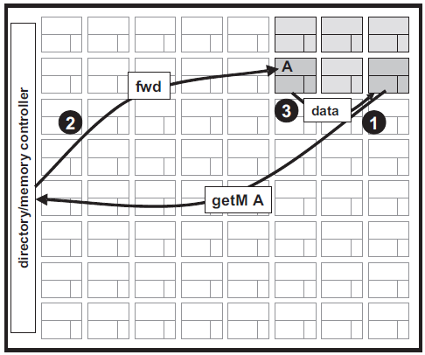
Figure 16: DRAM directory [8]
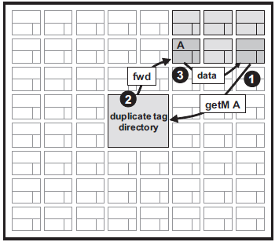
Figure 17: Centralized duplicate tag directory [8]

Implementation of directories in multicores architectures
Directories can be implemented different ways, depending on their locations or the information stored in an entry. Three different types of directory implementation will be presented in the next sections; DRAM directory with on-chip directory cache, duplicate tag directory and static cache bank directory [8]. Some examples of real architectures that use directory protocols for cache coherence in their systems will also be presented in the following sections.

DRAM (off-chip) memory
A DRAM-based directory implementation treats each tile as a potential sharer of the data [8]. The directory is centralized in the off-chip (DRAM) memory and is implemented with centralized protocols such as the full-map or limited directory protocols described in previous sections.
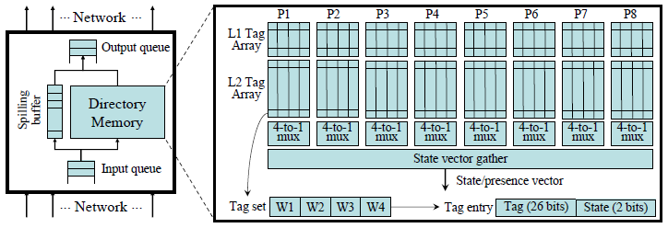
Figure 18: Duplicate tag directory [9]
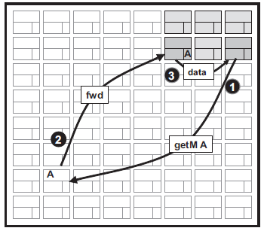
Figure 19: Static cache bank directory [8]

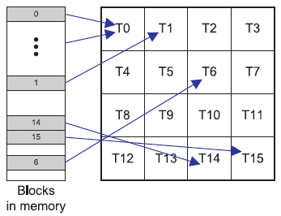
Figure 20: Mapping of blocks to home tiles [10]
Any request that needs to be done to the directory need to go through the memory or directory controller as shown in figure 16. The directory states are logically stored in the off-chip memory, but it could be cached in the on-chip memory at the memory controller (see figure 16) for better performance [8]. One major disadvantage of this implementation is that it does not exploit distance locality. The request may incur significant latency to reach the directory even if the needed data is located nearby. For example, as shown in figure 16, the data is located only two tiles away from the requester. The request still needs to go through the entire network to reach the controller, and it takes almost the same time to come back from the controller to the destination tile (tile “A” in figure 16).

Duplicate tag directory
Another approach for implementing directory is to use a centralized duplicate tag store in the on-chip memory instead of storing directory states into the off-chip memory as shown in figure 17. Directory state for a block can be determined by examining a copy of the tag of every possible cache that can hold the block of data [8]. Mechanisms to keep the stored tags up-to-date are also implemented. The advantage of using this architecture is that there is no need to store each state in the directory and to access the off-chip memory through the controller each time. If a block is not found in the duplicate tag directory, it means that it is not cached at all. Also, even if still not exploited optimally, distance locality is a little more exploited than the previous described directory architecture
since the maximum distance to access the directory is reduced (see figure 17).
Figure 21: SGI Origin2000 cache and directory architecture [1]

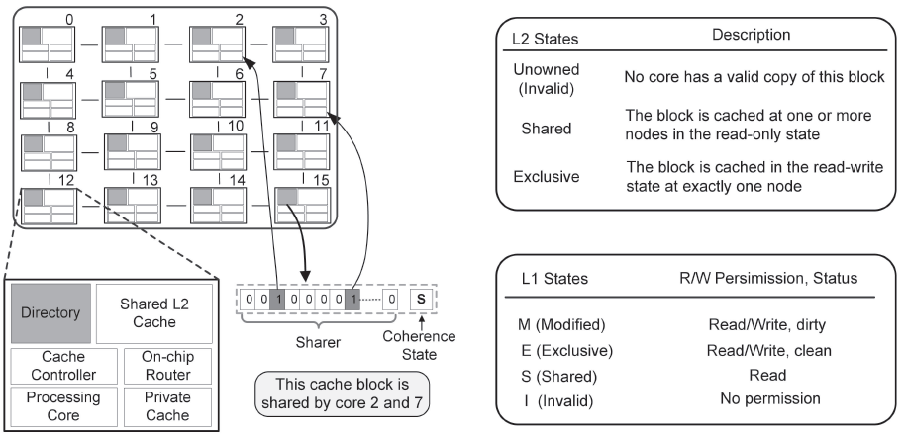
Figure 18 shows the internal implementation of a duplicate tag directory for eight cores, each one of them having a two-way associative L1 instruction and data split cache and a four-way set associative cache where L1 and L2 caches are non-inclusive [9]. Each tag consists of the tags bits and the state bits. A directory lookup is directed to the corresponding bank to search the related cache sets in all the duplicate tag arrays in parallel. The results from all tag arrays are gathered to form a state vector as in the full-map directory protocol.

Implementing a duplicate tag store can become challenging as the number of cores increases [8]. For example, if we have 64 cores in the architecture, the duplicate tag store will need to contain the tags for all 64 possible caching locations. If each tile implements 16-way set associative L2 caches, then the aggregate associativity of all tiles is 1024 ways.

Static cache bank directory
A directory can also be distributed among all the tiles by mapping a block address to a tile called the home tile [8] (see figure 19). Tags in the cache bank of each tile are extended to contain directory entry state (sharing bit vector as in the full-map protocol, for example). All requests are forwarded to the home tile of a block which contains directory entry for it. If a request reaches the home tile and fails to find a matching tag, it allocates a new tag and gets the data from memory [8]. The retrieved data is places in the home tile’s cache and a copy is returned to the requesting tile. Before evicting a cache block, the protocol must first invalidate sharers and write back dirty copies in the memory. This implementation avoids the use of a separate directory in the off-chip or in an on-chip memory.

Home tiles are usually selected by simple interleaving on low-order blocks [8]. Figure 20 shows an example of how blocks can be mapped to home tiles. Home tile locations are not necessarily optimal since the block used by a processor can be mapped to a tile located across the chip. This problem can be solved by using a more dynamic cache bank directory at the cost of increased complexity.

One example of real architecture implementing distributed directory is the SGI Origin2000 multiprocessor system [1]. It implements 16-core architecture with shared L2 cache. Both the directory and the shared L2 memory are distributed. Each directory entry is associated to an L2 cache block and has a sharer field and a state field. The sharer field is a bit vector and show which core shares a copy of the data (as in the full-map protocol). The state field keeps the coherence state of the block. The cache block state information is kept in the directory memory and each core’s private cache as shown in figure 21 [1]. Figure 21 shows the coherence states an L2 and L1 cache block can have [1]. For example, in figure 21, the home tile for a specific cache block (tile number 12) contains directory information about which tile is sharing the block (tiles 2 and 7). The state field is set to “shared” since two private caches are storing the data.

Another architecture implementing distributed directory is the Tilera Tile64 architecture [11]. It is a 64-core processor consisting of an 8X8 grid of tiles (see figure 22). The processor provides a shared distributed memory environment in which a core can directly access a cache in other core using the on-chip interconnect (neighborhood sharing) called the Tile Dynamic Network (TDN) [11]. The coherency is maintained at the home tile for any given piece of data, and data is not cached at non-home tiles [11].

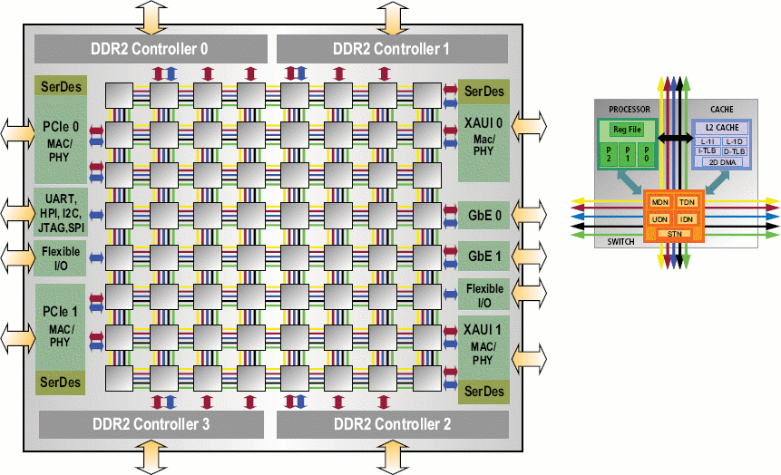
Figure 22: Tilera Tile64 architecture [12]

Summary
In this paper, different directory-based protocols have been presented; the full-map directory protocol, the limited directory protocol and the chained directory protocol. Full-map directories use a bit vector of length equal to the number of processors in the system while limited directories use a limited number of pointers referring to the processors sharing the data. Chained directories use a single pointer referring to a head cache holding the data which also points to another one until the tail of the chain is reached.

Directories can either be centralized or distributed among shared caches in the system. Different architectures implement directories in different ways depending on their location or the information they contain. Directories can be located either on the off-chip memory or the on-chip memory. Directories located on the off-chip memory are not really used since accessing the requested information takes much more time than accessing data from the on-chip memory. Instead, directories can be stored on the on-chip memory by storing a duplicate tag of all cache blocks that are stored in the tiles of the system. However, this solution does not exploit data locality and the size of the directory increases a lot as the number of processors grow in the architecture. The implementation that offers best performance has the directory distributed among the tiles of the system since data locality can be exploited. There are architectures that already implement distributed directories such as the SGI Origin2000 and the Tilera Tile64 architectures.

Finally, the non-uniform cache architectures (NUCA) was presented in this paper. Uniform cache architectures (UCA) does not exploit data locality into the cache memory, meaning that data situated physically closer to the processor is accessed at the same speed than data that is situated farther. Non-uniform cache architectures exploit this aspect by dividing the memory into multiple banks which are connected in a 2D mesh network. The architecture can be static or dynamic. In static-NUCA, data is always mapped to a specific bank. If some processor frequently uses some data that is statically mapped at the farthest point in the network, data locality is never exploited. In dynamic-NUCA, data is allowed to be dynamically mapped and to migrate among the banks in the network. This method better exploits data locality when a processor frequently accesses the same data.

References

- H. Lee, S. Cho, B.R. Childers, "PERFECTORY: A Fault-Tolerant Directory Memory Architecture“, Computers, IEEE Transactions on, vol.59, no.5, May 2010, p.638-650
- M.E. Acacio, J. Gonzalez, J.M. Garcia, J. Duato, "A two-level directory architecture for highly scalable cc-NUMA multiprocessors," Parallel and Distributed Systems, IEEE Transactions on, vol.16, no.1, Jan. 2005, pp. 67- 79
- D. Chaiken, C. Fields, K. Kurihara, A. Agarwal, "Directory-based cache coherence in large-scale multiprocessors," Computer , vol.23, no.6, Jun 1990, pp.49-58
- U. Bruning, “Shared memory with caching” [online], University of Heidelberg, 2004 [cited nov. 04 2010], available from the World Wide Web: <http://ra.ziti.uni-heidelberg.de/pages/lectures/hws08/ra2/script_pdf/dbcc.pdf>
- R.V. Meter, “Computer Architecture”, Keio University, 2007 [cited nov. 04 2010], available from the World Wide Web: <http://web.sfc.keio.ac.jp/~rdv/keio/sfc/teaching/architecture/architecture-2007/lec08.html>
- C. Kim, D. Burger, S.W. Keckler, “An Adaptative, Non-Uniform Cache Structure for Wire-Delay Dominated On-Chip Caches”, in Proc. 10th Int. Conf. ASPLOS, San Jose, CA, 2002, pp. 1-12
- J. Lira, C. Molina, A. Gonzalez, “Analysis of Non-Uniform Cache Architecture Policies for Chip-Multiprocessors Using the Parsec Benchmark Suite”, MMCS’09, Mar. 2009, pp. 1-8
- M.R. Marty, M.D. Hill, “Virtual Hierarchies to Support Server Consolidation”, ISCA’07, June 2007, pp. 1-11
- J. Chang, G.S. Sophi, “Cooperative Caching for Chip Multiprocessors”, Computer Architecture, ISCA '06. 33rd International Symposium on, 2006, pp.264-276
- S. Cho, L. Jin, "Managing Distributed, Shared L2 Caches through OS-Level Page Allocation“, Microarchitecture, 2006. MICRO-39. 39th Annual IEEE/ACM International Symposium on, Dec. 2006, pp.455-468
- D. Wentzlaff, P. Griffin, H. Hoffmann, L. Bao, B. Edwards, C. Ramey, M. Mattina, C.C. Miao, J.F. Brown, A. Agarwal, "On-Chip Interconnection Architecture of the Tile Processor“, Micro, IEEE , vol.27, no.5, Sept.-Oct. 2007, pp.15-31
- Linux Devices, “4-way chip gains Linux IDE, dev cards, design wins” [online], Linux Devices, Apr. 2008 [cited Oct. 21 2010] , available from World Wide Web: <http://thing1.linuxdevices.com/news/NS4811855366.html>
- J.A. Brown, R. Kumar, D. Tullsen, “Proximity-Aware Directory-based Coherence for Multi-core Processor Architectures”, SPAA’07, June 2007, pp. 1-9

