Jean-Philippe Bergeron 4656474

Questions

Shared Memory Systems

Questions

1.
Draw a bus based shared memory system with 3 processor and 2 memories.
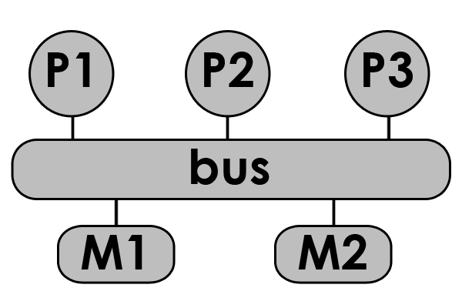

2.
What are the 2 right requirements for shared memory system
  - Have multiple memory modules
  - Support for memory coherency
  - Support for atomic operations on data
  - Communicate from processor to processor

3.
What is an atomic operation?
An operation that can't be divided or interrupted.

4.
By using Load-Locked(LL) and Store-Conditional(SC) in the following code, in which condition can sc fail. Give an example.
lock: ll,reg1, location /* LL location to reg1 */
bnz reg1, lock /* if location is locked, try again*/
sc location, reg2 /* SC reg2 into location*/
beqz lock /* if failed, start again */
ret /* return control to the caller of lock */
It can fail in case another processor gets the lock after LL returns that the lock is unlocked.

5.
In a system with two processor and 2 cache. If there is no cache coherence protocol, can one processor read an old value in the case of
- Write-through cache yes
- Write-back cache yes

Problems

1.
Convert this loop into a parallel program using INITIALIZE(), LOCK(), UNLOCK() or BARRIER(). All processor starts at the same time.
INITIALIZE | assigns a number (proc_num) to each processor in the system; assigns the total number of processors (num_procs).
LOCK(data) | Allows a processor to “check out” a certain piece of shared data.  While one processor has the data locked, no other processors can obtain the lock.  The lock is blocking, so once a LOCK is encountered, execution of the program cannot proceed until the LOCK is obtained.
UNLOCK(data) | releases a lock so that other processors can obtain it.
BARRIER(n_procs) | When a BARRIER is encountered, a processor waits at that BARRIER until n_procs processors reach the BARRIER, then execution can proceed.
int global_sum = 0;
int local_sum = 0;

for (int i=0; i< 1024; i++){
for (int j=0; j< 1024; j++){
local_sum += j;
}
}
global_sum += local_sum;
printf("sum is %d", global_sum);

Is the barrier essential?

Answer
INITIALIZE;
int global_sum = 0; // can be done by all thread
int local_sum = 0;

lower_ind = (1024 / num_procs) * proc_num;
upper_ind = (1024 / num_procs) * (proc_num + 1);
for (int i= lower_ind; i< upper_ind; i++){
for (int j=0; j< 1024; j++){
local_sum += j;
}
}
LOCK(global_sum);
global_sum += local_sum;
UNLOCK(global_sum);
BARRIER(num_procs);
printf("sum is %d", global_sum);

Yes, global_sum has to be computed before the printf can be executed.

2.
Assume the following atomic function for swap. Design a locking function using swap.
int swap ( int* register, int oldval, int newval)
{
int old_reg_val = *register;
if (old_reg_val == oldval)
*register = newval;
return old_reg_val;
}
make a lock and unlock functions using swap
void lock(int* register) {
while (swap(register,0,1) ==1 ) {}
}
void unlock(int* register) {
*register = 0;
}

3.
Describe the functionality of test&set and how can it be used to implement a lock?
The function writes one to the memory location, it returns the value that was in the memory before the set.

2 possible solution
lock: t&s register, location
bnz lock /* if not 0, try again */
ret /* return control to caller */
or
while (t&s(location) !=0) {}

4.
How would you implement the test&set function in C? Assume your function will be executed atomically.
int test&set(*location){
int previous_value = *location;
*location = 1;
return previous_value;
}

5.
Where should barriers be used in the following program and why?
INITIALIZE; //assign proc_nums and num_procs
if (proc_num == 0) { //initialize the sum
read_array(global_array_to_sum, size); //read the array and array size from file
LOCK(global_sum);
global_sum = 0;
UNLOCK(global_sum);
}
local_sum = 0;
size_to_sum = size/num_procs;
lower_ind = size_to_sum * proc_num;
upper_ind = size_to_sum * (proc_num + 1);
BARRIER(num_procs); //answer 1
for (int i = lower_ind; i < upper_ind; i++)
local_sum += global_array_to_sum[i];
LOCK(global_sum); //locks the sum variable so only this process can change it
global_sum += local_sum;
UNLOCK(global_sum); //gives the sum back so other procs can add to it
BARRIER(num_procs); //answer 2
if (proc_num == 0)
printf("sum is %d", global_sum);
The barrier at place answer1 is needed because global_array_to_sum has to be read by processor 0 before it can be used.
The barrier at place answer2 is needed because the variable global_sum has to be computed before it can be displayed.

