CEG 4131 Assignment 5 Solutions

1.
( a) Dependence graph:
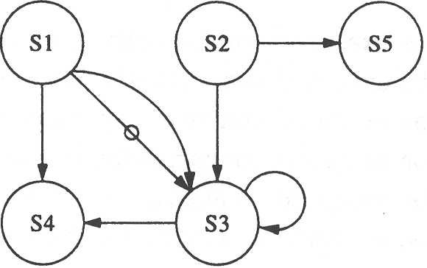

(b) There are storage dependences between instruction pairs (S2, S5) and (S4, S5).
There is a resource dependence between Sl and S2 on the load unit, and another between S4 and S5 on the store unit.
(c) There is an ALU dependence between S3 and S4, and a storage dependence between S1 and S5.

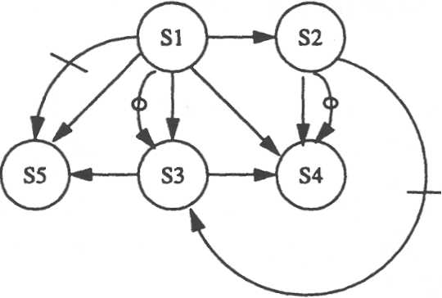
2.
The input and output sets for the instructions are enumerated below:
I1 = {B, C}, O₁ = {A},
1₂ = {B,D}, O₂ = {C},
I3 = ∅, O₃ = {S},
I4 = {S,A,X(I)}, O₄ = {S},
I5 = {S,C}, O5 = {C}.
Using Bernstein's conditions, we find that
S1 and S3 can be executed concurrently, because I1 ∩ 03 = ∅, I3 ∩ O1 = ∅, and 01 ∩ O3 = ∅.
S2 and S3 can be executed concurrently, because I2 ∩ O3 = ∅, 13 ∩ O2 = ∅, and O2 ∩ O3 = ∅ ..
S2 and S4 can be executed concurrently, because 12 ∩ O4 = ∅, 14 ∩ O2 = ∅, and O ₂ ∩ O₄ = ∅.
S1 and S5 cannot be executed concurrently, because I1 ∩ O 5 = {C}.
S1 and S2 cannot be executed concurrently, because I1 ∩ O₂ = {C}.
S1 and S4 cannot be executed concurrently, because 14 ∩ O ₁ = {A}.
S2 and S5 cannot be executed concurrently, because I5 ∩ O₂ = O5 ∩ O₂ = {C}.
S3 and S4 cannot be executed concurrently, because 14 ∩ O₃ = O₄ ∩ O₃ = {S}.
S3 and S5 cannot be executed concurrently, because I5 ∩ O₃ = {S}.
S4 and S5 cannot be executed concurrently, because I5 ∩ 14 = I5 ∩ 0₄ = {S}.
The program can be reconstructed as shown in the flow graph below:

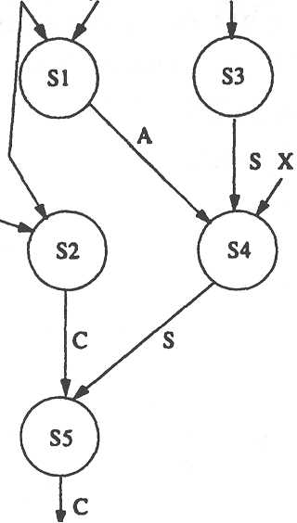

3.
( a) Since the processing elements of an SIMD machine read and write data from different memory modules synchronously, no access conflicts should arise. Thus any PRAM variant can be used to model SIMD machines.
(b) The processors in an MIMD machine can read the same memory location simultaneously. However, writing to a same memory location is prohibited. Thus the CREW-PRAM can best model an MIMD machine.

