CEG 4131 Assignment 2

1. You are asked to design a direct network for a multicomputer with 64 nodes using a three-dimensional torus, a six-dimensional binary hypercube, and cubeconnected-cycles (CCC) with a minimum diameter. The following questions are related to the relative merits of these network topologies:
Let d be the node degree, D the network diameter, and I the total number of links on a network. Suppose the quality of a network is measured by (d x D x i)⁻¹. Rank the three architectures according to this quality measure.

2. Answer the following questions related to multistage networks:
a) How many legitimate states are there in a 4 x 4 switch module, including both 'broadcast and permutations? Justify your answer with reasoning.
b) Construct a 64-input Omega network using 4 x 4 switch modules in multiple stages. How many permutations can be implemented directly in a single pass through the e~k without blocking?

3. Topologically equivalent networks are those whose graph representations are isomorphic with the same interconnection capabilities. Prove the topological equivalence among the Omega, Flip, and Baseline networks.
(a) Prove that the Omega network is topologically equivalent to the Baseline network
(b) The Flip network (figure on the next page) is constructed using inverse perfect shuffle
for interstage connections. Prove that the Flip network is topologically equivalent to the Baseline network.
(c) Based on the results obtained in (a) and (b), prove the topological equivalence between the Flip network and the Omega network.

4. Using AND and OR gates (no wired-OR) to construct an n x n crossbar switch network between n processors and n memory modules. Let the width f each crosspoint be w bits (or a word) in each direction.
(a) Prepare a schematic design of a typical crosspoint switch using Cij as the enable signal for the switch in the ith row and jth column. Estimate the total number of AND and OR gates needed as a function of n and w.
(b) Assume that processor Pi has higher priority over processor Pj if i < j when they are competing for access to the same memory module. Let k = log₂ n be the address width. Design an arbiter which generates all the crosspoint enable signals Cij again using only two-input AND and OR gates and some inverters if needed. The memory address decoder is assumed available from each processor and thus is not included in the arbiter design. Indicate the complexity of the arbiter design as a function of n and k.

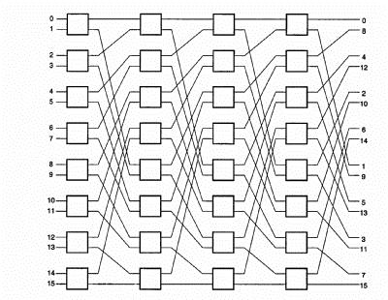

Flip network

