
Université d’Ottawa · University of Ottawa

École d'ingénierie et de technologie School of Information Technology
de l'information (EITI) and Engineering (SITE)

CEG 4131 Computer Architecture III: FINAL EXAM

Date: December 9th | Professor: Dr. M. Bolic
Duration: 3 hours | Session: Fall 2005-2006
Total Points = 100

Note: Closed book exam. One double-sided cheat-sheets is allowed. Calculators are allowed.

Name: _______________________Student ID:_______________

Students have to do questions 1, 2, 3 and one of the two problems in questions 4 and 5.

 | Question | Maximum | Score
 | 1 | 20
 | 2 | 20
 | 3 | 20
Select either 4-1 or 4-2  Select either 5-1 or 5-2 | 4-1 or 4-2 | 20
Select either 4-1 or 4-2  Select either 5-1 or 5-2 | 5-1 or 5-2 | 20
 | Total | 100
QUESTION #1 (a 2 points, b,c,d,e,f,g 3 points each, total 20)
Define, compare and comment on the following (within 2-4 sentences each):

- What is a difference between the shared bus and the linear array?

- What is the degree of parallelism? What degree of parallelism is assumed in the derivation of Amhdal’s law?

- What criterion is used for Flynn’s classification on parallel systems?

- What is the difference between virtual cut through and wormhole routing?

- Compare the three different shared memory system classification: UMA, NUMA, and COMA.

- Define the parallel random-access machine (PRAM) model?

- What are the basic hardware elements of a vector processor?

QUESTION #2: (3 + 3 + 6 + 5 + 3 = 20 Points)
Interconnection networks

Consider the following 16x16 Omega network.

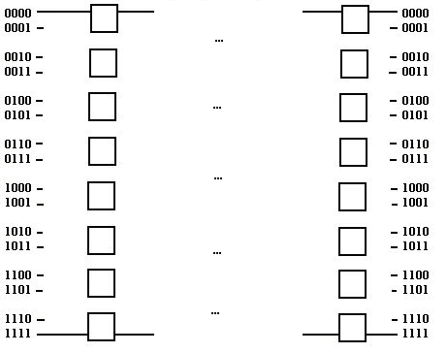

- Determine the number of stages.
- Determine the number of 2 x 2 switches needed to implement the network.
- Draw a 16-input Omega network using 2 x 2 switches as building blocks.
- Show the switch settings for routing a message from node 1011 to node 0101 and from node 0111 to node 1001 simultaneously.
- Does blocking exist in this case? Explain.

QUESTION #3 (a, b 10 points each, total 20 points)
Message passing systems

a) A message passing program running on two processors executes the following sequence of tasks:
Processor 1 | Processor 2
Compute for 1000 cycles  Receive message 1  Compute for 2000 cycles  Send message 2 to processor 2  Compute for 5000 cycles | Compute for 500 cycles  Send message 1 to processor 1  Compute for 500 cycles  Receive message 2  Compute for 5000 cycles
Assume that a processor that sends a message is busy for entire 1000 cycles time that it takes for the message to reach the destination processor. The delay from when a message is sent until when it is received on the destination processor is 1000 cycles, and it takes 500 cycles to complete RECEIVE operation if the message being received is available. What is the total execution time?

b) Consider a 64-processor system and assume a 64-node hypercube network architecture is used to connect all different nodes. Based on the E-cube routing algorithm show how to route a message from node A (101101) to node B (011010).

QUESTION #4-1 (a, b, c, d 5 points each, total 20 points)
Shared memory systems
This question is prepared by Prof. Miodrag Bolic

Three processors P1, P2, P3 with their individual caches are connected via a bus with a shared memory. In the initial state memory location x has the value 3 and the caches are empty. Given is the following sequence of operations:
- P1 reads location x.
- P2 writes 8 into location x.
- P3 reads location x.
- P1 reads location x.
- P2 writes 9 into location x.
Give the state of the cache controller (if a protocol is used) and the contents of the caches and the memory (x) after each step, if
(a) no snooping protocol is used. Caches are write-back caches.
(b) no snooping protocol is used. Caches are write-through caches.
(c) two-state write-through write invalidate protocol is used (Figure 1).
(d) basic MSI write-back invalidation protocol is used (Figure 2).

a) | Content of x in P1’s cache | Content of x in P2’s cache | Content of x in P3’s cache | Content of memory location x
1. P1 reads location x.
2. P2 writes 8 into location x.
3. P3 reads location x.
4. P1 reads location x.
5. P2 writes 9 into location x.

b) | Content of x in P1’s cache | Content of x in P2’s cache | Content of x in P3’s cache | Content of memory location x
1. P1 reads location x.
2. P2 writes 8 into location x.
3. P3 reads location x.
4. P1 reads location x.
5. P2 writes 9 into location x.

c) | State of P1’s cache | Content of x in P1’s cache | State of P2’s cache | Content of x in P2’s cache | State of P3’s cache | Content of x in P3’s cache | Content of memory location x
1. P1 reads location x.
2. P2 writes 8 into location x.
3. P3 reads location x.
4. P1 reads location x.
5. P2 writes 9 into location x.

d) | State of P1’s cache | Content of x in P1’s cache | State of P2’s cache | Content of x in P2’s cache | State of P3’s cache | Content of x in P3’s cache | Content of memory location x
1. P1 reads location x.
2. P2 writes 8 into location x.
3. P3 reads location x.
4. P1 reads location x.
5. P2 writes 9 into location x.

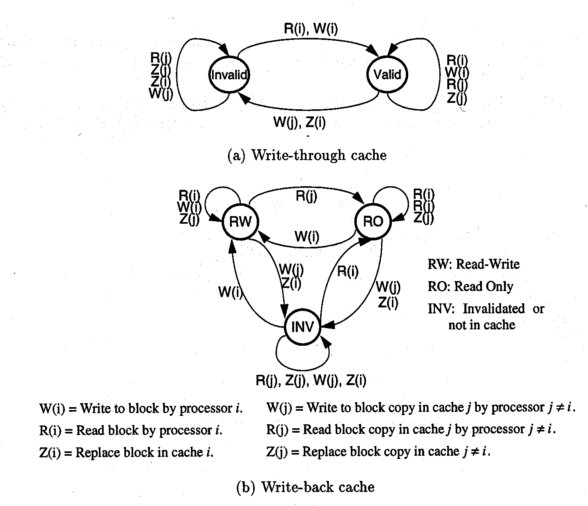
R = Read, W = Write, Z = Replace
i = local processor, j = other processor

Figure 1 State machine for write through write invalidate cache coherence protocol

Figure 2 State machine for write-back write invalidate cache coherence protocol
QUESTION #4-2 (5 + 5 + 10 = 20 Points)
This question is prepared by Prof. Mansour Assaf

You are asked to perform capacity planning for a three-level memory system. The first level, M₁, is a cache with three capacity choices of 64 Kbytes, 128 Kbytes, and 256 Kbytes. The second level, M₂, is a main memory with a 4-Mbyte capacity, and the third level is a 400 Mbyte hard disk. Let c_{1,} c_{2,} and c₃ be the costs per byte and t₁, t₂, and t₃ the access times for M₁, M₂, and M₃, respectively. Assume c₁ = 20 c₂, c₂ = 2000 c₃, t₂ = 10 t₁, and t₃ = 1000 t₂. The cache hit ratios for the three capacities are assumed to be 0.7, 0.9, and 0.98, respectively.

- What is the average access time t_{a} in terms of t₁ = 20ns in the three cache designs? (Note that t₁ is the time from CPU to M₁, t₂ is that from CPU to M₂, and t₃ is that from CPU to M₃, not from M₁ to M₂.nor from M₂ to M₃).
- Express the average byte cost of the entire memory hierarchy if c₃ = $0.0001/Kbyte.
- Compare the three memory designs and indicate the order of merit in terms of average costs and average access times, respectively. Choose the optimal design based on the product of average cost and average access time.
QUESTION #5-1 (a, b 10 points each, total 20 points)
Parallel programming and vector processing
This question is prepared by Prof. Miodrag Bolic

1. Consider a following program for parallel addition using a message passing parallel system. Assume that the array_to_sum is stored initially in the local memory of processor 0. Using the same logic as in the code for parallel addition, write a program for parallel multiplication Y = a × X on the message passing system. Assume that array X and scalar a are initially stored in the local memory of the processor 0 and all the elements of the array Y have to be printed by processor 0 after they are computed.

INITIALIZE; //assign proc_num and num_procs
if (proc_num == 0) //processor with a proc_num of 0 is the master,
//which sends out messages and sums the result
{
read_array(array_to_sum, size); //read the array and array size from file
size_to_sum = size/num_procs;
for (current_proc = 1; current_proc < num_procs; current_proc++)
{
lower_ind = size_to_sum * current_proc;
upper_ind = size_to_sum * (current_proc + 1);
SEND(current_proc, size_to_sum);
SEND(current_proc, array_to_sum[lower_ind:upper_ind]);
}
//master nodes sums its part of the array
sum = 0;
for (k = 0; k < size_to_sum; k++)
sum += array_to_sum[k];
global_sum = sum;
for (current_proc = 1; current_proc < num_procs; current_proc++)
{
RECEIVE(current_proc, local_sum);
global_sum += local_sum;
}
printf(“sum is %d”, global_sum);
}
else //any processor other than proc_num = 0 is a slave
{
sum = 0;
RECEIVE(0, size_to_sum);
RECEIVE(0, array_to_sum[0 : size_to_sum]);
for (k = 0; k < size_to_sum; k++)
sum += array_to_sum[k];
SEND(0, sum);
}
END;

2. Consider the following code implemented on a vector processor used to multiply 64 element vector Y = a × X:

L.D F0,a ; load scalar a
LV V1,Rx ; load vector X
MULVS.D V2,V1,F0 ; vector-scalar multiply
SV Ry,V2 ; store the result

Instructions have the following startup delay: Load and store unit 12, Multiply unit 7 clock cycles.

Compute the total execution time of vector instructions if the instructions are chained. Assume that
- there is only 1 load/store unit
- there are one load and one store unit.

QUESTION #5-2 (5 + 5 + 5 + 5 = 20 points)
Scheduling
This question is prepared by Prof. Mansour Assaf

A sequential program consists of the following seven statements, S1 through S8. Considering each statement as a separate process.

S1: A = B + C
S2: C = D + E
S3: F = G + E
S4: C = A + F
S5: M = G + C
S6: A = L + C
S7: A = E + A
S8: M = 2 * A

- Clearly identify input set I_{i} and output set O_{i} of each process.
- Use Bernstein’s conditions to detect the maximum parallelism embedded in this code. If any pair of process cannot be executed concurrently, specify which of the three conditions is not satisfied.
- Justify the portions that can be executed in parallel and the remaining portions that must be executed sequentially. Are Bernstein’s conditions sufficient for this problem?
- According to Bernstein’s conditions and taking into account the precedence relations, rewrite the code using parallel constructs such as Cobegin and Coend. No variable substitution is allowed. All statements can be executed in parallel if they are declared within the same block of a (Cobegin, Coend) pair.

